4.13 Implement Floyd's Algorithm to find the shortest path between all pairs of cities. Display the distance matrix before and after applying the algorithm. Identify and print the shortest path
AIM
To implement Floyd’s Algorithm to compute the shortest paths between all pairs of cities in a weighted graph, display the distance matrix before and after applying the algorithm, and identify the shortest path..
ALGORITHM
1. Start
2.Input the number of routers n and cost of each link (∞ if no direct link).
3. Build an initial distance matrix:
- Distance to itself = 0
- Distance to neighbors = given link cost
- If no direct connection = ∞.
4. Display the initial distance matrix.
5.Apply Floyd’s Algorithm
6. Display shortest path distance from Router A to Router F.
7.Simulate link failure: set dist[B][D] = dist[D][B] = ∞.
8.Run Floyd’s Algorithm again to recompute all-pairs shortest paths.
9.Display shortest path distance from Router A to Router F after failure.
10.End

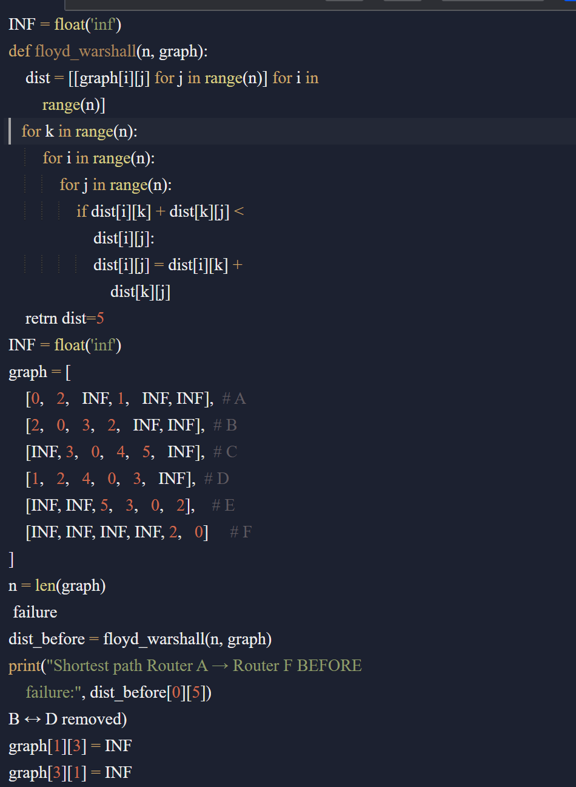
Input:
Routers: A, B, C, D, E, F
Links:
A–B = 2
A–D = 1
B–C = 3
B–D = 2
C–D = 4
C–E = 5
D–E = 3
E–F = 2
Output:
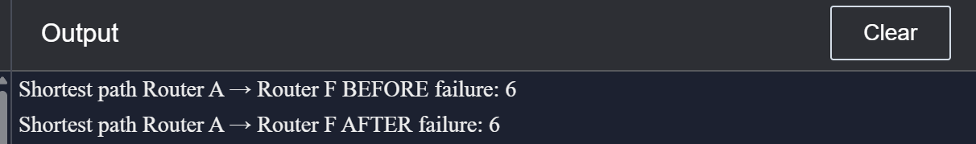
RESULT:
The program correctly implements Floyd’s Algorithm to calculate shortest paths in the router network.
- Before the B–D link failure, the shortest path from Router A → Router F = 5.
- After the B–D link failure, the shortest path increases to 6.

PERFORMANCE ANALYSIS:
- Time Complexity: O(n³)
- Space Complexity: O(n²)

