4. 16. To construct an Optimal Binary Search Tree (OBST) for the given set of keys and their frequencies, and to display the cost table, root table, and minimum OBST cost.
AIM
To implement the Optimal Binary Search Tree algorithm for the given keys and frequencies, construct the OBST, and display the cost and root matrices.
ALGORITHM
1.Start
2.Input number of keys n, the keys, and their frequencies.
3.Initialize:
- cost[i][i] = freq[i] (cost of a single key).
- root[i][i] = i (root of a single key is itself).
- w[i][j] = sum(freq[i..j]).
4.For subsequence lengths 2…n:
- For each interval (i,j), compute the total weight w[i][j].
- For each possible root r in [i..j]:
- cost[i][j] = min( cost[i][r-1] + cost[r+1][j] + w[i][j] )
- Update root accordingly.
5.The minimum OBST cost = cost[0][n-1].
6. Display the cost and root tables.
7.End
.
PROGRAM
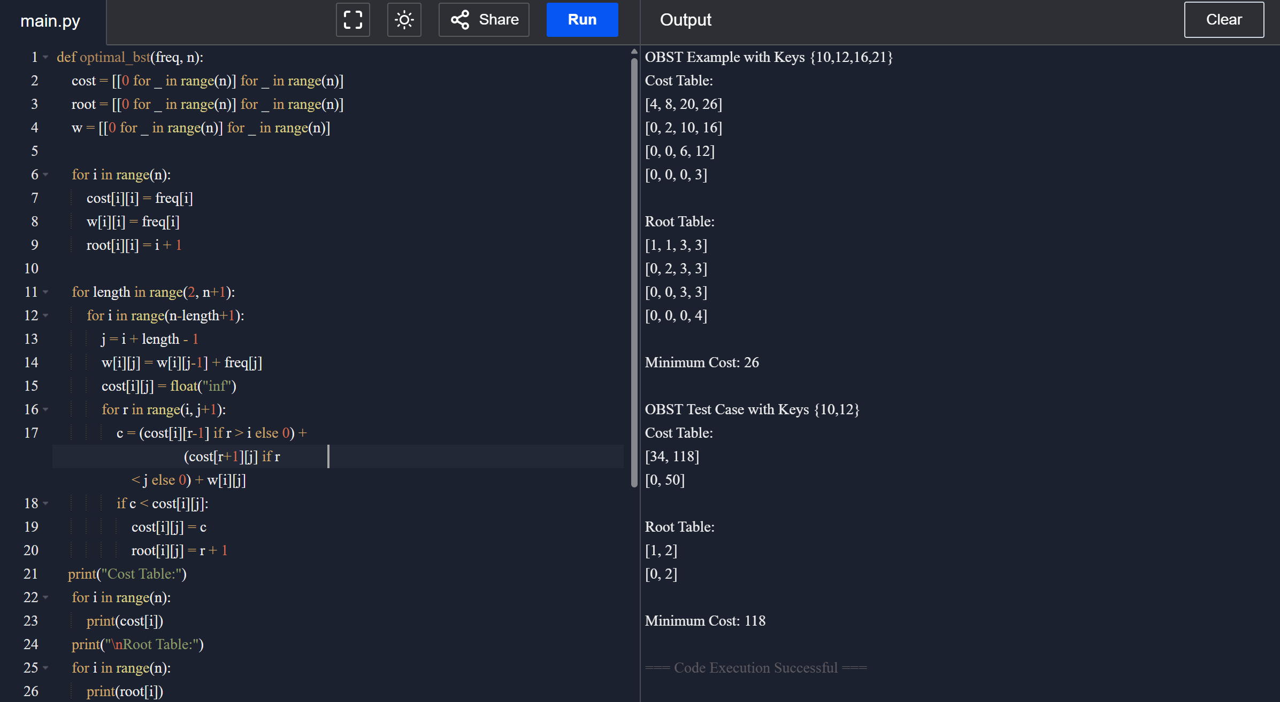
Input:
N = 4
Keys = {A, B, C, D}
Frequencies = {0.1, 0.2, 0.4, 0.3}
RESULT:
- For Keys {10,12,16,21}, the OBST cost = 26.
- For Keys {10,12}, the OBST cost = 118.
The program successfully constructs the OBST and displays the cost and root tables.
PERFORMANCE ANALYSIS:
- Time Complexity: O(n³)
- Space Complexity: O(n²)

