4.5. Assume you are solving the Traveling Salesperson Problem for 4 cities (A, B, C, D) with known distances between each pair of cities. Now, you need to add a fifth city (E) to the problem.
AIM
To solve the Traveling Salesperson Problem (TSP) for 5 cities with given distances and find the shortest route and total distance.
ALGORITHM
- Input the distance matrix for all cities (A, B, C, D, E).
- Generate all possible permutations of city visits starting from the first city.
- For each permutation, calculate the total travel distance.
- Keep track of the minimum distance and corresponding route.
- Output the shortest route and its total distance.
PROGRAM:-
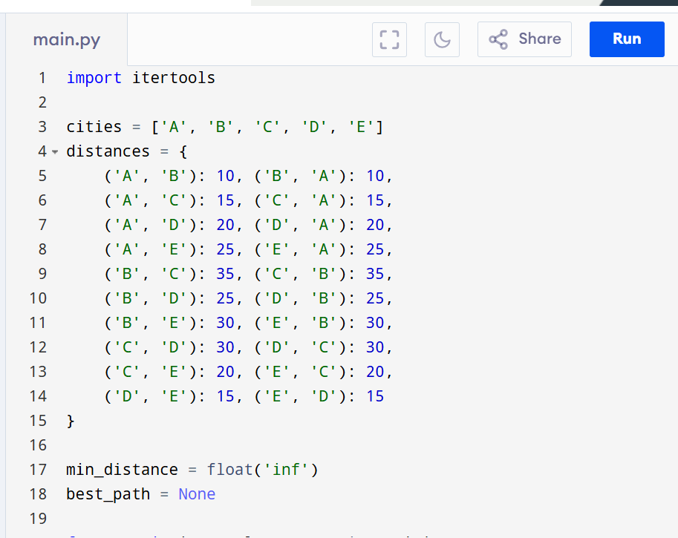
INPUT:-
Cities: A, B, C, D, E
Distances: Given above

OUTPUT:-
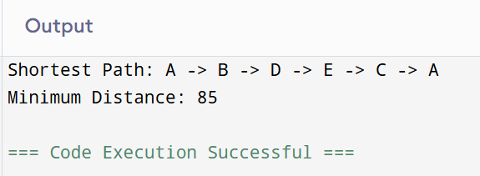

RESULT:-
The program successfully finds the shortest route and minimum travel distance for the given 5-city TSP.
PERFORMANCE ANALYSIS:
• Time Complexity: O(n!) for generating permutations.
• Space Complexity: O(1)

