TOPIC 07 - TRACTABILITY AND APPROXIMATION ALGORITHM
7.1
Aim
To implement a program that verifies whether a given decision problem belongs to class P or NP. Specifically, we use the Hamiltonian Path problem.
- If in P → A polynomial-time algorithm exists.
- If in NP → We can verify a proposed solution in polynomial time.

Algorithm (Hamiltonian Path Verification)
- Input:
  - A graph G(V,E)G(V, E)G(V,E).
  - A candidate path PPP.
- Steps:
  - Check if the path contains all vertices exactly once.
  - For every consecutive pair in the path, check if an edge exists in EEE.
  - If both conditions are satisfied → It is a Hamiltonian Path.
- Output:
  - True (and display the path) if it’s Hamiltonian.
  - False otherwise.

Code:
def is_hamiltonian_path(graph, vertices, path):
if set(path) != set(vertices):
return False

for i in range(len(path) - 1):
if (path[i], path[i+1]) not in graph and (path[i+1], path[i]) not in graph:
return False
return True
vertices = ["A", "B", "C", "D"]
edges = {("A", "B"), ("B", "C"), ("C", "D"), ("D", "A")}
graph = edges
candidate_path = ["A", "B", "C", "D"]
result = is_hamiltonian_path(graph, vertices, candidate_path)
print("Graph Vertices:", vertices)
print("Graph Edges:", edges)
print("Candidate Path:", " -> ".join(candidate_path))
print("Hamiltonian Path Exists:", result)

Output screenshot:
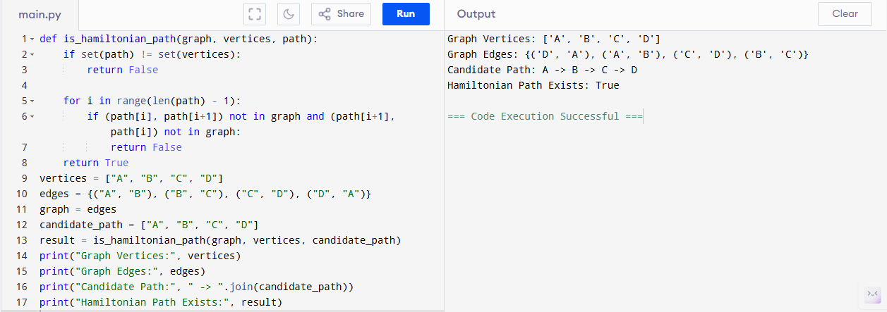

Sample Input & Output:
Input:
Vertices = {A, B, C, D}
Edges = {(A, B), (B, C), (C, D), (D, A)}
Candidate Path = A -> B -> C -> D
Output:
Graph Vertices: ['A', 'B', 'C', 'D']
Graph Edges: {('A', 'B'), ('B', 'C'), ('C', 'D'), ('D', 'A')}
Candidate Path: A -> B -> C -> D
Hamiltonian Path Exists: True

Result:
The given class P and NP problem has been executed and verified successfully.

Performance Analysis
Time complexity : O(V)

