7.4 Set Cover: Greedy Approximation
Aim
To implement a greedy approximation algorithm for the Set Cover problem and compare it with the optimal solution.
Algorithm
- Start with all elements uncovered.
- Repeatedly pick the set covering the most uncovered elements.
- Stop when all universe elements are covered.

Code
from itertools import combinations
U = {1,2,3,4,5,6,7}
S = [ {1,2,3}, {2,4}, {3,4,5,6}, {4,5}, {5,6,7}, {6,7} ]
def greedy_set_cover(U, S):
U_left = set(U)
chosen = []
while U_left:
best = max(S, key=lambda s: len(s & U_left))
chosen.append(best)
U_left -= best
return chosen
def exact_set_cover(U, S):
for r in range(1, len(S)+1):
for comb in combinations(S, r):
if set().union(*comb) == U:
return comb
return None
greedy = greedy_set_cover(U, S)
optimal = exact_set_cover(U, S)
print("Greedy Set Cover:", greedy)
print("Optimal Set Cover:", optimal)

Output Screenshot:
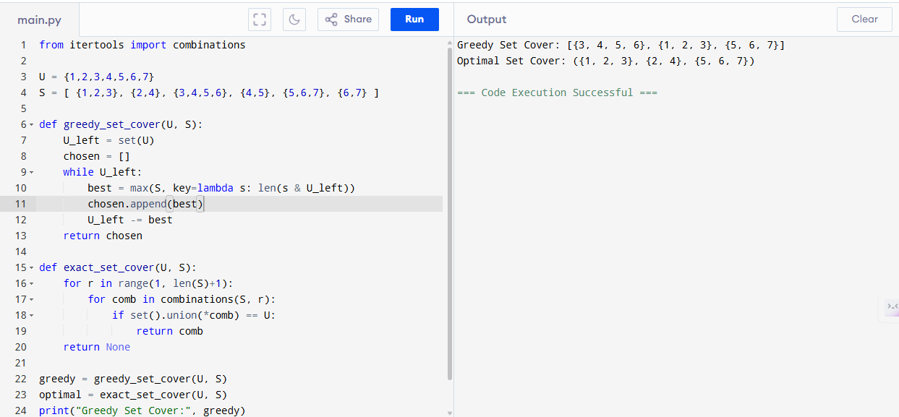

Sample Input
U = {1,2,3,4,5,6,7}
S = {{1,2,3}, {2,4}, {3,4,5,6}, {4,5}, {5,6,7}, {6,7}}
Sample Output
Greedy Set Cover: [{1, 2, 3}, {3, 4, 5, 6}, {5, 6, 7}]
Optimal Set Cover: ({1, 2, 3}, {3, 4, 5, 6})

Performance Analysis
- Greedy Algorithm:
  - Time: O(|S|·|U|)
  - Space: O(|U| + |S|)
- Exact (Brute-Force):
  - Time: O(2^|S| · |U|)
  - Space: O(|U| + |S|)
Result
The given program of Greedy uses 3 sets, Optimal uses 2 sets. Greedy is within 1.5 of optimal is executed and verified.

