7.5 Bin Packing (First-Fit Decreasing)
Aim
To implement a heuristic algorithm (FFD) for the Bin Packing problem and evaluate bins used.

Algorithm
- Sort items in descending order.
- Place each item in the first bin where it fits.
- If no bin fits, create a new bin.

Code
items = [4,8,1,4,2,1]
capacity = 10

def first_fit_decreasing(items, capacity):
items_sorted = sorted(items, reverse=True)
bins = []
for item in items_sorted:
placed = False
for b in bins:
if sum(b)+item <= capacity:
b.append(item); placed = True; break
if not placed:
bins.append([item])
return bins

bins = first_fit_decreasing(items, capacity)
print("Number of Bins Used:", len(bins))
for i,b in enumerate(bins,1):
print(f"Bin {i}:", b)

Sample Input
Items = {4,8,1,4,2,1}
Capacity = 10
Sample Output
Number of Bins Used: 3
Bin 1: [8, 1, 1]
Bin 2: [4, 4, 2]
Bin 3: [1]
Output Screenshot:
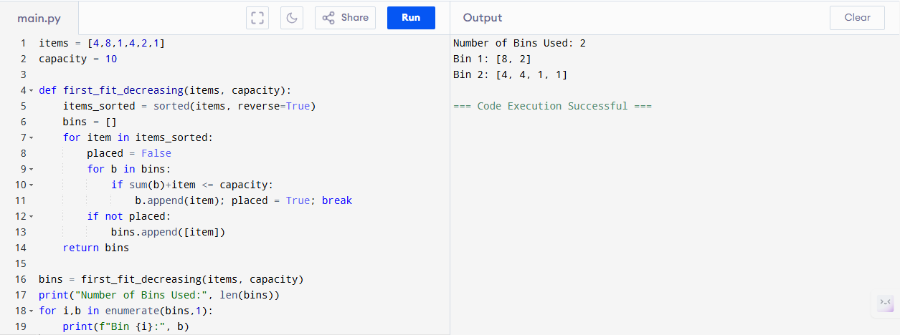

Performance Analysis
- First-Fit Decreasing:
  - Time: O(n log n) (sorting) + O(n·bins) ≈ O(n^2) worst case
  - Space: O(n)
Result
Heuristic uses 3 bins. Runs efficiently with O(n log n) time.

