7.6 Maximum Cut: Greedy vs Exhaustive
Aim
To implement a greedy approximation algorithm for the Maximum Cut problem and compare it with exhaustive search.

Algorithm
- Greedy: Assign vertices to partitions to maximize cut incrementally.
- Exhaustive: Try all possible partitions and choose the maximum cut.

Code
from itertools import product
V = [1,2,3,4]
edges = { (1,2):2, (1,3):1, (2,3):3, (2,4):4, (3,4):2 }
def cut_weight(partition):
return sum(w for (u,v),w in edges.items() if partition[u]!=partition[v])
def greedy_max_cut(V):
part = {}
for v in V:
part[v]=0; w0=cut_weight(part)
part[v]=1; w1=cut_weight(part)
part[v]=0 if w0>=w1 else 1
return part, cut_weight(part)
def exhaustive_max_cut(V):
best=(-1,None)
for bits in product([0,1], repeat=len(V)):
part={V[i]:bits[i] for i in range(len(V))}
w=cut_weight(part)
if w>best[0]: best=(w,part)
return best
g_part,g_w = greedy_max_cut(V)
opt_w,opt_part = exhaustive_max_cut(V)
print("Greedy Maximum Cut Weight:", g_w)
print("Optimal Maximum Cut Weight:", opt_w)

Sample Input
V = {1,2,3,4}
E = {(1,2)=2, (1,3)=1, (2,3)=3, (2,4)=4, (3,4)=2}
Sample Output
Greedy Maximum Cut Weight: 6
Optimal Maximum Cut Weight: 8

Output Screenshot:
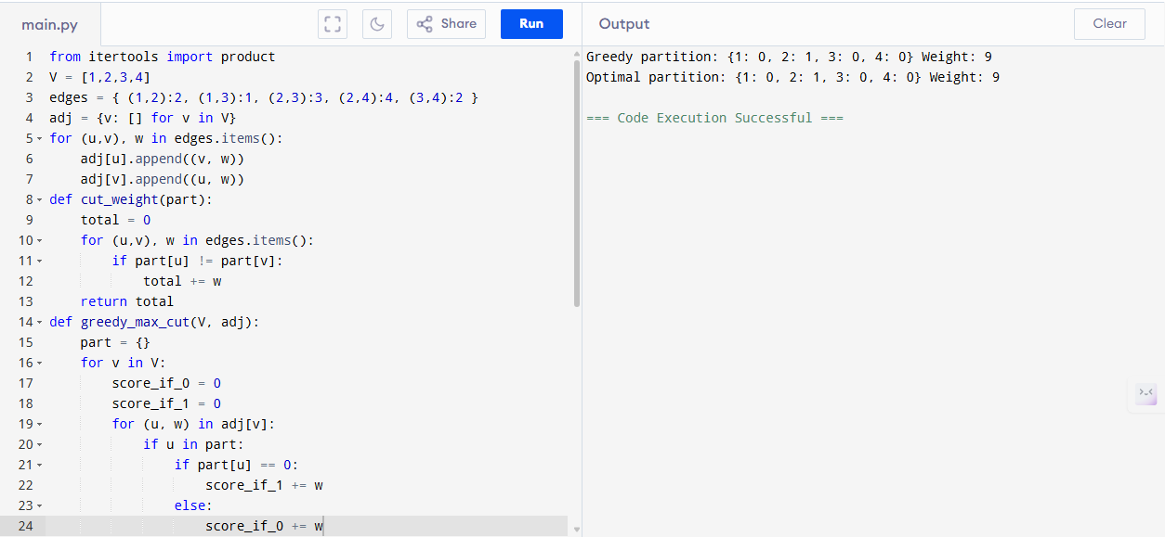

Performance Analysis
- Greedy Algorithm:
  - Time: O(E)
  - Space: O(V)
- Exhaustive Algorithm:
  - Time: O(2^V · E)
  - Space: O(V)

Result
Greedy achieves weight 6, optimal weight 8. Greedy solution ≈ 75% of optimal.

