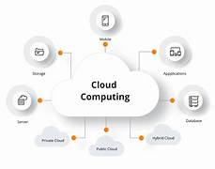

Cloud:

The **cloud** (in computing) refers to delivering computing services—like servers, storage, databases, networking, software, and analytics—**over the internet** instead of owning and managing physical hardware locally.

**Types of Cloud Deployment**

* **Public Cloud** → Shared by many users (AWS, Azure, GCP).
* **Private Cloud** → Dedicated for one organization (on-prem or hosted).
* **Hybrid Cloud** → Combination of both.

On-Prem Hosting:

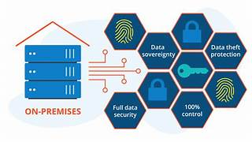

**On-Prem Hosting (On-Premises Hosting)** means running and managing your IT infrastructure (servers, storage, networking, applications) **within your own organization’s physical location or data center**, instead of renting resources from a cloud provider.

**Advantages:**

* Full control over data, security, and compliance.
* Customization according to business needs.
* No dependency on external cloud providers

Cloud VS On-Prem Hosting:

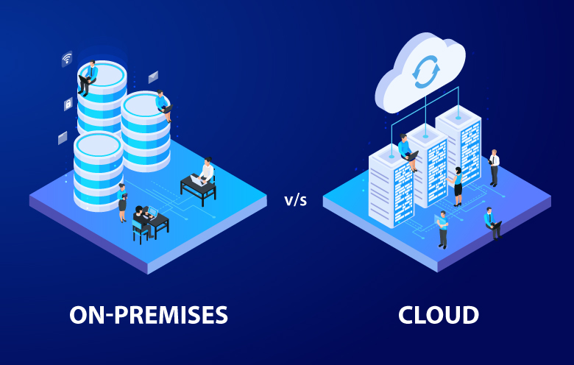

| **Aspect** | **Cloud Hosting** | **On-Prem Hosting** |
| --- | --- | --- |
| **Ownership** | Rented from cloud provider (AWS, Azure, GCP, etc.) | Owned & managed by the company |
| **Cost Model** | **OpEx** (pay-as-you-go, subscription) | **CapEx** (high upfront investment) + ongoing OpEx |
| **Deployment Time** | Minutes to hours (instant provisioning) | Weeks to months (procurement, setup, retrofitting) |
| **Scalability** | Elastic scaling – resources auto-adjust to demand | Limited – requires buying and installing new hardware |
| **Maintenance** | Cloud provider handles patches, upgrades, backups | Company IT team responsible for all maintenance |
| **Accessibility** | Access from anywhere with internet | Limited to internal network (unless VPN enabled) |
| **Security & Control** | Security handled by provider, but less direct control | Full control over security, data, and compliance |
| **Reliability** | High uptime with provider SLAs | Depends on company’s infra (power, cooling, IT staff) |
| **Examples** | Gmail, Salesforce, AWS EC2, Azure VMs | Bank’s private data center, in-house servers |

**When to Choose Cloud**

* Fast deployment needed
* Cost flexibility required
* Seasonal / unpredictable workloads
* Remote accessibility & collaboration

**When to Choose On-Prem**

* Strict regulatory or compliance requirements
* Need full control over infrastructure & data
* Long-term predictable workloads
* Organization can afford high CapEx + IT staff

Different Hosting Techniques

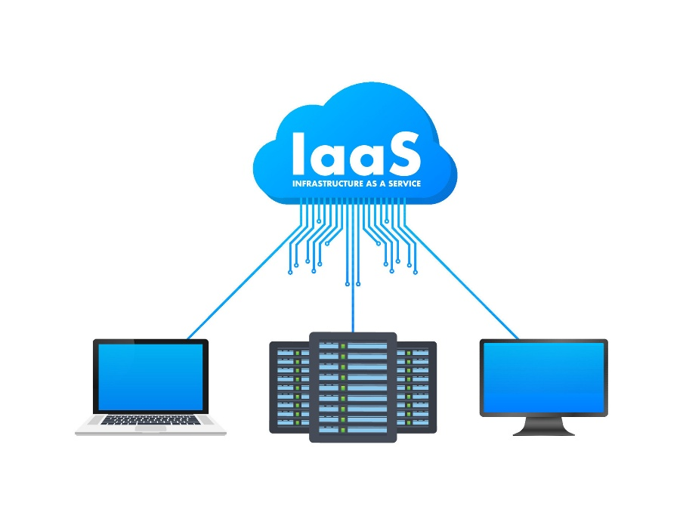

**IaaS (Infrastructure as a Service)**

**Definition:**  
IaaS provides virtualized computing resources like servers, storage, and networking over the internet. Users manage operating systems, applications, and data, while the provider manages the underlying hardware and virtualization.

**Uses:**

* Hosting websites and applications
* Development and testing environments
* Backup and disaster recovery
* High-performance computing

**Places Used:**

* Data centers of organizations
* Cloud provider platforms like AWS, Azure, Google Cloud

**Advantages:**

* Scalable and flexible resources
* No need to invest in physical hardware
* Quick provisioning of servers and storage
* Full control over applications and OS

**Disadvantages:**

* User must manage OS and apps
* Security and compliance responsibility lies with the user
* Can be costly if not optimized properly

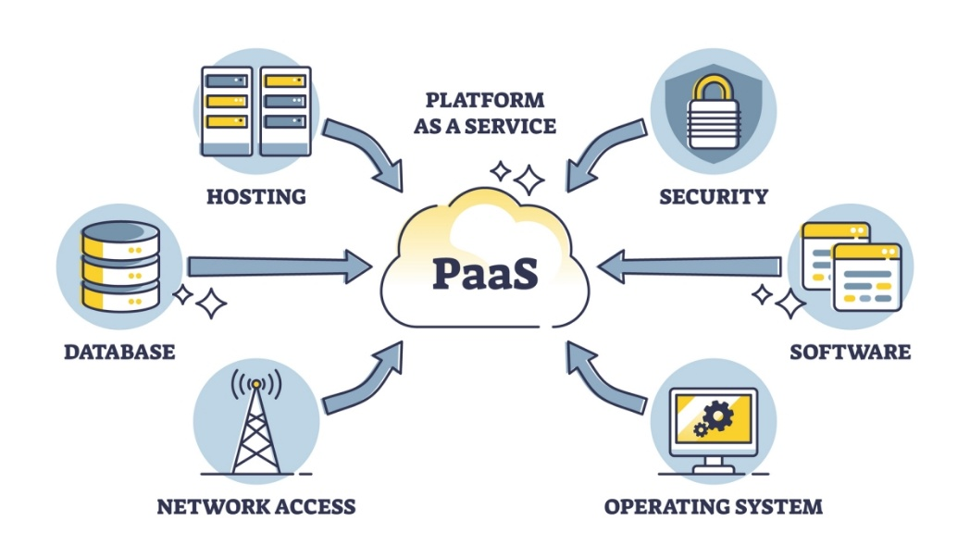

**PaaS (Platform as a Service)**

**Definition:**  
PaaS offers a ready-made platform for developers to build, deploy, and run applications without managing infrastructure. The provider handles servers, storage, OS, middleware, and runtime.

**Uses:**

* Rapid application development
* Hosting web and mobile applications
* Collaboration for distributed developer teams
* Integration with databases and APIs

**Places Used:**

* Cloud platforms like Google App Engine, Microsoft Azure App Service, Heroku
* Development companies and startups for faster app delivery

**Advantages:**

* Focus on application code, not infrastructure
* Faster development and deployment
* Pre-configured environments reduce setup time
* Easier collaboration among teams

**Disadvantages:**

* Less control over underlying infrastructure
* Dependency on provider for uptime and updates
* Limited customization compared to IaaS

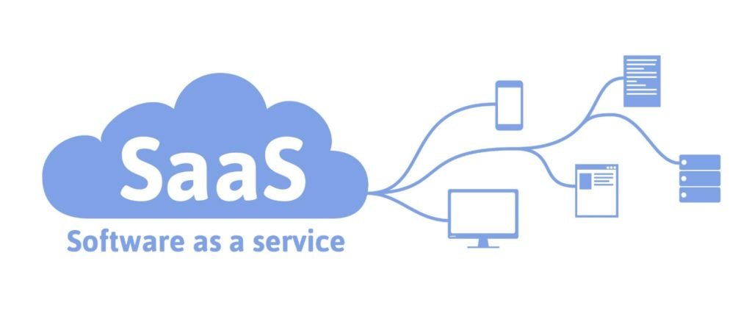

**SaaS (Software as a Service)**

**Definition:**  
SaaS delivers fully functional software applications over the internet, ready to use. Users only access and use the software; the provider manages everything, including infrastructure, platform, and application.

**Uses:**

* Email and communication tools
* Office productivity applications
* Customer relationship management (CRM)
* File storage and collaboration

**Places Used:**

* Cloud services like Gmail, Microsoft 365, Salesforce, Zoom, Dropbox
* Offices, educational institutions, and remote working setups

**Advantages:**

* No installation or maintenance required
* Accessible from anywhere via internet
* Cost-effective subscription model
* Automatic updates and security handled by provider

**Disadvantages:**

* Less control over data and software customization
* Dependence on internet connectivity
* Potential issues with compliance or data privacy