**1.What is DevOps?**

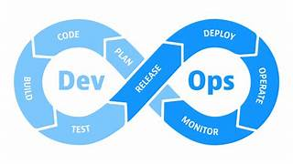

DevOps is a combination of “Development” and “Operations” A set of practices, tools, and a culture that aims to automate and integrate the processes between software development and IT operations.It focuses on collaboration, continuous integration (CI), continuous delivery (CD), and automation to deliver high-quality software faster and more reliably.

**2.Advantages of DevOps**

1. **Faster Software Delivery**
   * Continuous Integration (CI) and Continuous Deployment (CD) pipelines automate builds, testing, and deployment — enabling rapid releases.
2. **Better Collaboration and Communication**
   * Dev and Ops teams work together with shared goals, reducing misunderstandings and silos.
3. **Improved Software Quality**
   * Continuous testing and integration help identify bugs early in the development cycle.
4. **Automation of Repetitive Tasks**
   * Tasks like code integration, deployment, and infrastructure provisioning are automated, saving time and reducing human error.
5. **Continuous Feedback and Improvement**
   * Real-time monitoring and feedback loops ensure faster detection and resolution of issues.
6. **Enhanced Security (DevSecOps)**
   * Security checks are integrated into the CI/CD pipeline, ensuring early detection of vulnerabilities.
7. **Scalability and Reliability**
   * Infrastructure as Code (IaC) enables easy scaling and consistent environment setup across systems.
8. **Cost Efficiency**
   * Automation and early issue detection reduce operational and maintenance costs.
9. **Higher Customer Satisfaction**
   * Frequent updates and quicker fixes lead to a better user experience.

**3.What is Agile?**

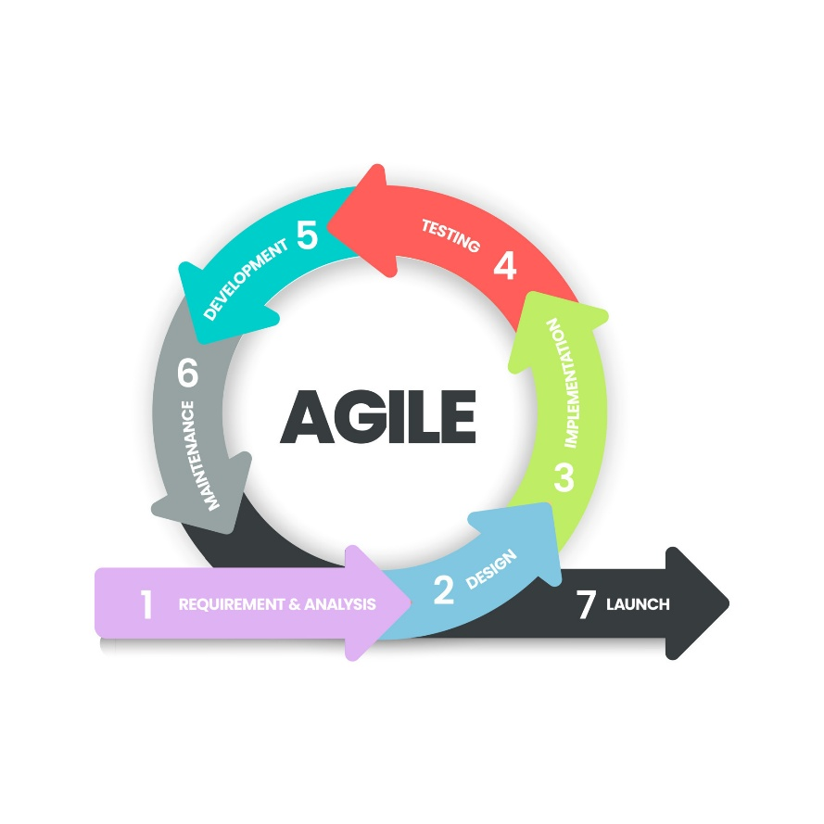

Agile is a software development methodology focused on iterative development, flexibility, and customer collaboration.  
Instead of delivering the product all at once, Agile teams deliver it in small, usable parts (called sprints or iterations) and continuously improve based on feedback.

**Key principles:**

* Individuals and interactions over processes and tools
* Working software over comprehensive documentation
* Customer collaboration over contract negotiation
* Responding to change over following a plan