**1.What is scrum in agile?**

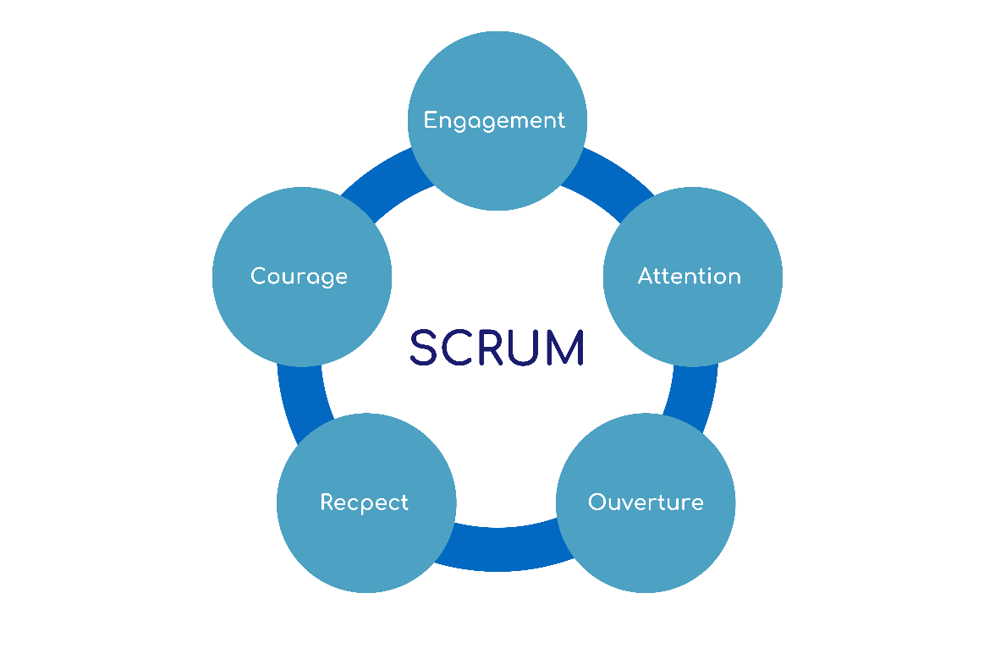

Scrum is one of the most popular frameworks within the Agile methodology.It provides a structured way to manage and deliver projects iteratively — focusing on teamwork, accountability, and continuous improvement.

**Advantages of Scrum**

* Faster delivery of working features
* Quick response to changing requirements
* Better communication and teamwork
* Continuous improvement through retrospectives
* Increased transparency and visibility

**2.What are the meetings of agile.**

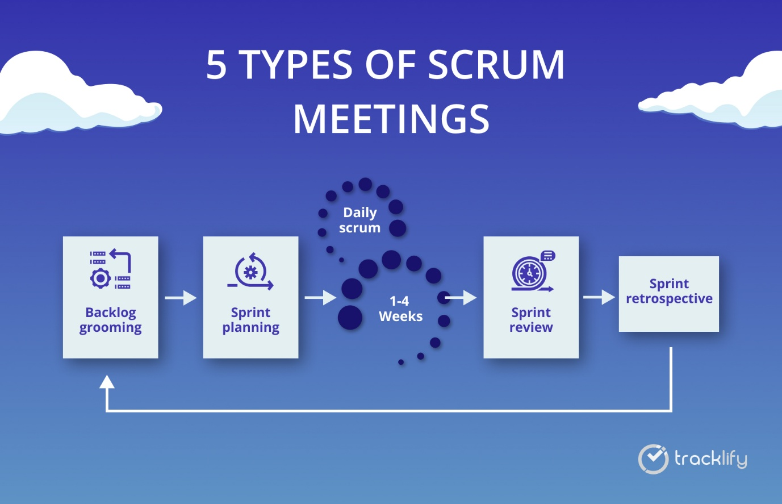

**Backlog Grooming (Backlog Refinement):**

* **When**: Ongoing (once or twice every Sprint)
* **Purpose**: To review, update, and prioritize the Product Backlog.
* **Attendees**: Product Owner, Scrum Master, Development Team
* **Key Activities**:
  + Clarify requirements and acceptance criteria
  + Remove outdated or low-priority items
  + Estimate and prioritize user stories for upcoming sprints

**Sprint Planning:**

* **When**: At the start of each Sprint (every 2–4 weeks)
* **Purpose**: To decide what work will be completed in the upcoming Sprint.
* **Attendees**: Product Owner, Scrum Master, Development Team
* **Key Outcomes**:
  + Sprint Goal: Objective for the Sprint
  + Sprint Backlog: List of selected tasks/stories

**Daily Scrum (Daily Stand-up):**

* **When**: Every day during the Sprint (15 minutes)
* **Purpose**: To discuss progress, plans, and blockers.
* **Attendees**: Development Team (facilitated by Scrum Master)
* **Typical Questions**:
  1. What did I do yesterday?
  2. What will I do today?
  3. Are there any impediments?

**Sprint Review:**

* **When**: At the end of the Sprint
* **Purpose**: To demonstrate the completed work to stakeholders and gather feedback.
* **Attendees**: Scrum Team + Stakeholders
* **Outcome**: Feedback to improve the product and adjust the backlog.

**Sprint Retrospective:**

* **When**: After the Sprint Review, before the next Sprint starts
* **Purpose**: To reflect on the Sprint and identify process improvements.
* **Attendees**: Entire Scrum Team
* **Focus Areas**:
  + What went well?
  + What didn’t go well?
  + What can be improved next time?