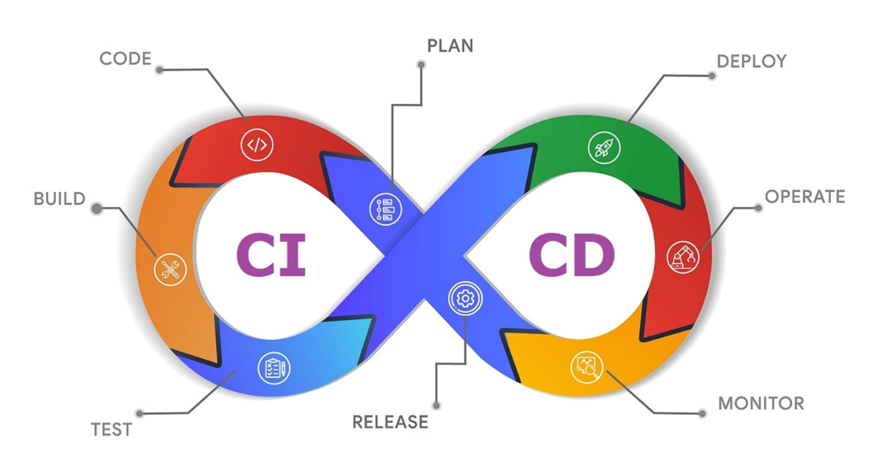

**1.what is CICD pipeline?**

A CID pipeline stands for Continuous Integration and Deployment (sometimes written as CI/CD pipeline). It’s an automated process that helps developers build, test, and deploy code efficiently and reliably.

**1. Continuous Integration (CI):**

* Developers frequently merge code changes into a shared repository (like GitHub or Azure Repos).
* Each time code is pushed, the CI system:
  + Builds the application automatically.
  + Runs automated tests to check for bugs or integration issues.
* Goal: Detect errors early and ensure all code works well together.

Example tools: Jenkins, GitHub Actions, GitLab CI, Azure Pipelines, CircleCI.

**2. Continuous Deployment (CD):**

* After CI succeeds, the CD part automatically deploys the application to staging or production environments.
* This step may include:
  + Deploying to servers or cloud platforms (Azure, AWS, etc.)
  + Running post-deployment tests
  + Rolling back if something fails

Goal: Deliver updates to users quickly and safely without manual steps.

**CID Pipeline Stages:**

1. Source – Developer commits code to a version control system.
2. Build – Code is compiled, dependencies are installed.
3. Test – Unit, integration, or UI tests are executed.
4. Deploy – Application is deployed to staging or production.
5. Monitor – Application health and performance are tracked after deployment.

**2.advantages of CICD pipelines.**

1. Faster Software Delivery

* Automates build, test, and deployment steps — reducing manual effort.
* Enables teams to release updates more frequently and quickly.

2. Early Bug Detection

* Every code change is tested automatically.
* Bugs are caught early in the development cycle, saving time and cost.

3. Consistent and Reliable Deployments

* Automated pipelines ensure the same process is followed every time.
* Eliminates human errors during deployment.

4. Improved Code Quality

* Integration tests, linting, and code analysis run automatically.
* Ensures only high-quality, tested code moves to production.

5. Better Collaboration Between Teams

* Developers, testers, and operations work on a single automated workflow.
* Reduces “it works on my machine” issues.

6. Easy Rollbacks

* CI/CD tools track versions of code and deployments.
* Makes it easy to revert to a stable version if something goes wrong.

7. Reduced Manual Effort

* Developers don’t need to manually deploy or test code.
* Saves time and allows teams to focus on new features.

8. Continuous Feedback

* Instant notifications for build or test failures.
* Helps teams fix issues quickly and maintain project health.

9. Enhanced Security

* Security scans and vulnerability checks can be integrated into the pipeline.
* Ensures safe and compliant deployments.

**3.how do you configure CICD pipeline in AzureDevOps?**

1. Prerequisites

Before you start:

* You have an Azure DevOps account → https://dev.azure.com
* A project created in Azure DevOps
* Your code stored in a repo (Azure Repos, GitHub, or Bitbucket)
* A target environment (e.g., Azure Web App, VM, or Kubernetes)

2. Continuous Integration (CI) Setup

Step 1: Create a Pipeline

1. Go to Pipelines → Create Pipeline
2. Choose your code source (e.g., *Azure Repos Git*, *GitHub*)
3. Select your repository

Step 2: Configure the Build (YAML)

Azure DevOps will auto-detect your language and suggest a YAML file.  
You can edit or create your own, for example:

# azure-pipelines.yml

trigger:

- main # Runs pipeline when code is pushed to main branch

pool:

vmImage: 'ubuntu-latest'

steps:

- task: UsePythonVersion@0

inputs:

versionSpec: '3.10'

- script: |

pip install -r requirements.txt

pytest

displayName: 'Install dependencies and run tests'

- task: PublishBuildArtifacts@1

inputs:

pathToPublish: '$(Build.ArtifactStagingDirectory)'

artifactName: 'drop'

This defines a CI pipeline — builds the code, runs tests, and publishes build artifacts.

3. Continuous Deployment (CD) Setup

Step 3: Create a Release Pipeline

1. Go to Pipelines → Releases → New Pipeline
2. Select the artifact from your CI build
3. Add a Stage (e.g., *Staging*, *Production*)
4. Choose a deployment task (for example:
   * Azure App Service Deploy for web apps
   * Azure Kubernetes Service Deploy
   * Azure SQL Database Deployment)

Step 4: Configure Deployment Tasks

Example (for Web App):

* Add task → *Azure App Service Deploy*
* Select your subscription and app name
* Choose the artifact from CI
* Save the pipeline

Step 5: Enable Continuous Deployment Trigger

* In the Artifact section, enable “Continuous deployment trigger”
* This ensures every successful build automatically triggers a release

4. Optional Enhancements

* Add Approvals before production deployment
* Add Environment Variables (e.g., DB connection strings)
* Integrate Security scans, Load tests, or Notifications
* Use Azure Key Vault for secret management