IIPS Production Market Data & Intelligence Ingestion Program v1.0
v1.0 — Requirements / Development Roadmap
PLANNING SPECIFICATION — NOT AN IMPLEMENTATION AUTHORIZATION
Date: 2026-09-08

1. Scope & Authority Boundary
This is a planning/requirements specification. It establishes the intended development sequence, dependencies, deliverables and certification gates. It does not itself authorize implementation, provider procurement, production credentials or production activation; those remain subject to explicit program authority and phase gates.
Scope: external providers → acquisition → ingestion → normalization → canonical data → historical/point-in-time storage → corporate actions → intelligence datasets → engine/research consumption → evidence/provenance → governed APIs/G2 → UI → E2E certification → production onboarding → operations.

2. Target Product / Supplied UI Screenshot
The supplied UI screenshot is incorporated as the target/reference product surface. It is a functional product-parity target, not merely a visual mock. The existing roadmap describes this target as an integrated investment/research platform and the dashboard as an aggregation layer over the underlying product domains.
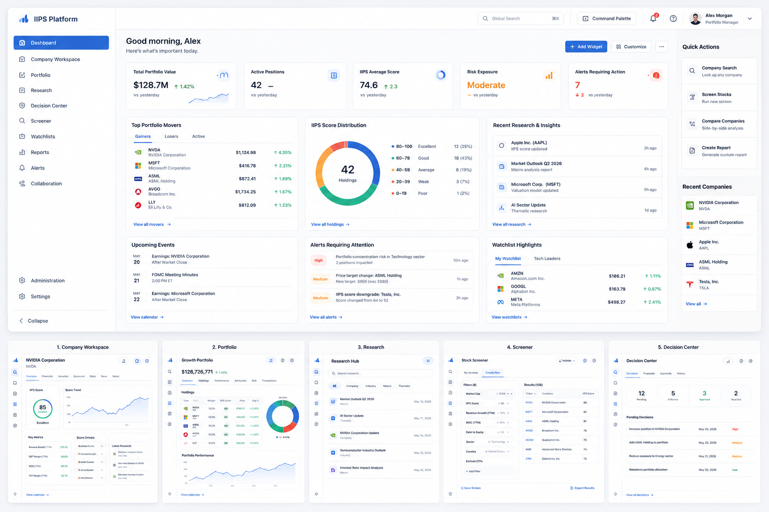
Figure 1 — Supplied IIPS UI screenshot / product-parity reference

3. Product Surface Scope
Surface | Scope | Primary data role | Notes
Dashboard | Yes | Aggregation / presentation | Must consume governed domain outputs; no invented business logic
Company Workspace | Yes | Data + analytics | Overview, financials, valuation, scorecard, risks, news, notes, evidence
Portfolio | Yes | Data + analytics | Holdings, allocation, performance, risk, transactions, analytics
Research | Yes | Data + intelligence | Research library, search, taxonomy, company/sector/macro research
Screener | Yes | Data + filtering | Universe, filters, scores, sortable results, saved screens
Decision Center | Yes | Governed workflow | Decisions, proposals, approvals, history, evidence
Watchlists | Yes | Data + triggers | Persistent lists, triggers, score changes
Reports | Yes | Data + provenance | Templates, generated reports, source/timestamp/lineage
Alerts | Yes | Events + notification | Rules, events, notifications, acknowledgement
Collaboration | Applicable | Contextual collaboration | Comments, mentions, shared research/watchlists, assignments, activity
Administration | Applicable | Governed platform baseline | Provider/admin configuration only where authorized
Settings | Applicable | Identity/preferences/configuration | Data preferences and user configuration only where applicable
Global Search | Yes | Cross-domain search | Search company, research, holdings, decisions, evidence, alerts, reports
Command Palette / Quick Actions | Applicable | Action orchestration | Open/create/review actions against governed domains

4. Data Domain Scope
ID | Domain | Operating mode | Requirement | Primary phases | Primary consumers
D01 | Market prices / quotes | LIVE + historical | Required | P05–P08 | UI, engines, portfolio, dashboard
D02 | Historical OHLCV | Historical / PIT | Required | P05–P08 | Charts, research, screening, engines
D03 | Fundamentals / financial statements | PIT + snapshot | Required | P09 | Company, research, scoring
D04 | Corporate actions | PIT + effective-date | Required | P08 | Portfolio, price adjustment, evidence
D05 | Instrument / security master | Current + historical lifecycle | Required | P04 | All domains
D06 | News / events | LIVE + historical | Required | P10 | Research, alerts, dashboard
D07 | Analyst estimates / consensus | Snapshot + PIT | Required | P10 | Research, valuation, dashboard
D08 | Macroeconomic data | Snapshot + historical/PIT | Required | P10 | Research, thematic analysis
D09 | Alternative data | Governed/approved only | Required by applicability | P10 | Research/engines where approved
D10 | Exchange/reference metadata | Current + historical where relevant | Required | P04–P05 | Security master, data quality

5. Operating Modes
LIVE — Current provider-fed data with explicit received/as-of timestamps, freshness and degraded-state semantics.
SNAPSHOT — Frozen deterministic dataset for certification, reproducibility and controlled demonstrations.
HISTORICAL / POINT-IN-TIME — Data queried as it was knowable at a defined historical/as-of boundary; publication/effective times preserved.
Mode mixing must be explicit. No consumer may silently combine live, snapshot and PIT data.

6. Master Phase Sequence
Phase | Name | Objective | Dependencies | Next
P00 | Program Baseline & Governance | Establish scope, baseline, contracts, ownership, certification model and non-goals before implementation. | None | P01–P17
P01 | Data Contract & Canonical Domain Model | Define canonical schemas, identifiers, timestamps, units, currencies, source/provenance and operating modes. | P00 | P02–P12
P02 | Provider Abstraction & Entitlement Model | Create provider-neutral adapter contracts and explicit licensing/entitlement boundaries. | P00,P01 | P03,P05,P16
P03 | Secrets, Security & Tenant Controls | Secure provider credentials, service identities, tenant isolation and access controls. | P00,P02 | P05,P11,P16
P04 | Instrument / Security Master | Establish authoritative instrument identity, mappings, listings, exchanges, currencies and lifecycle state. | P01,P02,P03 | P05–P12
P05 | Market Data Acquisition & Ingestion | Implement deterministic/local ingestion first, then provider adapters for quotes, prices and historical market data. | P01–P04 | P06–P12
P06 | Normalization & Canonical Data Pipeline | Normalize provider-specific payloads into governed canonical representations without feeding raw provider data directly to engines. | P01,P04,P05 | P07–P12
P07 | Data Quality, Freshness & Reconciliation | Detect missing, stale, malformed, contradictory and out-of-order data; expose quality state and reconciliation evidence. | P04–P06 | P08–P15
P08 | Historical / Point-in-Time & Corporate Actions | Support historical and PIT semantics, adjusted/unadjusted series, effective dates and corporate-action lineage. | P04–P07 | P09–P15
P09 | Fundamentals & Financial Intelligence | Ingest and normalize financial statements, ratios, valuation inputs and related fundamental datasets. | P04–P08 | P10–P15
P10 | News, Events, Estimates & Macro/Alternative Data | Establish governed ingestion for news/events, consensus estimates, macro and approved alternative datasets. | P04–P08 | P11–P15
P11 | Engine / Research / Evidence Integration | Connect canonical data to existing engines and research flows with provenance, reproducibility and evidence lineage. | P06–P10 | P12–P15
P12 | Certified Data APIs / G2 Product Contracts | Expose governed data through stable APIs/contracts with live, snapshot and PIT semantics. | P06–P11 | P13–P15
P13 | Product UI Data Integration | Make all applicable existing UI surfaces consume governed data; retain non-data surfaces as baseline where applicable. | P07–P12 | P14,P15
P14 | UX, Accessibility, Responsive & Visual Parity | Harden UX and qualify against the supplied screenshot target, including browser/visual validation where environment permits. | P13 | P15
P15 | Full E2E Certification & Functional Parity | Certify provider-to-UI data lineage, engine outputs, evidence, degraded states and screenshot functional parity. | P07–P14 | P16,P17
P16 | Production Provider Onboarding & Activation | Complete licensing, credentials, production connectivity, entitlement validation and controlled activation. | P02,P03,P05,P07,P15 | P17
P17 | Operations, Monitoring & Release Certification | Operationalize monitoring, incident handling, provider failover/staleness controls, release evidence and production certification. | P15,P16 | None

7. Dependency Logic / Critical Path
The sequence moves from governance and contracts to identity, acquisition, canonicalization, quality, historical/PIT semantics, intelligence datasets, engine/evidence integration, APIs, UI, visual/browser qualification, E2E certification, production activation and operations.
Critical path: P00 → P01 → P02/P03 → P04 → P05 → P06 → P07 → P08 → P09/P10 → P11 → P12 → P13 → P14 → P15 → P16 → P17

8. Phase Requirements & Gate Intent

P00 — Program Baseline & Governance
Establish scope, baseline, contracts, ownership, certification model and non-goals before implementation.
Dependencies: None.
Gate intent: Scope/authority baseline.

P01 — Data Contract & Canonical Domain Model
Define canonical schemas, identifiers, timestamps, units, currencies, source/provenance and operating modes.
Dependencies: P00.
Gate intent: Canonical contract gate.

P02 — Provider Abstraction & Entitlement Model
Create provider-neutral adapter contracts and explicit licensing/entitlement boundaries.
Dependencies: P00,P01.
Gate intent: Provider abstraction/entitlement gate.

P03 — Secrets, Security & Tenant Controls
Secure provider credentials, service identities, tenant isolation and access controls.
Dependencies: P00,P02.
Gate intent: Security gate.

P04 — Instrument / Security Master
Establish authoritative instrument identity, mappings, listings, exchanges, currencies and lifecycle state.
Dependencies: P01,P02,P03.
Gate intent: Identity/master gate.

P05 — Market Data Acquisition & Ingestion
Implement deterministic/local ingestion first, then provider adapters for quotes, prices and historical market data.
Dependencies: P01–P04.
Gate intent: Acquisition gate.

P06 — Normalization & Canonical Data Pipeline
Normalize provider-specific payloads into governed canonical representations without feeding raw provider data directly to engines.
Dependencies: P01,P04,P05.
Gate intent: Canonical pipeline gate.

P07 — Data Quality, Freshness & Reconciliation
Detect missing, stale, malformed, contradictory and out-of-order data; expose quality state and reconciliation evidence.
Dependencies: P04–P06.
Gate intent: Data quality gate.

P08 — Historical / Point-in-Time & Corporate Actions
Support historical and PIT semantics, adjusted/unadjusted series, effective dates and corporate-action lineage.
Dependencies: P04–P07.
Gate intent: Historical/PIT gate.

P09 — Fundamentals & Financial Intelligence
Ingest and normalize financial statements, ratios, valuation inputs and related fundamental datasets.
Dependencies: P04–P08.
Gate intent: Fundamentals gate.

P10 — News, Events, Estimates & Macro/Alternative Data
Establish governed ingestion for news/events, consensus estimates, macro and approved alternative datasets.
Dependencies: P04–P08.
Gate intent: Intelligence data gate.

P11 — Engine / Research / Evidence Integration
Connect canonical data to existing engines and research flows with provenance, reproducibility and evidence lineage.
Dependencies: P06–P10.
Gate intent: Engine/evidence gate.

P12 — Certified Data APIs / G2 Product Contracts
Expose governed data through stable APIs/contracts with live, snapshot and PIT semantics.
Dependencies: P06–P11.
Gate intent: API/G2 gate.

P13 — Product UI Data Integration
Make all applicable existing UI surfaces consume governed data; retain non-data surfaces as baseline where applicable.
Dependencies: P07–P12.
Gate intent: UI integration gate.
All existing IIPS UI surfaces remain in scope; market-data applicability is marked per work item.

P14 — UX, Accessibility, Responsive & Visual Parity
Harden UX and qualify against the supplied screenshot target, including browser/visual validation where environment permits.
Dependencies: P13.
Gate intent: UX/visual/browser gate.
The supplied screenshot is a functional parity reference. Real governed data and real interactions are required behind certified UI.

P15 — Full E2E Certification & Functional Parity
Certify provider-to-UI data lineage, engine outputs, evidence, degraded states and screenshot functional parity.
Dependencies: P07–P14.
Gate intent: Full E2E certification gate.
Representative chain: provider datum → canonical record → quality state → engine/derived result → evidence/provenance → API/G2 → UI → interaction.

P16 — Production Provider Onboarding & Activation
Complete licensing, credentials, production connectivity, entitlement validation and controlled activation.
Dependencies: P02,P03,P05,P07,P15.
Gate intent: Production activation authority gate.

P17 — Operations, Monitoring & Release Certification
Operationalize monitoring, incident handling, provider failover/staleness controls, release evidence and production certification.
Dependencies: P15,P16.
Gate intent: Operational/release certification gate.

9. Core Non-Functional Requirements
ID | Requirement | Definition
NFR-01 | Provenance | Every governed datum and derived result retains source/provider, dataset/version where applicable, timestamps/as-of and lineage.
NFR-02 | Reproducibility | SNAPSHOT and PIT results are replayable and deterministic within the certified contract.
NFR-03 | Freshness | LIVE consumers receive explicit freshness/staleness state; stale data never silently appears current.
NFR-04 | Quality | Invalid, incomplete, contradictory or unavailable data is classified and propagated, not silently coerced.
NFR-05 | Security | Provider secrets never appear in source, fixtures, logs or client bundles; tenant/role boundaries hold end-to-end.
NFR-06 | Provider neutrality | Provider adapters are replaceable behind stable contracts.
NFR-07 | Auditability | Ingestion, reconciliation, transformation, recalculation and activation produce auditable evidence.
NFR-08 | UI integrity | Certified UI metrics originate from governed backend sources and are reproducible.
NFR-09 | Degraded operation | Provider outage, stale feed and partial dataset conditions have explicit backend/UI behavior.
NFR-10 | Release safety | Production activation is separately authorized and reversible; certification does not automatically authorize production.

10. Screenshot Functional-Parity Acceptance
- Every displayed number must originate from a governed backend source and be reproducible.
- Top Portfolio Movers must navigate to the corresponding real Company Workspace object.
- IIPS Score Distribution interactions must act on real holdings/results.
- Research items must open actual research objects with provenance.
- Alerts must open the actual alert and underlying evidence.
- Decision items must open the governed decision workflow.
- Loading, empty, stale, unavailable and error states must reflect backend data-state contracts.
- Visual qualification must record browser/environment concessions rather than silently declaring parity.

11. Development Strategy
- Use deterministic/local provider fixtures first so early development is not blocked by production credentials or licensing.
- Keep raw provider payloads separate from canonical governed data.
- Do not feed raw provider data directly into engines or UI.
- Use provider-neutral adapters so providers can be replaced without changing canonical consumers.
- Certify each major phase before treating its outputs as certified dependencies.
- Treat production licensing, credentials and activation as later explicit gates.
- Build underlying analytical domains before the executive dashboard; the dashboard is the last-mile aggregation surface.

12. Excel Tracker
The companion workbook contains the phase roadmap, detailed work-item register, dependency matrix, UI coverage matrix, data-domain matrix, phase-gate register and status legend. All work items are initialized to NOT STARTED.

13. Authority / Status
This specification is the proposed master development sequence for a new program. It does not reopen or alter completed IIPS E2E certifications. Implementation should begin only after the appropriate program authority establishes the next gate.

14. Traceability to Existing Master Roadmap
The structure preserves the existing roadmap's engine/product convergence framing and product-completion sequence. The earlier roadmap explicitly identifies Company Workspace, Portfolio, Research, Screener, Decision Center, Watchlists/Alerts, Reports, Collaboration, Search/Command Center, Dashboard, E2E integration, UX/visual parity and final certification as the path to the screenshot target.
This specification adds the production data-plane prerequisites needed to make those surfaces operate on realistic, governed data rather than disconnected mock metrics.

IIPS Integration Boundary and Repository Strategy
Purpose. This program operationalizes the production data plane for the existing completed IIPS product. It is not a second product build and is not, by default, an architecture rewrite.

Repository Boundary
The program uses a dedicated Git repository, iips-production-market-data, with Windows workspace G:\IIPS-Production-Market-Data. The existing completed IIPS product/platform remains in its existing repository. Separate repositories represent an engineering and ownership boundary, not separate products.

Integration Boundary
The new data plane integrates with the existing IIPS product through stable, governed and certified contracts/APIs. The eventual runtime topology is not prescribed by the repository split; the components may ultimately be deployed as separate services, a combined deployment, or another governed topology.

Existing IIPS Reuse-First Rule
Before implementation, existing certified IIPS capabilities are to be classified as REUSE, ADAPT, EXTEND, or NEW. The baseline includes existing certified architecture/contracts, engines and methodology, evidence/provenance/replay mechanisms, DTO/G2 and product API contracts, UI surfaces, fixtures, and applicable E2E certification capabilities.
REUSE means preserve the certified capability unchanged. ADAPT means make only the minimum integration change required. EXTEND means add capability while preserving the certified boundary. NEW means genuinely missing capability in the data plane.

No Silent Architecture or Methodology Rewrite
The production market-data program does not authorize a redesign of the existing IIPS architecture or methodology. If integration discovery identifies a genuine architectural conflict or methodology change, that change requires an explicit authority decision and, where applicable, an ADR/certification path.

P01 Prerequisite
The Existing IIPS → New Data Program Integration/Reuse Baseline is a prerequisite to P01 implementation. It must identify exact existing contracts, engines, evidence/provenance, DTO/G2 interfaces, UI surfaces, fixtures, certification boundaries, and the precise new data-plane integration points before canonical data contracts are implemented.

Deployment and Product Identity
The existing IIPS product remains the consuming/product platform. The new program supplies governed, validated, timestamped, reproducible market and intelligence data through the certified integration boundary. Repository separation must not be interpreted as a requirement for a separate end-user product.

