Deviation Report - Temperature Excursion
Document ID: DEV-2026-014
Revision: 1
Owner: Quality Assurance
Classification: Confidential

Summary
During shipment SHP-88213 of lot LOT-24117 (Neuravex 100 mg vials) from the Manufacturing Site to the Central DC on 14 August 2026, the shipper was left on the tarmac in Memphis during a flight delay. The data logger recorded an excursion above 8 C.

Timeline
Time | Event
09:30 | Shipper tendered to carrier (PCM shipper 96h)
11:00 | Flight delay; shipper held on tarmac
12:40 | Logger exceeds 8 C
17:00 | Shipper moved to cold room
18:15 | QA notified; lot placed on HOLD

Temperature Data
The logger trace is shown in Figure 3.
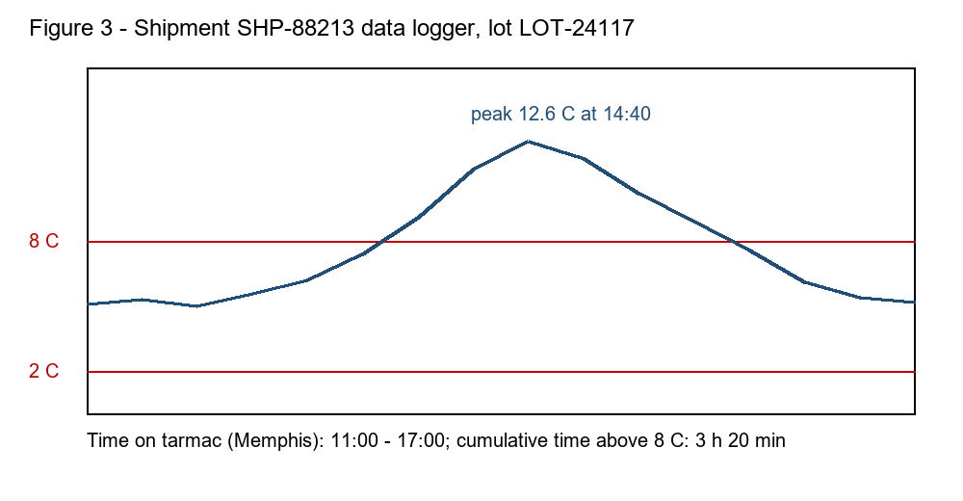

Root Cause
The carrier did not follow the hand-off requirement to move temperature-controlled freight to a cold room within 60 minutes of a delay. The 96h PCM configuration was adequate for transit time but not for 6 hours of direct summer sun.

Disposition and CAPA
Cumulative time above 8 C exceeded 2 hours, so the lot was quarantined per SOP-CC-001. No reading exceeded 25 C and the lot was not frozen, so QA performed a stability review. Based on stability data the lot was released on 22 August 2026. CAPA-2026-031: carrier re-training and a summer tarmac exclusion clause; summer lanes now use +20% coolant mass.

