Cardiometabolic Service Line Strategy Brief 2026
Document ID: STRAT-2026 | Revision: 1 | Classification: Internal | Owner: Riverbend Health Strategy Office

1. Heart Failure Program Position
Riverbend Health admitted 2,230 heart failure patients in the last four quarters. The GDMT four-pillar rate at discharge is 41%, well below the 80% benchmark, and the 30-day readmission rate is 21.4% after a peak of 24.8%. Competitor St. Brendan Regional opened a dedicated HF titration clinic in 2025 and is recruiting for two industry trials.
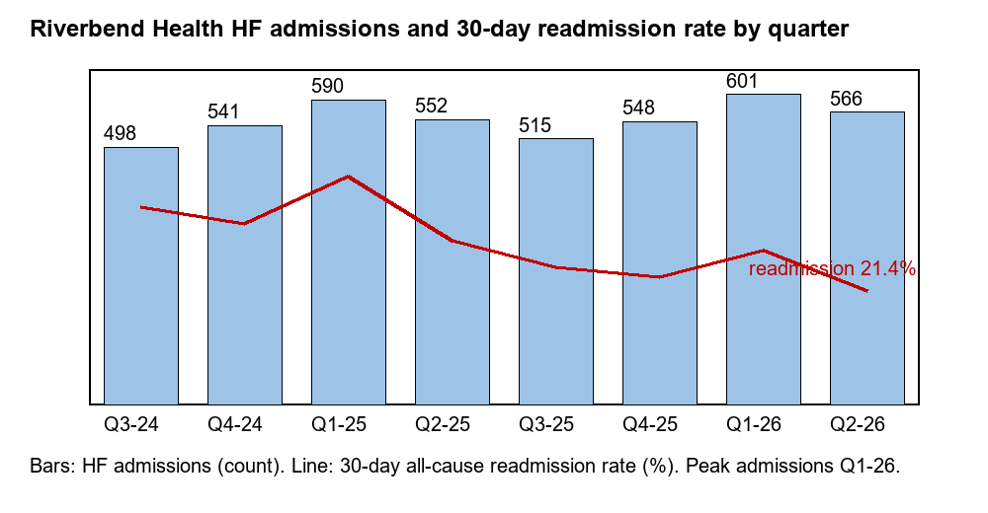

2. Partnership and Trial-Site Opportunities
Partner | Opportunity | Fit | Next step
Cardiora Therapeutics | Site for SYN-HF-101 Phase 3 expansion | High - HF clinic volume | Feasibility call in Q4
Pentara Health AI | TitrateAI pilot to lift the GDMT rate | High - closes the 41% vs 80% gap | Data-sharing review
Meridian Cardio Devices | Remote monitoring program (MER-Sense) | Medium - needs device clinic staffing | Business case
Glycova Bio | Site for SYN-DM-208 outcomes study | Medium - large diabetes panel | Await site selection

3. Diabetes Program Position
The primary-care diabetes panel is 38,400 adults; 58% have an A1C below 8%, short of the 70% target. CGM use outside insulin users is 12%. A remission pathway and pharmacist-led titration are the lowest-cost levers.

4. Recommendations for Leadership
- Fund a pharmacist-led GDMT titration clinic in FY27 (target four-pillar rate of 65% within 12 months).
- Apply to be a site for two late-stage HF trials to strengthen academic positioning.
- Pilot CGM-linked coaching for non-insulin patients with an A1C above 9%.

