**CURRICULAM VITAE**

**DINESH KUMR JANGIR–** 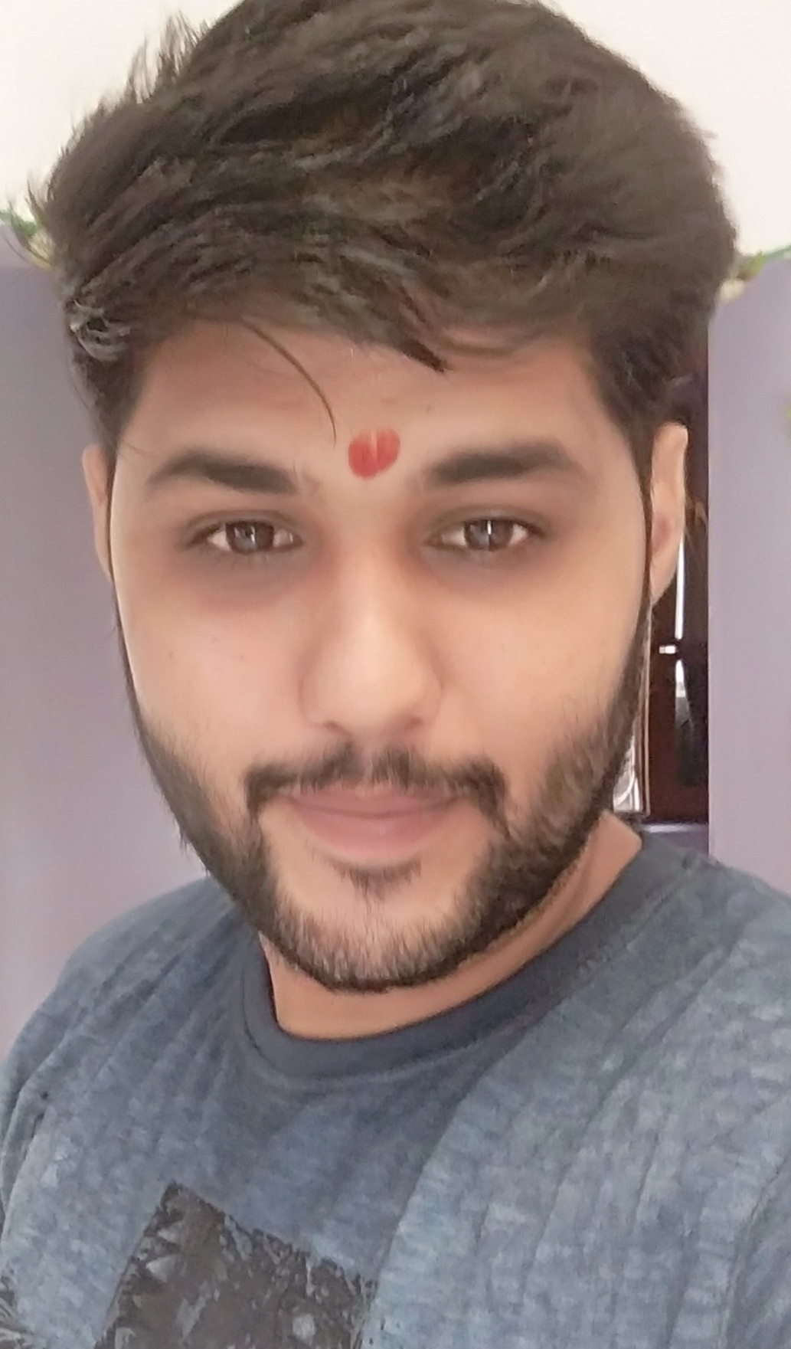

ADDRESS – Chirawa Jhunjhunu, Rajasthan Contact No. 7023466007 Email Id: dinesh.rec.j@gmail.com

**SUMMARY -**

**Experience of more than 3 years across planning, co-ordination and execution of projects, strong credentials in delivering challenging projects within demanding time and cost constraints across, maintenance, quality for civil & construction well experience in BUILDING CONSTRUCTION.**

**JOB PROFILE/key skills :-**

* Have an **art** to **deal with the clients and satisfy them** according to their needs.
* **Project Quantity Surveying**  according to the approved drawings provided at sites and planning for the procurement of the materials within schedules time resulting in cover up the project growth rate according to the given schedule of the clients.
* Knowledge of site execution like BBS, making & quantity surveying (excavation , frame work, steel/BBS,RCC/PCC, Backfilling , plaster work etc.)
* Experienced in all type of building RCC structures
* Knowledge of the all testing related to construction material like testing of **aggregates , sand , Cement , concrete etc.**

**Professional Training & experience :-**

**2018-Onward Civil/ site engineer at MANAV INFRA STRUCTURE Pvt. Ltd.**

**Clinents:GL JANGID**

**COMPANY PROFILE :-**

* **Company is into the execution of the Government contracts like RESIDENTIAL BUILDING AND MALLS, ETC .**

**Roles & Responsibilities : -**

* Worked as site engineer for the project completion of residential building 3 blocks of G+12 and 270 flats at gokulpura Jaipur, rajasthan.
* Supervision of all construction work including structures as per detailed drawing & standard specifications.
* Coordinating with contractor for working schedule and quality of work.
* Ensure constructions quality
* Quantity surveying
* Project planning.
* Design mix for concrete
* Laying all marking

Company name: Krishna construction : ( 2020- onwards)

Residential building of SAI INCLAVE GROUP at mandore jodhpur, 6 block of 5 floor in which some of blocks slab casted and further in process and A Villa construction project of 40 duplex villa at omax city jaipur and my work to handling all type of work on site and work is done .

* coordinating with contractors
* Material Quantity and estimate
* Villa construction
* Project planning
* Labour control

**Education : -**

* B-tech from Shridhar University, pilani IN 2019.

**HOBBIES –**

* Travelling to historical place
* Learning
* Listing to Music

**STRENGTH**

* Hardworking
* Positive thinking

**Personal Details**

NAME : DINESH KUMAR JANGIR

FATHERS NAME : MR. RAKESH KUMAR JANGIR

DOB : 19-03-1998

PERMANENT ADD : Shiv colony ,chirawa, DIST- jhunjhunu ( Raj.)

MATIAL STETUS : SINGLE

GENDER : MALE

RELIGION : HINDU

LANGUAGE KNOWN : HINDI, ENGLISH

**DECLARATION:-**

I hereby declare that all the above information are true to the best of my knowledge and belief .

Date :-

Place :-