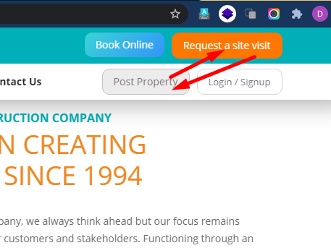

post property ka button change hoga Request a site vist se but post property ke button ka color Request a Site visit jiasa hoga



Home Page Listing

**Total Area BedRoom Furnishing Status**

1200 sq.Ft 2 Fully Furnish Ready to Move

Vishal Property Detail Page

1.

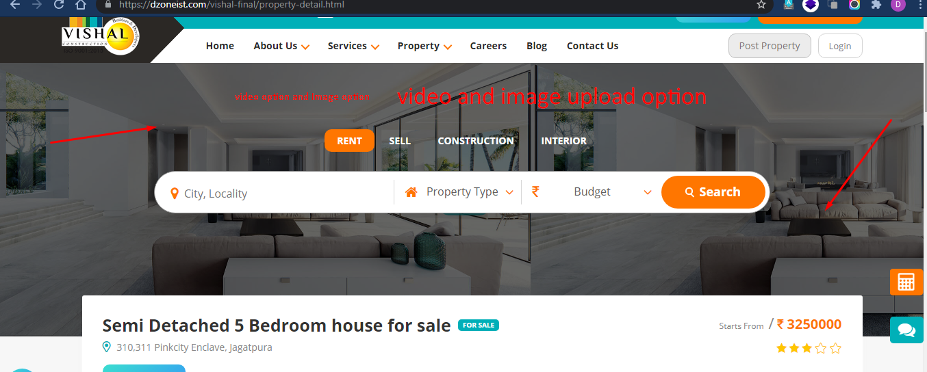

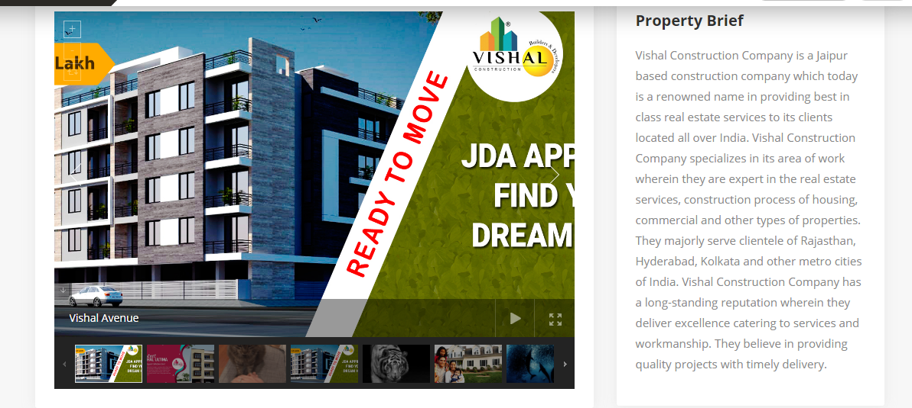

2. option to upload: image/video and pdf

## 3. Facts and Features

## Bedroom Bathroom Balcony status

2 2 1 ready to move/under construction/sold out

**Furnishing property type transaction type Floor Total Floor**

furnished sale/rent/construction/interior new/resale [1,2,3,4] 10

semi furnished

unfurnished  
  
  
**Total Area Super Builtup Area Builtup Area Carpet Area**

1200 1000 900 850

4. Property Details

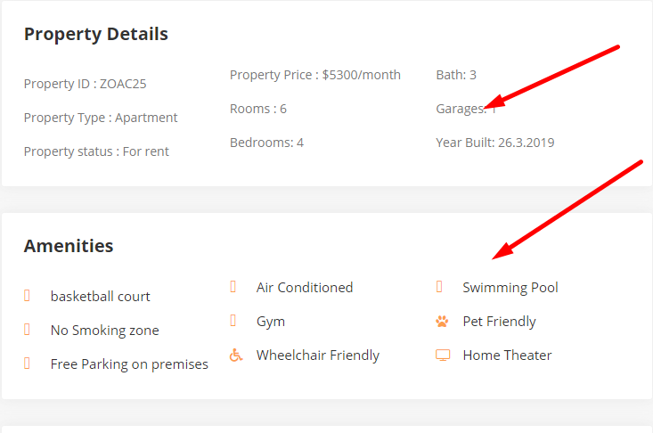

property detail and amenities will be dynamic (complete dynamic) key and value both can change by admin

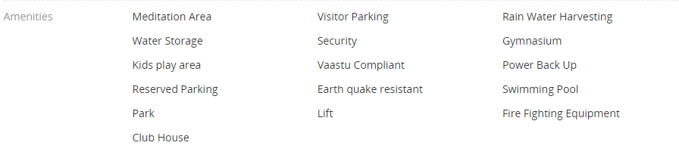

Location  
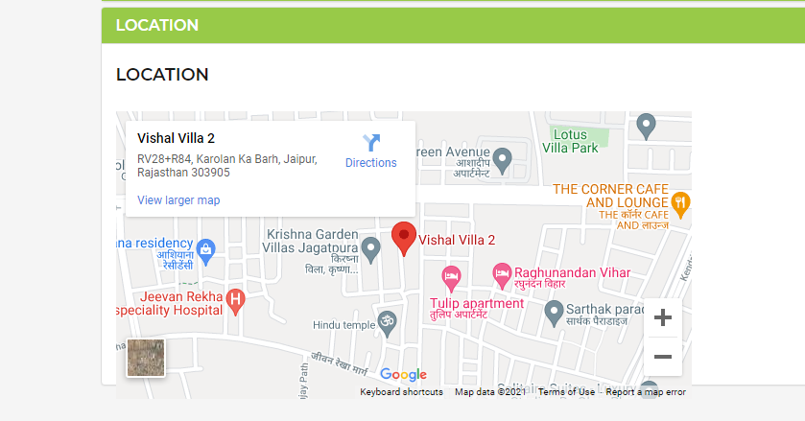

Add location area with map (embeded code or lat long)