Laravel: solve some small errors of survey page creator

**The corrections are simple and I write all in details to make fast all. But please to navigate on web so you understand the document fast**

CONDITION:

- show me last similar job with suervey

- after acept no apolagies, non request of other money

- show me every day the result (after 2 days enought resulti t is necessary delate the milestone)

- max budget 60$

the use acces to web is: [www.diagnosiaziendale.it](http://www.diagnosiaziendale.it) login: [student@lms.com](mailto:student@lms.com) password: secret

The access to admin:n now it isn’t possible for safe

It is necessary make some changes to creator page of questions. The goal is work perfectly the creation of questions and show in user page. the graphic is very important, so it is neecssary attention to solve all graphic questions.

**The change regard the following page in admin**

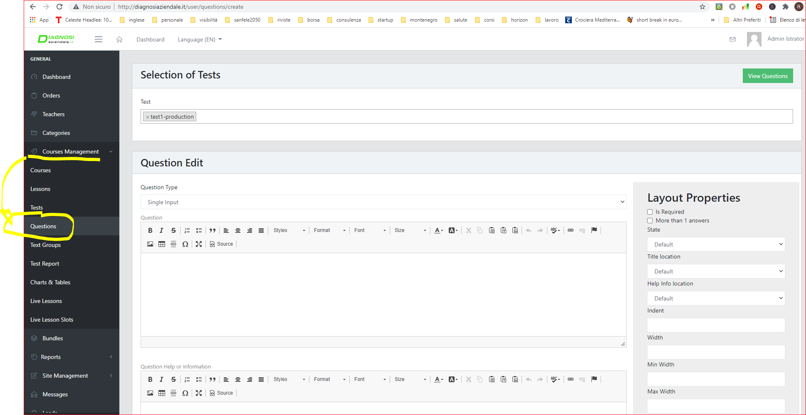

to see the questions you must go in studend and select the **course and the test**

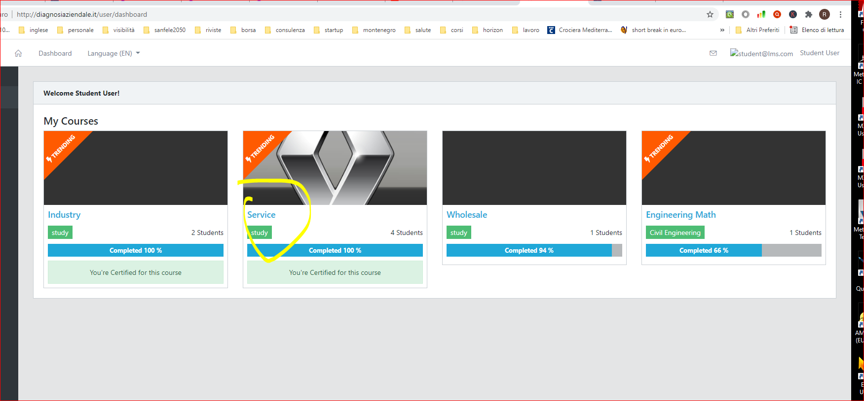

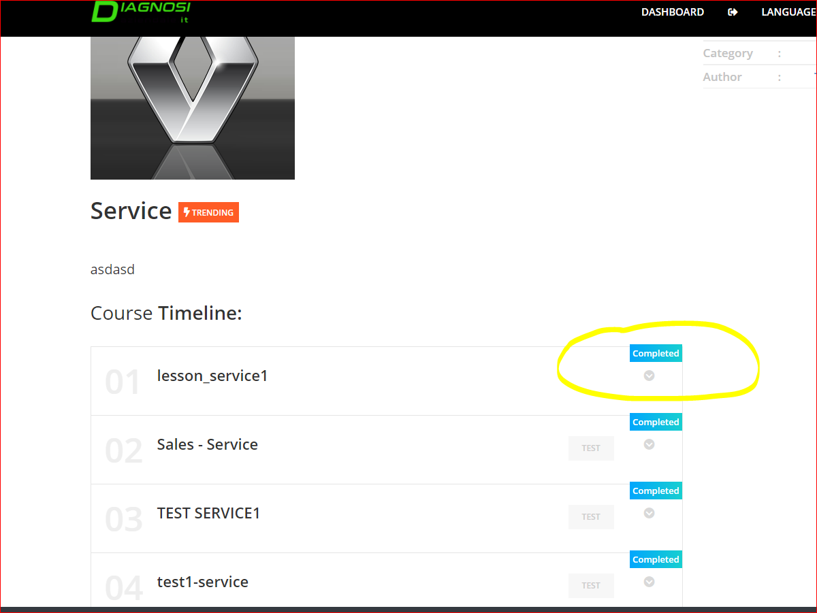

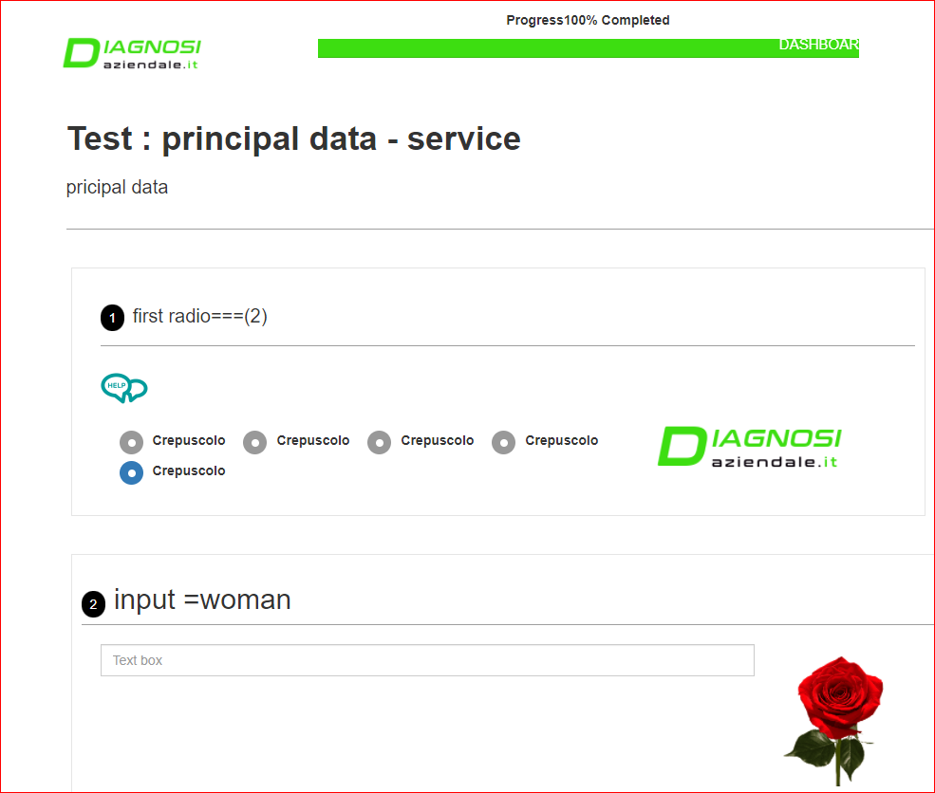

* 1. The software don’t open the page **edit**. So it is necessary solve this problem

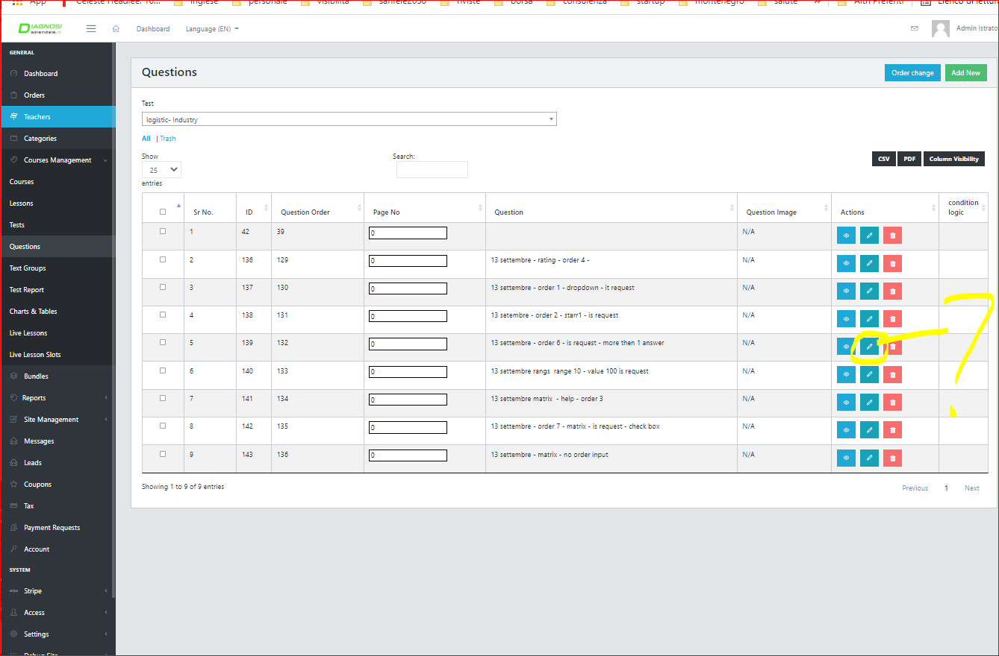

1.2 Request. If the administrator input the option “is request” click on request when the student don’t answer that questions and click report, the software must show pop up that write or show what question isn’t answer

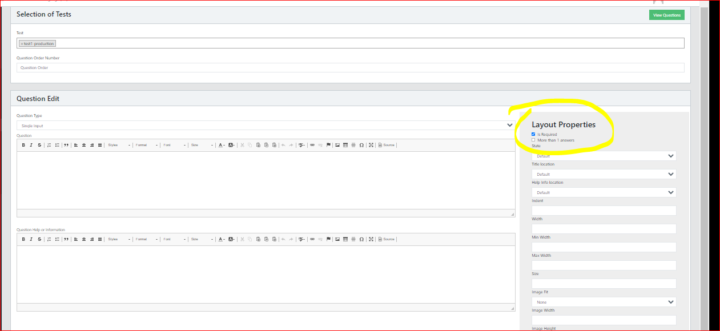

1.3Rating: it have some problems. first it don’t show in the student area. 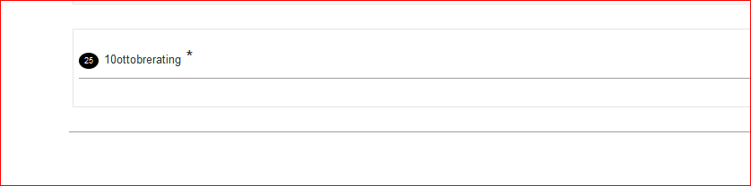

Secondi t is necessary verify if why in student page donìt show the value but only “O”. If you see the image I input 1,2,3,4,… but in student page there is only 0

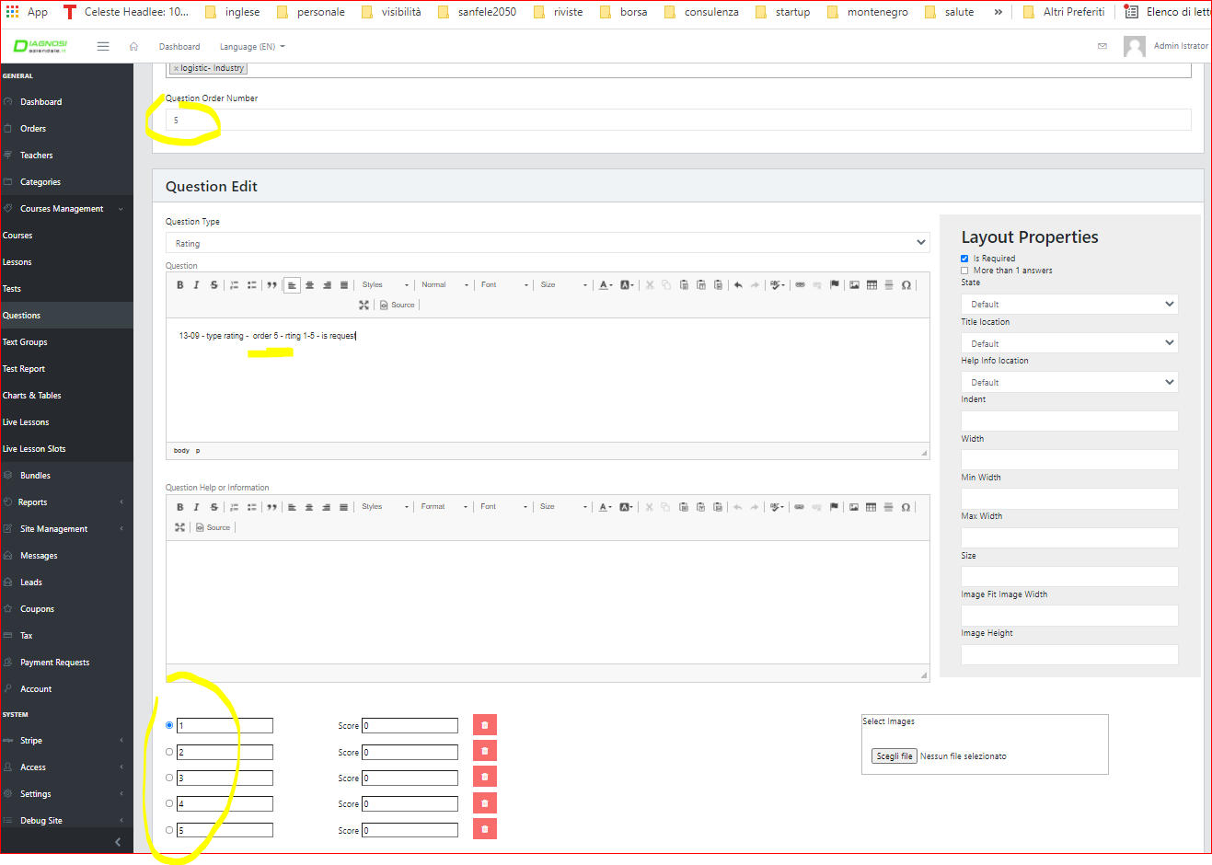

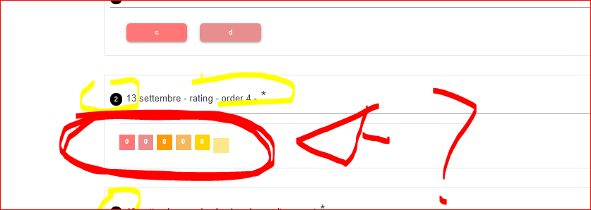

* 1. Stars.

Also stars now don’t show the stars.



Regard the **stars, rating** and other with color button, the administartor must decide the colors. so it is necessary add the color options in the creation question page.

1.5 help: it is necessary make better graphic of popup

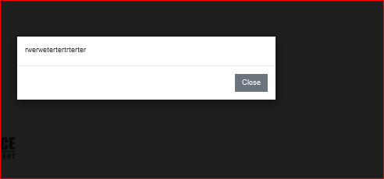

1.6 . Value in Euro (€). The single input mus have also the option “value in €” and “number”. Pratically the input can be text (jhons), number (500) or value in € (100.000,00 €). It is necessary show “€” and decimala s example.

Remember that all answer with number and value in € don’t have the score (so it is important to create the table).

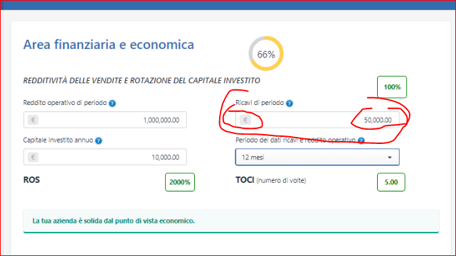

1.7 matrix

Now the matrix have more options regard th etype of answers: check box, radio box and single text.

Now it don’t work, but show only check box. it is necessary solve this to have different options of answers.

Also it is necessary add the options: numbr and value in €. See point 3.6. So it is necessary add them.

It is very important remember that the chackbox and radiobox have a score for every answers. The single value, number and value in € don’t have the score. So it is necessary make these difference. You can also make different matrix, one for every type of answers. These features it is important becasue one score or alternativ eoptions and all number/value € of all answers (row and columns) mus be used for analysis.

As all questions the answers of matrix must be save in the database.

It is also necessary verify if work the option “IS REQUET” AND “MORE THAN 1 ANSWERS”. it is important for value input because regard the value input it is necessary answer to all row/columns (they are economic value, for more years)

I attach an exampel of question with matrx.

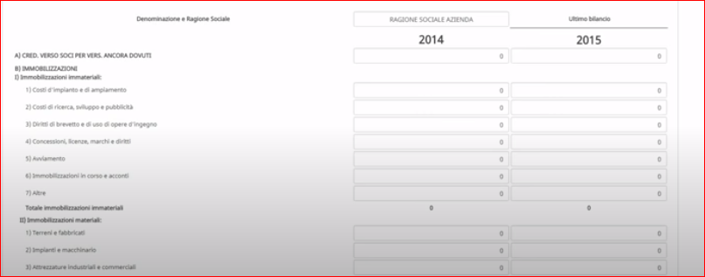

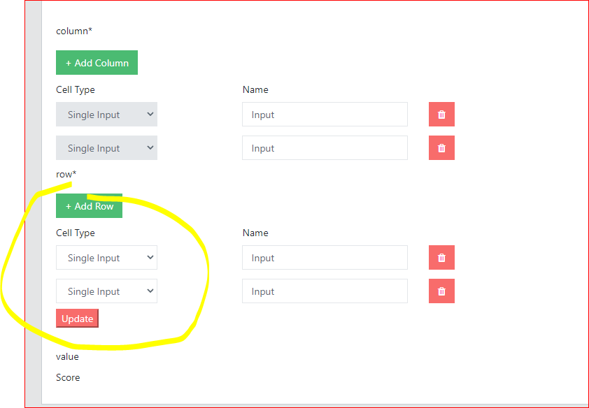

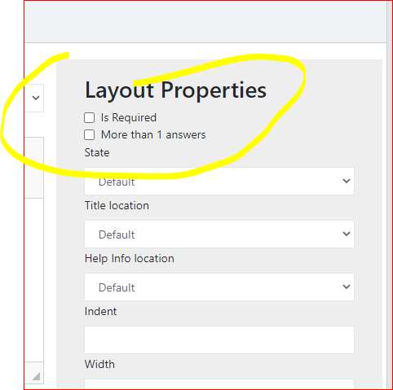

As you see by image if select single value it show me only check box and enought informations regard the check box (as your images). Remeber that regard single value, I can have numbr, text and value in e (this must be evident with simbol of €)

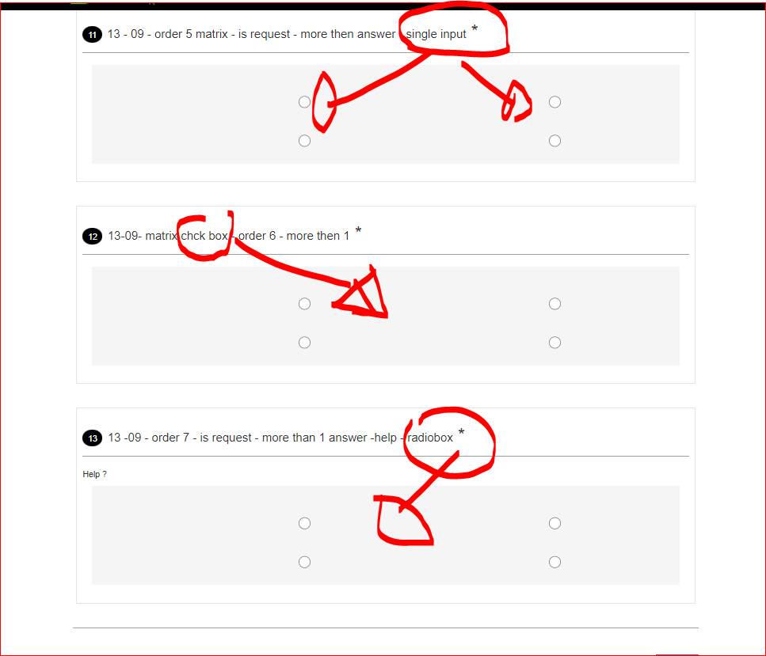

Regard the matrix you must remember that the matrix must have answer with number and value in €. So don’t have the score, the others must have the score.

1.8 rangs

Now the rangs is made bed. there are incorrect impostations. It is necessary minimun value, type of value (number or value in €, max value and step and range) Also the graphic is better.

Pratically it is necessary so decide the type (value in € or number), the minimum and max (for example 0 – 100.000.000,00 €) and scale for example 10000,00. so in this way the user have 0; 10.000,00; 20.000,00, 30.000,00.

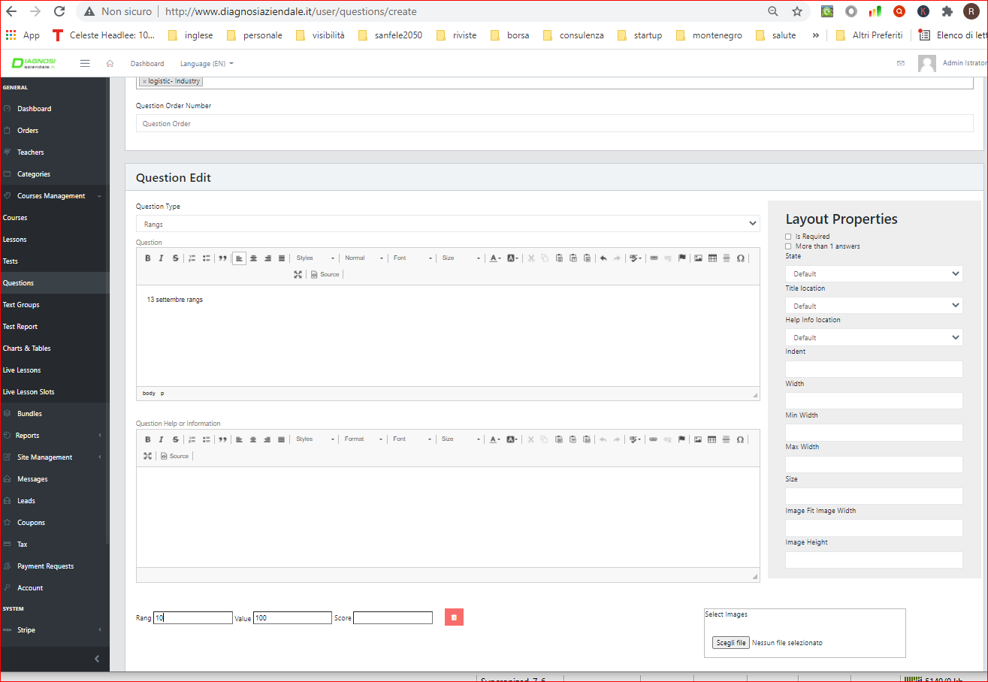

Please research some java script similar my image and copy them because also the graphic is orrible.

A you see by images there are some options:

A: it is necessary must do 2 graphic type: (- and + with input number) 

and (- and + with cursor/bar) 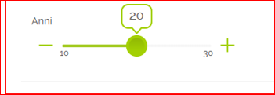

b. Must by 2 tyoe of value: value in € 

and number 

Regard the rangs you must remember that the rangs don’t have the score.

1.9 question with “file”. It must have 2 functions. First, the administrator must can upload the file to see the file. Second he must add it in the report using shorte code. For example if the file is a logo, by shortcode it ad in the report.

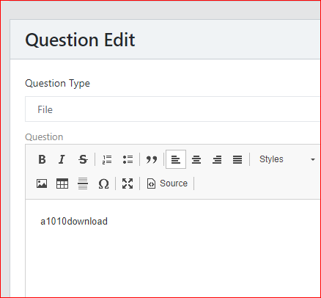



**1.10** **% completated:** the graphic is orrible. 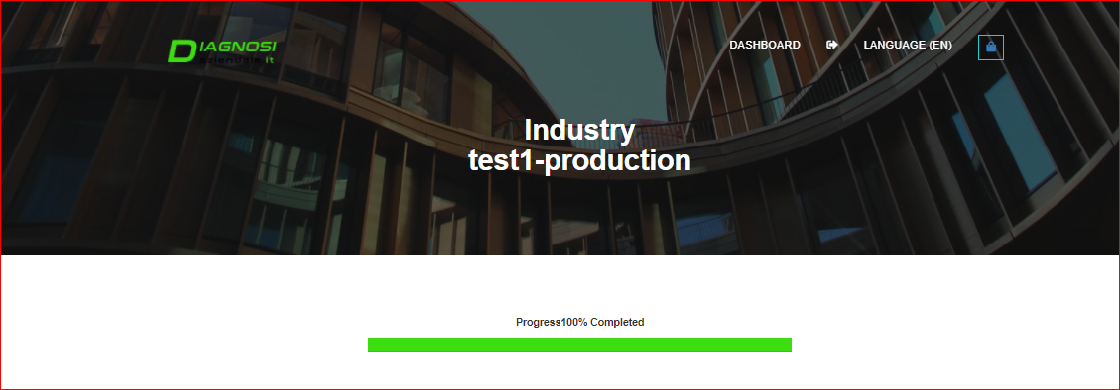

Can you make a beautful graphic? for example one similar of these…

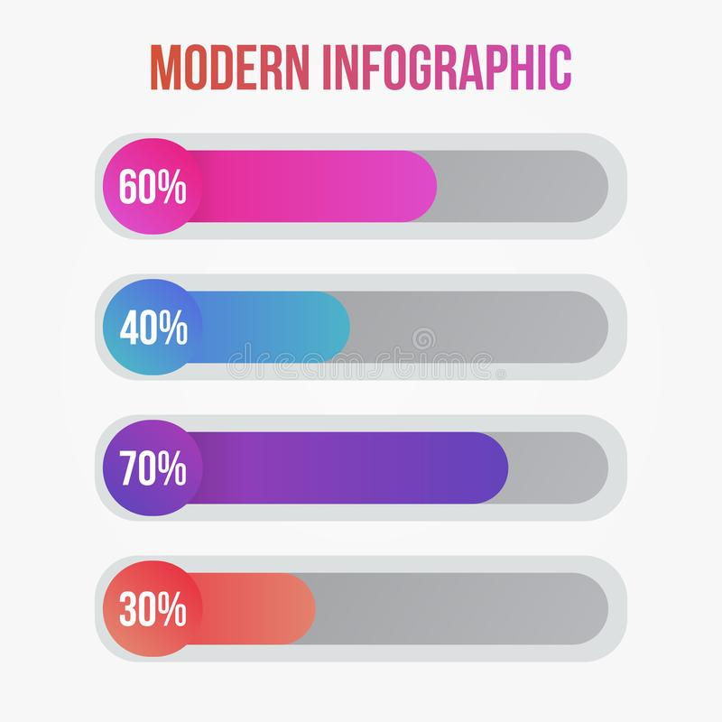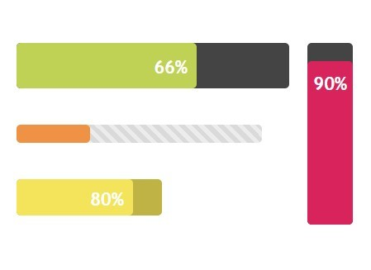

1.11 The project must have about 2000 questions, so it is necessary don’t bore those who have to answer the questions. So it is necessary to have excellent and dynamic graphics of the questions and answers (as a English course). For this the administrator must be able to change every setting and position of the questions and answers. Basically the administrator must be able to change the texts and position, add images, size and position. I enclose some examples and positions of the images and answers. The actual errors is that the box to creation of questions (see image) is distinct from the creation of answers, so there are a lot of graphical problems of integration of graphic. see the examples and I recommend seeing Surveyjs.io

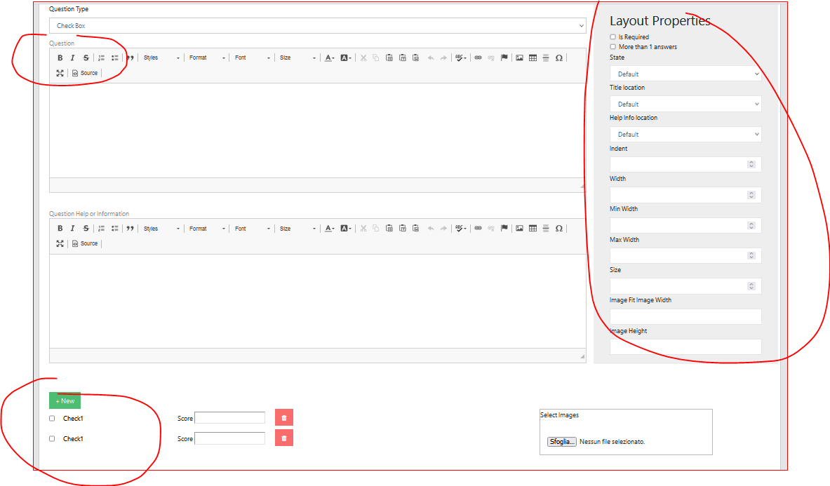

Surveyjs.io have integration graphic of question and answers as image and it is possisble make all personalizations.

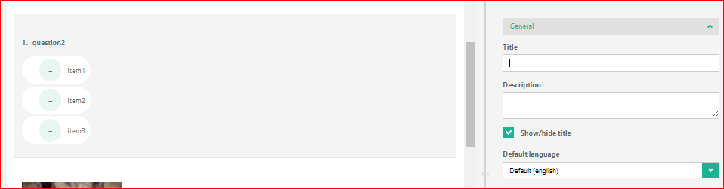

<https://surveyjs.io/create-survey> <https://surveyjs.io/Overview/Library/example#integrate-widgets>

<https://surveyjs.io/Examples/Library>

.

see the positions of image, question and answers

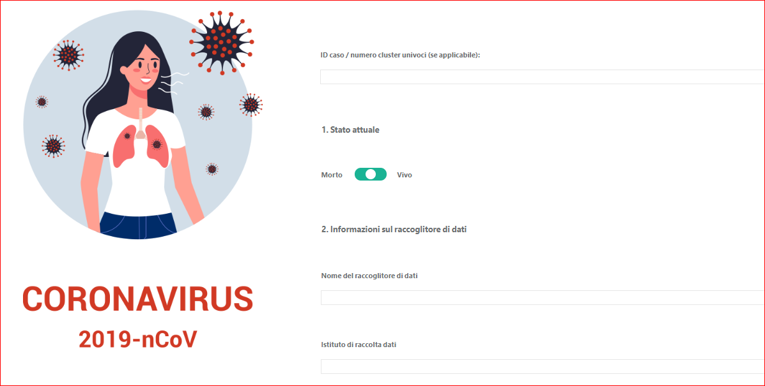

see the position of images, graphic in general and button

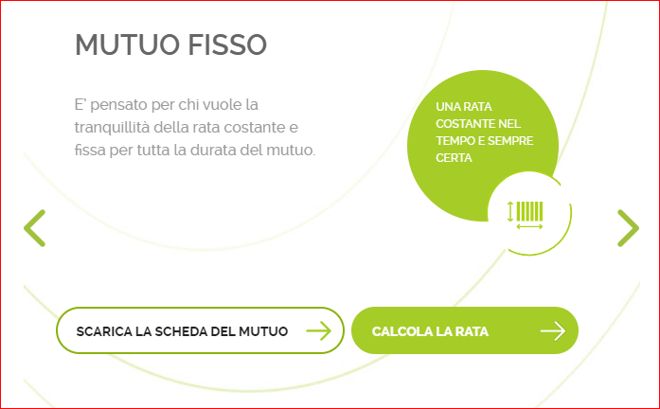

The actual problems:

It is necessary create the impostation to decide the number of answers for line as following example

for example:

answer 1 answer 2 answer 3 answer 4

or

answer 1 answer 2

answer 3 answer 4

or

answer 1

answer 2

answer 3

answer 4

**It is necessary solve better the impostations, so the** the position, dimension of answers and image. Now don't make this. see in details all types of positions.

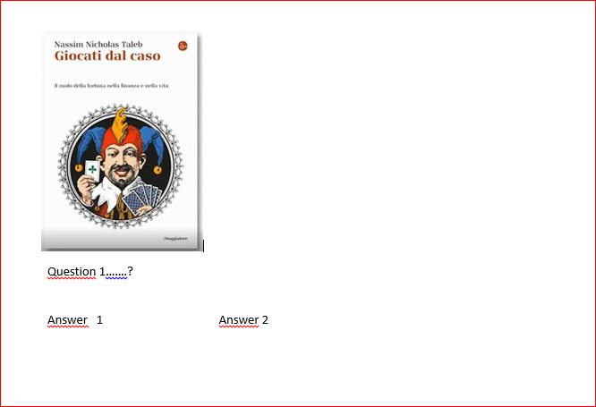

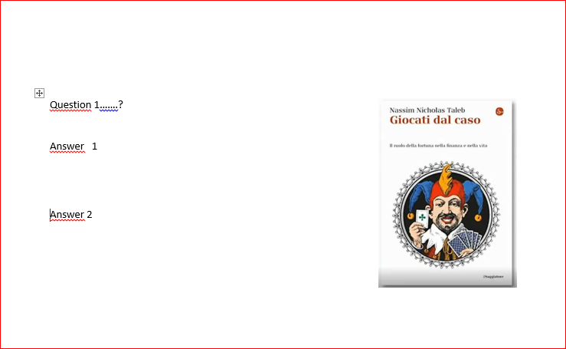

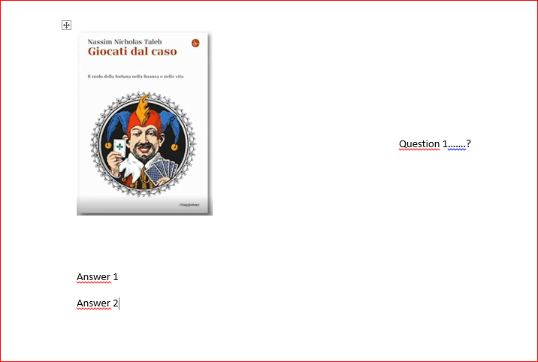

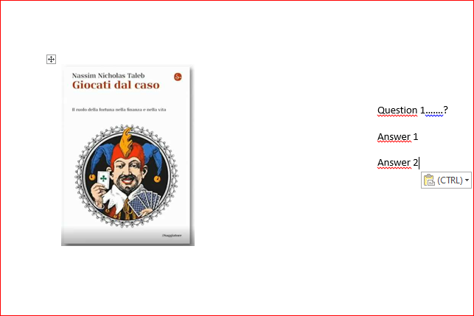

Finally it is necessary add the options to change the colors of bagrouund of questions.

1.12

There is a strange errors that before didn’t make. Regard some course, when by user go in questionnaire don’t open the page. It is necessary solve this error.

