IPL Batting Performance Analysis Report using Power BI

1. Introduction
The Indian Premier League (IPL) is one of the most popular professional cricket leagues in the world. This project analyzes IPL batting performance data using Microsoft Power BI.

2. Objective of the Project
- Analyze batting performance of IPL players
- Identify top-performing teams and batsmen
- Study strike rate, runs, and dismissal patterns
- Build an interactive Power BI report

3. Dataset Description
The dataset includes match-wise batting data with columns such as match_id, team, batsman_id, runs, balls, fours, sixes, strike rate, and wicket details.
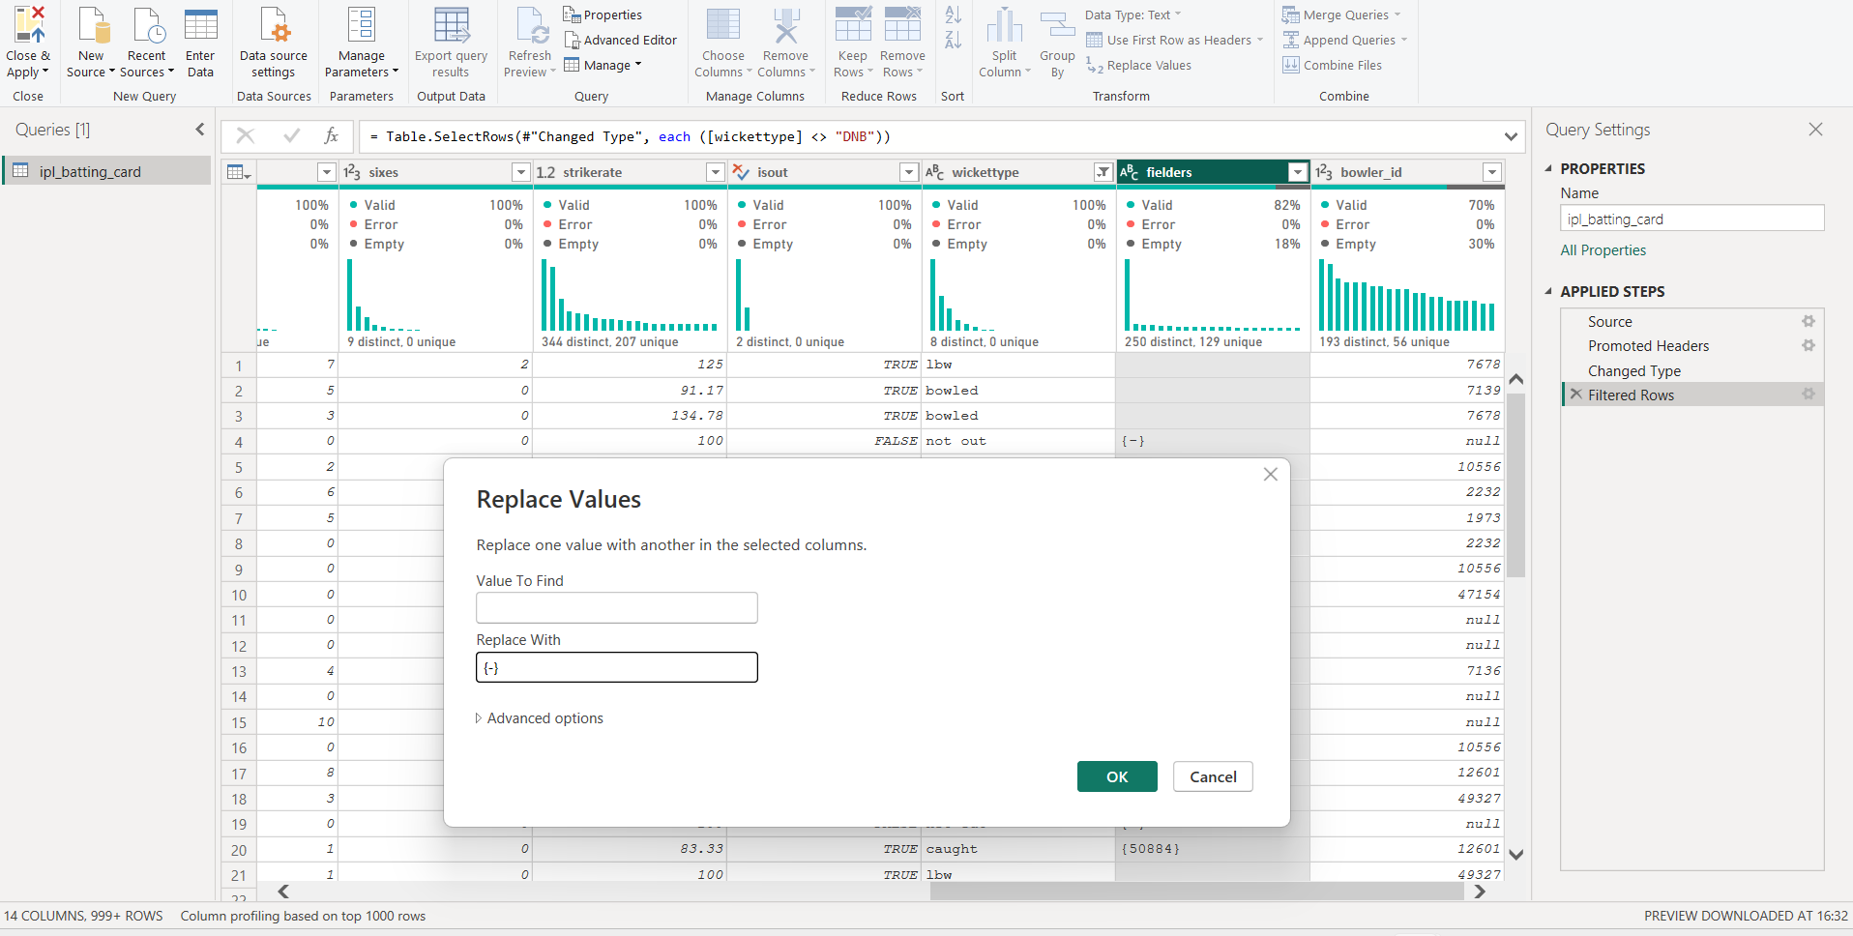
Wherever fielders rows are empty I have replaced by {-}.
4. Data Cleaning and Preprocessing
- Removed NULL bowler id by 0.
- Removed duplicate and unnecessary rows

5. Tools and Technologies Used
- Power BI Desktop
- Power Query
- DAX
- MS Excel / CSV

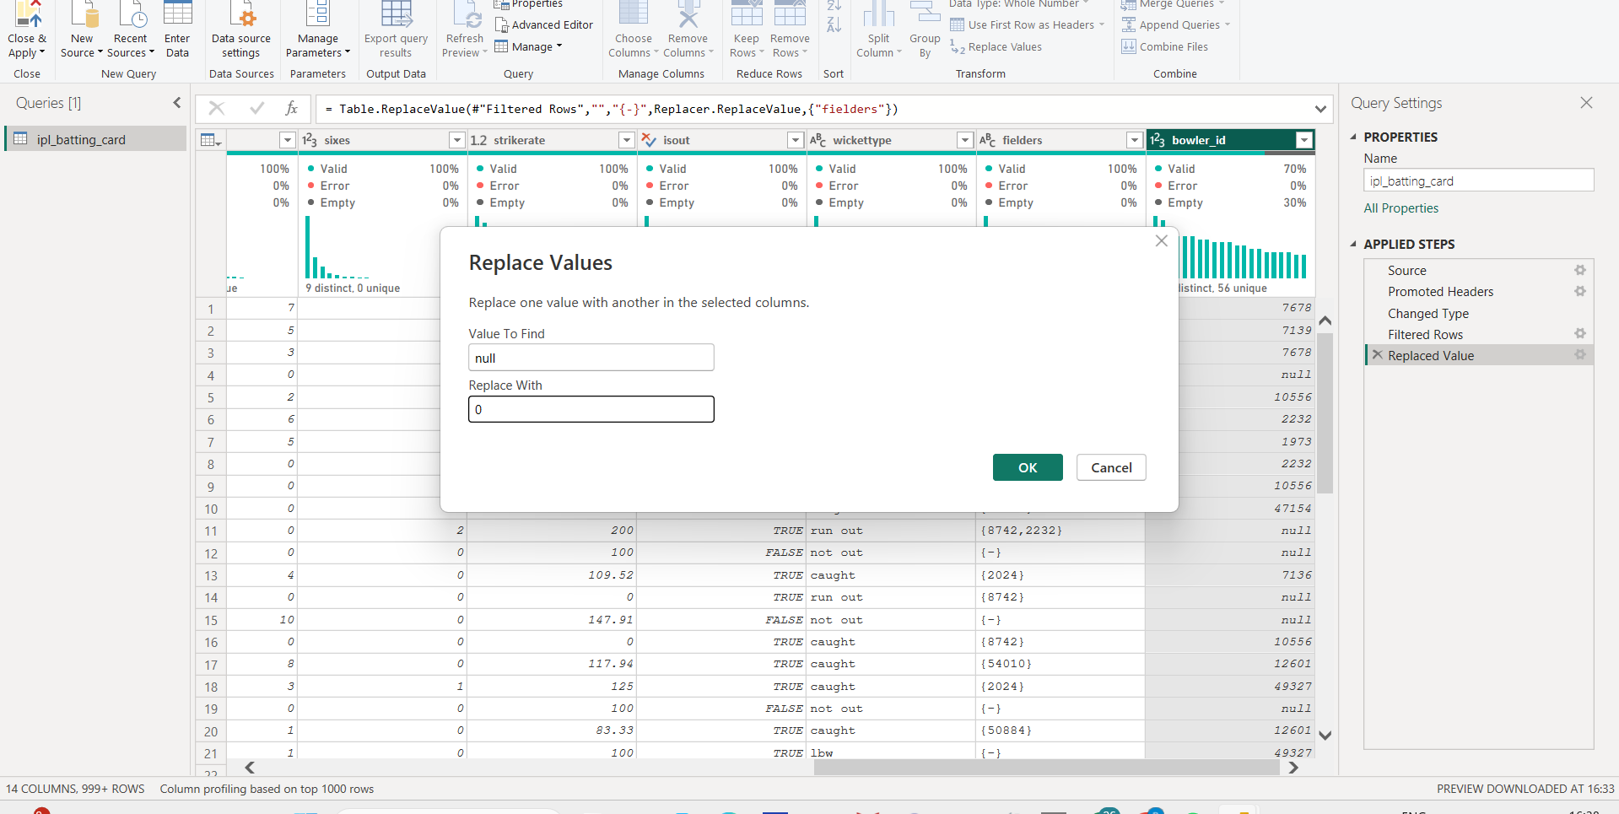

8. Conclusion
Power BI provides effective visualization and insights for IPL batting analysis.

9. Future Scope
- Include bowling analysis
- Add season-wise trends
- Predict player performance

