

Sanjivani Rural Education Society’s

Sanjivani College of Engineering, Kopargaon-423603
(An Autonomous Institute Affiliated to Savitribai Phule Pune University, Pune)
IT Based Skill Enhancement Course

Software Requirements Specification (SRS)

Project On
FoodExpress
(Online Food Ordering System)
Under the Guidance of
Prof. Muthuraj S

Project Version: 1.0
Date: August 2026
Prepared By : Group 06
Group member :
- Kanifnath Markad
- Ankita Gaikwad
- Ramkrushn Kadam
- Kiran Dhage
Document Control
Version | Date | Author | Description/Change
1.0 | 21 Aug 2026 | Group 06 | Initial Draft

Introduction
  - Purpose
The purpose of this Software Requirements Specification (SRS) document is to define the functional and non-functional requirements of the FoodExpress – Online Food Ordering and Restaurant Management System. This document serves as a reference for developers, testers, project stakeholders, and future maintenance teams by providing a detailed description of the system's features, behaviour, interfaces, constraints, and performance expectations.
The proposed website aims to provide an online platform where customers can browse restaurants and food items, view food details, add items to a cart, place orders, make UPI payments, and track their orders. It also enables administrators to manage food items, restaurants, users, and customer orders through an Admin Dashboard.

  - Scope
The FoodExpress website is a web-based online food ordering platform developed to provide customers with a convenient way to browse food items and place orders online.
The system will provide the following functionalities:
- Customer registration and login.
- Browse available food items.
- View detailed information about food items.
- Search and explore available food.
- Add food items to the shopping cart.
- Update item quantities and view the order total.
- Place orders using Home Delivery, Pickup, or Dine-In options.
- Make payment using UPI.
- View placed orders and order status.
- Customer profile management.
Administrator login and dashboard.
Manage restaurants, food items, users, and customer orders.
  - Store application data securely in a MongoDB database.

Term | Description
SRS | Software Requirements Specification
UI | User Interface
API | Application Programming Interface
CRUD | Create, Read, Update and Delete operations
MVP | Minimum Viable Product
  - References
- React.js Documentation.
- Node.js Documentation.
- Express.js Documentation.
- MongoDB Documentation.
- HTML5, CSS3, JavaScript and Tailwind CSS Documentation.

1.5 Document Overview
This Software Requirements Specification is organized into the following sections:
- Section 1 – Introduction: Describes the purpose, scope, definitions, references, and document organization.
- Section 2 – Overall Description: Explains the system overview, product functions, users, operating environment, constraints, and assumptions.
- Section 3 – Functional Requirements: Defines detailed functional requirements using uniquely identified requirement specifications.
- Section 4 – Non-Functional Requirements: Specifies performance, security, reliability, usability, scalability, and maintainability requirements.
- Section 5 – External Interface Requirements: Describes user interfaces, hardware interfaces, software interfaces, and communication interfaces.
- Section 6 – System Models and Diagrams: Presents design models including Use Case, Activity, Sequence, Class, ER, and Architecture diagrams.
- Section 7 – Data Requirements: Defines database entities, relationships, validation rules, and data management requirements.
- Section 8 – Business Rules: Documents system rules and operational policies.
- Section 9 – Acceptance Criteria: Lists measurable criteria for validating successful implementation.
- Section 10 – Appendices: Includes supplementary information, glossary, wireframes, and supporting documents.

Overall Description

2.1 Product Perspective
The FoodExpress – Online Food Ordering and Restaurant Management System is a standalone web-based platform designed to provide customers with a centralized place to explore restaurants, browse food items, manage their cart, and place food orders online.
The website replaces the traditional approach of visiting a restaurant or placing orders manually by providing an organized and easily accessible online platform. Customers can browse restaurants and food items, view details, add items to the cart, select an order type, make UPI payment, and view their orders. Administrators can manage application data through a secure dashboard, ensuring that restaurants, food items, users, and orders remain updated.

2.2 Product Functions
The proposed system provides the following major functions:

Customer Functions
- Register and log in to the website.
- Browse available food items.
- View detailed food information.
- Search and explore food items.
- Add food items to the cart.
- Update cart quantities and view the total amount.
- Select Home Delivery, Pickup, or Dine-In.

Enter delivery, pickup, or dine-in details.
- Secure administrator login.
- Access the administrative dashboard.
- View dashboard statistics.
- Manage restaurants.
- Add, update, and delete food items.
- Manage food categories and restaurant information.
- View and manage customer orders.
- Update order status.
These functions collectively provide a user-friendly platform for customers while enabling administrators to efficiently manage restaurants, food items, customers, and orders.

Maintain application content and order information.
The system consists of two primary user classes.

1. Administrator
Description:
The administrator is responsible for managing the FoodExpress platform and ensuring that restaurant, food, customer, and order information remains accurate and up to date.
Responsibilities
- Manage food items and categories.
- View registered customers.
- View customer orders.
- Update order status.
- Maintain website and food information.
Skill Level
- Basic to intermediate computer knowledge.
- Familiarity with web browsers and administrative interfaces.

2. Customer
Description:
Customers are users who use the FoodExpress website to explore restaurants and food items, manage their cart, place orders, and view order information.
Responsibilities
- Register and log in.
- Browse food items.
- Search and view food details.
- Add and manage items in the cart.
- Place food orders.
- Make UPI payments.
- View order history and status.
Manage profile information.
- Basic internet browsing knowledge.
- No technical expertise required.

2.4 Operating Environment
The application will operate in the following environment.
Component | Specification
Application Type | Web Application
Frontend | HTML5, CSS3, JavaScript, React.js, Tailwind CSS
Backend | Node.js, Express.js
Database | MongoDB
API Testing | Postman
Version Control | Git and GitHub
IDE | Visual Studio Code
Supported Browsers | Google Chrome, Microsoft Edge, Firefox
Internet Connection | Required

2.5 Design and Implementation Constraints
The following constraints apply to the development and deployment of the system:

Technical Constraints
- The frontend shall be developed using React.js.
- The backend shall use Node.js with Express.js.
- MongoDB shall be used as the primary database.
- RESTful APIs shall be used for communication between the frontend and backend.
- The system requires a stable internet connection for access.

2.6 Assumptions and Dependencies

Assumptions
- Users have access to a stable internet connection.
- Customers use modern web browsers that support HTML5, CSS3, JavaScript, and React.js.
- Administrators are trained to manage FoodExpress through the dashboard.
- All food, customer, and order information entered into the system is accurate.
- The hosting environment supports Node.js and MongoDB.

Dependencies
The successful operation of the system depends on:
- React.js for frontend development.
- Node.js and Express.js for backend services.
- MongoDB for database storage.
- Git and GitHub for version control.
- Postman for API testing during development.
- Reliable web hosting and internet connectivity.
These assumptions and dependencies are based on the proposed FoodExpress technology stack and intended deployment environment.

Functional Requirements
FR-001: Customer Registration
Field | Details
Requirement ID | FR-001
Requirement Name | Customer Registration
Description | The system shall allow new customers to create an account by providing their details.
Priority | High
Inputs | Name, Email, Password
Processing | Validate the entered details and store them in the database
Outputs | Customer account created successfully
Acceptance Criteria | The customer can register successfully using valid information

FR-002: Customer Login
Field | Details
Requirement ID | FR-002
Requirement Name | Customer Login
Description | The system shall allow registered customers to log in securely.
Priority | High
Inputs | Email, Password
Processing | Verify user credentials and authenticate the customer
Outputs | Customer is logged into the system
Acceptance Criteria | Only valid users can access their account

FR-003: Browse Products and Services
Field | Details
Requirement ID | FR-003
Requirement Name | Browse Restaurants and Food
Description | The system shall allow customers to browse restaurants and available food items.
Priority | High
Inputs | Restaurant or food selection
Processing | Retrieve and display available restaurants and food items from the database
Outputs | List of restaurants and food items displayed
Acceptance Criteria | Customers can successfully browse available restaurants and food

FR-004: Submit Customer Enquiry
Field | Details
Requirement ID | FR-004
Requirement Name | Cart Management
Description | The system shall allow customers to add, remove, and update food items in the cart.
Priority | High
Inputs | Food item and quantity
Processing | Validate cart actions and calculate the updated cart total
Outputs | Updated cart and total amount displayed
Acceptance Criteria | Customers can successfully manage cart items

FR-005: Admin Management
Field | Details
Requirement ID | FR-005
Requirement Name | Admin Management
Description | The system shall allow the administrator to manage restaurants, food items, customers, and customer orders.
Priority | High
Inputs | Admin actions (Add, Update, Delete, View)
Processing | Perform CRUD operations on application content and manage customer orders.
Outputs | Updated FoodExpress information and order records.
Acceptance Criteria | The administrator can successfully manage all required website and order information.

Non Functional Requirements

4.1 Performance
The system shall provide efficient performance to ensure a smooth user experience.
- The website shall load each page within 3 seconds under normal network conditions.
- The system shall support multiple users accessing the website simultaneously without significant performance degradation.
- Customer orders shall be stored in the database immediately after successful order creation.
- Restaurant and food search results shall be displayed within 2 seconds for valid search queries.

4.2 Security
The system shall ensure the security of user information and website data.
- Customers and administrators shall log in using authenticated credentials.
- User passwords shall be stored in encrypted (hashed) form within the database.
- Only authorized administrators shall have access to the Admin Dashboard.
- The system shall validate all user inputs to reduce the risk of invalid or malicious data.

4.3 Availability and Reliability
The system shall remain reliable and available for users.
- The website shall be available 24×7, except during scheduled maintenance.
- Customer orders shall be stored without data loss.
- The database shall be backed up periodically to prevent data loss.
- In the event of a server failure, the system should be recoverable using the latest backup.

4.4 Usability and Accessibility
The website shall provide a user-friendly experience.
- The interface shall be simple and easy to navigate.
- The website shall be responsive and accessible on desktop, tablet, and mobile devices.
- Navigation menus shall remain consistent across all pages.
- Forms shall display clear validation messages for invalid or incomplete inputs.

4.5 Scalability
The system shall support future growth.
- The database shall accommodate additional restaurants, food items, customers, and orders.
- The application architecture shall allow future integration of additional online payment, notification, delivery tracking, and mobile application features.
- The system shall support increasing numbers of users with minimal modifications.

4.6 Maintainability
The system shall be easy to maintain and enhance.
- The application shall follow a modular architecture to simplify updates.
- Source code shall be properly documented and organized.
- Bugs and issues shall be logged for easier troubleshooting.
- Future enhancements can be implemented without major changes to the existing system.

External Interface Requirements

5.1 User Interface
- Home Page
- Login/Register
- Food Details Page
- Cart Page
- Checkout Page

Orders Page
- Desktop
- Laptop
- Tablet
- Smartphone

5.3 Software Interfaces
- MongoDB Database
- REST APIs
- Node.js Server

5.4 Communication Interfaces
- HTTP/HTTPS
- REST API
- UPI Payment Interface

System Models and Diagrams
Use Case Diagram
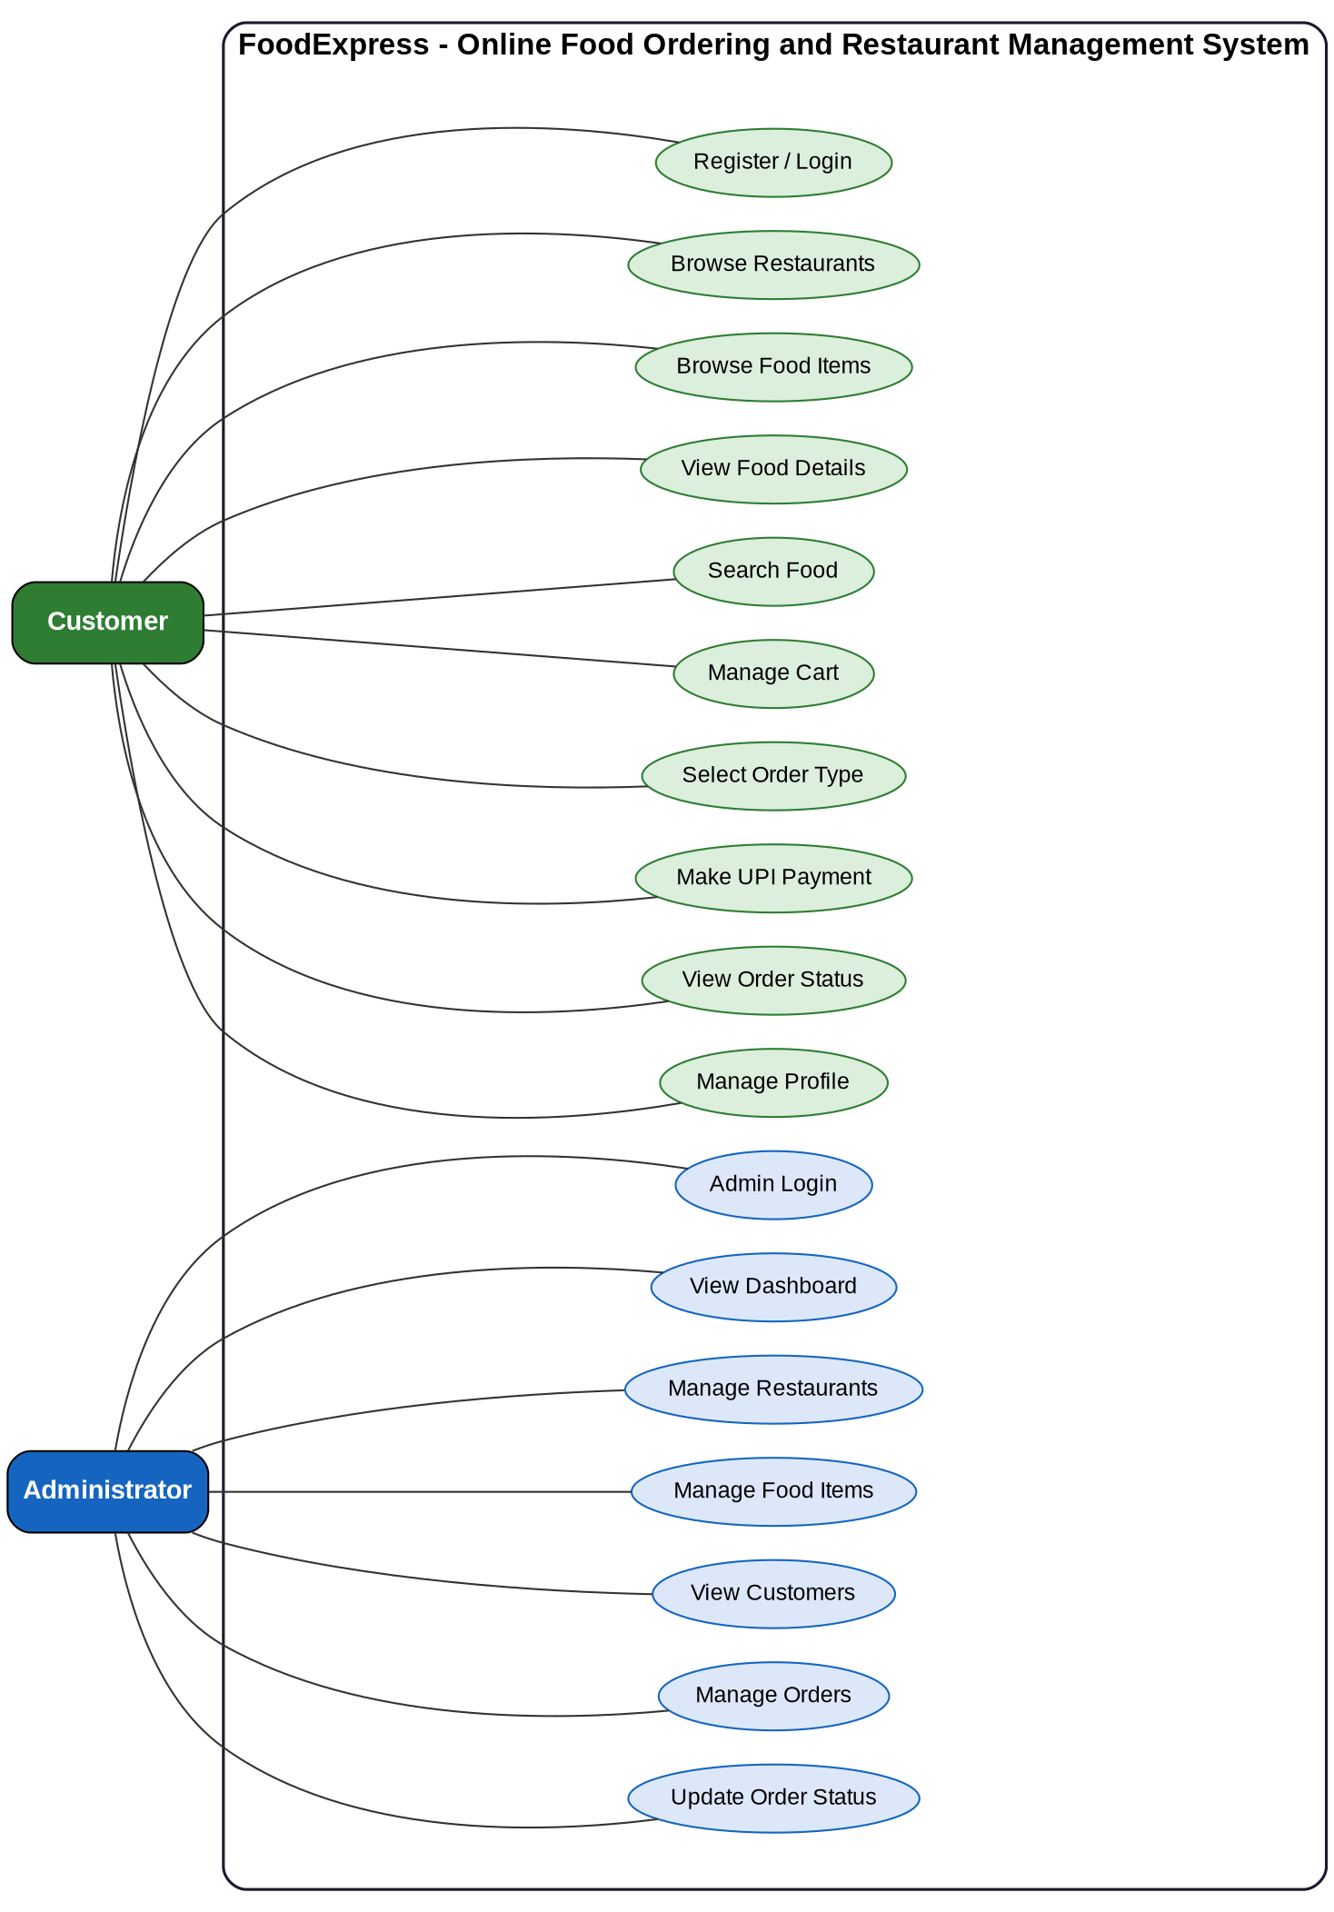

Activity Diagram
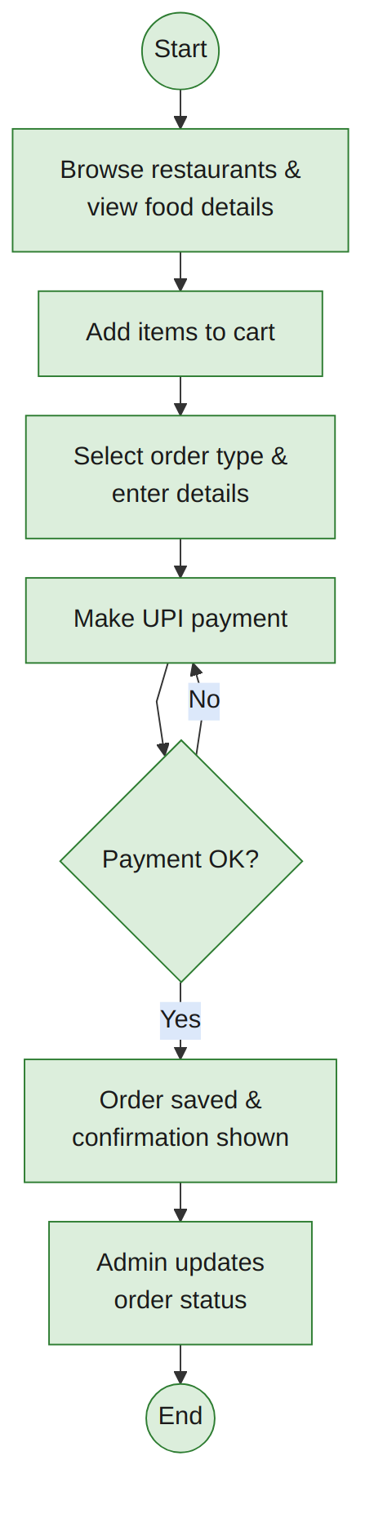

Sequence Diagram

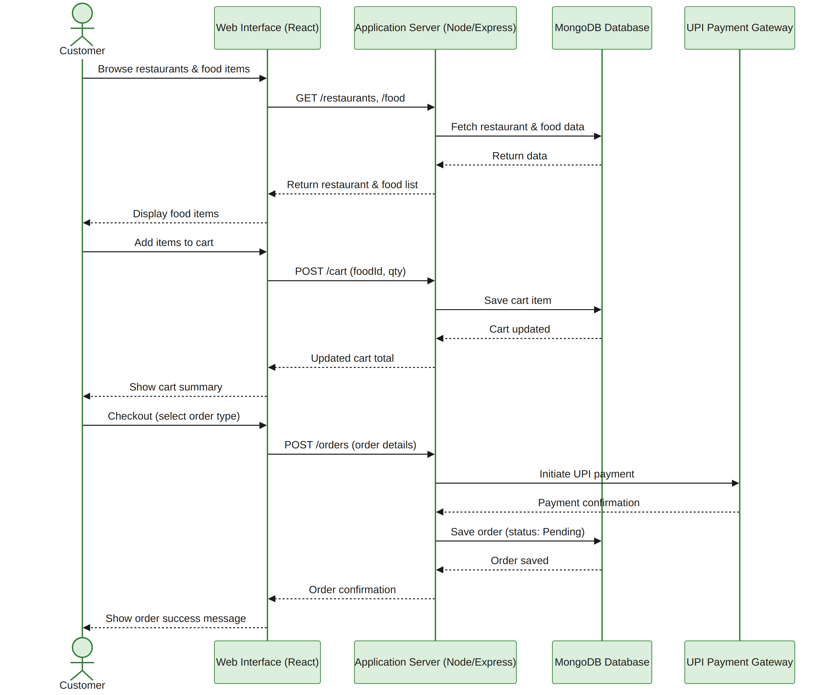

Class Diagram
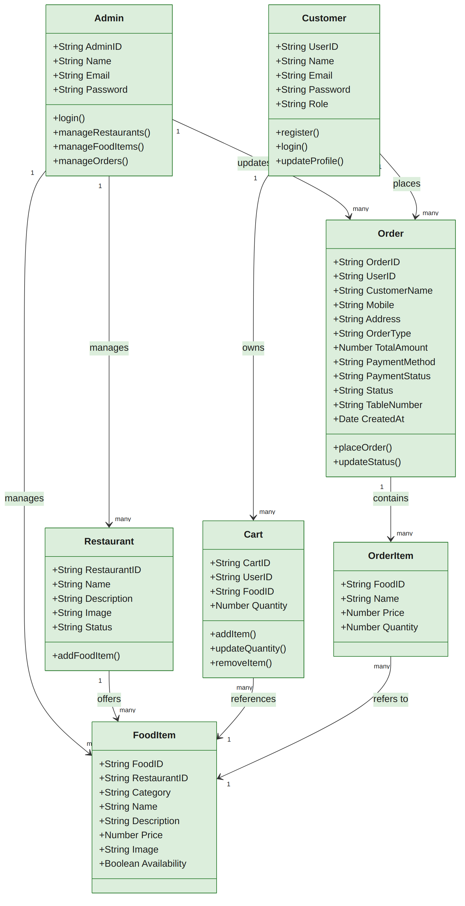

ER diagram
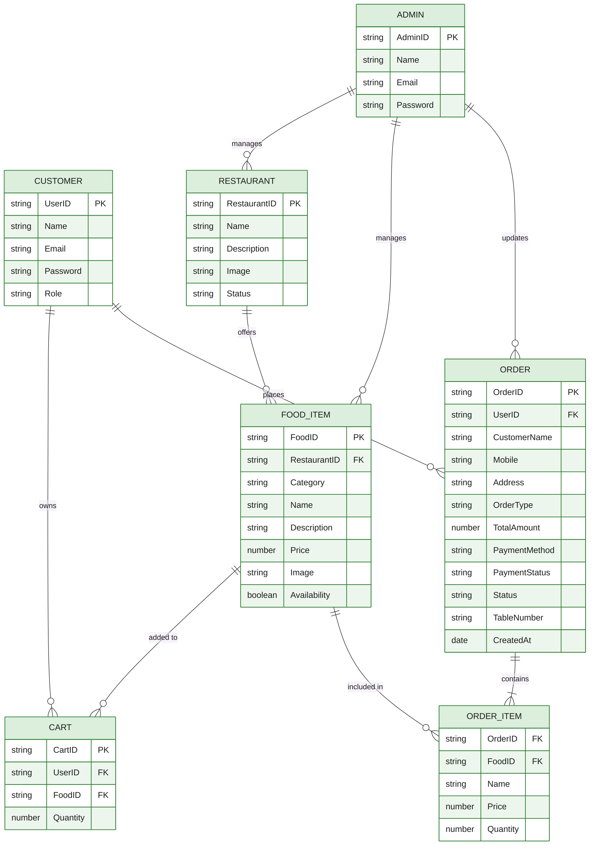

Data Flow Diagram
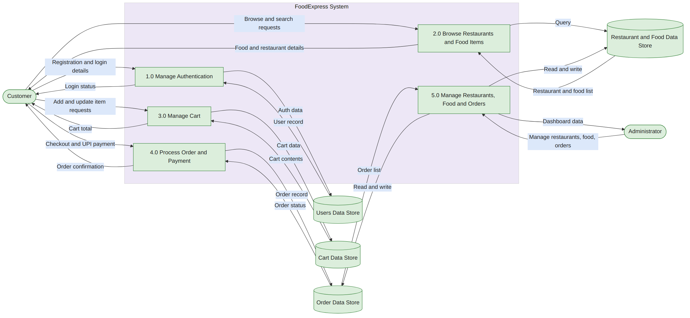
Architecture Diagram
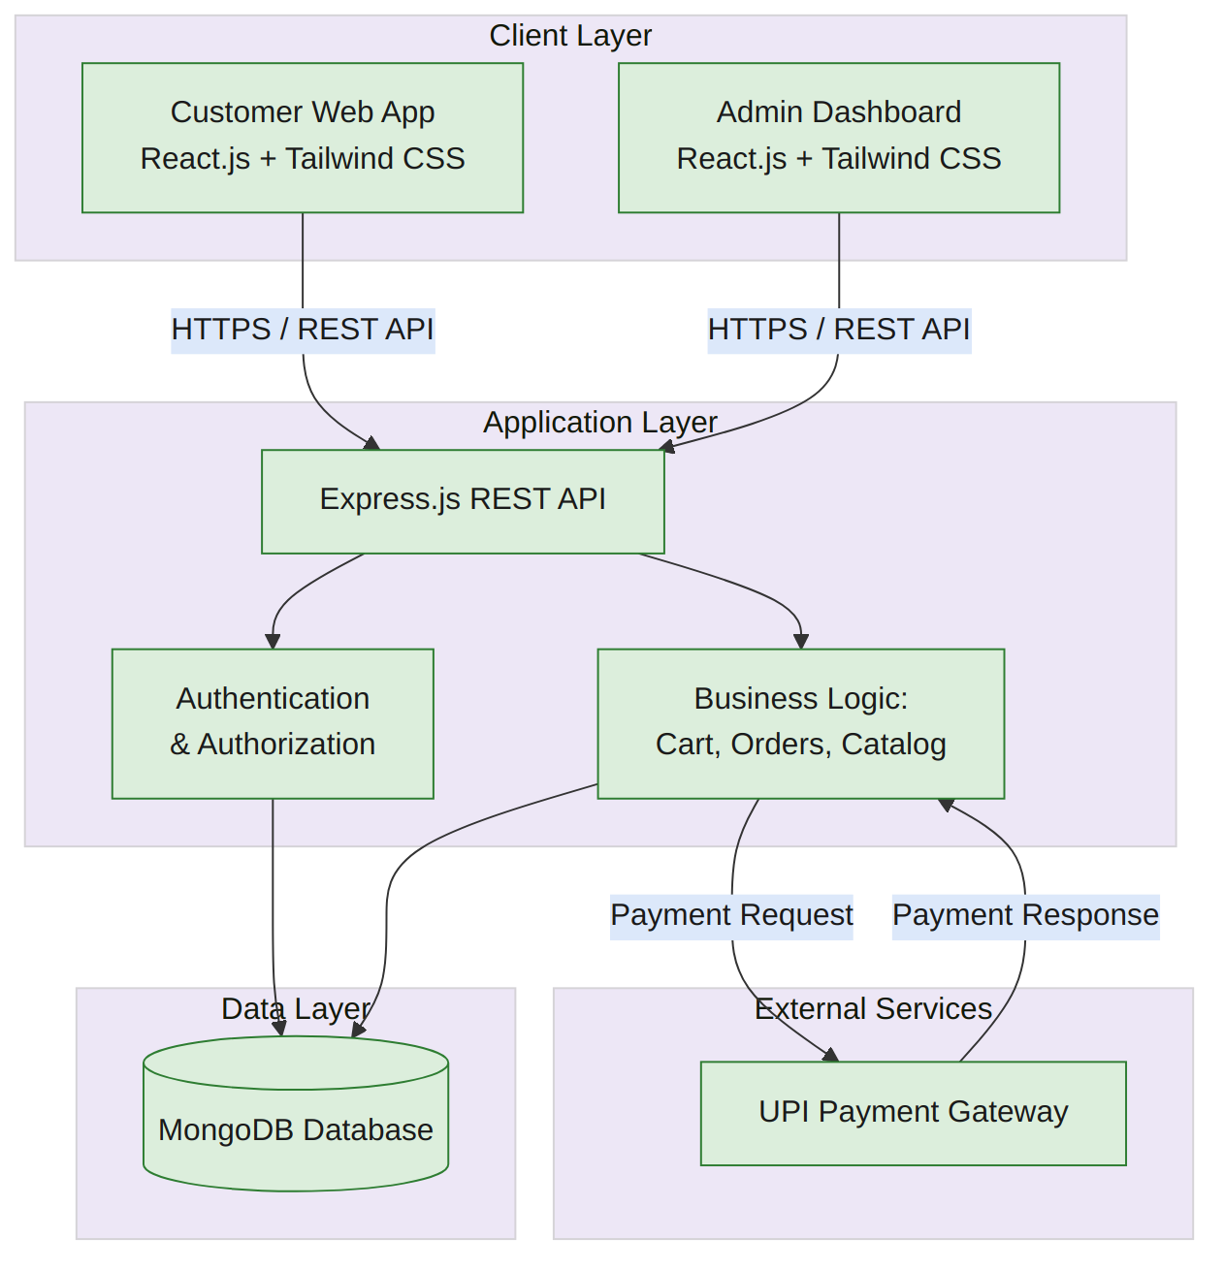

Data Requirements

7.1 Entities
The system consists of the following data entities:
- Admin – Stores administrator information.
- Customer (User) – Stores registered customer details.
- Food Item – Stores food item details, price, category, and availability.
- Cart – Stores food items selected by a customer before checkout.
- Order – Stores customer order information and order status.

Order Item – Stores individual food items included in an order.
Each entity contains the following attributes:
- Admin: AdminID, Name, Email, Password.
- Customer: UserID, Name, Email, Password, Role.
- Food Item: FoodID, RestaurantID, Category, Name, Description, Price, Image, Availability.
- Cart: CartID, UserID, FoodID, Quantity.
- Order: OrderID, UserID, CustomerName, Mobile, Address, OrderType, TotalAmount, PaymentMethod, PaymentStatus, Status, TableNumber, CreatedAt.

Order Item: FoodID, Name, Price, Quantity.
The relationships between the entities are:
- One Restaurant can contain multiple Food Items.
- One Customer can have multiple Orders.
- One Customer can have multiple Cart Items.
- One Order can contain multiple Order Items.
- One Food Item can appear in multiple Orders.

An Admin manages Restaurants, Food Items, Customers, and Orders.
The system shall enforce the following validation rules:
- All mandatory fields must be completed before submission.
- Email addresses must follow a valid email format.
- Mobile numbers must contain only numeric characters and be of valid length.
- User email addresses must be unique.
- Passwords must meet the minimum security requirements.
- Food names, restaurant names, and required order details cannot be left blank.
- Only authorized administrators can add, edit, or delete website and order data.

7.5 Data Retention
- Customer order records shall be stored until they are removed according to the system's data management policy.
- Restaurant and food information shall remain in the database until updated or removed by the administrator.
- User account information shall remain stored until the account is deleted by the administrator or user.
- System logs and database records shall be retained for maintenance and future reference.

7.6 Backup Requirements
- The MongoDB database shall be backed up regularly.
- Backup copies shall be stored securely to prevent data loss.
- The system shall support restoration of data from backup in case of system failure.
- Periodic verification of backup integrity shall be performed.

7.7 Data Privacy Requirements
- User passwords shall be stored in encrypted (hashed) form.
- Customer personal information shall be accessible only to authorized administrators.
- The system shall protect customer data from unauthorized access.
- Secure communication (HTTPS) shall be used for data transmission.
- Customer information shall not be shared with third parties without permission.

Business Rules

8.1 Business Policies
- Only authorized administrators can access the Admin Dashboard.
- Customers can browse restaurants and food items and add items to the cart.
- Customers must register and log in to place orders.
- All food items must belong to a valid restaurant.
- Only administrators can add, update, or delete restaurants and food items.

8.2 Validation Rules
- All mandatory customer, delivery, and order fields must be completed before placing an order.
- Email addresses must follow a valid email format.
- Mobile numbers must contain only numeric digits and have a valid length.
- Duplicate email addresses are not allowed during customer registration.
- Food and restaurant names must not be empty.
- Images uploaded by the administrator must be in supported formats (JPG, JPEG, PNG).

8.3 Workflow Rules
- Customer visits the FoodExpress website.
- Customer browses restaurants and food items.
- Customer views food details and adds items to the cart.
- Customer proceeds to checkout and selects an order type.
- The customer provides the required order information and completes UPI payment.
- The order is stored in the database.
- Administrator views the order in the dashboard and updates the order status.
- Customer views the placed order and its current status in the Orders section.

8.4 Calculation Rules
- The system calculates the total order amount from food price and quantity.
- The total number of customer orders is automatically updated in the Admin Dashboard.
- The system records the order creation date and time automatically.
- Food, restaurant, customer, and order counts are updated automatically whenever records are added or removed.

8.5 Approval Rules
- Only administrators are authorized to manage and publish restaurant and food information.
- New restaurants and food items become visible to customers after being added by the administrator.
- New customer orders are marked as Pending by default and can be updated by the administrator according to the order workflow.
- Unauthorized users cannot modify or delete any website or order data.

Acceptance Criteria
The software shall be considered successfully developed and accepted when the following criteria are met:

AC-01 User Authentication
- Customers can successfully register and log in using valid credentials.
- Administrators can securely log in to the Admin Dashboard.
- Invalid login credentials display appropriate error messages.

AC-02 Product and Category Management
- Administrators can add, update, delete, and view restaurants and food items.
- Changes made by the administrator are reflected on the customer website.

AC-03 Product and Service Display
- Customers can browse all available restaurants and food items.
- Food details, including images, descriptions, prices, and availability, are displayed correctly.

AC-04 Search Functionality
- Customers can add food items to the cart and update quantities.
- The system calculates and displays the correct cart total.

AC-05 Project Gallery
- Customers can complete checkout by selecting Home Delivery, Pickup, or Dine-In.
- The system stores valid customer orders successfully.

AC-06 Customer Enquiry
- Customers can complete the UPI payment step and submit the order.
- The created order is successfully stored in the MongoDB database.
- A confirmation message is displayed after successful order placement.

AC-07 Enquiry Management
- Administrators can view all customer orders.
- Administrators can update order status.

AC-08 Website Performance
- Website pages load within 3 seconds under normal network conditions.
- The website functions correctly on major browsers (Chrome, Firefox, Edge).

AC-09 Responsive Design
- The website displays correctly on desktops, laptops, tablets, and mobile devices.
- Navigation and user interface remain consistent across different screen sizes.

AC-10 Security
- User passwords are stored in encrypted (hashed) form.
- Only authorized administrators can access the Admin Dashboard.
- Unauthorized users cannot modify website or order content.

AC-11 Database Operations
- Restaurant, food, user, cart, and order data are stored and retrieved correctly from the MongoDB database.
- No data loss occurs during normal system operations.

AC-12 Overall System Acceptance
The system will be considered accepted if:
- All functional requirements are implemented successfully.
- All non-functional requirements are satisfied.
- All major modules operate without critical errors.
- User Acceptance Testing (UAT) is completed successfully.
- The project meets the objectives defined for the FoodExpress project.

Appendices
10.1 Glossary
Term | Description
Admin | Authorized user responsible for managing FoodExpress content and orders.
Customer | Registered user who browses food and places orders.
Restaurant | Food service provider displayed on the FoodExpress website.
Food Item | Food product available for browsing and ordering.
Cart | Temporary collection of food items selected by a customer.
Order | Customer request containing one or more food items.
UPI | Unified Payments Interface used for digital payment.
MongoDB | NoSQL database used to store application data.

10.2 Sample Reports
The system can generate or display the following reports:
- Customer Order Report
- Food Item List Report
- Registered Customer Report
- Order Status Report

10.3 Screen Mock-ups
The following user interface screens are included in the system design:
- Home Page
- Customer Login & Registration Page
- Restaurants Page
- Food Details Page
- Cart Page
- Checkout Page
- Orders Page
- Profile Page
- Admin Login Page
- Admin Dashboard
Restaurant Management Page
Requirement ID | Requirement | Module
FR-001 | Customer Registration | Authentication
FR-002 | Customer Login | Authentication
FR-003 | Restaurant and Food Browsing | Customer Module
FR-004 | Cart Management | Cart Module
FR-005 | Order Placement | Order Module
FR-006 | Admin Management | Admin Dashboard
FR-007 | Order Status Management | Admin Dashboard
FR-008 | UPI Payment | Checkout Module
FR-009 | Customer Order History | Orders Module
FR-010 | Profile Management | Profile Module
FR-011 | Restaurant Management | Admin Dashboard
FR-012 | Food Management | Admin Dashboard
Food Management Page

Order Management Page
- Project Name: FoodExpress – Online Food Ordering and Restaurant Management System
- Frontend Technologies: HTML, CSS, JavaScript, React.js, Tailwind CSS
- Backend Technologies: Node.js, Express.js
- Database: MongoDB
- Development Tools: Visual Studio Code, Git, GitHub, Postman
- Target Users: Customers and Administrators
- Deployment Platform: Web-based application
- Reference Documents: Project Proposal, SRS Document Template, React.js, Node.js, Express.js, and MongoDB documentation.

