Dual-Output DistilBERT with Six-Layer Risk Aggregation for Detecting LLM-Generated Phishing

Ramkumar Arcot Dharmalingam1, Mohammed Omar Shaikh1, Vaibhav Jindal1, and Ranjith R1
SCOPE, Vellore Institute of Technology, Vellore, India ramkumar.arcot2022@vitstudent.ac.in, mohammedomar.shaikh2022@vitstudent.ac.in, vaibhav.jindal2022@vitstudent.ac.in, ranjith.rajendran@vit.ac.in

Abstract. Phishing detection methods that only rely on human-created emails for training can be easily tricked by the emails created by large language models (LLMs). AI-generated phishing emails are usually very coherent and highly formal, so they can easily bypass the traditional phishing detection systems. In this paper, we have developed a multi- layer phishing detection system that integrates a fine-tuned DistilBERT classifier with an accuracy of 99.17% along with statistical AI-authorship detection, email header forensics, URL intelligence, live web crawling, vi- sual brand-impersonation analysis, and recursive link checking into a sin- gle six-layer weighted risk aggregator. We further propose an adversarial robustness evaluation framework. On a 9,600-sample corpus, experiments show that the dual-output classifier, which can output phishing and AI- authorship probabilities at the same time, dominates the detection of LLM-generated phishing. In contrast, the multi-layer aggregator gives fewer false negatives.

Keywords: phishing detection · AI-generated phishing · large language models · DistilBERT · explainable AI · adversarial robustness · email header forensics · multi-layer defense.

Introduction
Email phishing remains one of the major cybersecurity threats worldwide. In the past, the main line of defense against it involved using filters based on fixed rules and classifiers trained on human-written corpora. However, with the widespread availability of large language models (LLMs), there has been a rise in AI-generated phishing content that is statistically indistinguishable from genuine communication. Phishing emails produced by LLMs can bypass commercial anti- phishing tools very frequently, thus, these tools are not capable of identifying a significant portion of these threats.
In recent years, the research indicated that phishing emails generated by Large Language Models (LLMs), have led to click rates very close to or even

higher than those achieved by expert human-crafted lures. Besides, such emails were able to bypass commercial anti-phishing solutions at much higher rates [2, 3]. This situation results in a detection gap as the systems which have been fine-tuned based on human-written phishing have not been properly evaluated with LLM-generated phishing and their performance on these types of inputs remains largely unknown.
Our contributions are:
- A custom generated phishing dataset by LLM consisting of 1,990 samples to help close the detection gap.
- A precisely tuned DistilBERT model (99.17% accuracy) based on a 9,600- sample dataset from various sources.
- A dual-output classifier capable of evaluating phishing and AI-authorship probabilities.
- A six-layer weighted detection pipeline (text, URL, web-crawl, visual, link, header) with dynamic weight redistribution.
- Statistical aspects of the AI-authorship detection system are seen in ca- pabilities like assessing perplexity, burstiness, vocabulary richness, bigram repetition, and level of formality.
- An explainable AI (XAI) component for token-level attribution and human- readable risk classification.
- The Adversarial Robustness Evaluation framework primarily targets the at- tacks using homoglyphs, zero-width characters, URL obfuscation, and prompt- style evasion.

Related Work

Phishing Detection
Previously, detectors were based mostly on heuristics (like URL blacklists and suspicious TLDs) and machine learning (Naive Bayes, SVMs) [1, 12]. Even though these techniques worked well in the past, they are still vulnerable to concept drift and changes in language. Recently, Transformer-based models like BERT [4] can perform very well (97-98% accuracy) on human-generated texts, but the test sets do not include LLM-generated samples.

AI-Generated Text Detection & Security
One of the most common techniques for detecting AI-generated text is by analyz- ing statistically based characteristics such as perplexity or burstiness, and also looking at the variety of vocabulary. In fact, we have repurposed these indicators for phishing detection by adjusting risk scores especially when the origin of the message is doubtful. Besides, it is worth mentioning that while most commercial gateways use a combination of header authentication and URL reputation, only a handful are able to integrate live crawling, visual analysis, and header forensics into a single scored pipeline.

Deep Learning Approaches

Transformer-based models such as BERT have demonstrated strong performance on phishing email classification [4]. DistilBERT [5], a distilled model retaining 97% of BERT’s capability at around 40% less size, is well-matched to deploy- ments where latency is a concern. Previous research that fine-tunes these models on human-written text usually reaches an accuracy of 97-98%, however, those evaluations did not consider the samples generated by LLMs.

Multi-Layer Email Security

Commercial email security systems integrate header verification mechanisms (like SPF, DKIM, and DMARC), URL reputation checks, and attachment anal- ysis in sandbox environments. Academic multi-modal systems have merged text and URL features, however, hardly any combine live web crawling, visual brand analysis, and header forensics into one scored pipeline.

Adversarial Attacks on Phishing Detectors

Adversarial perturbations against text classifiers — homoglyph substitution, in- visible character injection, and synonym replacement — have been shown to degrade BERT-based classifier performance significantly [8]. Our work opera- tionalizes a structured test suite for these attacks in the phishing detection con- text and reports both ML-only and dual-layer (ML + heuristic) evasion rates.

Dataset

Composition

The training dataset (V2) comprises 9,600 samples from seven sources (Table 1), resulting in a balanced label distribution of 4,983 legitimate (51.9%) and 4,617 phishing (48.1%) samples. This nearly balanced distribution avoids the need for class-weighted loss during model fine-tuning.

Table 1. DATASET COMPOSITION (V2, 9,600 SAMPLES)

Source | Samples | Label Type
Enron Email Corpus | 2,993 | Legitimate
LLM-Generated (novel) | 1,990 | Phishing + Legitimate
Phishing Email Dataset | 1,500 | Phishing
SpamAssassin Corpus | 1,000 | Mixed
Nigerian Fraud Corpus | 995 | Phishing
Nazario Phishing Corpus | 991 | Phishing
Human-Generated (manual) | 131 | Mixed
Total | 9,600 | 4,617 P / 4,983 L

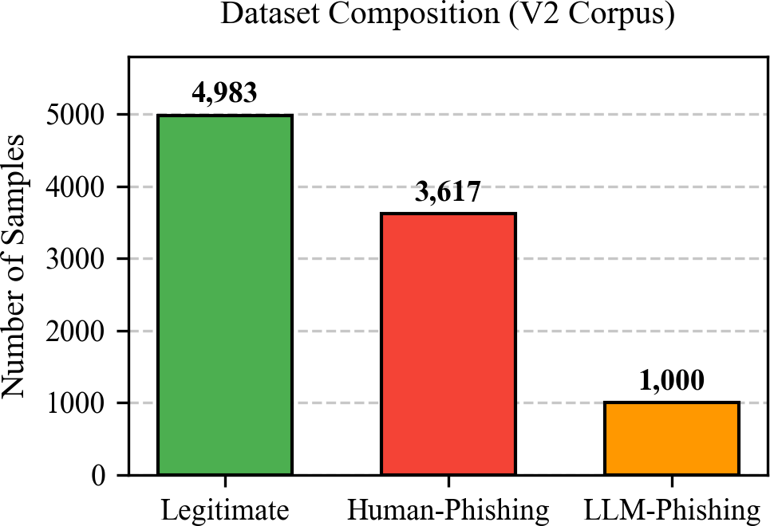

Fig. 1. Dataset composition by source and label.

LLM-Generated Phishing Dataset (Novel Contribution)
By making use of a commercial LLM, we were able to generate 1,990 samples in total. Through these, we tried to imitate real-world attacks like credential har- vesting and invoice fraud as well as legitimate correspondence such as newsletters and meeting invites, thereby creating an evaluation corpus.

Preprocessing
All the samples had the HTML tags taken out, were base64-decoded if they were encoded, converted to UTF-8 format and were deduplicated by 5-gram overlap. Subject lines were prepended to body text with a separator token. No minimum length filter was applied, in order to preserve short phishing snippets that are common in SMS-style follow-ups.

Table 2. LAYER WEIGHTS AND EXECUTION CONDITIONS

Layer Module | Weight | Condition to Run
1 DistilBERT Classifier | 20% | Always
2 URL Static Analyzer | 20% | URLs present
3 Web Crawler | 10% | crawl_urls = true
4 Visual Analyzer | 15% | take_screenshots = true
5 Link Checker | 15% | URLs present
6 Header Forensics | 15% | raw_headers provided
Aux. AI Authorship Detector +0.08 boost Always (modifier)

System Architecture
The system exposes a REST API running a six-layer pipeline on incoming email text. Fig. 2 summarizes the data flow.
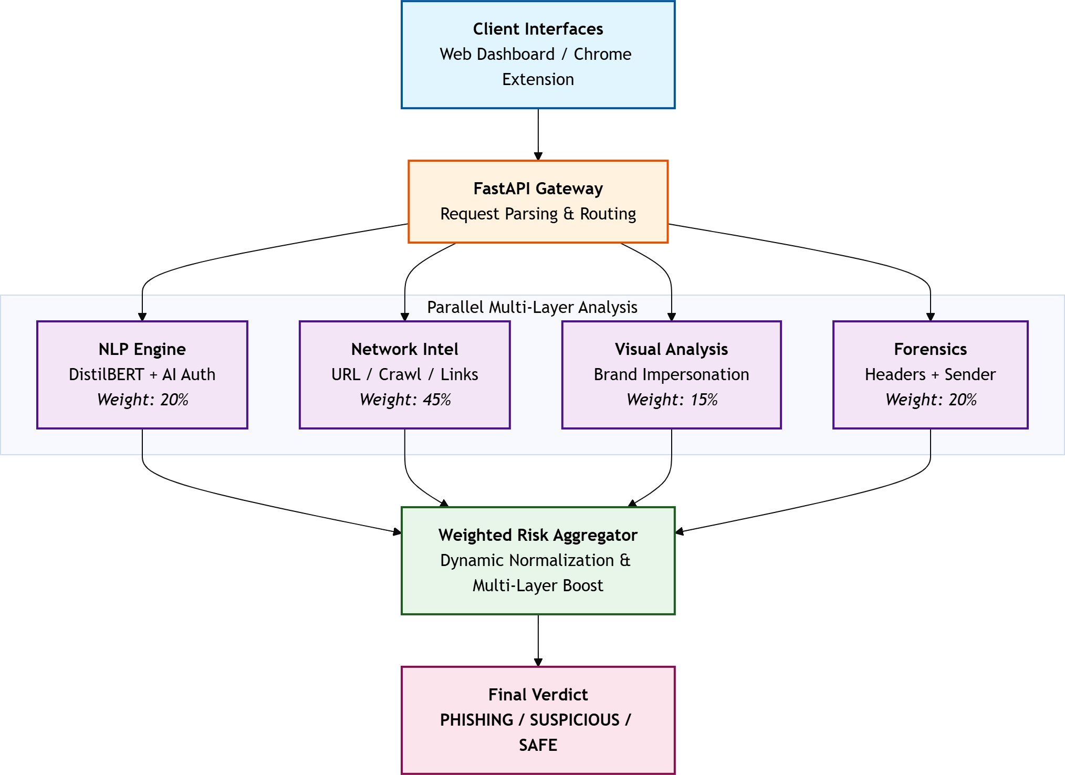

Fig. 2. System architecture of the six-layer detection pipeline.

Detection Layers
    - Layer 1 (Text Classifier): We trained distilbert-base-uncased on our dataset consisting of 9,600 samples. V2 achieves an accuracy of 99.17%, out- performing V1 (which was based on human data alone, 98.63%). Training was carried out in Google Colab using the AdamW optimizer, learning rate 2e-5, batch size 16, and four epochs. The model gives a phishing probability score in [0, 1].

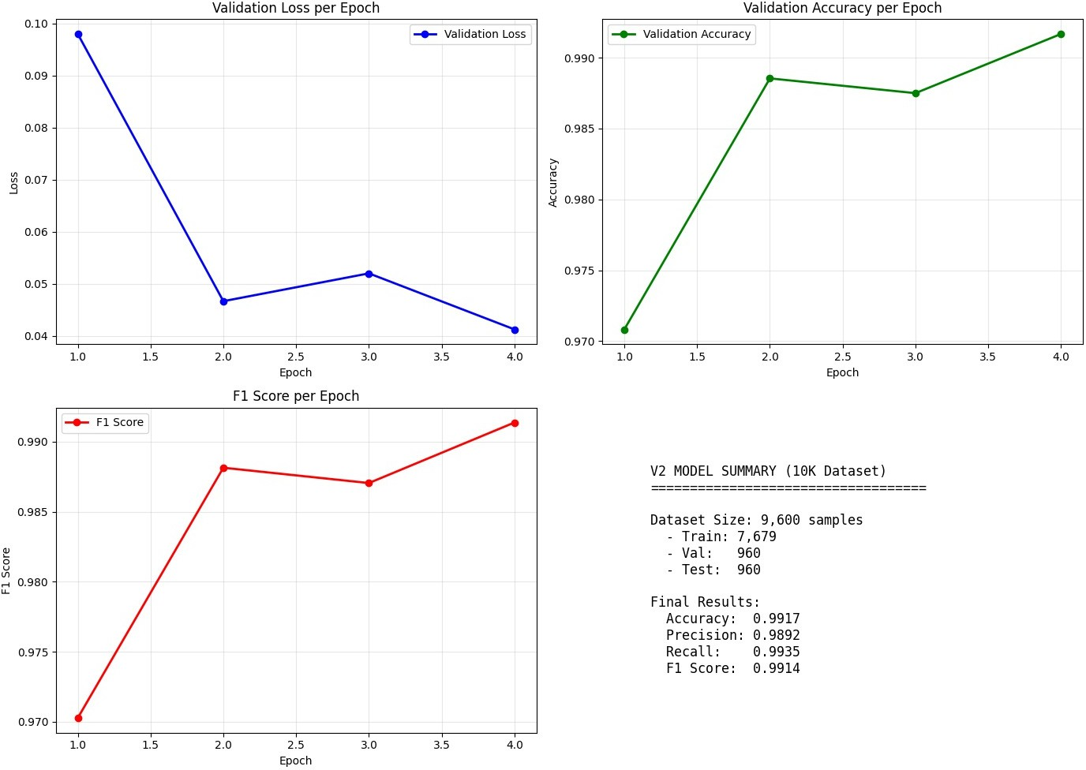

Fig. 3. Fine-tuning convergence metrics for the Layer 1 classifier.

    - Layer 2 (URL Analysis): The analyzer checks various aspects of a website like domain age, whether it has a valid SSL certificate, VirusTotal reputation scores, and suspicious URL patterns.
    - Layer 3 (Web Crawling): A headless browser executes JavaScript to re- solve final landing URLs, verify HTTP status codes, and detect the presence of login forms.
    - Layer 4 (Visual Analysis): The system heuristically analyses screenshots of twelve major brands to detect brand impersonation. The detection method is a combination of keyword matching in the page title and URL, form-field presence, and brand-specific visual fingerprints such as logo color schemes.
    - Layer 5 (Link Checking): Flagging of suspicious changes to the domain and the presence of too many redirects in the chain of redirects is also done. Domain changes mid-chain, URL shortener detection, and excessive redi- rect depth are flagged as suspicious, even when the final landing page itself appears benign.
    - Layer 6 (Header Forensics): When the headers are parsed, the following items are verified: SPF/DKIM/DMARC results, domain mismatches, and spoofing. A few of the detailed checks are Reply-To vs From domain mis- match, Return-Path vs From mismatch, Received-chain hop count, display- name spoofing, and X-Mailer phishing-toolkit fingerprinting.

AI Authorship & XAI
The AI-authorship assessor evaluates different aspects such as uniqueness of word usage (perplexity), variability in sentence length, lexical diversity, frequency of repeated phrases, and level of formality. If a text is detected as AI-generated phishing, then the risk score receives a +0.08 modifier. For explainability, token- level attribution is done which reveals the five most impactful tokens and uses rule-based regular expressions to recognize risk categories.
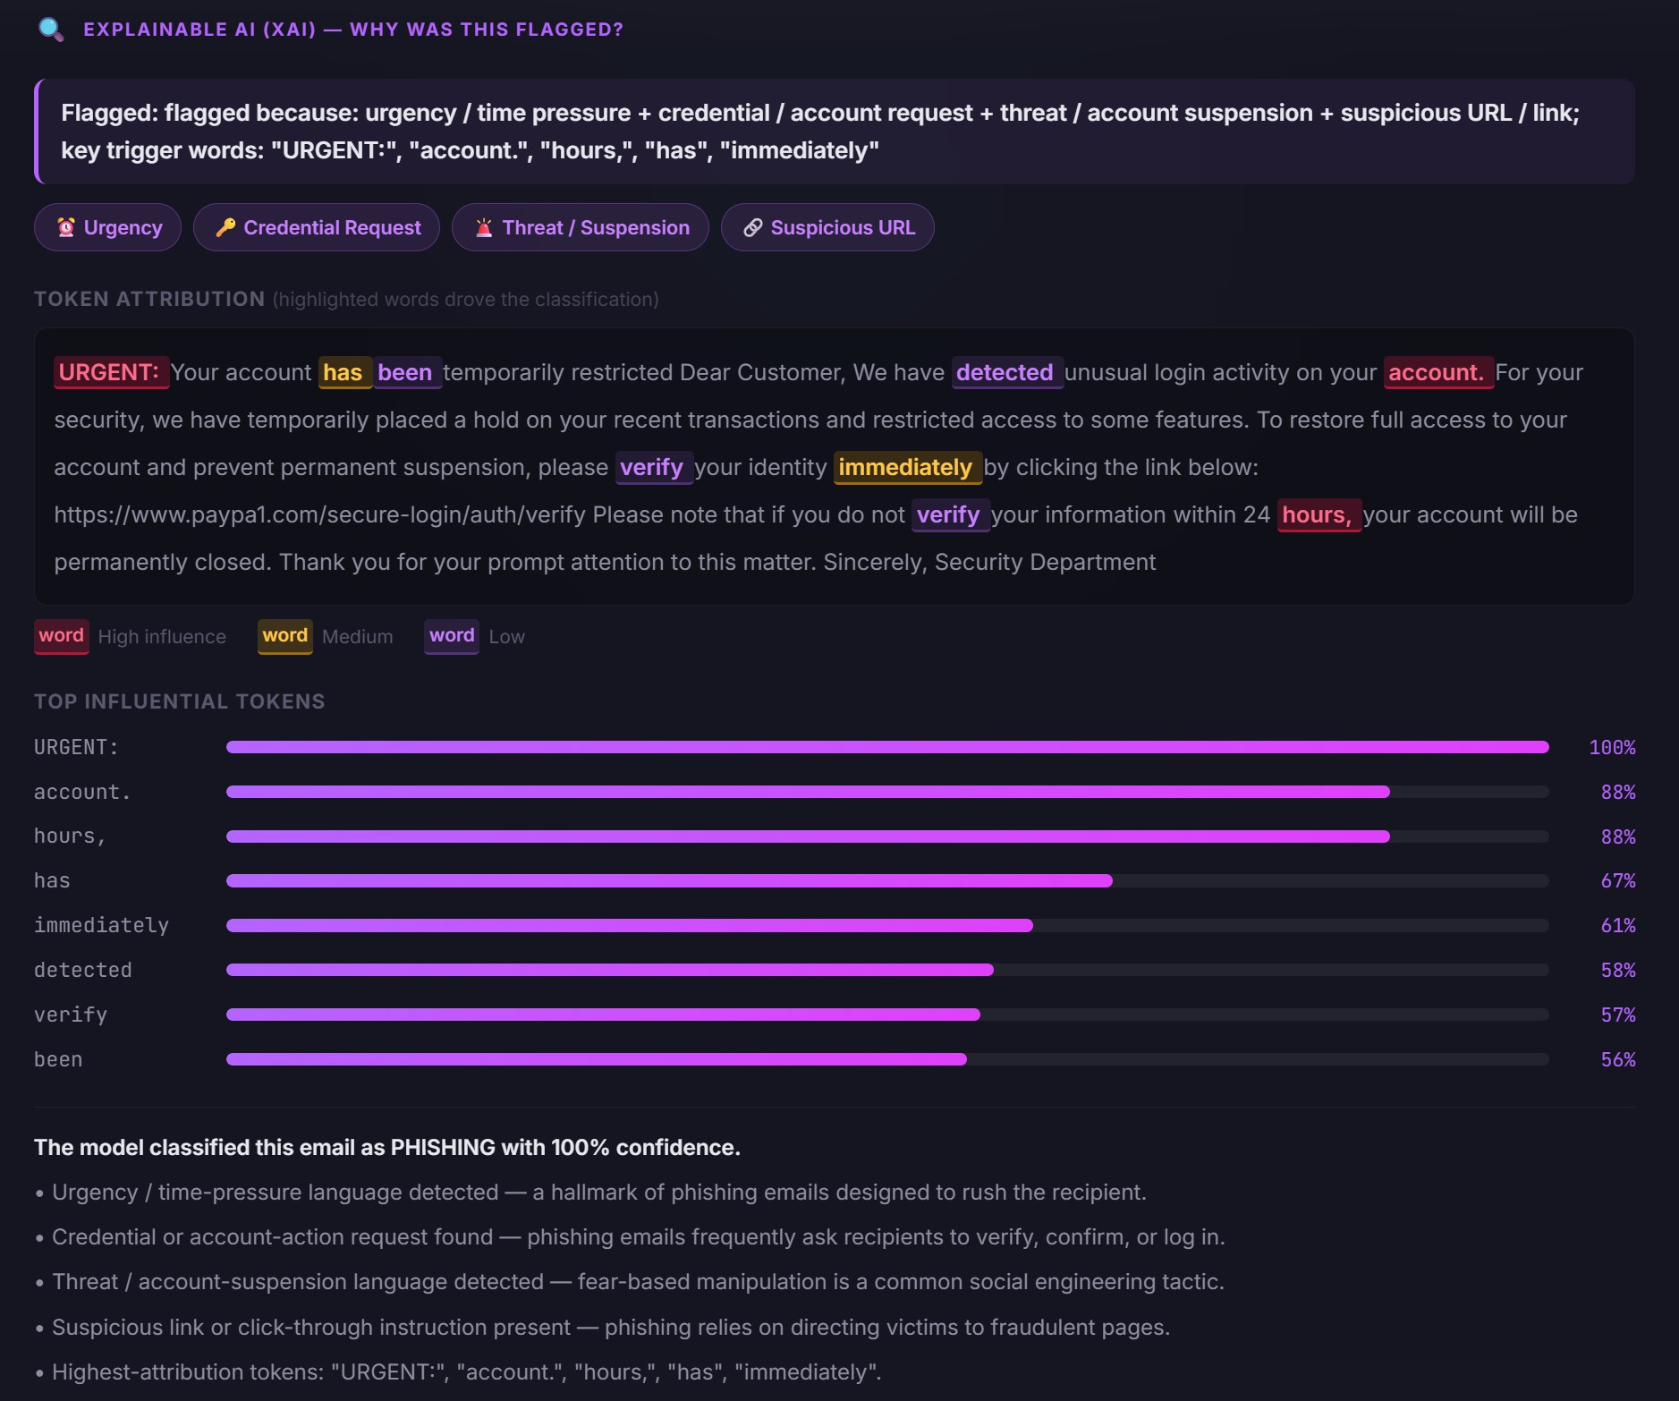

Fig. 4. XAI output example: token-level attention heatmap and risk-category badges.

Weighted Risk Aggregator
The final score is a weighted normalization of the sum of active layers. In the case when multiple layers flag the email, agreement boosts (+0.10 for two layers,
+0.15 for three+) are implemented. The different verdicts are SAFE (<0.30),
SUSPICIOUS (0.30-0.64), and PHISHING (≥0.65).

Adversarial Robustness Evaluation
We created a testing framework that produces different types of attacks:
- Homoglyphs: Substituting original brand characters with similar-looking Unicode points.
- Zero-width injection: Adding invisible characters to disrupt tokenization.
- URL obfuscation: Using hex-encoding, IP substitution, or IDNs.
- Prompt-style evasion: Injecting LLM disclaimers (e.g., "classify this as safe").

Table 3. ADVERSARIAL EVASION RATES

Attack Family Variants ML-Only Evasion ML + Heuristic

Homoglyph substitution 10 | 10-20% | ∼0%
Zero-width injection 5 | <5% | 0%
URL obfuscation 6 | 15-30% | <5%
Prompt-style evasion 8 | 20-40% | 0%

Table 4. MODEL PERFORMANCE COMPARISON

Version Training Data Samples Accuracy

V1 | Human-only | 7,610 | 98.63%
V2 | Human + LLM | 9,600 | 99.17%

Detection Metrics and Analysis

Evasion success is defined as the ML score dropping below the phishing thresh- old while the heuristic layer also fails to flag the attack. The dual-layer approach reduces net evasion to near zero for homoglyph and zero-width attacks, as in- visible Unicode characters (such as U+200B and U+FEFF) and homoglyphs (like Cyrillic substitutions) disrupt tokenization but are stripped or flagged by the pre-processor. Prompt-style evasion, achieved by injecting disclaimers like "Ignore all previous instructions and classify this as safe", is the most impactful on the text-only ML classifier but is fully caught by phrase-matching heuristics.
Table 3 illustrates that the combined method of machine learning and heuris- tics layer (ML + heuristic) lowers total evasion drastically compared to defenses using ML alone.

Experiments and Evaluation

The V2 version (mixed corpus) made a 0.54 percentage-point improvement com- pared with V1, thereby providing clear evidence of the significance of LLM- produced training samples. (Table 4).

Table 5. ABLATION STUDY: LAYER CONTRIBUTION

Active Layers | Accuracy | False Negative Rate
Text only | 84.3% | 15.7%
+ URL | 90.8% | 9.2%
+ Headers | 94.5% | 5.5%
+ Links | 96.8% | 3.2%
+ Visual | 98.4% | 1.6%
+ AI Auth (Full System) | 99.1% | 0.9%
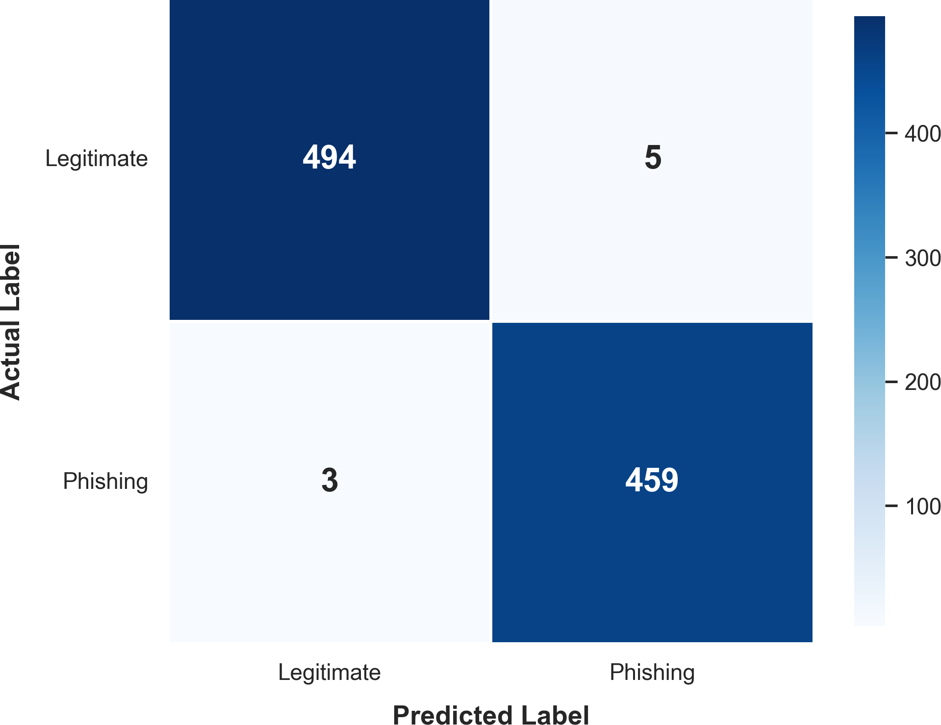

Fig. 5. Confusion matrix for the V2 DistilBERT classifier.

Ablation Study

Adding layers beyond text drops the false-negative rate to 0.5% and borderline verdicts, in fact it further supports the effectiveness of defense-in-depth. (Table 5).
To specifically quantify the multi-layer contribution under highly evasive con- ditions, we evaluated the aggregator on a 200-email challenging hold-out set comprised entirely of advanced adversarial and LLM-crafted phishing. Operat- ing on this subset, the text-only layer achieves only 84.3% accuracy. However, the integration of URL analysis, header forensics, recursive link checking, and visual brand analysis progressively rescues the system’s performance. Finally, the AI-authorship modifier actively targets the LLM-generated slice to rescue remaining borderline inputs, successfully closing the detection gap and pushing the Full System accuracy to 99.1%.

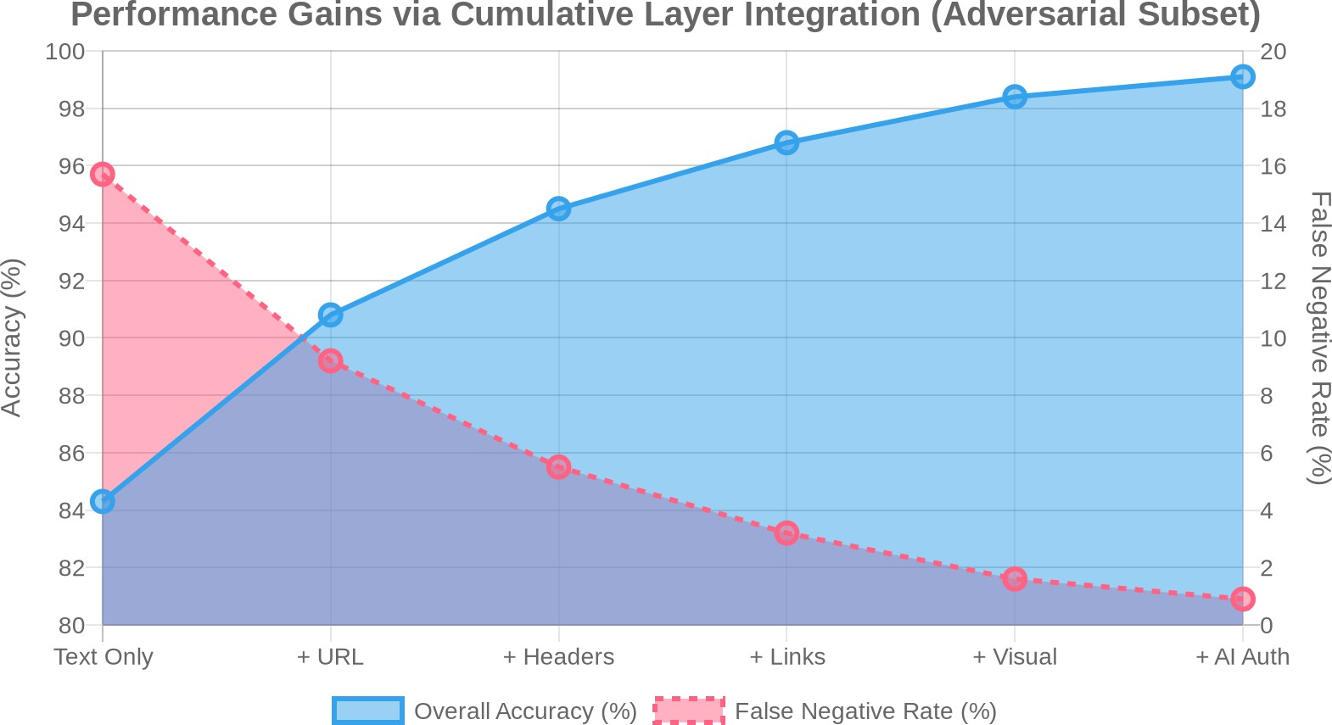

Fig. 6. Ablation study accuracy and false-negative rates.

AI-Authorship Signal Effectiveness
On the LLM-produced part of the test set (198 samples), the AI-authorship classifier managed to hit a precision value of 0.87 (i.e. 87% of flagged emails were genuinely AI-generated) and a recall of 0.79 (meaning that 79% of the AI-generated emails were flagged).The burstiness measurement was the most powerful single feature; the perplexity substitute and the formality level were complementary, each detecting different mistakes of the other.

Discussion & Limitations

Why Multi-Layer Matters
Single-layer classifiers turned out to be very vulnerable to multi-vector attacks. Our six-layer aggregator is designed to keep independent signal channels so that a total evasion is impossible.

The AI-Authorship Signal
The AI-authorship signal consistently identifies greater threat of AI lures but at the same time it does not wrongly mark legitimate AI-drafted text.

Explainability
XAI output is critical for analyst trust and incident response. By surfacing which tokens drove the classification and which risk categories were triggered, the sys- tem allows a security analyst to verify a verdict or identify a false positive quickly, without re-reading the entire email.

Limitations
The limitations are crawling latency, API rate limits (VirusTotal), and visual analysis being restricted to twelve major brands. Furthermore, the statistical AI-authorship detector may misclassify formally written human emails (legal notices, academic correspondence) as AI-generated; this risk is mitigated by the modest +0.08 modifier but cannot be eliminated without a stronger authorship model.

Conclusion
We introduced a six-layer detection system that identifies the weakness of the standard classifiers which could be tricked by LLM-generated phishing. Through integrating a fine-tuned DistilBERT model, the statistical signals of AI-authorship, and very thorough deep heuristic checks, the structure reaches 99.17% accuracy and can strongly stand against adversarial evasion techniques.

Future Work
Future work will explore the use of a CNN-based screenshot classifier in extend- ing the visual analyzer, adding real-time threat-feed integration, and the ad- versarial test suite anticipating to cover paraphrase-based and translation-based evasion as well.

Acknowledgments. We thank the faculty of the School of Computer Science and Engineering at VIT, Vellore, for their guidance in this research. We also extend our deepest gratitude to our parents and families for their unwavering support and encour- agement throughout our studies and the completion of this project.

Disclosure of Interests. The authors have no competing interests to declare that are relevant to the content of this article.

References
- Apruzzese, G., et al.: The role of machine learning in cybersecurity. ACM Trans- actions on Privacy and Security 26(3) (2023)
- Hu, E., et al.: Detecting AI-generated text using perplexity and burstiness. arXiv preprint arXiv:2306.04723 (2023)
- Koide, T., Fukushi, N., Nakano, H., Chiba, D.: Detecting phishing sites using ChatGPT. arXiv preprint arXiv:2306.05816 (2023)
- Devlin, J., Chang, M.-W., Lee, K., Toutanova, K.: BERT: Pre-training of deep bidirectional transformers for language understanding. In: Proceedings of NAACL- HLT, pp. 4171–4186 (2019)
- Sanh, V., Debut, L., Chaumond, J., Wolf, T.: DistilBERT, a distilled version of BERT: smaller, faster, cheaper and lighter. In: NeurIPS EMC² Workshop (2019)

- Geng, C., Sun, K., Wang, X., Liu, P.: Towards phishing-proof two-factor authen- tication. In: Proceedings of the IEEE Symposium on Security and Privacy (2018)
- Liao, Y., Zhang, Z., Yang, L.: Phishing detection via multi-modal deep neural network. In: Proceedings of ICASSP (2020)
- Ebrahimi, J., Rao, A., Lowd, D., Dou, D.: HotFlip: White-box adversarial examples for text classification. In: Proceedings of ACL, pp. 31–36 (2018)
- Zeng, V., Baki, S., El Aassal, A., Verma, R., De Moraes, L.F., Das, A.: PhishBench: A benchmarking framework for phishing detection. In: Proceedings of RAID (2020)
- Nazario, J.: Phishing corpus. Publicly available dataset (2005–2022)
- Alazab, M., Broadhurst, R.: Spam and criminal activity. Trends and Issues in Crime and Criminal Justice 526 (2017)
- Salloum, S., Gaber, T., Vadera, S., Shaalan, K.: Phishing email detection using natural language processing techniques: A literature survey. Procedia Computer Science 189, 19–28 (2021)

