TASK 3 – POWER BI DASHBOARD REPORT
Madhav Ecommerce Sales Dashboard

1. Project Overview
Objective
The objective of this project is to develop an interactive Business Intelligence dashboard using Microsoft Power BI to analyze ecommerce sales performance. The dashboard provides meaningful insights into sales, profit, customer behavior, payment methods, and product performance to support business decision-making.

2. Business Problem
Businesses generate large amounts of sales data every day. Without proper visualization and analysis, it becomes difficult to identify profitable products, customer purchasing patterns, high-performing states, and business trends.
This dashboard helps decision-makers monitor key performance indicators (KPIs), compare performance across different categories, and identify opportunities to improve sales and profitability.

3. Dataset Description
The project uses two datasets:
Orders.csv
Contains customer order information including:
- Order ID
- Order Date
- State
- Customer Name
Details.csv
Contains transaction details including:
- Category
- Sub-Category
- Quantity
- Amount
- Profit
- Payment Mode

4. Data Preparation (Power Query)
The dataset was cleaned and transformed using Power Query.
Data Cleaning Steps
- Imported Orders.csv and Details.csv
- Checked for missing values
- Removed duplicate records
- Verified data types
- Renamed columns where necessary
- Loaded cleaned data into Power BI

5. Data Modeling
A relationship was created between the Orders and Details tables to enable efficient analysis across both datasets.
The data model supports filtering, aggregation, and interactive reporting.
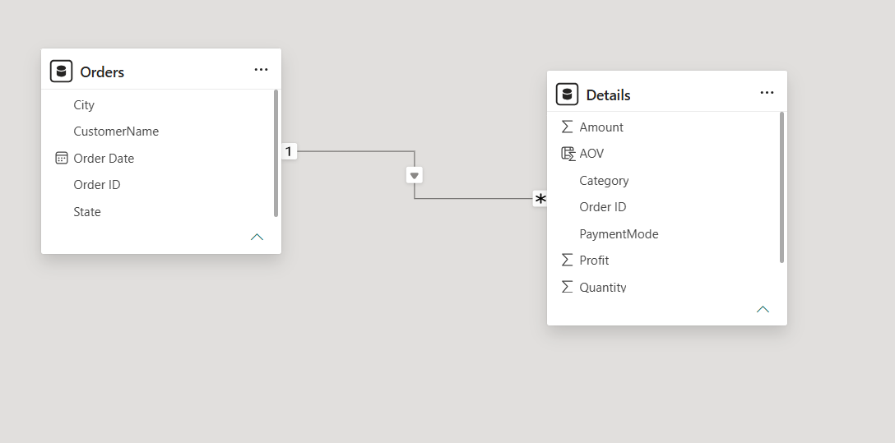
6. DAX Measures
Several DAX measures were used to calculate important KPIs.
Examples include:
- Total Sales
- Total Profit
- Total Quantity
- Average Order Value (AOV)
These measures provide accurate calculations that automatically respond to slicers and filters.

7. Dashboard Features
The dashboard includes:
KPI Cards
- Total Sales
- Total Profit
- Total Quantity
- Average Order Value
Visualizations
- Sales by State
- Quantity by Category
- Profit by Month
- Sales by Customer
- Quantity by Payment Mode
- Profit by Sub-Category
Interactive Filters
- Quarter Filter
- State Filter

8. Key Business Insights
The dashboard provides the following insights:
- Maharashtra generated the highest sales.
- Clothing contributed the largest share of product quantity sold.
- Cash on Delivery (COD) was the most preferred payment method.
- Printers generated the highest profit among all sub-categories.
- Monthly profit remained consistently high during the selected quarter.
- Customer-wise analysis helps identify high-value customers.
- Interactive slicers allow users to analyze different states and quarters dynamically.

9. Tools & Technologies Used
- Microsoft Power BI
- Power Query
- DAX (Data Analysis Expressions)
- Data Modeling
- Interactive Dashboard Design

10. Dashboard Preview
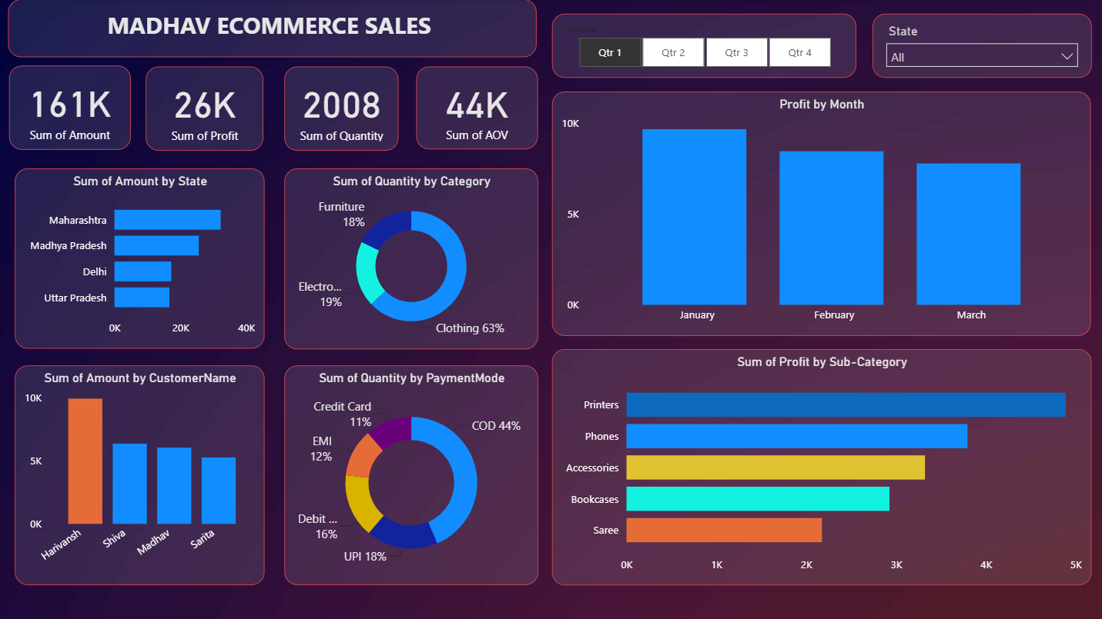

11. Learning Outcomes
Through this project, I gained practical experience in:
- Data Cleaning using Power Query
- Data Modeling
- Creating Relationships
- Writing DAX Measures
- Building Interactive Dashboards
- KPI Development
- Business Intelligence Reporting
- Data Visualization
- Business Insight Generation

12. Conclusion
This project demonstrates how Microsoft Power BI can transform raw ecommerce sales data into meaningful business insights. The interactive dashboard enables users to monitor KPIs, analyze customer behavior, compare sales performance, and make informed business decisions through dynamic visualizations and filters.

