Telecom Customer Churn Analysis & Prediction
Project Report | Ramkumar Sharma | Data Analyst Portfolio Project
Tools: SQL Server, Python (Pandas, scikit-learn, Matplotlib, Seaborn), Random Forest, Power BI, Excel

1. Executive Summary
Customer churn is one of the costliest problems a telecom company faces. Winning a new subscriber takes far more effort and money than keeping an existing one, so knowing who leaves, why they leave, and who is likely to leave next can protect a meaningful share of revenue.
This project analyses a base of 6,418 customers to answer three questions: how large is the churn problem, what is driving it, and which newly joined customers are most at risk. Of the 6,418 customers, 4,275 stayed, 1,732 churned and 411 are new joiners. Churn stands at 27.0% across the full base (28.8% when measured only on the 6,007 customers whose outcome is known), and churned customers account for about 17.5% of total revenue (3.41 million of 19.47 million in the dataset).
Three findings stand out:
- Contract type is the strongest warning sign. Month-to-month customers churn at 46.5%, against 11.0% on one-year and 2.7% on two-year contracts.
- Customers mostly leave for competitors, not over price. Competitor-related reasons explain 761 of the 1,732 exits (44%), while price explains 196 (11%).
- Service experience is the second big driver. Attitude of support staff or the provider accounts for 301 exits, and general dissatisfaction for another 300.
A Random Forest model trained on historical customers reached 84% accuracy on unseen data and was then used to score the 411 new joiners. A three-page Power BI dashboard brings the descriptive analysis, churn reasons and predicted churners together for business users.
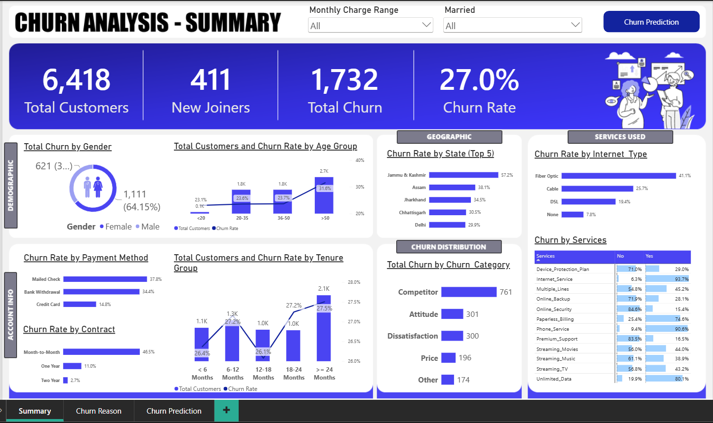
Figure 1: Power BI Summary page showing headline KPIs and churn breakdowns

2. Objectives
- Measure overall churn and understand how it varies by demographics, geography, account type and services used.
- Identify the reasons customers give for leaving and group them into actionable categories.
- Build a machine learning model that predicts churn from customer attributes.
- Apply the model to newly joined customers to produce a prioritised list of customers at risk.
- Present the results in a dashboard that a non-technical retention team could use directly.

3. Data Overview
The dataset holds one row per customer and 32 columns across four areas:
- Demographics: gender, age, marital status and state.
- Account details: tenure, contract type, value deal, payment method, paperless billing and number of referrals.
- Services: phone service, multiple lines, internet service and type, online security, online backup, device protection, premium support, streaming TV, movies and music, and unlimited data.
- Financials and outcome: monthly charge, total charges, refunds, extra data charges, long distance charges, total revenue, customer status (Stayed, Churned or Joined), churn category and churn reason.
The data was split into two analysis views: vw_ChurnData with the 6,007 customers whose outcome is known (4,275 stayed, 1,732 churned), used for analysis and model training, and vw_JoinData with the 411 new joiners, used for prediction. Churn category and churn reason exist only for customers who left, so they were used for diagnosis and left out of model training to avoid leaking the answer into the model.
Some blank values are meaningful rather than missing. The 1,390 blanks in the internet-related service fields match customers with no internet service, and the 622 blanks in multiple lines match customers with no phone service. These were kept as their own category when the model was prepared.

4. Approach
Step 1: Data preparation. The data was organised into the two views described above and checked column by column for blanks and unusual values.
Step 2: Exploratory analysis. Churn was broken down by gender, age group, marital status, state, tenure group, contract, payment method, internet type and each add-on service to find where it concentrates.
Step 3: Churn reason analysis. The 20 individual churn reasons were reviewed alongside the five churn categories (Competitor, Attitude, Dissatisfaction, Price and Other) to separate controllable causes from uncontrollable ones.
Step 4: Predictive modelling. Categorical fields were label-encoded and the target was set to churned versus stayed. The data was split 80/20 into training and test sets, a Random Forest with 100 trees was trained, and it was evaluated on the 1,202 held-out customers.
Step 5: Scoring new customers. The trained model and its encoders were applied to the 411 new joiners, and customers predicted to churn were exported to a file for the dashboard.
Step 6: Dashboarding. A Power BI report with three pages (Summary, Churn Reason and Churn Prediction) was built, with filters for monthly charge range and marital status.
Note on rates. Segment churn rates in this report match the dashboard and are calculated on all 6,418 customers. New joiners cannot yet have churned, so excluding them raises the rates slightly (for example, overall churn becomes 28.8% and month-to-month churn 52.4%). The ranking of segments stays the same.

5. Key Findings

5.1 Who is churning
- Gender: Women make up 1,111 of the 1,732 churned customers (64.15%) and men 621. This mostly reflects the customer base, which is 63% female. Churn rates are close: 27.4% for women and 26.2% for men.
- Age: Customers over 50 churn the most at 31.6%, against about 23.6% for ages 20 to 35 and 23.7% for ages 36 to 50. The under-20 group is very small (117 customers).
- Tenure: Churn is flat across tenure groups, between 26.1% and 27.5%. Length of relationship alone does not protect a customer from leaving.
- Geography: The highest churn rates are in Jammu & Kashmir (57.2%, from a base of 320 customers), Assam (38.1%), Jharkhand (34.5%), Chhattisgarh (30.5%, a small base of 59) and Delhi (29.9%).

5.2 Account and billing factors
- Contract: Month-to-month contracts churn at 46.5%, versus 11.0% on one-year and 2.7% on two-year plans. This is the clearest lever in the data.
- Payment method: Mailed check (37.8%, but only 349 customers) and bank withdrawal (34.4%) show far higher churn than credit card (14.8%).
- Value deals: Churn rises steadily from Deal 1 (7.5%) to Deal 5 (53.8%), so the later deals do not appear to be building loyalty.
- Monthly charge: Churned customers pay about 18% more per month on average (73.10 versus 61.84), so those leaving include higher-spending accounts.

5.3 Services
- Internet type: Fiber optic customers churn at 41.1%, against 25.7% for cable, 19.4% for DSL and 7.8% for customers with no internet. The fastest connection type is losing the most customers, which points to a pricing, reliability or competitor issue worth investigating.
- Protective add-ons: Among internet customers, those without premium support churn at 42.2% against 15.4% for those with it. Online security shows the same pattern (42.4% without, 14.6% with). Customers who take these services churn at roughly a third of the rate, although the data cannot prove the services themselves cause that.

5.4 Why customers leave
Churn category | Customers | Share of churn
Competitor | 761 | 44%
Attitude | 301 | 17%
Dissatisfaction | 300 | 17%
Price | 196 | 11%
Other | 174 | 10%

The top individual reasons are that a competitor had better devices (289), a competitor made a better offer (274) and the attitude of the support person (208). Competitors also won customers with more data (106) and higher download speeds (92). Only 72 customers cited price directly, so blanket discounting would have addressed a small part of this churn.
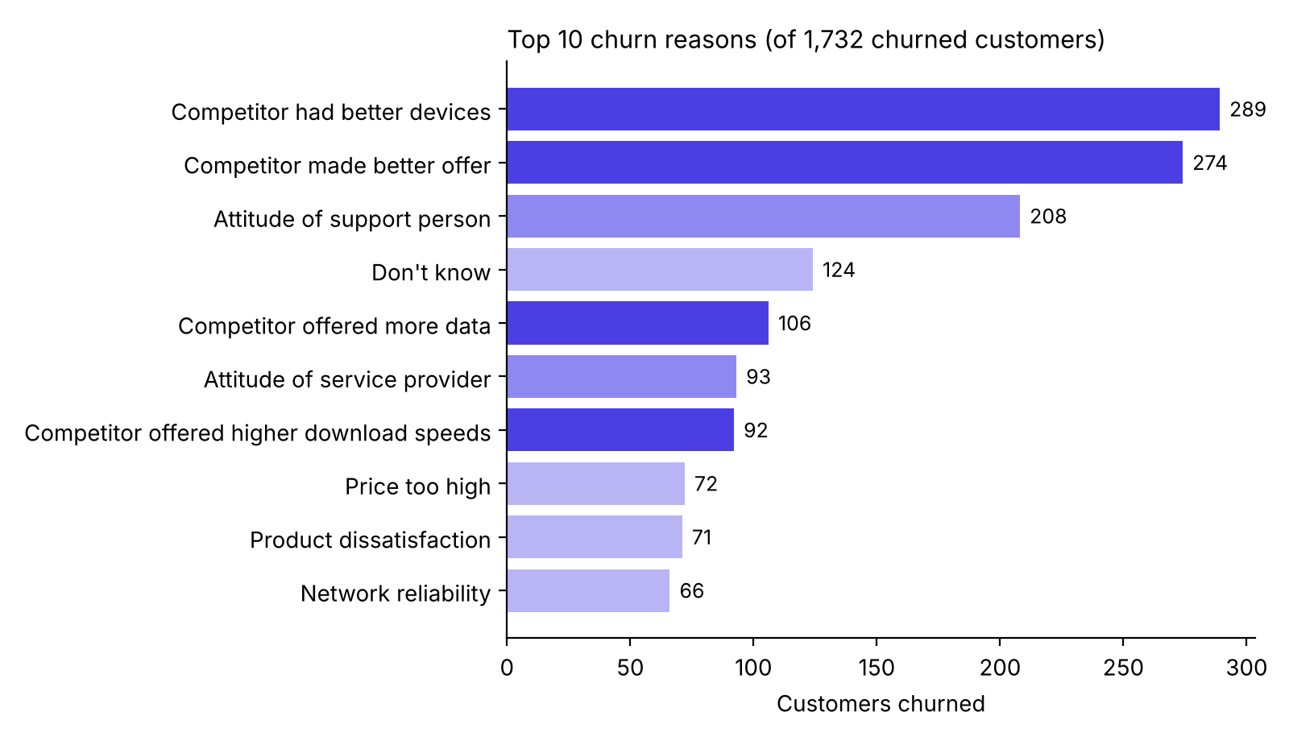
Figure 2: Top 10 churn reasons by number of churned customers

6. Predictive Model
A Random Forest classifier suits this problem because it handles a mix of categorical and numeric features, captures non-linear relationships and provides feature importance scores that help explain results to business stakeholders.
Metric | Churned class | Stayed class | Overall
Precision | 0.78 | 0.86 | -
Recall | 0.65 | 0.92 | -
F1-score | 0.71 | 0.89 | -
Accuracy | - | - | 0.84

On the 1,202 held-out customers, the model correctly identified 229 of the 355 customers who actually churned and wrongly flagged 64 loyal customers (783 true negatives, 64 false positives, 126 false negatives, 229 true positives).
In plain terms: when the model flags a customer as likely to churn it is right about 78% of the time, and it catches roughly two out of every three real churners. That is a solid baseline, and recall is the main area to improve.
The feature importance chart shows the model relies most on contract type, followed by total revenue, total charges, monthly charge, long distance charges and age. Note that total revenue and total charges build up over a customer's life and stop growing when someone leaves, so these features partly reflect that a customer has already left. This is worth testing in future iterations.
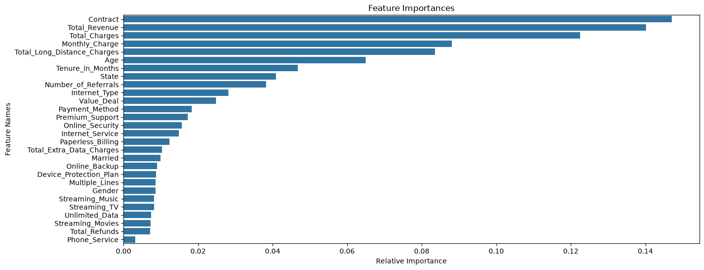
Figure 3: Random Forest feature importances

7. Predicted Churners Among New Joiners
The model flagged 378 of the 411 new joiners as likely to churn. The Churn Prediction page profiles this group:
- Gender: 246 women and 132 men.
- Contract: 355 on month-to-month, 17 on one-year and 6 on two-year plans.
- Payment method: 192 by credit card, 150 by bank withdrawal and 36 by mailed check.
- State: Uttar Pradesh (44), Maharashtra (40) and Tamil Nadu (37) have the most flagged customers.
- Age: 12 under 20, 112 aged 20 to 35, 128 aged 36 to 50 and 126 over 50.
- Value at risk: average monthly charge of about 42 and combined revenue to date of about 42.6 thousand.
The dashboard lists each flagged customer with monthly charge, total revenue, refunds and number of referrals, so a retention team can start with the highest-value accounts.
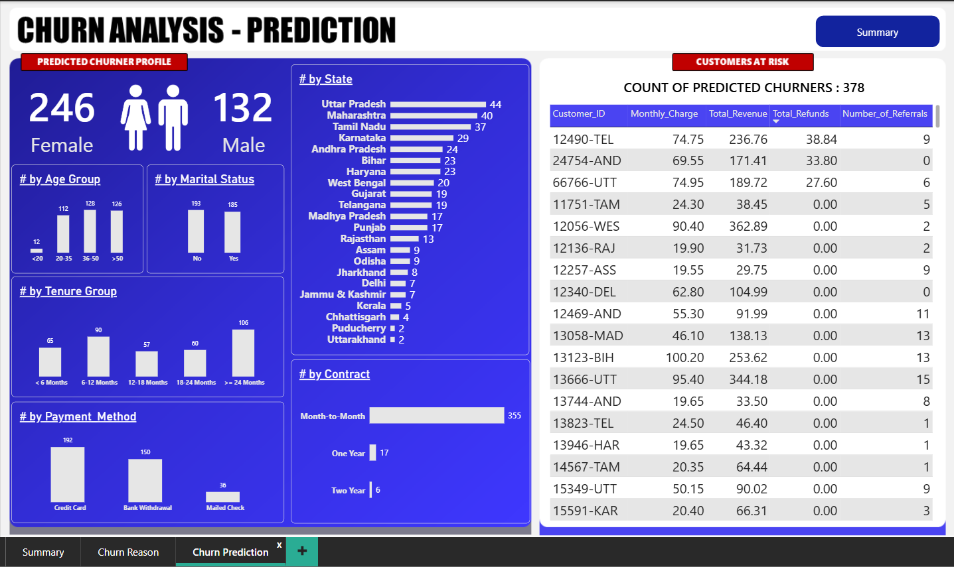
Figure 4: Power BI Churn Prediction page showing the profile of predicted churners
How to read this result. The 92% flag rate is far above the historical churn rate of 28.8%, so the output should be treated as a risk ranking, not a forecast that 92% of these customers will leave. Two things in the data explain much of the gap. First, the new joiners look different from the historical base: 89% are on month-to-month contracts (against 49% historically) and 39% are on Deal 5, the deal with the highest historical churn. Second, the joiners' total charges and total revenue are very low for their stated tenure (roughly one to two months of billing against a median tenure of 15 months), and low cumulative revenue is one of the patterns the model associates with churn. Validating the joiner data and reporting churn probabilities instead of a yes/no flag would make the list more reliable.

8. Business Recommendations
- Move customers off month-to-month plans. Offer incentives such as a device upgrade or loyalty discount for moving to a one-year contract. The gap between 46.5% and 11.0% churn is the largest opportunity in the data.
- Answer the competitor, not just the price. Competitors win on devices, offers, data allowances and speeds, so device upgrade programmes and competitive data bundles are likely to work better than blanket discounts.
- Invest in support quality. About one in six exits is linked to the attitude of support staff or the provider. Soft-skills training, call quality monitoring and faster issue resolution are low-cost fixes.
- Review the fiber optic experience. A 41.1% churn rate on this product warrants a look at pricing, reliability and installation experience.
- Bundle protective services. Offering premium support and online security free or discounted for the first few months could be tested, since customers who use them churn at about a third of the rate.
- Test card-based billing. Credit card customers churn least, so a pilot encouraging mailed check and bank withdrawal customers to switch to card billing is worth measuring.
- Run a proactive retention campaign. Use the predicted churner list to prioritise outreach to high-value new joiners early in their lifecycle.
- Investigate high-churn states. Jammu & Kashmir, Assam and Jharkhand deserve a targeted review of network coverage and local competitor activity.

9. Limitations and Next Steps
- Recall can be improved. The model misses about one in three real churners. Next steps include hyperparameter tuning, class weights or SMOTE for the class imbalance, and comparison with Logistic Regression, XGBoost and Gradient Boosting.
- Probabilities and thresholds. Reporting predicted churn probabilities with a tunable threshold would give retention teams a ranked priority list instead of a hard yes or no.
- Data quality. The raw data contains 107 records with negative monthly charges (74 stayed, 27 churned, 6 joined), and the joiner records show total charges that do not reconcile with tenure. Both should be validated with the data owner before the model is used in production.
- Feature design. Cumulative features such as total revenue and total charges partly encode whether a customer has already left. Testing the model without them, or using rate-based features, would give a cleaner picture.
- Validation. Cross-validation and a time-based split would give a more reliable estimate of real-world performance than a single 80/20 split.
- Deployment. The trained model could be wrapped in a simple app so new customers are scored automatically each month.

10. Conclusion
This project shows how a telecom business can move from asking who left to asking who is about to leave and what to do about it. The analysis points to contract structure, competitor offers and service experience as the main drivers of churn, and the model and dashboard turn those insights into a working retention tool. Together they cover the full analytics workflow: data preparation, exploratory analysis, machine learning, visualisation and business recommendations.

