**Project: Emircorp.com**

**Requirement:** Upgrade website to Beautiful, Seamless, and Responsive Designs – Crafted to Capture Attention and Elevate Customer Online Experience.

**Home | Services | Industries | Careers | Contact Us**

**Services**

1. **Process Safety & Risk Solutions** [Reference <https://synergenog.com/> 🡪 SERVICES]

Process Safety Management( its sub categories)

Technical Risk ( its sub categories)

Loss Prevention ( its sub categories)

Operational Safety ( its sub categories)

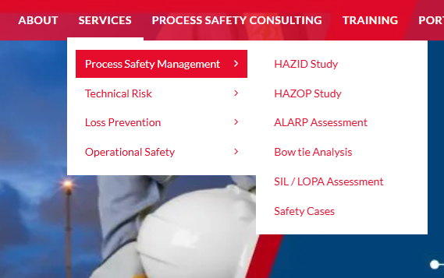

2. **Process Engineering**  <https://www.vistaprojects.com/consulting/process-engineering/>

3. **Mechanical Engineering** <https://www.vistaprojects.com/consulting/mechanical-engineering/>

4.  **Civil Engineering** [**https://www.vistaprojects.com/consulting/civil-engineering/**](https://www.vistaprojects.com/consulting/civil-engineering/)

5. **Piping** <https://www.vistaprojects.com/engineering/piping-engineering-services/>

6. **Electrical Engineering** <https://www.vistaprojects.com/consulting/electrical-engineering/>

7. **Instrumentation Engineering** <https://www.vistaprojects.com/engineering/instrumentation-controls-engineering-services/>

8. **Telecommunication Engineering** [Reference <https://www.hitachienergy.com/in/en/products-and-solutions/communication-networks/communications-networks-for-oil---gas>

9. **Pipeline Design & Engineering** [Reference <https://ausenco.com/services/consulting-services/pipeline-systems/gas-pipelines/>

10. **Structural Engineering**

[**https://www.vistaprojects.com/consulting/structural-engineering/**](https://www.vistaprojects.com/consulting/structural-engineering/)

**11. Drafting Engineering**

[**https://www.vistaprojects.com/engineering/drafting-design/**](https://www.vistaprojects.com/engineering/drafting-design/)

**12. Multi-discipline Engineering**

[**https://www.vistaprojects.com/engineering/multi-discipline-engineering/**](https://www.vistaprojects.com/engineering/multi-discipline-engineering/)

**13. audits and assessments : emircorp.pdf**

**Note : Engineering man power ,AI, aviation, not required**