Linux L1 Monitoring Workflow

Workflow Diagram
The diagram below illustrates the overall workflow, including Python script logic and Ansible playbook execution:
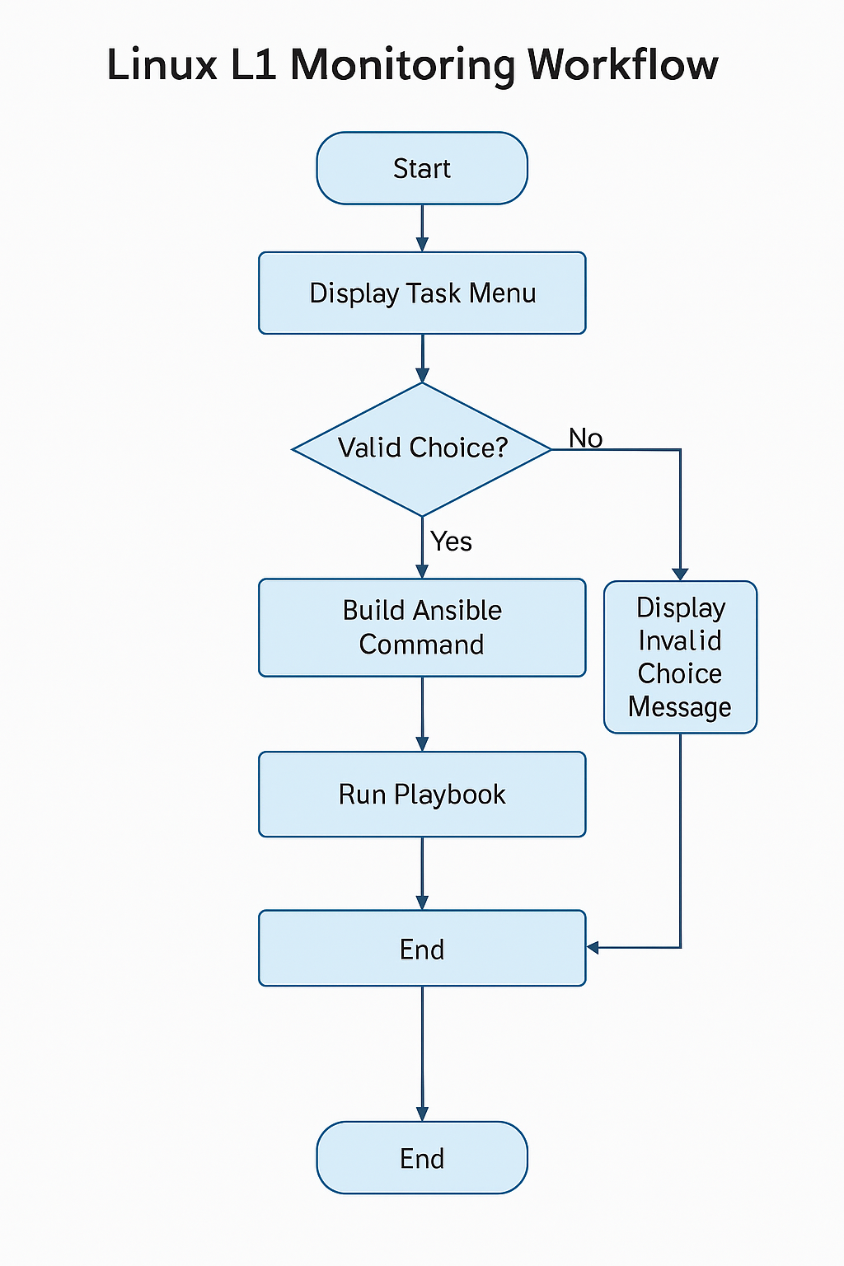

Process Explanation
This workflow automates Linux L1 monitoring tasks using a Python script and Ansible playbooks. The process begins with a menu-driven Python script that prompts the user to select a task (Disk, CPU, Memory, Connectivity, or Qualys Restart). Based on user input, the script dynamically constructs an Ansible command, optionally including parameters like server name or mount point. The command is executed using subprocess.run(), and error handling ensures failures are reported. This approach reduces manual effort, ensures consistency, and improves operational efficiency.
Folder Structure
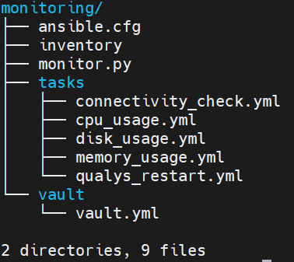

Python Script Workflow
Key steps in the Python script:
1. Display menu with available tasks.
2. Prompt user for choice and validate input.
3. Collect additional inputs (server name, mount point if applicable).
4. Build Ansible command dynamically based on user input.
5. Execute playbook using subprocess.run().
6. Handle errors and display appropriate messages.
7. Exit or prompt for invalid choice.

Ansible Playbooks
Below are the playbooks used in this workflow:
- connectivity_check.yml
- cpu_usage.yml
- disk_usage.yml
- memory_usage.yml
- qualys_restart.yml

Playbook Purposes
Below are the purposes of each playbook included in this workflow:
- Disk Usage Monitoring: Checks disk usage for specified mount points and alerts if usage exceeds a defined threshold.
- CPU Usage Monitoring: Monitors CPU utilization and retrieves top processes when usage exceeds a defined threshold.
- Memory Usage Monitoring: Calculates memory usage and alerts if usage exceeds a defined threshold.
- Linux Connectivity Check: Verifies connectivity to Linux servers, checks SSH port availability, and gathers system information.
- Qualys Service Restart: Restarts the Qualys Cloud Agent service and confirms its process is running.

Script Description
The script automates Level-1 health checks for Linux servers using Ansible playbooks. It provides a menu-driven interface to perform tasks such as Disk Check, CPU Check, Memory Check, Connectivity Check, and Qualys Restart.
"""
Linux L1 Monitoring Script and integrated Ansible playbook
==========================================================
Author: Ramkumar V
Email: ramkumar.a.v@capgemini.com
Version: 1.0.0
Date: 2025-11-23
Description:
Lightweight Level-1 health checks for Linux servers:
- Disk space usage
- CPU usage
- Memory utilization
- Top processes by CPU
- Linux connectivity
- Qualys service restart
Output: human-readable text to stdout.
"""
__author__ = "Ramkumar V"
__version__ = "1.0.0"
import subprocess
# List of playbooks
playbooks = [
"Disk Check",
"CPU Check",
"Memory Check",
"Linux Connectivity Check",
"Restart Qualys"
]
# Show menu
print("
" + "#" * 90)
print("#" + " " * 30 + "Linux L1 Monitoring" + " " * 39 + "#")
print("#" * 90 + "
")
print("Please select the task you want to run:
")
for i, pb in enumerate(playbooks, start=1):
print(f"{i}. {pb}")
print("
" + "*" * 90 + "
")
choice = input("Enter your choice (number): ").strip()
vault_file = "/home/rvi2815-2/monitoring/vault/vault.yml"
# Validate choice
if choice == "1":
extra_vars = ""
server_name = input("Enter the server name or IP [Press Enter to use default inventory]: ").strip()
mount_point = input("Enter the mount point (e.g., /var) [Press Enter for all mount points]: ").strip()
extra_vars = f"--extra-vars mount_point={mount_point}"
cmd = ["ansible-playbook", "/home/rvi2815-2/monitoring/tasks/disk_usage.yml"]
if server_name:
cmd.extend(["-i", f"{server_name},"])
if extra_vars:
cmd.extend(extra_vars.split())
print(f"
Running: {' '.join(cmd)}
")
try:
subprocess.run(cmd, check=True)
except subprocess.CalledProcessError as e:
print(f"Error running playbook: {e}")
elif choice == "2":
server_name = input("Enter the server name or IP [Press Enter to use default inventory]: ").strip()
cmd = ["ansible-playbook", "/home/rvi2815-2/monitoring/tasks/cpu_usage.yml"]
if server_name:
cmd.extend(["-i", f"{server_name},"])
print(f"
Running: {' '.join(cmd)}
")
try:
subprocess.run(cmd, check=True)
except subprocess.CalledProcessError as e:
print(f"Error running playbook: {e}")
elif choice == "3":
server_name = input("Enter the server name or IP [Press Enter to use default inventory]: ").strip()
cmd = ["ansible-playbook", "/home/rvi2815-2/monitoring/tasks/memory_usage.yml"]
if server_name:
cmd.extend(["-i", f"{server_name},"])
print(f"
Running: {' '.join(cmd)}
")
try:
subprocess.run(cmd, check=True)
except subprocess.CalledProcessError as e:
print(f"Error running playbook: {e}")
elif choice == "4":
server_name = input("Enter the server name or IP [Press Enter to use default inventory]: ").strip()
cmd = ["ansible-playbook", "/home/rvi2815-2/monitoring/tasks/connectivity_check.yml"]
if server_name:
cmd.extend(["-i", f"{server_name},"])
print(f"
Running: {' '.join(cmd)}
")
try:
subprocess.run(cmd, check=True)
except subprocess.CalledProcessError as e:
print(f"Error running playbook: {e}")
elif choice == "5":
server_name = input("Enter the server name or IP [Press Enter to use default inventory]: ").strip()
cmd = ["ansible-playbook", "/home/rvi2815-2/monitoring/tasks/qualys_restart.yml"]
if server_name:
cmd.extend(["-i", f"{server_name},"])
print(f"
Running: {' '.join(cmd)}
")
try:
subprocess.run(cmd, check=True)
except subprocess.CalledProcessError as e:
print(f"Error running playbook: {e}")
else:
print("Invalid choice!")

Ansible Playbook for Disk Usage Monitoring
The following Ansible playbook monitors disk usage for a specified mount point and alerts if usage exceeds a defined threshold:
---
- name: Monitor Mount Point Disk Usage
hosts: all
become: yes
vars:
mount_point: "{{ mount_point }}" # Dynamically passed variable
usage_threshold: 80
tasks:
- name: Ensure the mount point exists
stat:
path: "{{ mount_point }}"
register: mount_status
- name: Check disk usage
shell: df -h "{{ mount_point }}" | awk 'NR==2 {print $5}' | sed 's/%//'
register: disk_usage
- name: Pull disk info
shell: hostname -f; date; df -h {{ mount_point }}
register: disk_info
when: disk_usage.stdout | int < usage_threshold
- name: Display disk usage
debug:
msg: "{{ disk_info.stdout_lines }}"
when: disk_usage.stdout | int < usage_threshold
- name: Alert if disk usage exceeds threshold
debug:
msg: "Warning! Disk usage at {{ mount_point }} is {{ disk_usage.stdout }}%, exceeding the threshold of {{ usage_threshold }}%"
when: disk_usage.stdout | int >= usage_threshold

Ansible Playbook for CPU Usage Monitoring
The following Ansible playbook monitors CPU usage and retrieves top processes when usage exceeds a defined threshold:
---
- name: Monitor CPU Usage and Top Processes
hosts: all
become: yes
vars:
cpu_threshold: 80
tasks:
- name: Get current CPU usage (user + system)
shell: top -bn1 | grep "Cpu(s)" | awk '{print $2 + $4}'
register: cpu_usage
- name: Show current CPU usage
debug:
msg: "Current CPU usage: {{ cpu_usage.stdout }}%"
- name: Get top 5 CPU-consuming processes if usage exceeds threshold
shell: ps -eo pid,comm,%cpu --sort=-%cpu | head -n 6 | awk '{printf "%-8s %-10s %-5s\n", $1, $2, $3}'
register: top_processes
when: cpu_usage.stdout | float > cpu_threshold
- name: Get Info
shell: ps -eo pid,comm,%cpu --sort=-%cpu | head -n 1 | awk '{printf "%-8s %-20s %-5s\n", $1, $2, $3}'; ps -eo pid,comm,%cpu --sort=-%cpu | head -n 2 | tail -n +2 | awk '{printf "%-8s %-20s %-5s\n", $1, $2, $3}'; ps -eo pid,comm,%cpu --sort=-%cpu | head -n 3 | tail -n +3 | awk '{printf "%-8s %-20s %-5s\n", $1, $2, $3}'; ps -eo pid,comm,%cpu --sort=-%cpu | head -n 4 | tail -n +4 | awk '{printf "%-8s %-20s %-5s\n", $1, $2, $3}'; ps -eo pid,comm,%cpu --sort=-%cpu | head -n 5 | tail -n +5 | awk '{printf "%-8s %-20s %-5s\n", $1, $2, $3}'; ps -eo pid,comm,%cpu --sort=-%cpu | head -n 6 | tail -n +6 | awk '{printf "%-8s %-20s %-5s\n", $1, $2, $3}';
register: cpu_info
when: cpu_usage.stdout | float < cpu_threshold
- name: Display top CPU-consuming processes
debug:
var: cpu_info.stdout_lines
when: cpu_usage.stdout | float < cpu_threshold
- name: Alert if CPU usage exceeds threshold
debug:
msg: "Warning! CPU usage is exceeding the threshold of {{ cpu_usage.stdout }}%"
when: cpu_usage.stdout | float >= cpu_threshold

Ansible Playbook for Memory Usage Monitoring
The following Ansible playbook monitors memory usage and alerts if usage exceeds a defined threshold:
---
- name: Display Memory Usage with Threshold
hosts: all
gather_facts: yes
vars:
mem_threshold: 80 # Set threshold percentage
tasks:
- name: Calculate Memory Stats
set_fact:
total_mem: "{{ ansible_memtotal_mb }}"
free_mem: "{{ ansible_memfree_mb }}"
used_mem: "{{ ansible_memtotal_mb - ansible_memfree_mb }}"
usage_percent: "{{ ((ansible_memtotal_mb - ansible_memfree_mb) / ansible_memtotal_mb * 100) | round(2) }}"
- name: Show current Memory usage
debug:
msg: "Current Memory usage: {{ usage_percent }}%"
- name: Pull memory info
shell: free -h
register: memory_info
when: usage_percent | float < mem_threshold
- name: Display Memory Usage
debug:
var: memory_info.stdout_lines
when: usage_percent | float < mem_threshold
- name: Check Memory Threshold
when: usage_percent | float >= mem_threshold
debug:
msg: "WARNING: Memory usage is {{ usage_percent }}%, exceeds {{ mem_threshold }}%!"

Ansible Playbook for Linux Connectivity Check
The following Ansible playbook checks Linux connectivity, verifies SSH port availability, and gathers system information:
---
- name: Check Linux Connectivity and Gather Info
hosts: all
gather_facts: no
ignore_unreachable: yes
tasks:
- name: Check Linux connectivity
ping:
register: ping_result
ignore_errors: yes
- name: Check if port 22 is open
wait_for:
port: 22
timeout: 5
register: ssh_port_check
ignore_errors: yes
when: ping_result is succeeded
- name: Get hostname
shell: hostname -f; date; uptime
register: connect_info
when: ping_result is succeeded and ssh_port_check is succeeded
ignore_errors: yes
- name: Display results
debug:
var: connect_info.stdout_lines
when: ping_result is succeeded and ssh_port_check is succeeded
ignore_errors: yes
- name: Report unreachable servers
debug:
msg: "{{ inventory_hostname }} is NOT reachable or port 22 is closed."
when: ping_result is failed or ssh_port_check is failed

Ansible Playbook for Qualys Service Restart
The following Ansible playbook restarts the Qualys Cloud Agent service and verifies its process:
---
- name: Playbook
hosts: all
become: yes
tasks:
- name: Qualys service restart
shell:
cmd: systemctl restart qualys-cloud-agent
check_mode: false
- shell: ps -ef | grep qualys-c
register: qualys_process
- debug:
var: qualys_process.stdout_lines

