Cloud 9 Web based IDE

1. Go to URL : <https://c9.io/dashboard.html>
2. Click on Signup button and create account
3. Sign in to account
4. Click on Account Settings icon (Top right corner)



1. Click on Connected Services

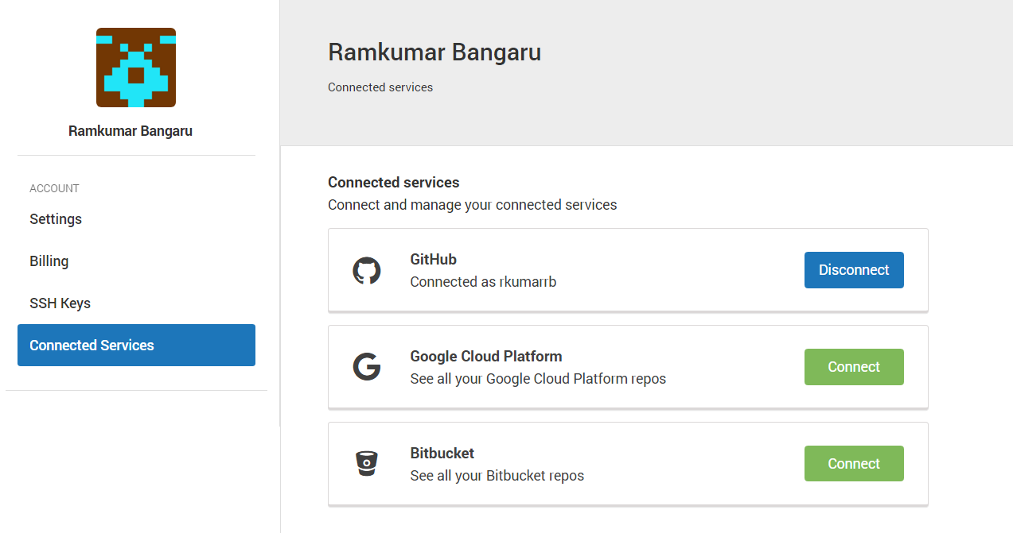

1. Click on GitHub “Connect” button [in the screenshot it shows as Disconnect as I already connected]
2. Give github username, password and login
3. Click on user logo



1. After that click on workspaces

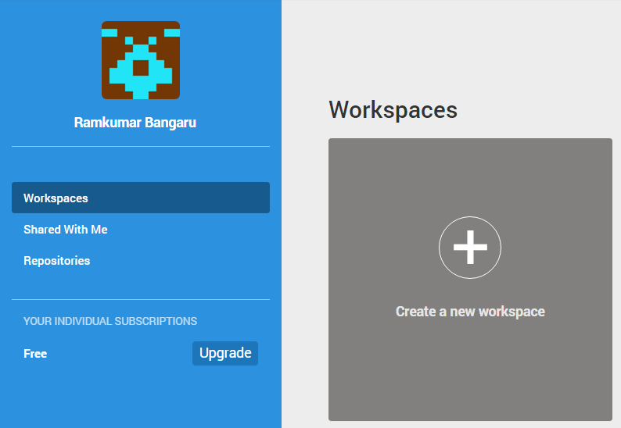

1. Click on Create a new workspace
2. Fill the form with values in the screenshot [Git URL in the screenshot is, git@github.com:rkumarrb/PyLearn.git]

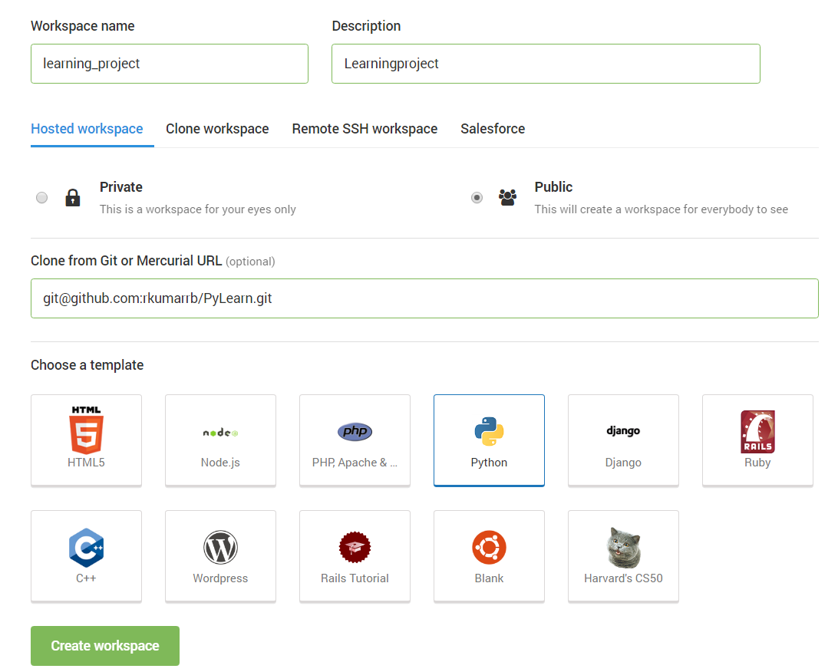

1. Now Go back to workspaces and click on Open button of created workspace

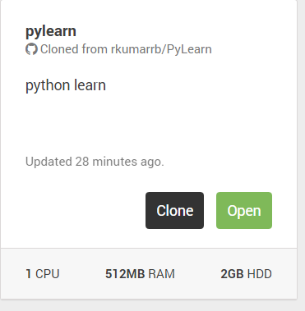

1. That will open workspace (looks like below)

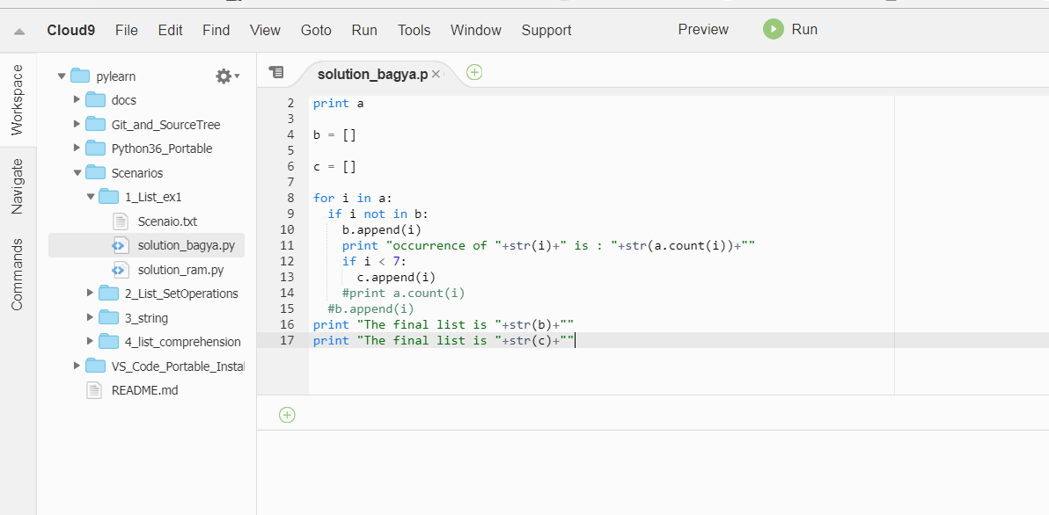

It is full development area, where we can write code, share screen, do text chat, execute code, can debug line by line and even supports GIT operations.

Once set up is done till this point, please let me know, I will explain the remaining process.