GIT Setup:

1. Extract the attached 7z file to C:\Folder (or Where ever you like)
2. Add the below path to path variable in environment variables (make sure you used semicolon to split the path

;<Where_it_extracted>\GitPortable\App\Git\cmd

1. Apply and close
2. Close all cmd and type git. It should show list of git commands

That’s all we are goo with Git Set up. Let’s move to Source tree

Atlassian Source Tree Setup:

1. Extract Zip file to C:\ folder (or Where ever you like)
2. Run SourceTreePortable.exe
3. Agree the license agreement and click continue
4. Create Atlassian account by clicking on Go To My Atlassian [you can create using your gmail ID]
5. Login with Atlassian account [If you have one already skip step 4]
6. In next screen, select GitHub

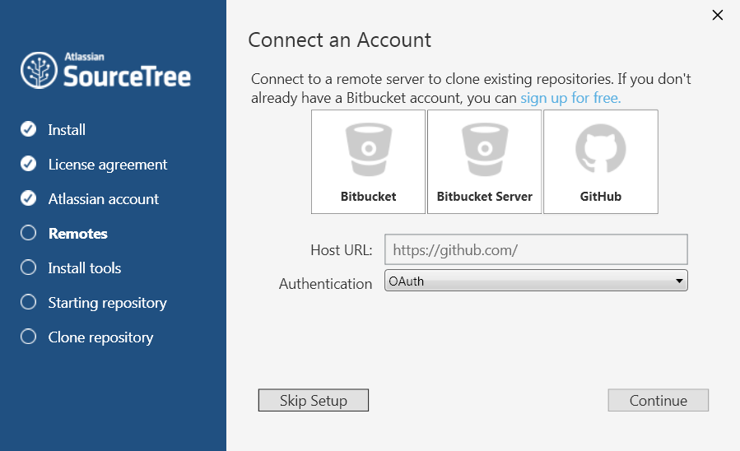

1. Select Authentication as Basic and give Github username and password

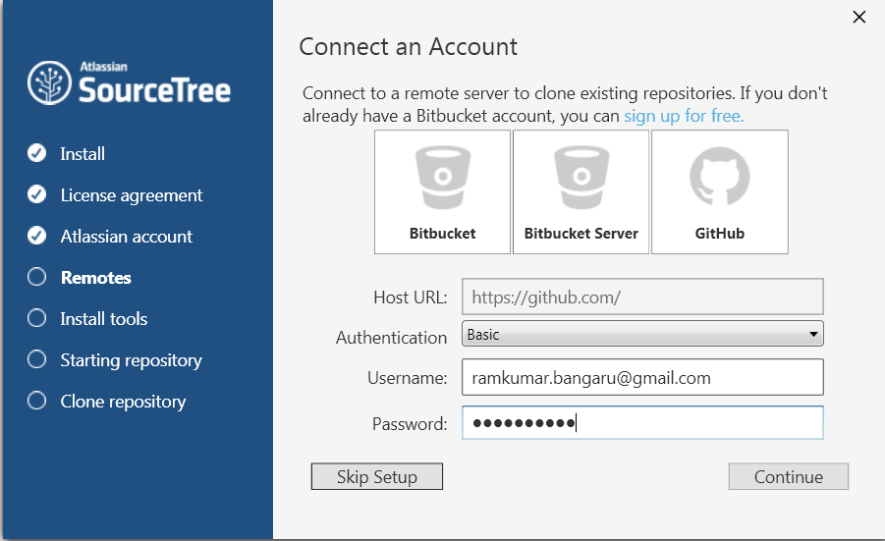

1. Click Continue and it will ask to clone your repo which can be skipped for now

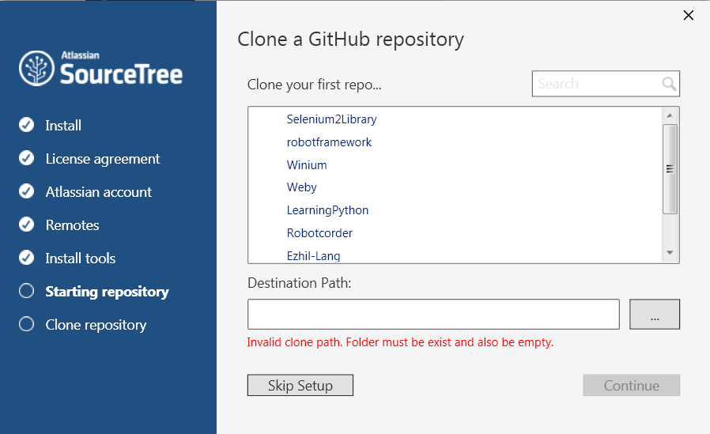

1. In the next screen, it prompt to load ssh keys which is not required as we are using password authentication, so click No

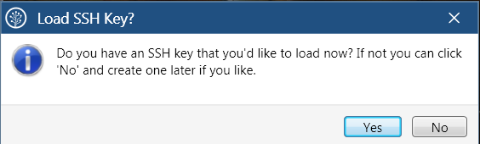

1. In the new Source Tree, Click on Clone
2. Give details of Repo to be cloned

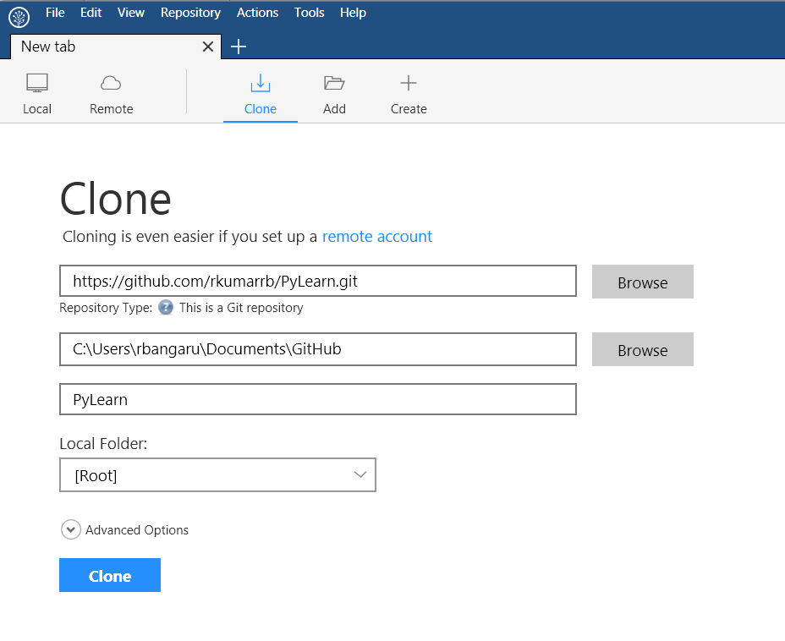

1. Click on clone which will be cloned the repo, in given path
2. After that, it show all the information including history in the following window

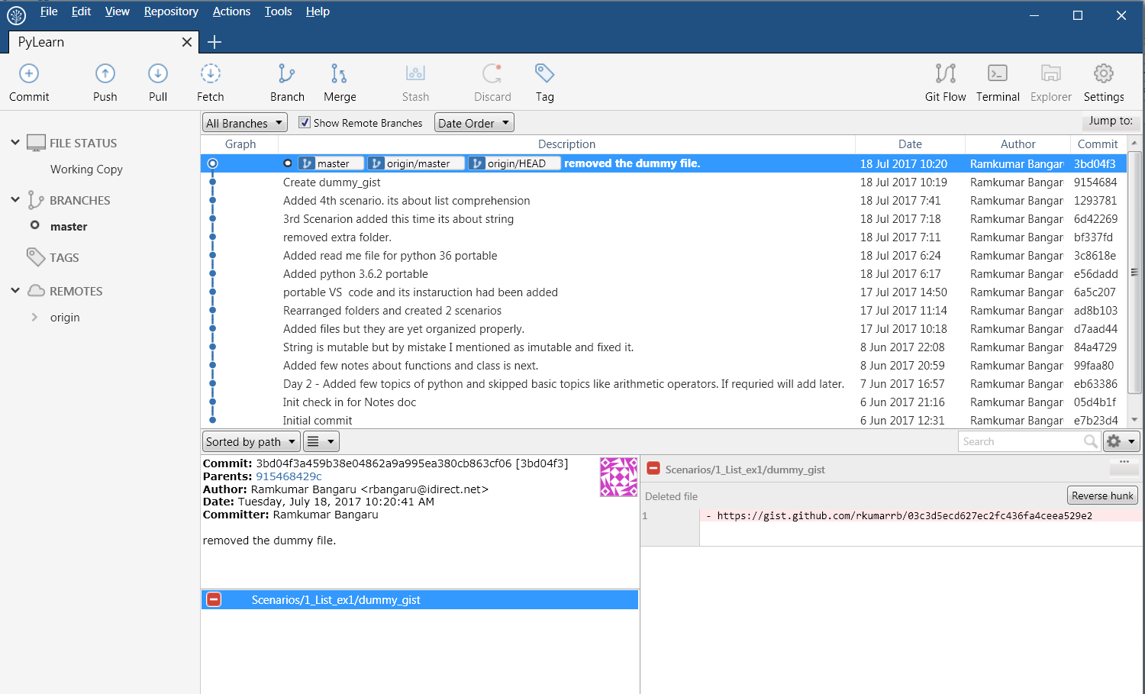

1. It has push, pull and other git operation buttons which can be used to work with GIT.
2. In Visual studio code, you can open the cloned folder and do changes over there too.

Please feel free to ping/call me if you have any questions or struck in any where