# Client : IDBI Bank Limited

Valuation Report

Ref. No. : IDBI Bank Limited/DL Nehru Enclave/Apr/24/1/ROHIT SHARMA/54251712 Dated 04/04/2024 Valuer Name : Adroit Technical Services Pvt. Ltd.



|  |  |  |  |  |  |  |  |  |  |
| --- | --- | --- | --- | --- | --- | --- | --- | --- | --- |
| **1.** | **Customer Details** | | | | | | | | |
|  | Name | | | |  | | | Apl. No. : NA | |
|  | Owner Name | | | |  | | | | |
|  | Case Type | | | |  | | | | |
| **2.** | **Property Details** | | | | | | | | |
|  | Address (as per TRF) | | | |  | | | | |
| Address (as per Document) | | | |  | | | | |
| Address (as per Inspection) | | | |  | | | | |
| Near by Landmark | | | |  | | | | |
| **3.** | **Document Details** | | | | | | | | |
|  | Document Provided | | | |  | | | | |
|  | Sanction Plan | | | |  | | | Approval No. : | |
| **4.** | **Quality Of Construction** | | | | | | | | |
| **A.** | **Exteriors** | | | | | | | | |
|  | Beam & Column Structure | | |  | | | | | |
|  | Appearance & Maintenance Of Building | | |  | | | | | |
|  | Common Areas Remarks | | |  | | | | | |
| **B.** | **Interiors** | | | | | | | | |
|  | Flooring & Finishing | | |  | | | | | |
|  | Woodwork | | |  | | | | | |
|  | Roofing & Terracing | | |  | | | | | |
|  | No. of Lift | | |  | | | | | |
| **5.** | **Physical Details** | | | | | | | | |
|  | Boundaries | East | | | | West | North | | South |
| As Per Documents |  | | | |  |  | |  |
| As Per Site |  | | | |  |  | |  |
| Boundaries Matching |  | | | | | | | |
| **Accommodation Details** | | | | | | | | |
|  | Stilt floor | |  | | | | | | |
| Ground floor | |  | | | | | | |
| First Floor | |  | | | | | | |
| Second Floor | |  | | | | | | |
| Third Floor | |  | | | | | | |
|  | Total No. of floors | | | |  | | |  | |
|  | Approx. age of the property (In Year) | | | |  | | |  | |
|  | Type of structure | | | |  | | | | |
| **5.** | **Tenure / Occupancy Details** | | | | | | | | |
|  | Status of Tenure | | | |  | | | Relationship of tenant : Under Construction- | |
| **6.** | **Stage of Construction** | | | | | | | | |
|  | Stage of Construction (% Progress) | | | |  | | | | |
| Stage of Construction (% Recommend) | | | |  | | | | |
| **7.**  Ref. No. : IDBI | **Violation Observed (if any)**  Bank Limited/DL Nehru Enclave/Apr/24/1/ROHIT SHARMA/54251712 - 1 - | | | | | | | | |

|  |  |  |  |  |  |  |
| --- | --- | --- | --- | --- | --- | --- |
|  | Nature and extend of violations | |  | | | |
| **6.** | **Area Details of the property** | | | | | |
|  | Plinth Area |  | | | | |
|  | Carpet Area |  | | | | |
|  | Saleable Area |  | | | | |
|  | FLOOR | Actual (Sft.) | | Permissible (Sft.) | Area adopted for Valuation (Sft.) | Deviations (%) |
| Stilt |  | |  |  |  |
| Ground Floor |  | |  |  |  |
| First Floor |  | |  |  |  |
| Second Floor |  | |  |  |  |
| Third Floor |  | |  |  |  |
| **Total** |  | |  |  |  |
|  |  |  | | | | |

|  |  |  |
| --- | --- | --- |
| 7. | **Calculation of Fair Market Value** | |
| Land Area(Sq. Ft.) | |  |
| Total Build Up Area(Sq. Ft.) | |  |
| Area adopted of the valuation (Sft.) | |  |
| Current Market Rate of land in the locality (INR) | |  |
| Applicable Rate of Land (INR) | |  |
| Current Market Value of Land (INR) | |  |
| Value of Land Share for subject property (INR) | |  |
| Applicable rate on construction(INR) | |  |
| Value of Construction (For Permissible Area) (INR) | |  |
| Fair Market Value of property (INR) | |  |
| Value of Amenities (INR) | |  |
| Fair Market Value with Amenities (INR) | |  |
| Circle/Guideline rate | |  |
| Rental Value (If Rented) (INR) | |  |
| Insurable Value (INR) | |  |
| Proposed area of construction | |  |
| Proposed rate per Sft. future construction | |  |
| Estimate Recommended for renovation/ construction | |  |
| Net market value (after completion)(INR) | |  |
| Distress value | |  |
| Relizable value | |  |
| Valuation Result | |  |
| **10. Assumptions / Remarks** | | |
| Subject property is comply with National Building Code, BIS (Bureau of Indian Standards) code and as per NDMA (National Disaster Management Authority) guidelines.   1. Subject property is a S+G+3 storied residential building constructed upon land ad measuring-100 Sq Yd. 2. As on date of visit subject property was under final finishing stage. 3. Measured built-up area of subject property is workout to be 4430 Sq ft against permissible area as per bye laws is 3960 sq feet and same has been adopted for valuation. 4. A copy of sale deed has been provided to us in favor of Yashpal, Reg no.25708, dated-10.10.2022. 5. A copy of (1/2 undivided share)agreement to sale has been provided to us executed by-Yashpal and in favor of Arnav Kumar Dutta and Soma Rani Singha, dated-11.12.2023. 6. Approved building plan has not been provided to us. 7. Kitchen was not constructed at the time of visit. 8. Second floor and Third floor constructed as duplex. 9. Rear side toilet and balcony and Front side balcony has been found hang. 10. Subject property has been located in regularised area. | | |
| **11.** | **Declaration** |  |
| **12.** | **Name, Address & Signature of Valuer** | Signature of the Valuer Date of Valuation |
| 13 | **List of Documents enclosed** | Agreement To Sale,Sale Deed |

# Appendix: Photograph

**IDBI Bank Limited/DL Nehru Enclave/Apr/24/1/ROHIT SHARMA/54251712 ARNAV KUMAR DUTTA**

# PLOT NO.17/136, SUBHASH NAGAR, TEHAR-I, NEW DELHI-110027

**Latitude - 28.63378 Longitude - 77.116205**

|  |  |
| --- | --- |
|  |  |
|  |  |

|  |  |
| --- | --- |
|  |  |
|  |  |

|  |  |
| --- | --- |
|  |  |
|  |  |



Ref. No. : IDBI Bank Limited/DL Nehru Enclave/Apr/24/1/ROHIT SHARMA/54251712

- 6 -

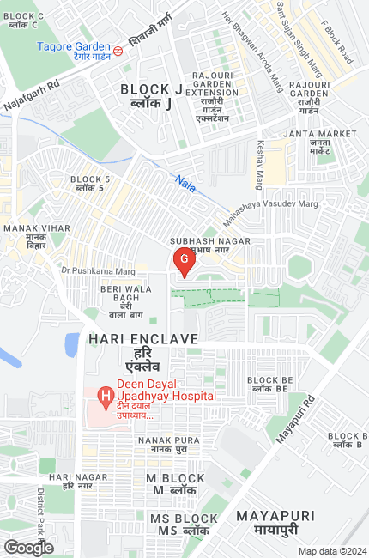

Ref. No. : IDBI Bank Limited/DL Nehru Enclave/Apr/24/1/ROHIT SHARMA/54251712 - 7 -