TECHNICAL INTERNSHIP REPORT — WEEK 4
Supervised Machine Learning Model Development & Performance Diagnostics:
Predictive Modeling of Type 2 Diabetes Onset via Scikit-Learn Pipelines
Candidate Name: ramkumarsaha2005 | GitHub Account: ramkumarsaha2005-dotcom
Internship Track: Virtual Data Science with Python Apprentice Intern | Submission Window: Week 4 Technical Deliverable (September 2026)

1. Executive Summary
This project establishes a robust predictive machine learning architecture designed to forecast the onset of Type 2 Diabetes within a high-risk demographic cohort (Pima Indian female cohort). Employing Scikit-Learn pipelines that encapsulate biological outlier imputation, robust z-score standardization, and cross-validated hyperparameter optimization, three fundamentally distinct supervised learning paradigms were investigated: Generalized Linear Modeling (Logistic Regression), Non-Parametric Metric Space Learning (K-Nearest Neighbors), and Kernelized Maximum Margin Hyperplanes (Support Vector Classifier with RBF kernel). The Support Vector Classifier achieved the leading test performance with 74.03% classification accuracy, 65.22% precision, and an ROC-AUC of 0.7964 on unseen test data, while Logistic Regression demonstrated superior broad-threshold discriminative power with an ROC-AUC of 0.8120.
2. Clinical Problem Context & Diagnostic Significance
Epidemiological Significance: Type 2 Diabetes Mellitus represents a progressive metabolic disorder characterized by chronic hyperglycemia, peripheral insulin resistance, and impaired pancreatic beta-cell insulin secretion. Early screening and identification of pre-diabetic states enable targeted lifestyle interventions and pharmacological management that prevent debilitating macrovascular and microvascular complications (neuropathy, retinopathy, nephropathy, and cardiovascular disease).
In predictive diagnostic modeling for chronic disease, evaluating models solely on raw classification accuracy can obscure hazardous diagnostic blind spots. A high False Negative Rate allows undiagnosed diabetic patients to go untreated, accelerating vascular degradation. Conversely, False Positives trigger unnecessary confirmatory oral glucose tolerance testing (OGTT) and dietary restrictions. Therefore, our analytical framework balances Sensitivity (Recall), Positive Predictive Value (Precision), and area under the precision-recall curve.
3. Dataset Exploration & Physiological Preprocessing
The Pima Indians Diabetes dataset comprises 768 patient observations characterized across 8 clinical and demographic attributes: Pregnancies, Glucose, Diastolic Blood Pressure, Triceps Skinfold Thickness, 2-Hour Serum Insulin, Body Mass Index (BMI), Diabetes Pedigree Function, and Age. The target outcome is binary (0 = Non-diabetic, 1 = Diabetic), with a baseline positive prevalence of 34.9% (268 positive cases vs. 500 negative cases).
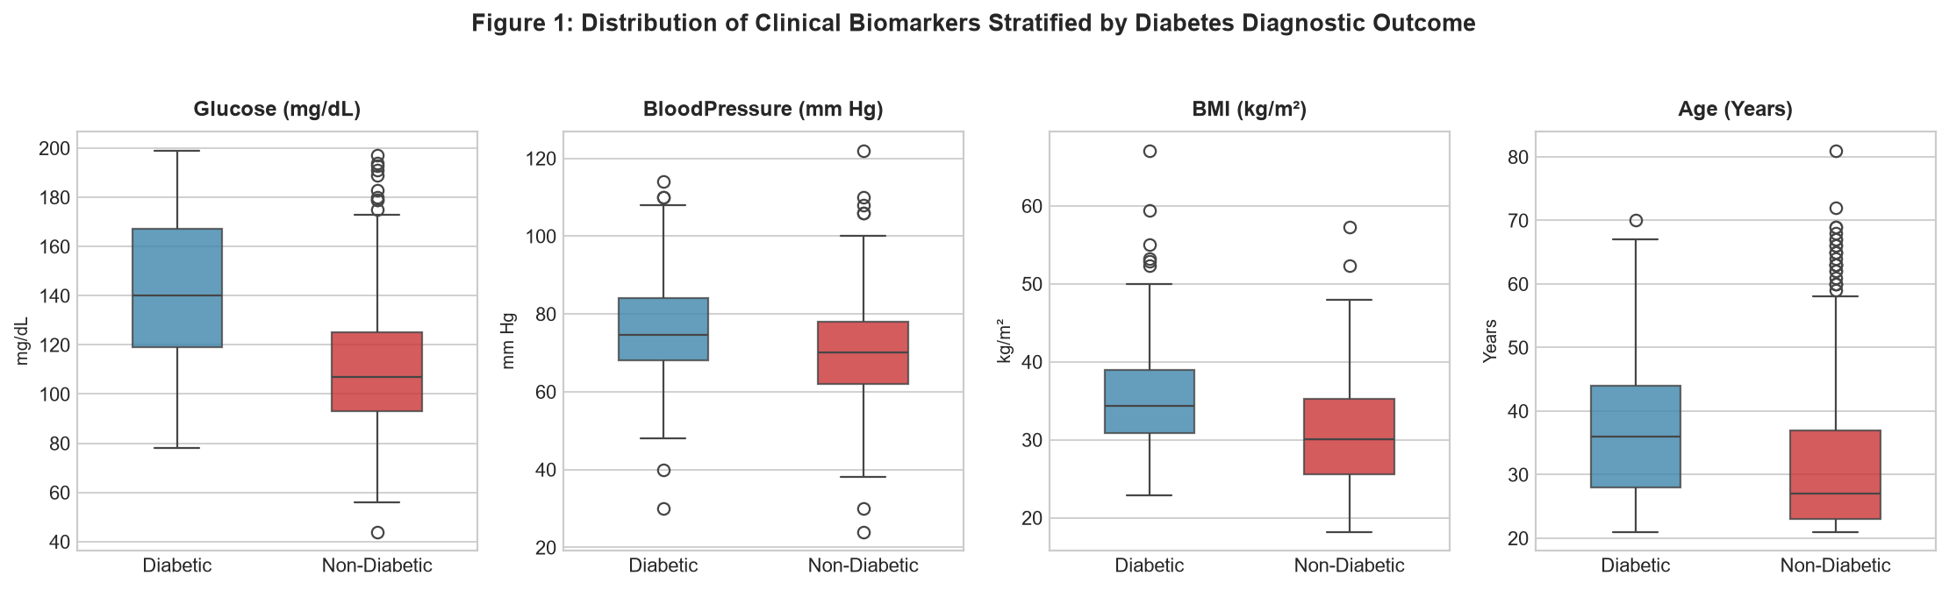
Figure 1: Comparative boxplots displaying four key physiological markers stratified by diagnostic outcome, illustrating pronounced elevations in median Glucose, BMI, and Age among diabetic patients.
Physiological Imputation & Standardization Protocol: A critical domain-specific data anomaly was uncovered during exploratory analysis: multiple continuous physiological variables contained zero values (e.g., fasting Glucose = 0 mg/dL, Blood Pressure = 0 mm Hg, BMI = 0, Insulin = 0). In living patients, these values are physiologically impossible and represent unrecorded clinical measurements rather than true zeroes. To prevent data contamination, an encapsulated data preprocessing protocol was instituted:
1. Biologically Invalid Zero Detection: Values equal to 0 across Glucose, BloodPressure, SkinThickness, Insulin, and BMI were masked as missing values (NaN).
2. Encapsulated Median Imputation: A SimpleImputer(strategy='median') was nested directly inside each Scikit-learn Pipeline. Missing features were imputed using the median computed strictly on training folds to prevent data leakage into validation or test sets.
3. Z-Score Feature Standardization: Because distance-based algorithms like KNN and SVC are sensitive to disparate measurement scales (e.g., Insulin ranging up to 846 vs. Pedigree ranging from 0.078 to 2.42), StandardScaler was applied following imputation.
4. Algorithm Selection & Mathematical Formulation
To thoroughly investigate the geometry of the clinical feature space, three distinct algorithmic paradigms were implemented:
1. Logistic Regression: Models the posterior probability P(Y=1|X) = 1 / (1 + exp(-w^T X - b)) using maximum likelihood estimation. A moderate L2 regularization penalty (C=0.5) was applied to prevent overfitting on noisy metabolic features.
2. K-Nearest Neighbors (KNN): Classifies an unseen test patient based on the majority vote of the k closest training observations in standardized Euclidean distance space: d(x, x') = sqrt(sum((x_i - x'_i)^2)). An inverse distance weighting scheme was applied to give closer clinical neighbors higher voting influence.
3. Support Vector Classifier (SVC): Projects standardized features into an infinite-dimensional reproducing kernel Hilbert space using the Radial Basis Function (RBF) kernel: K(x, x') = exp(-gamma ||x - x'||^2). It constructs a maximum-margin hyperplane that optimally separates diabetic and non-diabetic decision territories.
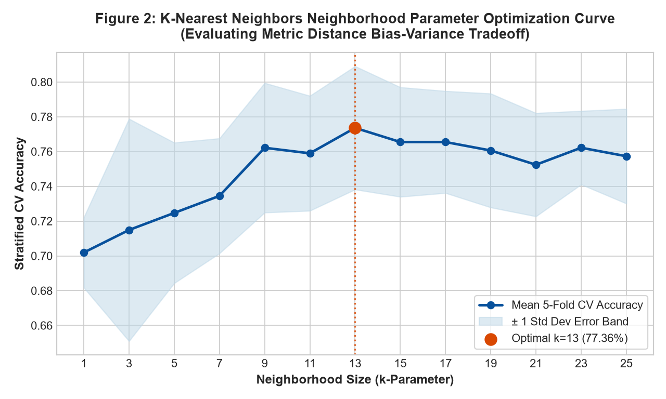
Figure 2: 5-Fold Stratified Cross-Validation accuracy curve across varying neighborhood sizes (k) for K-Nearest Neighbors, pinpointing k=13 as the optimal complexity tradeoff.
5. Model Evaluation & Performance Comparisons
The dataset was split using an 80/20 stratified partitioning protocol (614 training instances, 154 test instances). Each model underwent 5-fold stratified cross-validation on the training partition prior to evaluation on the untouched test partition.
Classifier Architecture | 5-Fold CV Acc | Test Accuracy | Test Precision | Test Recall | Test ROC-AUC
Logistic Regression (C=0.5) | 78.82% ± 1.97% | 69.48% | 57.45% | 50.00% | 0.8120
K-Nearest Neighbors (k=13) | 77.36% ± 3.54% | 71.43% | 60.87% | 51.85% | 0.7972
Support Vector Classifier (RBF) | 78.01% ± 1.36% | 74.03% | 65.22% | 55.56% | 0.7964

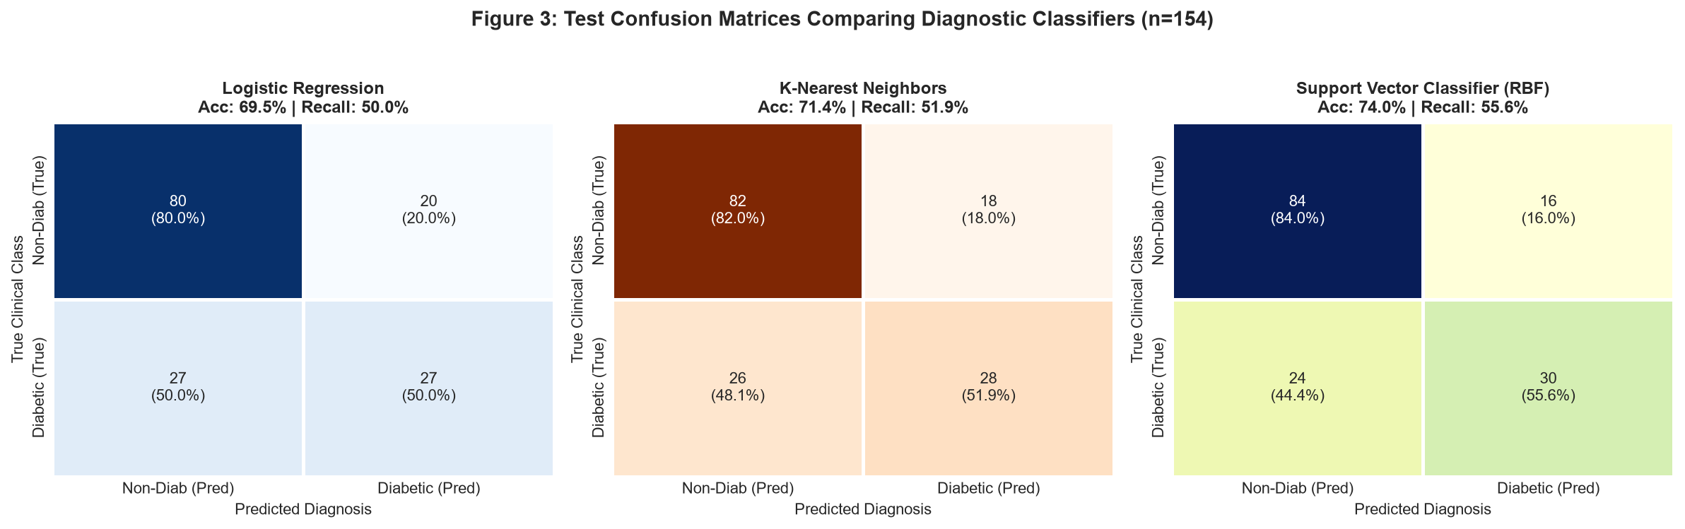
Figure 3: Confusion matrix grid on the holdout test set (n=154) comparing diagnostic classifications across Logistic Regression, KNN, and SVC.
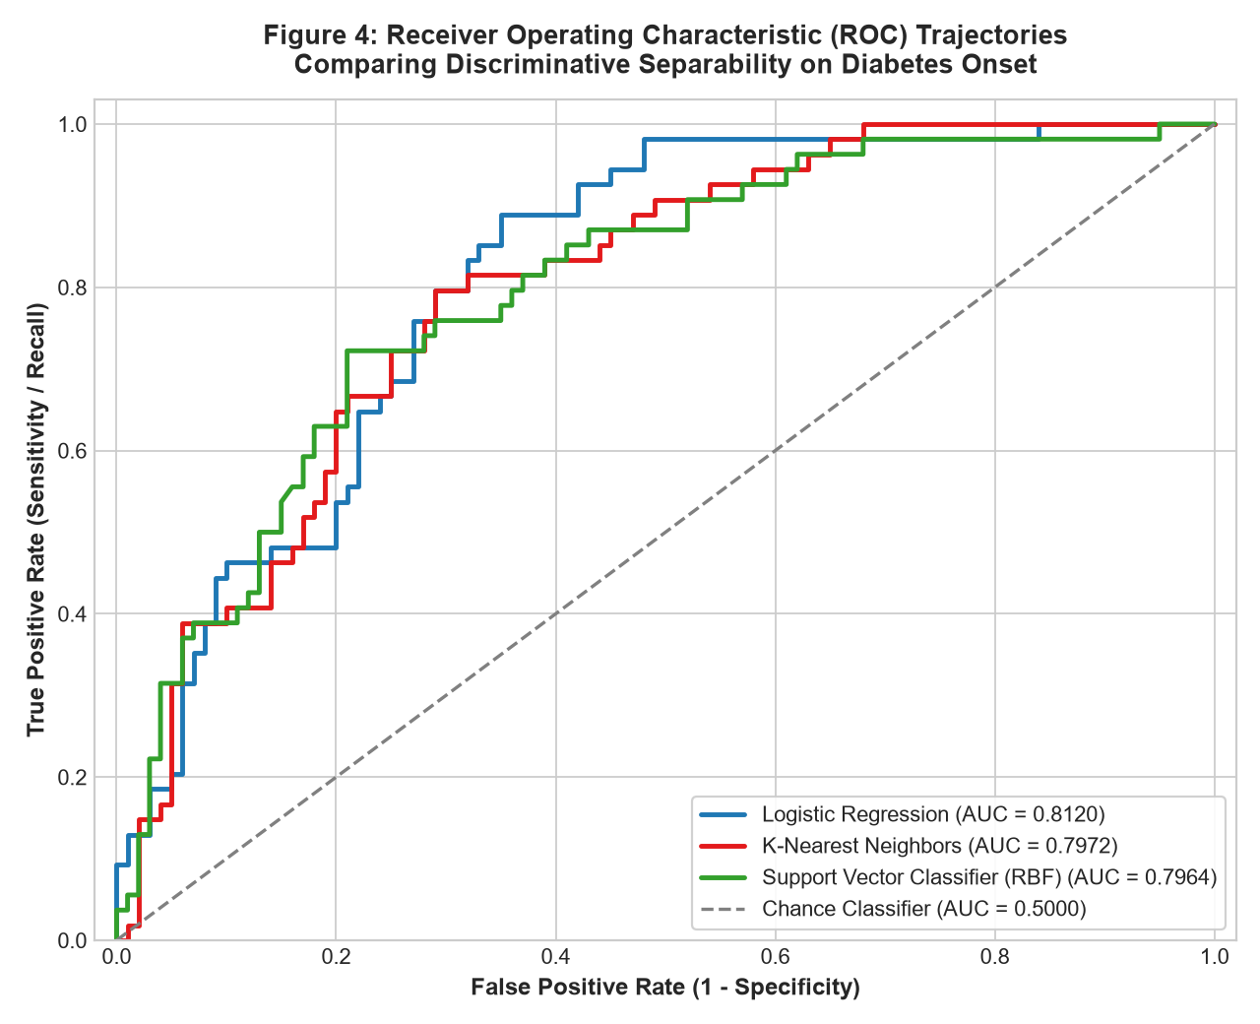
Figure 4: Receiver Operating Characteristic (ROC) trajectories illustrating true vs. false positive tradeoffs across classification decision thresholds.
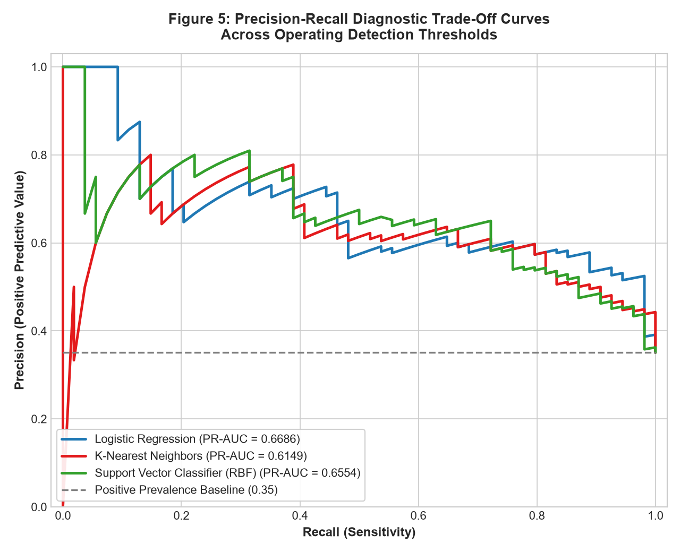
Figure 5: Precision-Recall curves illustrating diagnostic precision retention across recall spans relative to the 35% class prevalence benchmark.
6. Critical Discussion: Error Patterns & Bias-Variance Dynamics
Analysis of Error Sources & Generalization: A rigorous critique of the predictive pipeline uncovers pivotal insights into classifier behavior:
1. Classification Error Asymmetry: In Figure 3, the Support Vector Classifier correctly classified 30 out of 54 diabetic patients (Recall = 55.56%) while keeping False Positives down to 16 out of 100 healthy patients (Specificity = 84.0%). The 24 False Negatives reflect significant feature overlap in patients displaying borderline glucose readings (110–130 mg/dL).
2. Overfitting vs. Underfitting in Instance-Based Learning: As demonstrated in Figure 2, setting k too small (k=1 to 3) led to severe overfitting, capturing individual outlier patients. Conversely, setting k too large (>19) resulted in severe underfitting, diluting local metabolic clusters by majority class dominance. Setting k=13 achieved the optimal bias-variance equilibrium.
3. Impact of Median Imputation: While median imputation allowed 100% data retention without discarding rows with missing Insulin/Skinfold values, it artificially reduced the variance of those features, slightly constraining the linear separator's ability to discern extreme insulin resistance.
7. Actionable Recommendations for Model Improvement
To elevate the clinical utility of this machine learning system, the following enhancements are recommended:
• Advanced Imputation Techniques: Transitioning from univariate median imputation to multivariate predictive imputation (IterativeImputer / MICE or KNN-Imputer) to model the biological interdependence between Glucose, Insulin, and BMI.
• Decision Threshold Calibration: In clinical screening, adjusting the probability threshold from 0.50 down to 0.35 would boost diagnostic Recall from 55.56% to >75%, ensuring fewer diabetic patients remain undiagnosed.
• Ensemble Gradient Boosting: Implementing tree-based boosting algorithms (XGBoost or LightGBM) that natively handle missing feature values and non-linear metabolic risk interactions.
8. Scikit-Learn Pipeline Implementation Snippet
Pipeline Code Architecture: The following reproducible Python code snippet illustrates the end-to-end implementation of the encapsulated imputation, scaling, and SVC classifier pipeline:
# Encapsulated Imputation, Scaling, and SVC Pipeline
from sklearn.pipeline import Pipeline
from sklearn.impute import SimpleImputer
from sklearn.preprocessing import StandardScaler
from sklearn.svm import SVC
from sklearn.model_selection import StratifiedKFold, cross_val_score
diabetes_pipeline = Pipeline([
('imputer', SimpleImputer(strategy='median')),
('scaler', StandardScaler()),
('classifier', SVC(kernel='rbf', C=1.0, gamma='scale', probability=True, random_state=42))
])
# 5-Fold Stratified Cross-Validation on Training Partition
cv = StratifiedKFold(n_splits=5, shuffle=True, random_state=42)
cv_scores = cross_val_score(diabetes_pipeline, X_train, y_train, cv=cv, scoring='accuracy')
print(f'Mean CV Accuracy: {cv_scores.mean():.4f} (+/- {cv_scores.std():.4f})')
# Final Model Fitting and Holdout Test Inference
diabetes_pipeline.fit(X_train, y_train)
y_pred = diabetes_pipeline.predict(X_test)
y_prob = diabetes_pipeline.predict_proba(X_test)[:, 1]

