Admin Module Doc
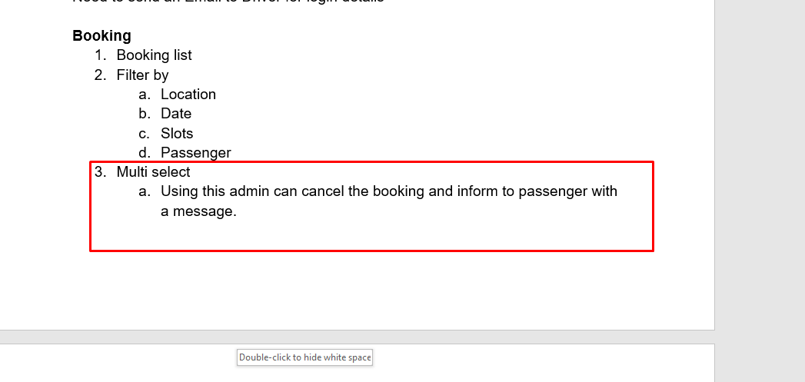

Explain more

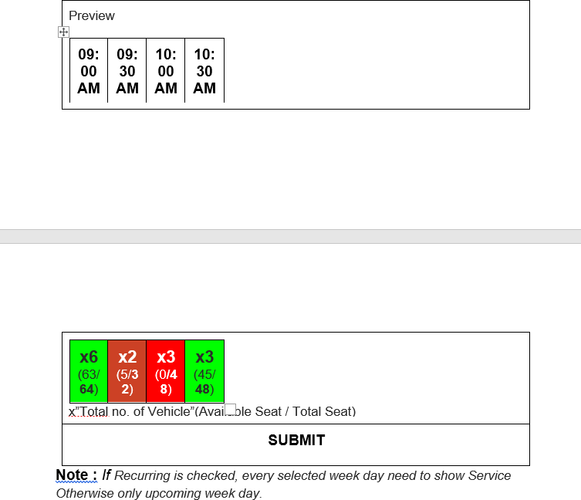
Admin Module : Please explain this

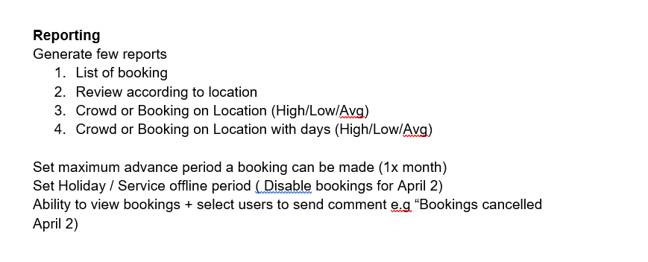
Explain more reporting part. Which value you want show on and filter type.

Driver Module

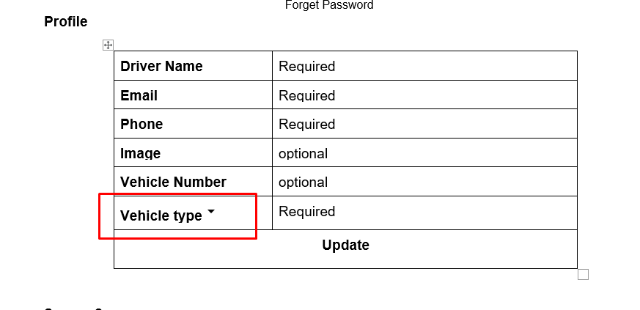
From the admin only assign single vehicle. Why need drop-down here. Please explain.

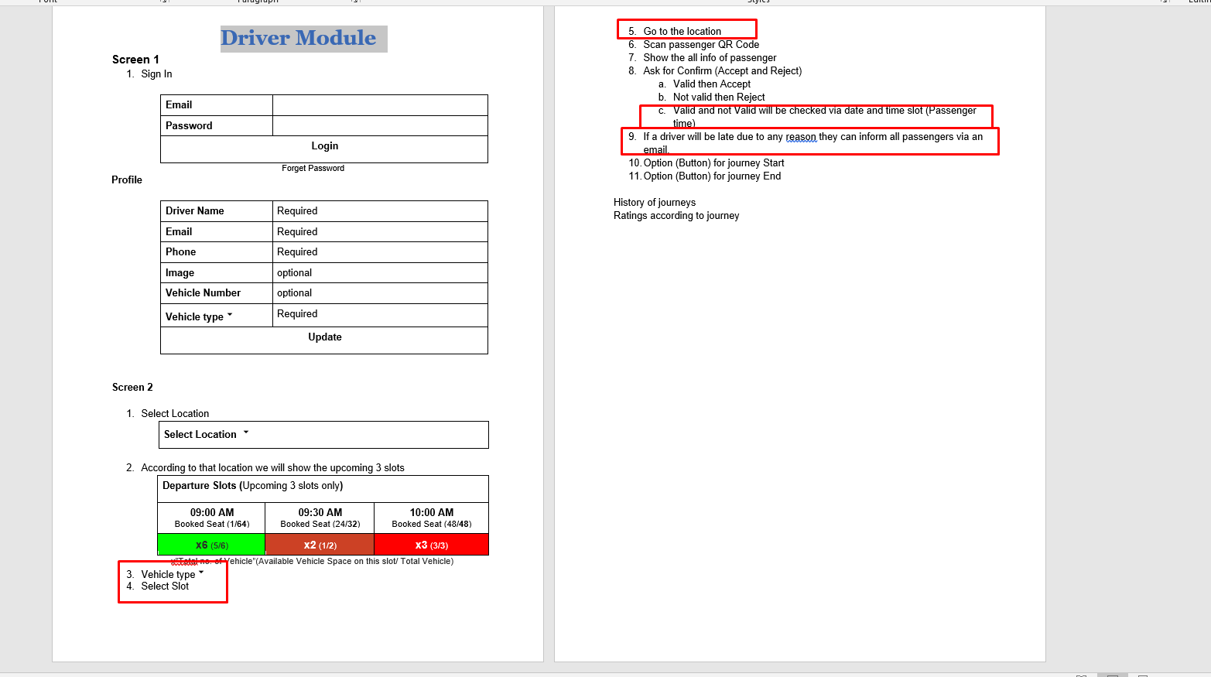
Please explain red points

User Module

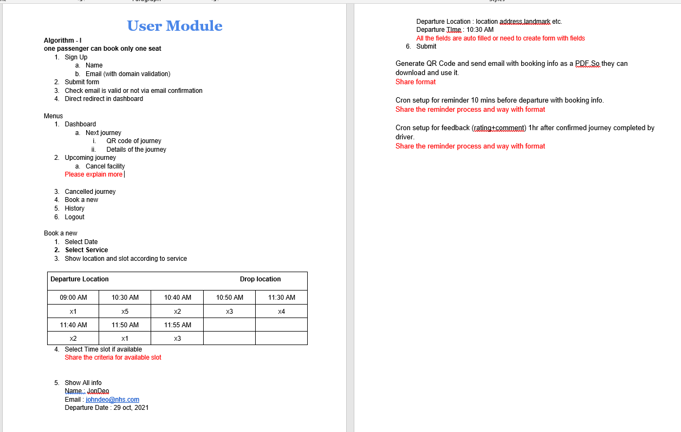
Please explain red points

