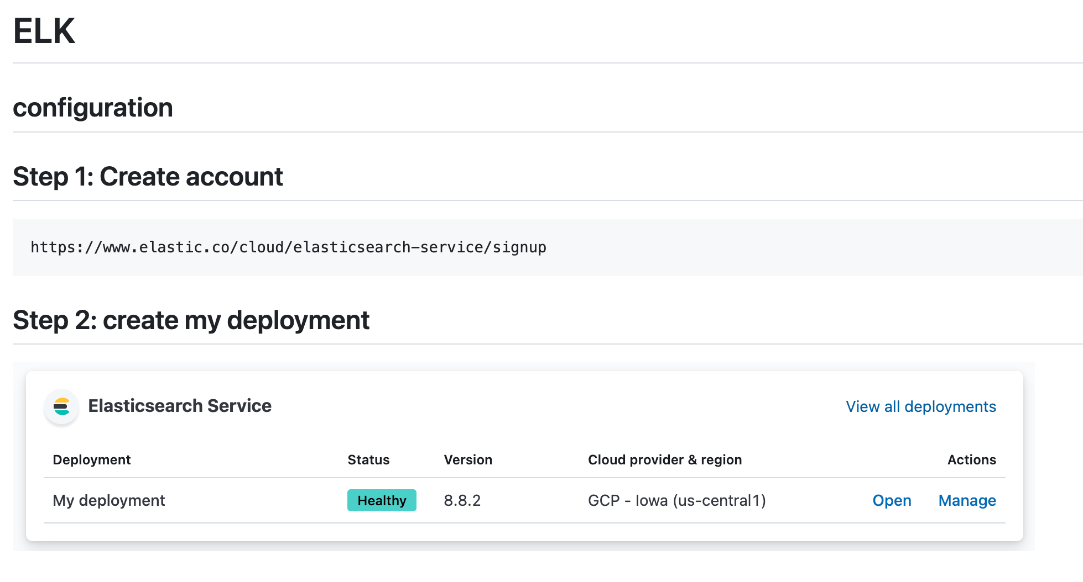

## **Step3: click on Manage ->security->reset password**

You will get username and password

**In kubernetes**

Step 1: Metrics server

kubectl apply -f<https://github.com/kubernetes-sigs/metrics-server/releases/latest/download/components.yaml>

Step2: curl -L -O [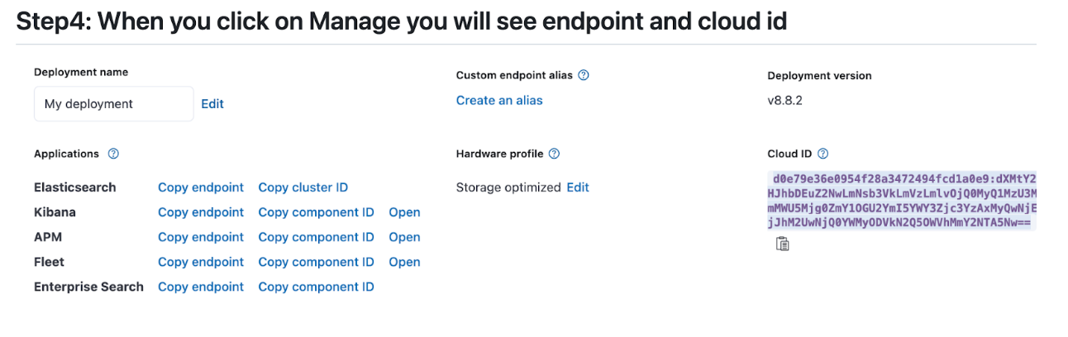https://raw.githubusercontent.com/elastic/beats/8.13/deploy/kubernetes/metricbeat-kubernetes.yaml](https://raw.githubusercontent.com/elastic/beats/8.13/deploy/kubernetes/metricbeat-kubernetes.yaml)

Add the authentication information in metricbeat-kubernetes.yaml inside env.

## **// old method - Step5: Metricbeat installation**

https://www.elastic.co/guide/en/beats/metricbeat/current/metricbeat-installation-configuration.html

curl -L -O https://artifacts.elastic.co/downloads/beats/metricbeat/metricbeat-8.9.2-amd64.deb

sudo dpkg -i metricbeat-8.9.2-amd64.deb

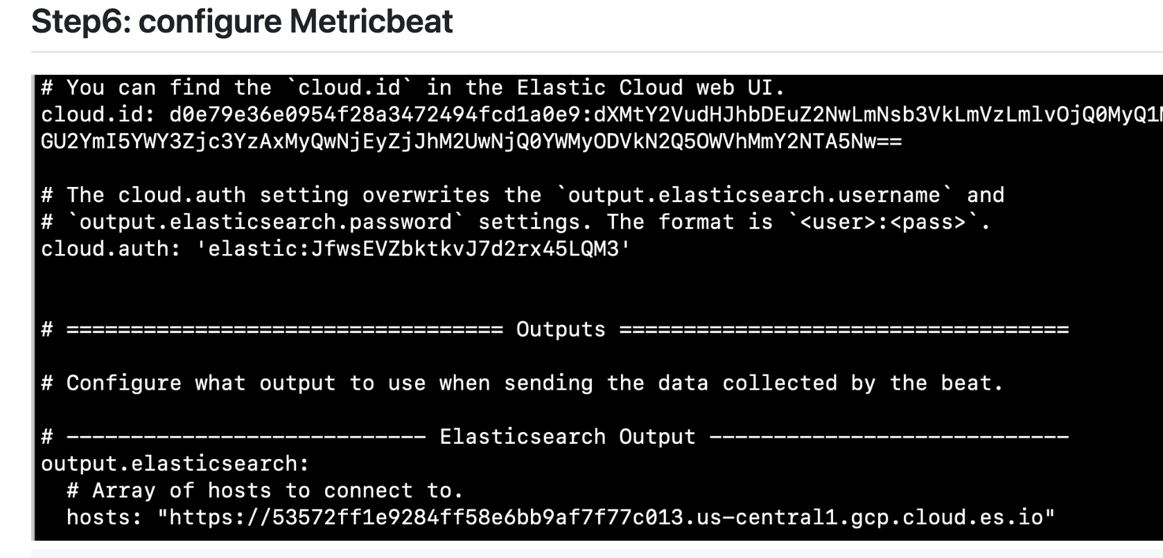

Enter your username and password, with your endpoints

cd /etc/metricbeat

copy username and password from manage->security->reset password, get cloudid & elasticsearch endpoint paste above

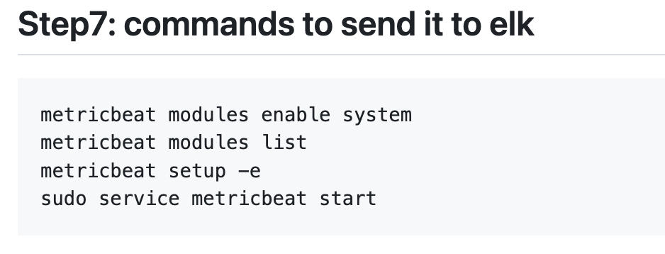

=============

**New method is below:**

curl -L -O https://raw.githubusercontent.com/elastic/beats/8.14/deploy/kubernetes/filebeat-kubernetes.yaml

Kubectl apply -f filebeat-kubernetes.yaml (paste authentication information before applying) filebeat-kufilebeat-kubernetes.yaml

bernetes.yaml