## **Jenkins Installation**

### **Master node configuration**

sudo apt update -y

sudo apt install openjdk-17-jre -y

java --version

curl -fsSL https://pkg.jenkins.io/debian-stable/jenkins.io-2023.key | sudo tee \

/usr/share/keyrings/jenkins-keyring.asc > /dev/null

echo deb [signed-by=/usr/share/keyrings/jenkins-keyring.asc] \

https://pkg.jenkins.io/debian-stable binary/ | sudo tee \

/etc/apt/sources.list.d/jenkins.list > /dev/null

sudo apt-get update -y

sudo apt-get install jenkins -y

sudo systemctl daemon-reload

sudo systemctl enable jenkins

sudo systemctl start jenkins

sudo systemctl status jenkins

## **Initial admin password Location**

/var/lib/jenkins/secrets/initialAdminPassword

## **slave node**

sudo apt update -y

sudo apt install openjdk-17-jre -y

java --version

Repo link:  
https://github.com/suhailasad/JenkinsMavenCode.git

GitHub + Jenkins + Maven + Docker + Kubernetes

Configure the job and commands as per below screenshots;  
   
List of plugins to be installed: maven, copy artifact

Please see the recording to see how to install the maven plugin and configure it.

In Jenkins instance, install docker and kubectl utility

Sudo snap install kubectl –classic

**JOB1**: config steps and commands

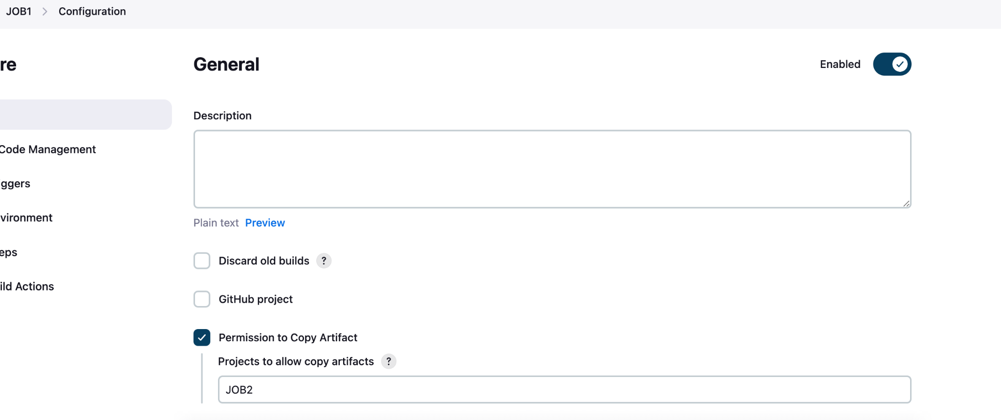

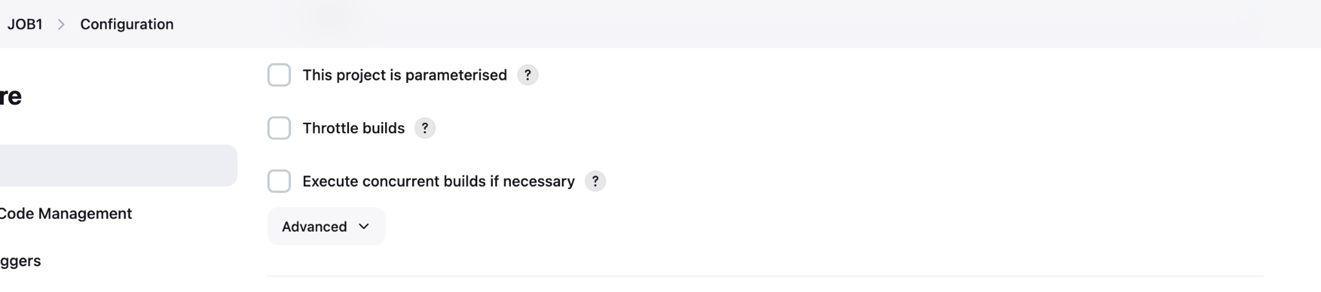

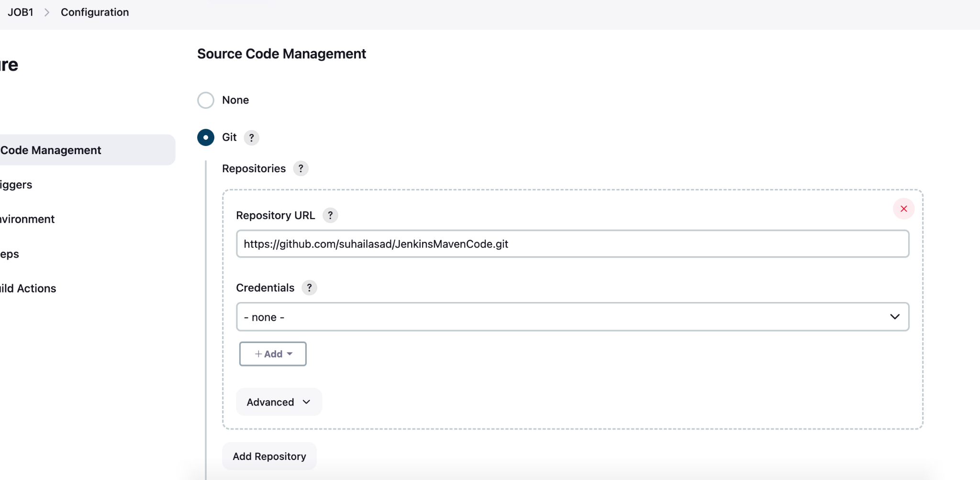

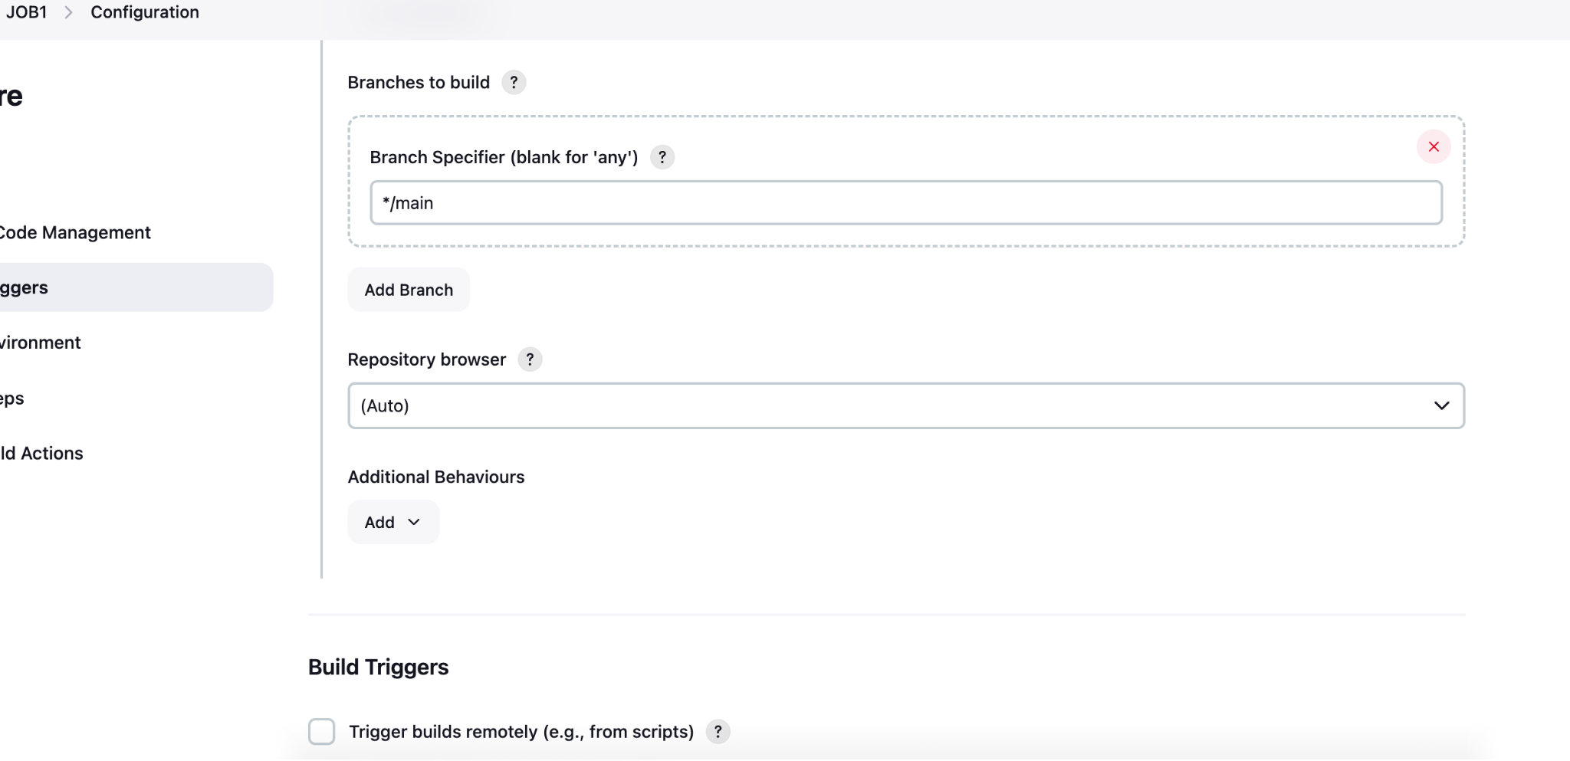

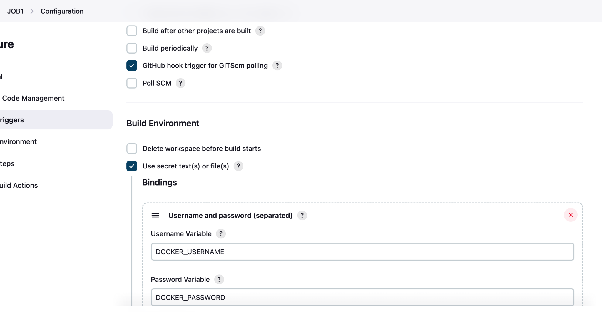

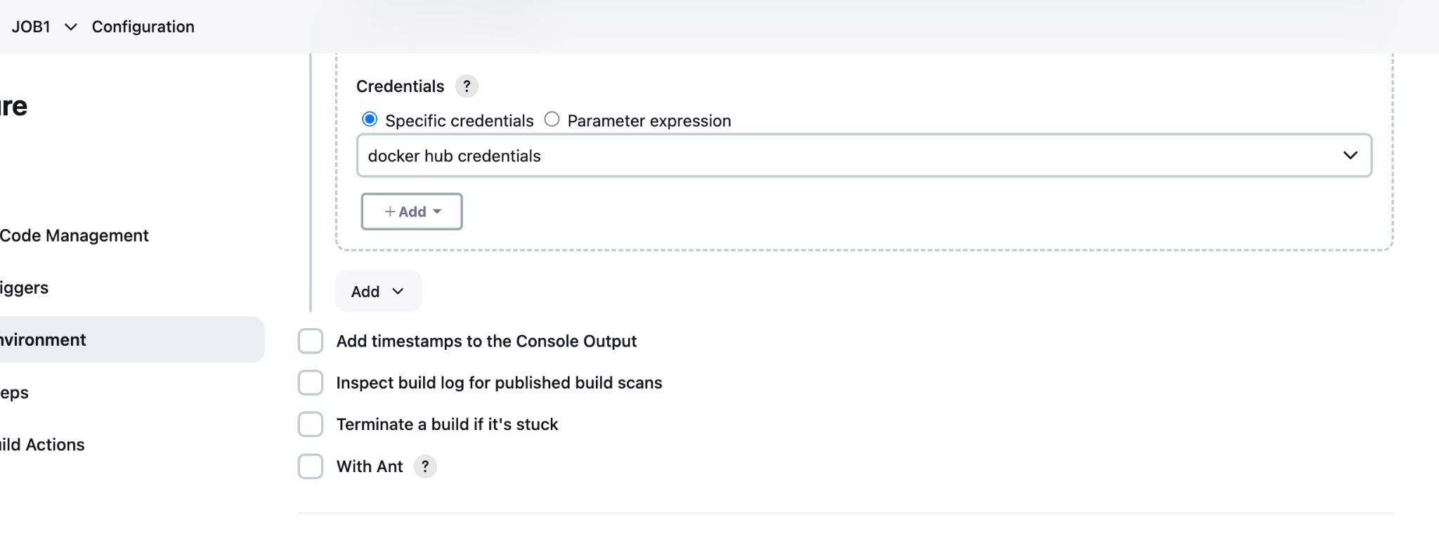

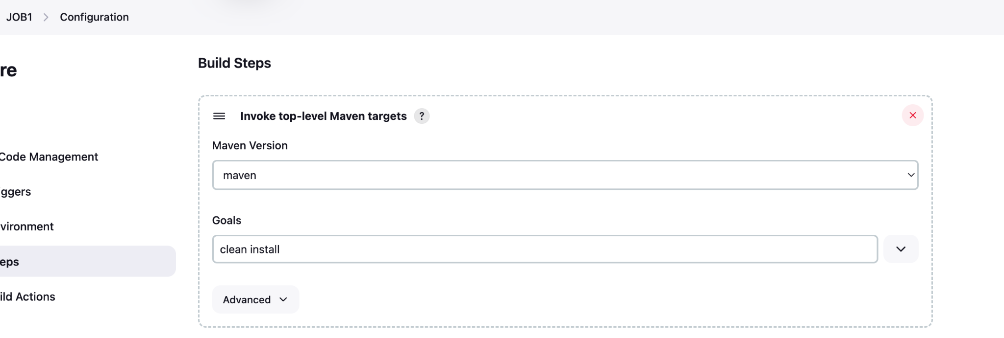

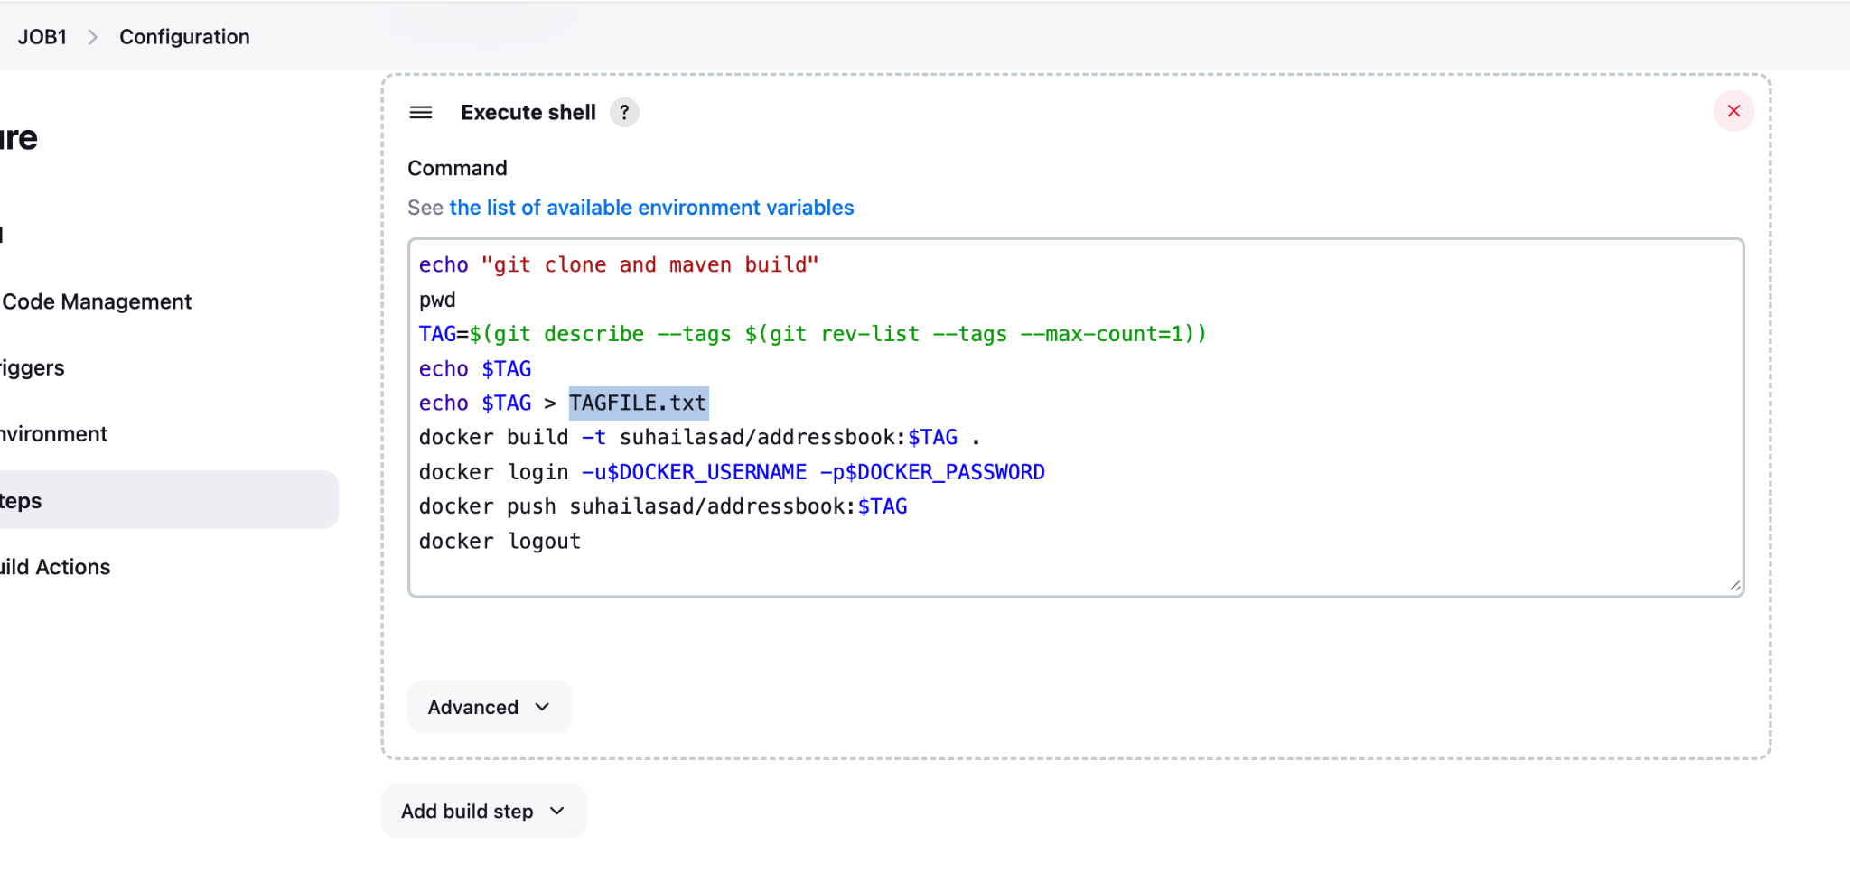

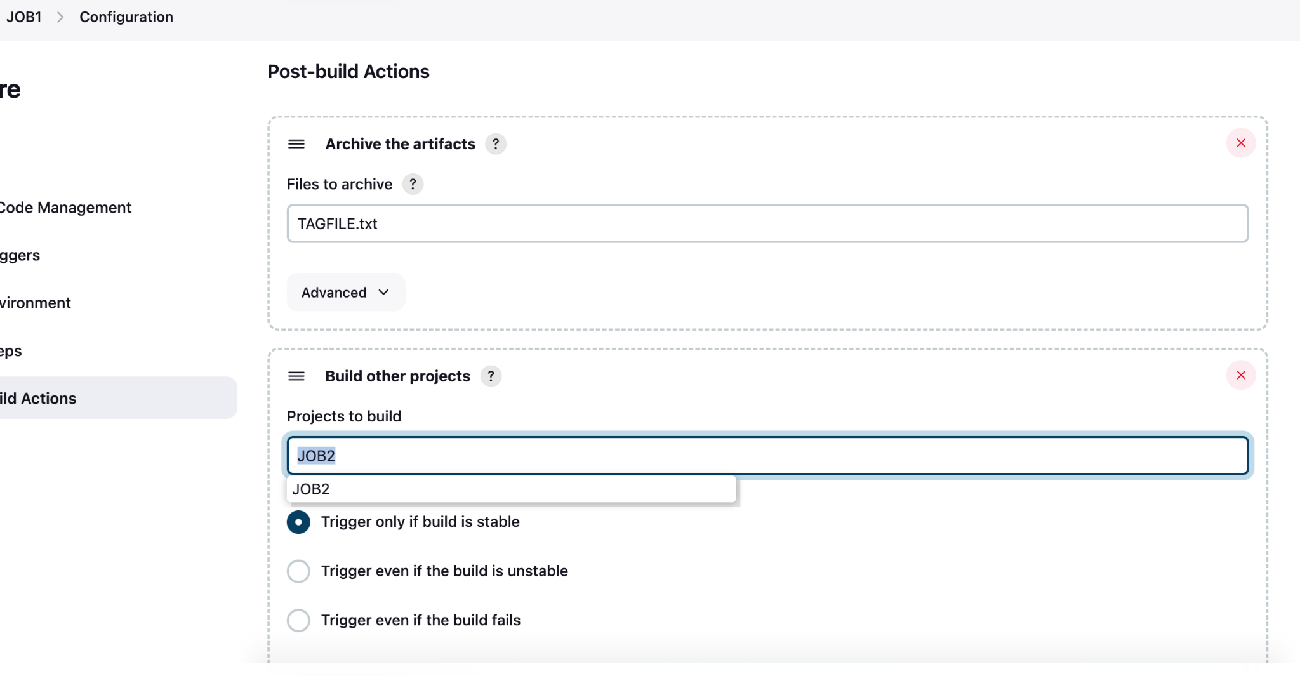

**JOB2**: config steps and commands

