Lambton College in Toronto Jigisha Patel

CSD2204 - Database Design and SQL Day 2 Task

• Consider the domain of your choice. (Walmart, hospital, SEO, Manufacturing, etc.)

• List the various entities involved.

• List the various attributes of the entities.

• Consider the relationship among the entities.

• Create and generate the ER diagram using the online tool of your choice.

• Export the ERD as Image.

**ER Diagram of Walmart**

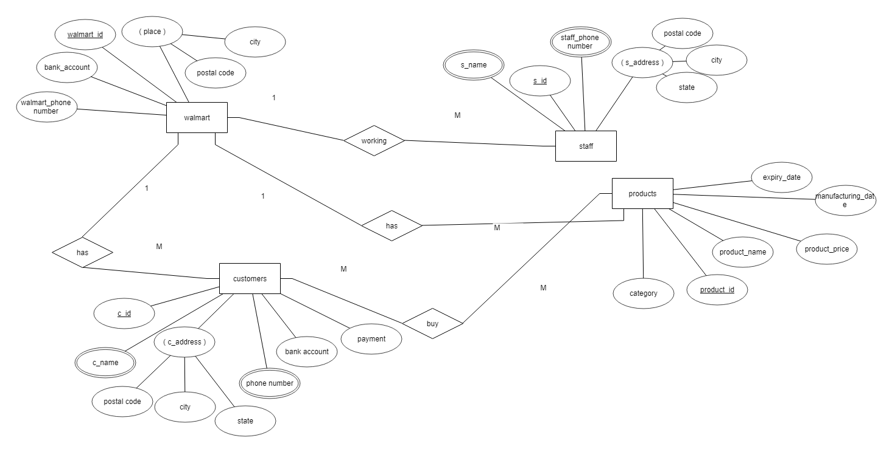

**Entities:**

Walmart

Customers

Staff

Products

**Attributes:**

1. **Walmart:**

wallmart_id(unique key),

Bank account

wallmart _phone number

place (place is composite attribute, postal code, city and state are sub attributes of place attribute)

1. **Customers**:

c_id(unique key)

c_name(multivalued attribute)

c_address(c-address is composite attribute: postal code, city and state are sub attributes of c_address attribute)

Phone number

Bank account

payment

1. **Products**:

Product_id(unique key)

Category

Product name(multivalued attribute)

Product price

Manufacturing_date

Expiry_date

1. **Staff**:

s_id(unique key)

s_name(multivalued attribute)

Phone number(multivalued attribute)

s_address(s_address is composite attribute: postal code, city and state are sub attributes of s_address attribute)

**Relationship among the entities**:

One to one (1 to 1): no

One to many (1 to M): Walmart to customers

Walmart to staff

Walmart to products

Many to many (M to M):customers and products