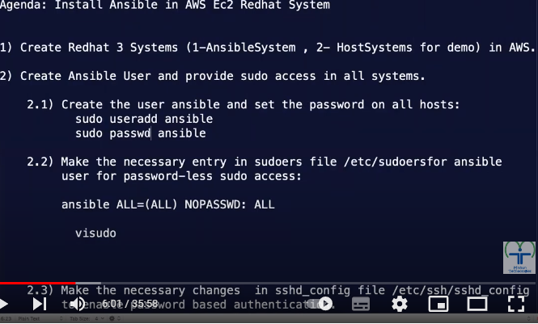

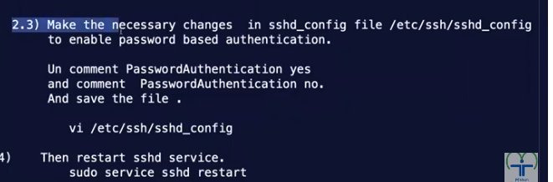

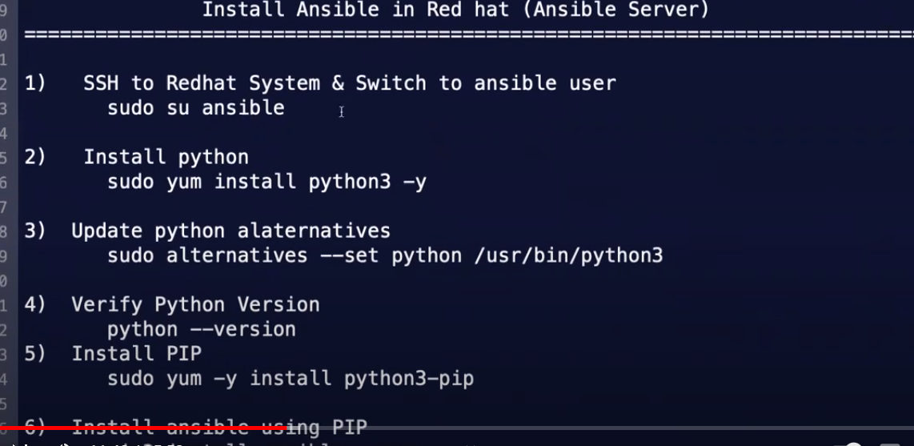

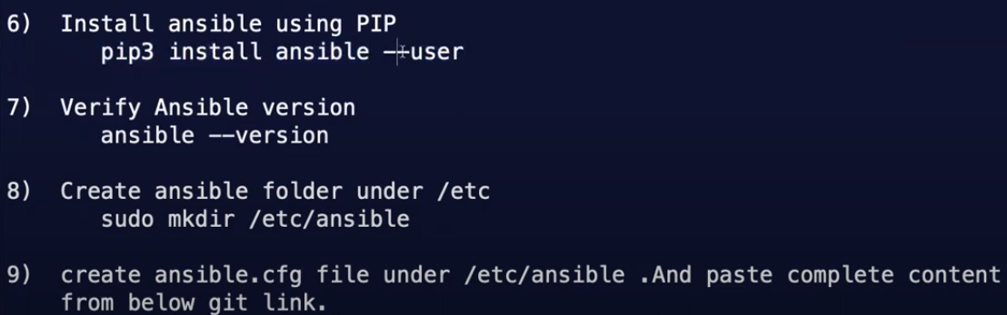

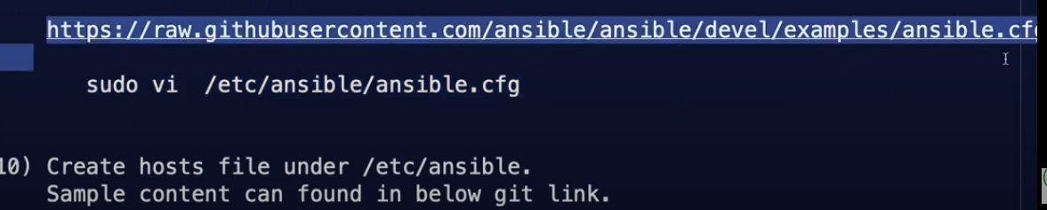

Go to the above github linsk and the available data is enter into the vi editor

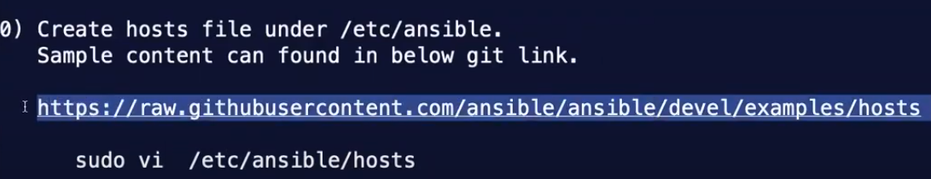

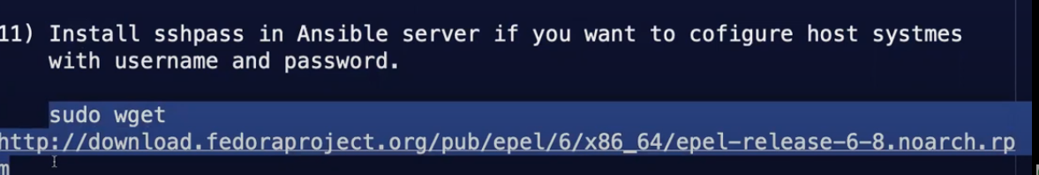

Now add the hosts in theinventory file

Sudo vi /etc/ansible/hosts

Three approaches are there for connecting agents to master

1.

Now give the private ip addresses of agents

Now we have to check the ansible master is connected or not by using the following command

Sudo vi /etc/ansible/ansible.cfg

Uncomment the following

Host_key_checking = false

Ansible all –m ping

Even though agents are not connected

Vi /etc/ansible/hosts

Private ip ansible_user=ansible ansible_password=ansible

Anothewr way for connection is ssh keys

2

For that

Ssh-keygen –t rsa

ssh-copy-id ansible@private ip of agent

ansible all –m ping

3

Sudo vi /etc/ansible/hosts

Private ipaddress of slave ansible_user=ec2-user ansible_ssh_private_key_file=~/aws.pem

As of noew I don’t have pem file here ,right now I want to take pem file

Vi aws.pem-------------------------🡪enter the pem file here

Chmod 400 aws.pem

Ansible all –m ping