What is SRE?
Site Reliability Engineering (SRE) is a discipline that incorporates aspects of software engineering and applies them to infrastructure and operations problems. The main goal is to create “scalable and highly reliable software systems.”
(or)
It is a discipline that applies software engineering mindsets and techniques to IT operations.
(or)
Site Reliability Engineering (SRE) is a method used to keep computer systems, websites, and applications reliable, fast, and available.
Main idea: Use engineering and automation to manage system operations.

Objectives of SRE:
The goal of Site Reliability Engineering (SRE) is to “find the perfect balance between releasing new features and ensuring the system is reliable for users.”
The main goals of SRE are:
- Reliability – Ensure systems meet availability and performance targets
- Scalability – Handle growth without failures
- Efficiency – Automate repetitive tasks
- Resilience – Recover quickly from failures
- Balance speed & stability – Enable fast releases without sacrificing reliability

Core Principles:
Benjamin Treynor Sloss, the founder of Google’s SRE team, famously stated: "SRE is what happens when you ask a software engineer to design an operations function."
1. The Core Objective: "Reliability is the Most Important Feature"
If a user cannot access a service, it doesn't matter how many innovative features that service has. SREs believe that reliability is the foundation of the entire user experience.
“Reliability” is a vague word.
- ❌ The system should be reliable (not measurable)
- ✅ The system should be available 99.9% of the time (measurable)
👉 SRE solves this by converting reliability into numbers.

- Embracing Risk: No system can be 100% reliable. SREs accept this and focus on defining an "acceptable" level of failure.
- Service Level Objectives (SLOs): Reliability is measured against specific targets (e.g., "The site should be up 99.9% of the time").
- Eliminating Toil: "Toil" is manual, repetitive, and automatable work. SREs strive to automate these tasks so they can spend at least 50% of their time on engineering projects.
- Monitoring & Observability: You cannot improve what you cannot measure. SREs build systems to monitor health, performance, and user experience.
- Automation: Replacing human intervention with code to manage infrastructure, deployments, and incident responses.
- Simplicity: Keeping systems as simple as possible. Complexity is the enemy of reliability.
2. Quantitative Goals (The "How")
SREs translate the abstract concept of "reliability" into concrete, measurable goals:
- Defining the Error Budget: Instead of aiming for 100% uptime (which is impossible and expensive), SREs define an "acceptable" level of failure. This allows for calculated risk-taking.
- Managing Toil: A major goal is to limit manual, repetitive operational work. If an SRE spends more than 50% of their time on manual tasks, the system is considered "broken" from an engineering perspective.
- Maximum Automation: The goal is to build self-healing systems. If a server fails, the system should detect it and restart it without a human ever receiving a page.
3. The 3 Pillars of SRE Success
To reach these goals, SRE teams focus on three specific outcomes:
Pillar | Focus | Goal
Observability | Telemetry and Metrics | To know exactly why a system is failing, not just that it is failing.
Scalability | Infrastructure as Code | To ensure the system can handle 10x or 100x the traffic without a linear increase in human effort.
Resiliency | Fault Tolerance | To design systems that gracefully degrade rather than crashing entirely during a dependency failure.

4. Cultural Goal: Blamelessness
One of the most unique goals of SRE is to change the culture of failure. In traditional ops, failure often leads to finger-pointing. In SRE, the goal is to treat every failure as a free lesson. * Failures are seen as bugs in the system or process, not the person.
- The goal is to ensure that once an incident happens, the system is improved so that specific type of failure can never happen again.

SRE key principles can be broken down into:
- Automation
- Application Performance Monitoring (APM)
- Maintaining Service Level Objectives (SLOs)
- Embracing and Managing Risk

Summary in a Sentence:
The goal of SRE is to engineer a highly automated, scalable system that meets the user's expectations for reliability while allowing the business to innovate as fast as possible.

SRE Key Metrics:
In SRE, metrics are not just isolated numbers; they form a hierarchical ecosystem where each level supports the one above it. To understand how they correlate, you must look at them through two distinct lenses: the Strategic Hierarchy (Business & Compliance) and the Operational Vital Signs (Technical Health).
1. The Strategic Hierarchy: SLI → SLO → SLA
This is the most critical correlation in SRE. It connects raw data to business promises.
- SLI (Service Level Indicator): The raw measurement (e.g., "99% of requests were successful"). This is the input.
Common SLI Categories:
- Availability - Measures how often the service is usable
Example: 999 successful requests out of 1000, Availability = 99.9%
- Latency - Measures how fast the system responds.
Example: 95% of requests respond in < 200 ms
- Error Rate - Measures how many requests fail.
Example: 5 failures in 1000 requests = 0.5% error rate

- SLO (Service Level Objective): The target for that measurement (e.g., "We want 99.9% success over 30 days"). This is the goal.
Examples of SLOs:
- 99.9% availability per month
- 95% of requests under 200 ms
- Error rate below 1%

- SLA (Service Level Agreement): The legal contract (e.g., "If success drops below 98%, we pay a fine"). This is the consequence.

- The Error Budget is the glue between these three. It is calculated as:
Error Budget = 100% - SLO

Note:
- If SLI > SLO: You are under budget. You have "money in the bank" to take risks, like deploying new features or performing maintenance.
- If SLI < SLO: Your budget is exhausted. You must stop feature work and focus exclusively on reliability to avoid hitting the SLA (the legal "danger zone").
How does SRE translate reliability into measurable goals?
SRE translates reliability into measurable goals using SLIs, SLOs, SLAs, and error budgets. SLIs measure system performance, such as availability and latency. SLOs define target values for these measurements. SLAs are formal promises made to users. Error budgets define the acceptable level of failure and help control release speed. This approach makes reliability measurable and manageable.
2. The Operational Correlation: The Four Golden Signals:
While the hierarchy tells you if you are healthy, the Four Golden Signals tell you where the pain is. They are highly co-related:
Metric | Correlation with Other Signals
Traffic | The Catalyst: As Traffic increases, Saturation almost always rises. If Saturation hits 100%, Latency will spike, and eventually, Errors will occur.
Saturation | The Predictor: High Saturation is a leading indicator. If your CPU is at 95% (Saturation), you can predict that Latency will soon increase for the next set of requests.
Latency | The Symptom: High Latency is often a precursor to Errors. When a system is too slow, connections time out, resulting in a 504 Gateway Timeout (Error).
Errors | The Outcome: Errors are the ultimate "bad" event. They directly burn your Error Budget and negatively impact your SLI.

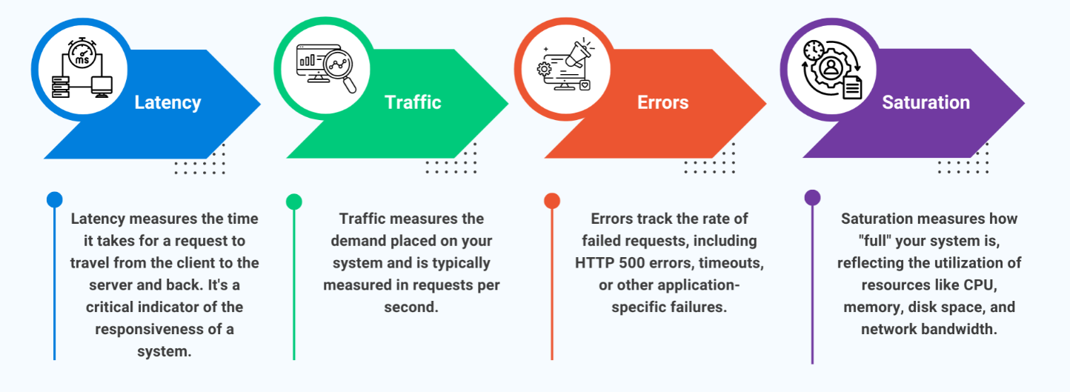

How to Use the Four Golden Signals:
To use the Four Golden Signals effectively, it is important to set up comprehensive monitoring and alerting for your system. This begins by:
- Defining Baselines and Thresholds: Establish normal operating ranges or Service Level Objectives for each signal. SLOs help identify anomalies and set up meaningful alerts. For instance, you might set a latency threshold of 200ms, beyond which an alert is triggered.
- Implementing Alerting: Configure alerts to notify your oncall team when signals exceed predefined thresholds, ensuring that you can respond to issues promptly. Use tools like PagerTree to manage and escalate alerts and notifications.
- Analyzing Trends: Review historical data regularly to understand trends and patterns. Regular reviews can help with proactive capacity planning and identifying areas for optimization. Tools like Google Data Studio or Power BI can aggregate and present this data in a consumable format.
- Automating Responses: Where possible, automate responses to common issues. For instance, auto-scaling can help manage traffic spikes, and automated runbooks can resolve recurring issues quickly.
SRE vs Traditional Operations?
Feature | Traditional Operations (SysAdmin) | Site Reliability Engineering (SRE)
Mindset | "Don't break the server." (Reactive) | "Design a system that can fail safely." (Proactive)
Primary Tool | Manual configuration and scripts. | Code (Infrastructure as Code, Go, Python).
Change | Viewed as a risk; often involves "Change Boards." | Viewed as inevitable; managed via Error Budgets.
Work Style | Toil-heavy: Repeating tasks manually. | Engineering-heavy: Automating tasks away.
Failure | Often leads to "Blame" or human error focus. | Blameless: Focused on systemic improvements.
Success Metric | "Uptime" (e.g., the server is on). | SLOs (e.g., the user experience is good).
SRE vs DevOps:
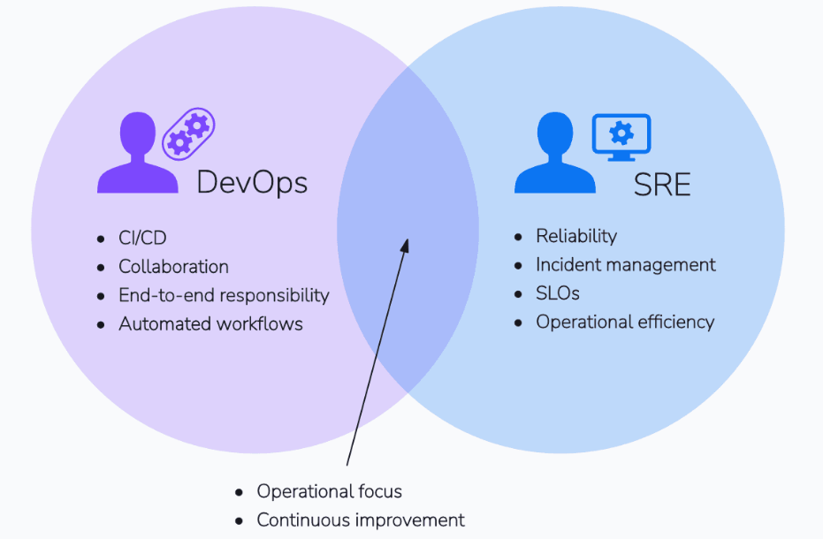
While DevOps and Site Reliability Engineering (SRE) share the same goal of bridging the gap between development and operations, they are not the same thing. The most common way to describe the relationship is:
"SRE is a specific implementation of the DevOps philosophy."
1. Philosophical vs. Pragmatic
- DevOps (The "What"): A cultural movement focused on breaking down silos, increasing deployment frequency, and creating a shared responsibility for the product. It is often a "mindset."
- SRE (The "How"): A job role and a set of engineering practices. It provides prescriptive ways to measure success, manage risk, and handle failures using software engineering principles.
2. Key Differences in Practice
Feature | DevOps | SRE
Primary Goal | Velocity & Agility | Reliability & Scalability
Focus | How to ship code faster. | How to keep the system up while shipping code.
Failure | Failure is a "learning opportunity." | Failure is managed via Error Budgets.
Measurement | Lead time for changes, deployment frequency. | SLIs, SLOs, and SLAs.
Core Skill | Collaboration and CI/CD. | Automation, Coding, and Systems Design.

Similarities between SRE and DevOps
SRE and DevOps share the goal of improving software development and operations by contributing to a more resilient and agile IT infrastructure. Both focus on automation, continuous monitoring, and optimizing system performance to reduce downtime and operational issues. They encourage a culture of shared responsibility, where development and operations teams work together to deliver software more quickly and reliably.

SRE Responsibilities:
An SRE's responsibilities are centered on the idea that operations is a software problem. Instead of manually managing servers, SREs build software to manage those servers.
To keep a balance between development and operations, SREs typically split their time: 50% on operational tasks (toil) and 50% on engineering projects that eliminate future toil.

1. Defining and Monitoring Reliability:
The most critical responsibility is quantifying "health."
- Defining SLIs and SLOs: Working with product owners to decide which metrics matter (Indicators) and what the target "uptime" should be (Objectives).
- Managing the Error Budget: Tracking how much "downtime" is left for the month and deciding if the team can ship new features or must focus on stability.
- Observability: Building dashboards and alerting systems that don't just say "it's broken," but point to why it's broken
2. Incident Response & On-Call
When the system fails, SREs are the first line of defense.
- On-Call Rotation: Being available to respond to critical system alerts.
- Incident Command: Leading the technical response during an outage to coordinate fixes and communication.
- Blameless Postmortems: Analyzing failures after the fact to identify root causes and ensure the same incident never happens twice.
3. Automation and Toil Reduction
SREs hate doing the same thing twice. If a task is repetitive, they automate it.
- Infrastructure as Code (IaC): Using tools like Terraform or Ansible to "code" the infrastructure so it is repeatable and version controlled.
- Self-Healing Systems: Writing scripts that automatically restart failed services, clear full disks, or scale up resources during traffic spikes.
- CI/CD Pipeline Support: Ensuring that the path from a developer's laptop to production is automated, fast, and safe.
4. Performance & Capacity Planning
SREs ensure the system can handle today's traffic and next year's growth.
- Load Testing: Intentionally stressing the system to find where it breaks.
- Capacity Forecasting: Analyzing trends to predict when more hardware or cloud resources will be needed before the system slows down.
- Efficiency Tuning: Optimizing resource usage (CPU/Memory) to reduce cloud costs without sacrificing performance.
5. Change Management & Release Engineering
Ensuring that new code doesn't crash the system.
- Canary Deployments: Rolling out changes to a small subset of users (e.g., 1%) to test for bugs before a full rollout.
- Rollback Automation: Ensuring that if a new release causes errors, the system can revert to the previous "known good" version in seconds.
6. Security & Compliance
In many organizations, SREs work closely with security teams (DevSecOps).
- Vulnerability Management: Ensuring patches are applied to infrastructure automatically.
- Access Control: Managing "Least Privilege" access to production environments.

Reliability Best Practices:
Reliability is not an accident; it is the result of deliberate architectural choices. In SRE, we follow a set of "battle-tested" best practices designed to minimize both the frequency and the impact of failures.
1. Design for Failure (The "Blast Radius")
Assume that every component—be it a database, a cloud region, or a third-party API—will eventually fail.
- Decoupling: Use asynchronous communication (like Message Queues) so that if Service A fails, Service B can keep functioning.
- Limit Blast Radius: Use "Cell-based Architecture" or "Bulkheading." If one part of the system fails, it should not be able to pull down the rest of the infrastructure.
- Graceful Degradation: If the "Personalized Recommendations" service is down, the website should show "Generic Best Sellers" instead of a 500 Error page.

2. Safe Deployment Practices
Most outages are caused by a "change" (new code or configuration).
- Canary Deployments: Release a change to 1% of users, monitor for errors, and only then proceed to 10%, 50%, and 100%.
- Blue-Green Deployment: Run two identical production environments. Switch traffic to "Green" (new). If it fails, switch back to "Blue" (old) instantly.
- Feature Flags: Wrap new features in toggles. This allows you to "turn off" a buggy feature in production without doing a full code rollback.
- Automated Rollbacks: Set up your CI/CD to automatically revert a deployment if the Error Rate or Latency SLIs cross a certain threshold.

3. Implement Protective Patterns
Don't let your services "suicide" by trying to handle impossible loads.
- Circuit Breakers: If a downstream service is slow/failing, the caller should stop trying for a while (trip the circuit) to allow the downstream service to recover.
- Retries with Exponential Backoff: If a request fails, don't retry immediately (which creates a "retry storm"). Wait 1s, then 2s, then 4s, adding "jitter" (randomness) to prevent synchronized hits.
- Rate Limiting & Throttling: Protect your resources from being overwhelmed by a single "noisy neighbor" or a DDoS attack.

4. Operational Hardening
Reliability is as much about the humans as it is about the code.
- Chaos Engineering: Periodically "inject" failures into production (e.g., kill a random pod, latent a network) to verify that your self-healing systems actually work.
- Game Days: Run "Fire Drills" where the team practices responding to a simulated major outage.
- Immutable Infrastructure: Never "patch" a server in place. If you need a change, build a new image and replace the old one. This eliminates "Configuration Drift."

5. Observability over Monitoring
Monitoring tells you if something is wrong; Observability helps you understand why.
- Standardize Metrics: Use a consistent naming convention for metrics across all teams.
- Contextual Logging: Ensure logs contain trace IDs so you can follow a single user's request across 10 different microservices.
- Alert on Symptoms, not Causes: Don't wake an engineer at 3 AM because "CPU is 90%." Wake them because "User checkout success rate has dropped below 99%."
Reliability Checklist for New Services:
Best Practice | Status | Why it Matters
Auto-scaling | [ ] | Handles traffic spikes without human intervention.
Health Checks | [ ] | Allows the Load Balancer to stop sending traffic to "sick" nodes.
Multi-AZ/Region | [ ] | Protects against a data center or cloud provider outage.
Secrets Mgmt | [ ] | Prevents outages caused by expired certificates or leaked keys.

Tools Commonly Used in SRE:
SREs use a "best-of-breed" toolchain to manage infrastructure, automate tasks, and gain visibility into system health. These tools are generally categorized by their function within the SRE Lifecycle.

1. Infrastructure as Code (IaC) & Provisioning
SREs treat infrastructure like application code. These tools allow them to build, version, and destroy environments consistently.
- Terraform: The industry standard for platform-agnostic infrastructure provisioning.
- Ansible / Chef / Puppet: Used for configuration management (ensuring the OS and software are set up correctly).
- Pulumi: Allows SREs to define infrastructure using familiar programming languages like Python or TypeScript.

2. Containerization & Orchestration
Most modern SRE work revolves around managing clusters that can scale automatically.
- Kubernetes (K8s): The primary orchestration tool for deploying and scaling containers.
- Docker / Containerd: The runtime used to package applications into portable units.
- Helm: The "package manager" for Kubernetes, used to manage complex K8s applications via reusable templates.

3. Observability & Monitoring
You cannot have an SLO (Service Level Objective) without data. SREs use these tools to track indicators and alert on failures.
- Prometheus: A time-series database and monitoring system, often the default for Kubernetes environments.
- Grafana: The leading dashboarding tool used to visualize data from Prometheus, CloudWatch, or SQL.
- ELK Stack (Elasticsearch, Logstash, Kibana): Used for log aggregation and searching through millions of lines of logs.
- OpenTelemetry: An open-source framework for collecting traces, metrics, and logs across microservices to enable full-stack observability.

4. Incident Management & On-Call
When a threshold is breached, these tools ensure the right person is notified immediately.
- PagerDuty / Opsgenie: Manages on-call rotations and sends alerts via SMS, phone calls, or app notifications.
- Slack / Microsoft Teams: Acts as the "Command Center" during incidents (often referred to as ChatOps).
- FireHydrant / Jeli: Specialized platforms for managing the incident lifecycle and automating postmortem generation.

5. Automation & CI/CD
SREs use these to ensure code is released safely and to automate "toil."
- GitHub Actions / GitLab CI / Jenkins: Automates the building, testing, and deployment of code.
- ArgoCD: A GitOps tool for Kubernetes that ensures the "live" state of a cluster matches the code stored in Git.
- RunDeck: Used for self-service operations and automating "runbook" tasks (like clearing cache or restarting services).

6. Chaos Engineering
To build resilient systems, SREs use tools to intentionally break things in a controlled way.
- Gremlin: A "Failure-as-a-Service" platform to test system resilience.
- Chaos Mesh: An open-source chaos engineering platform specifically for Kubernetes.
- AWS Fault Injection Simulator (FIS): A managed service for running fault injection experiments on AWS resources.
Tooling Summary Table:
Category | Primary Tools | SRE Value
Provisioning | Terraform, CloudFormation | Consistency & Speed
Visibility | Prometheus, Grafana, Datadog | Measuring SLOs
Log Analysis | ELK Stack, Splunk | Root Cause Analysis
Incident Response | PagerDuty, Slack | Reducing MTTR (Mean Time To Repair)
Resilience | Gremlin, Chaos Mesh | Proactive Failure Discovery

Incident Management Lifecycle & Blameless Postmortems:
In SRE, Incident Management is the process of responding to a crisis, while the Blameless Postmortem is the process of learning from it. Together, they form a "Virtuous Cycle" that ensures the system becomes stronger after every failure.
1. The Incident Management Lifecycle:
When a system breaches an SLO (Service Level Objective), the lifecycle begins. The goal is to move from "Detection" to "Resolution" as fast as possible to minimize the MTTR (Mean Time to Repair).
Phase 1: Detection & Alerting
- The Trigger: An automated monitor (like Prometheus) detects a symptom (e.g., 5% error rate) and triggers an alert.
- Notification: The on-call engineer is notified via a tool like PagerDuty.
Phase 2: Triage & Coordination
- Declaration: The engineer "declares" an incident (Major or Minor) in a central channel (Slack/Teams).
- Role Assignment: * Incident Commander (IC): The leader who coordinates the response (doesn't fix the code).
  - Operations Lead (Ops): The person actually performing the fixes/rollbacks.
  - Communications Lead (Comm): The person updating stakeholders and customers.
Phase 3: Mitigation (Not Resolution)
- Focus: Stop the bleeding.
- Action: If a new deployment caused the issue, Rollback. If traffic is too high, Scale up. The goal is to restore service, even if the "root cause" isn't fully understood yet.
Phase 4: Resolution
- Once the system is stable and the immediate threat is gone, the incident is closed.

2. The Blameless Postmortem:
Once the "fire" is out, the SRE team conducts a postmortem. The "Blameless" aspect is the most critical cultural component of SRE.
Why "Blameless"?
If engineers fear being fired for a mistake, they will hide their errors. If they know they won't be blamed, they will provide the honest details needed to fix the systemic issue.
SRE Philosophy: We assume that everyone involved acted with the best intentions and the best information they had at the time. If an error happened, it’s because the system allowed it to happen.

Anatomy of a Postmortem Document:
- Summary: What happened in two sentences.
- Impact: How many users were affected? For how long?
- Timeline: A minute-by-minute account of events (Detection → Mitigation → Resolution).
- Root Cause Analysis (The "Five Whys"): Digging deep into why the failure happened.
  - Bad: "The engineer typed the wrong command."
  - Good: "The CLI tool lacked a confirmation prompt for destructive actions."
- Action Items: Concrete tasks to prevent recurrence (e.g., "Add confirmation prompt to CLI," "Automate rollback").

3. Connecting the Two: The "Feedback Loop"
The postmortem is useless if the action items aren't completed. SREs ensure that these items are prioritized in the next sprint.
Feature | Incident Management | Postmortem
Timeframe | During the outage (High stress) | After the outage (Low stress)
Focus | MTTR (Mean Time to Repair) | MTBF (Mean Time Between Failures)
Outcome | Service Restored | System Hardened

