FLOWRATIO IS MONEYNESS
VFLOW RATIO IS VOLUME FLOW
YOU GET 4 CONDITIONS.
1) Money going in bullish and volume going in bullish.
2) Money going in negative and volume positive.
3) money positive and volume negative
4) Money flow and volume flow negative.
My observation:
vflow near .6 or below put GXOI is dominant.
Vflow near .9 or above call GXOI is dominant.
There are exceptions that you will observe from time to time for the above pattern. So you need to use your judgement based on market S/R lines that you can draw, as well as regression lines, fib levels etc.

Figure 1:CHK2 Protein Structure includes protein breakdown and the sequence we used from Uniprot.
Figure 2:The primers created and ordered by me from Genscript based on the mutations desired.
Figure 3: Gel electrophoresis results confirming successful PCR amplification of the CHK2 wild-type and mutated genes. The bands indicate the presence of DNA fragments at expected sizes.
Figure 4: Growth of DH5-Alpha E. coli colonies transformed with wild-type and mutated CHK2 plasmids on ampicillin-resistant LB-agar plates. Colony formation indicates successful transformation.
Figure 5: Sanger sequencing results verifying the presence of engineered CHK2 mutations. Peaks in the chromatogram confirm specific nucleotide substitutions.
Figure 6: An image of the monolyser used to lyse the cell wall of the DE3-BL21 cells to release the contents within and eventually isolate the protein.
Figure 7: An image of all the proteins of which optical density was taken, these include the wildtype and mutated plasmid DNA.
Figure 8: Spectrophotometric analysis of CHK2 protein expression in DE3-BL21 cells. Absorbance measurements at 280 nm confirm varying levels of protein production across different mutations.
Figure 9:Comparison of CHK2 protein yield across different mutations. Some mutations enhance protein expression, while others lead to degradation or misfolding.

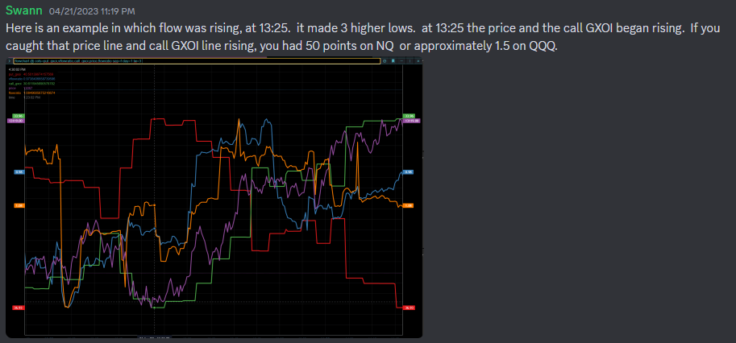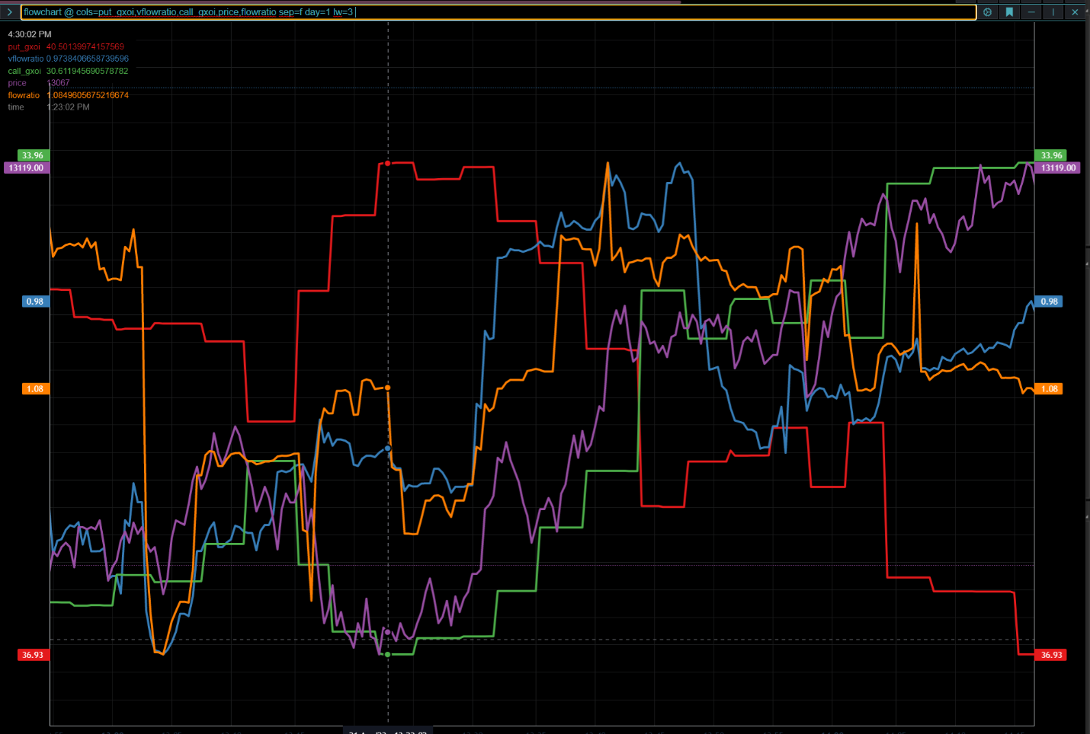at 14:05 the flow was starting down. Vflow was goin down at 13:50. This was indication of that move was exhausting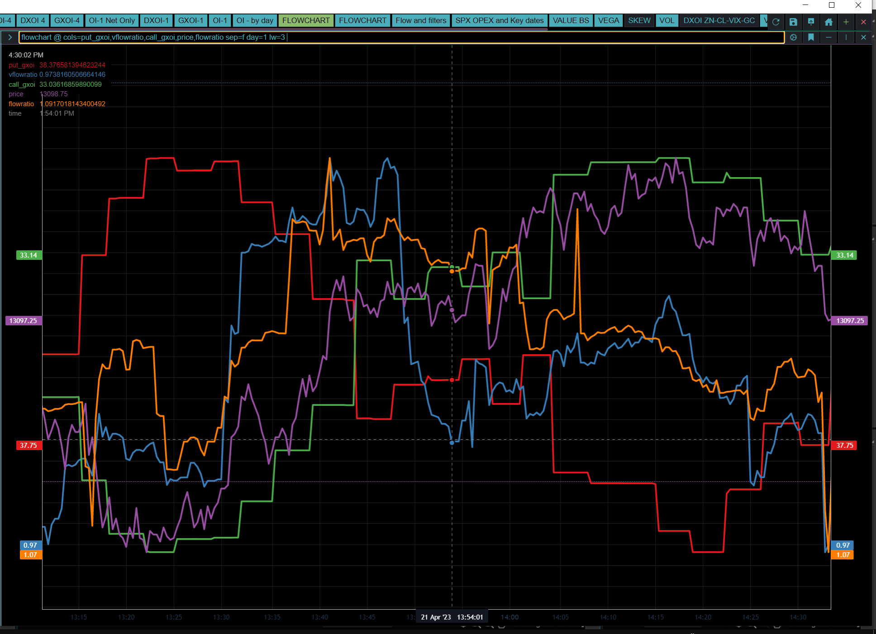
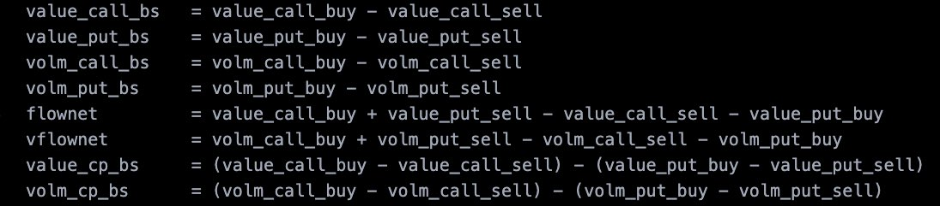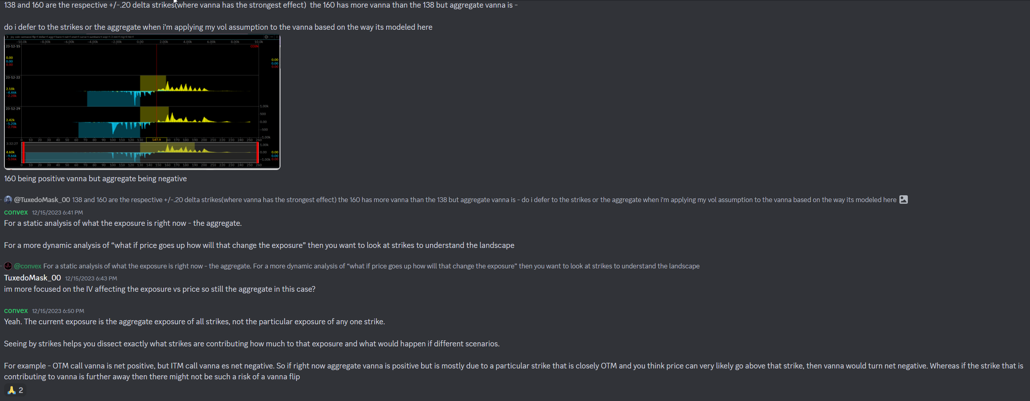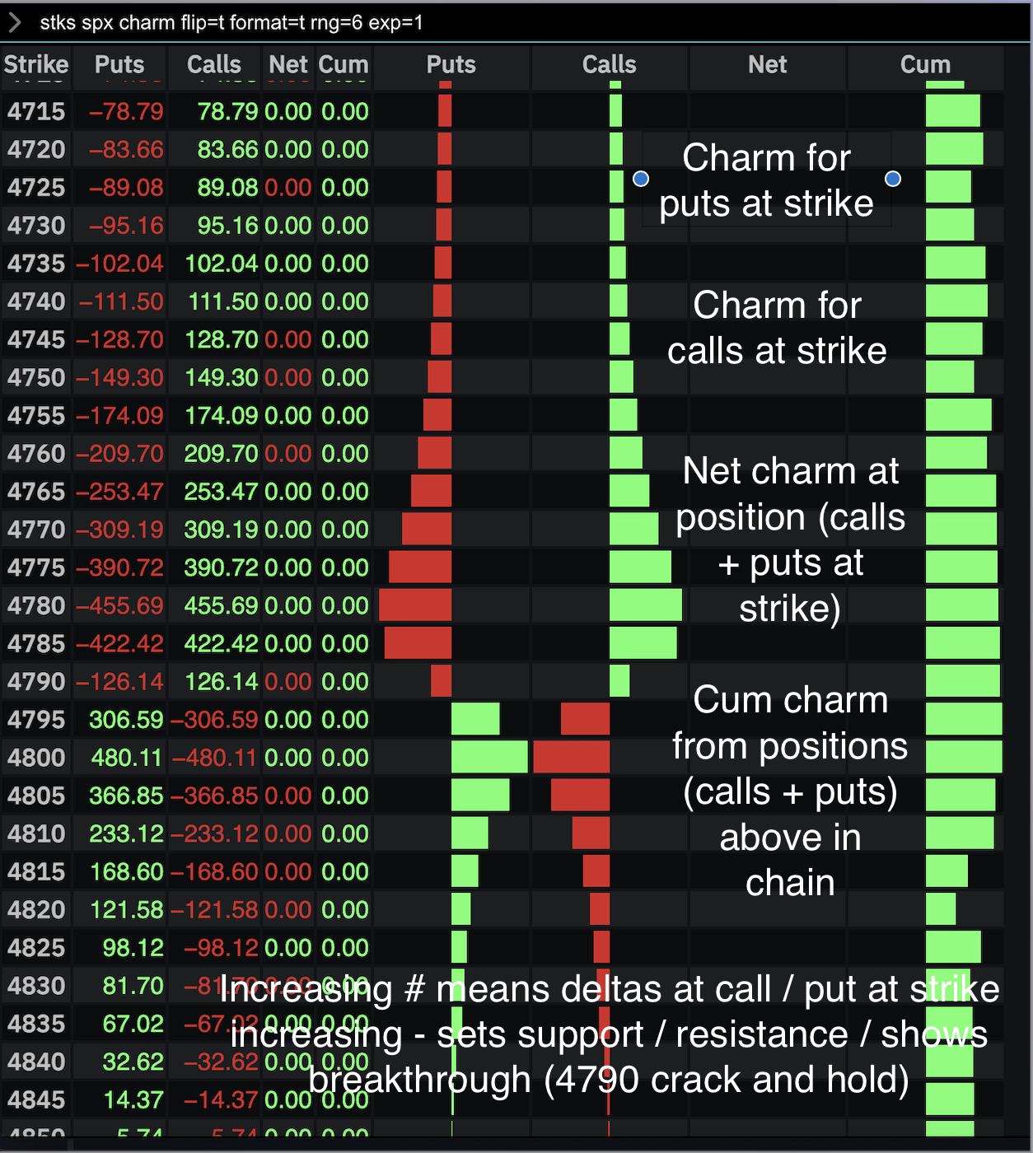
https://twitter.com/convexvalue/status/1736874690730189095?s=46&t=fKAtCiyxNi9fTvtwDRRURg

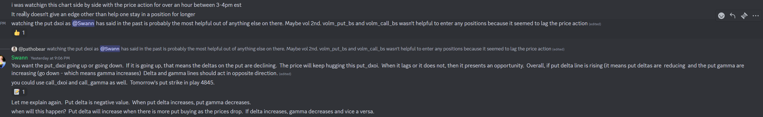

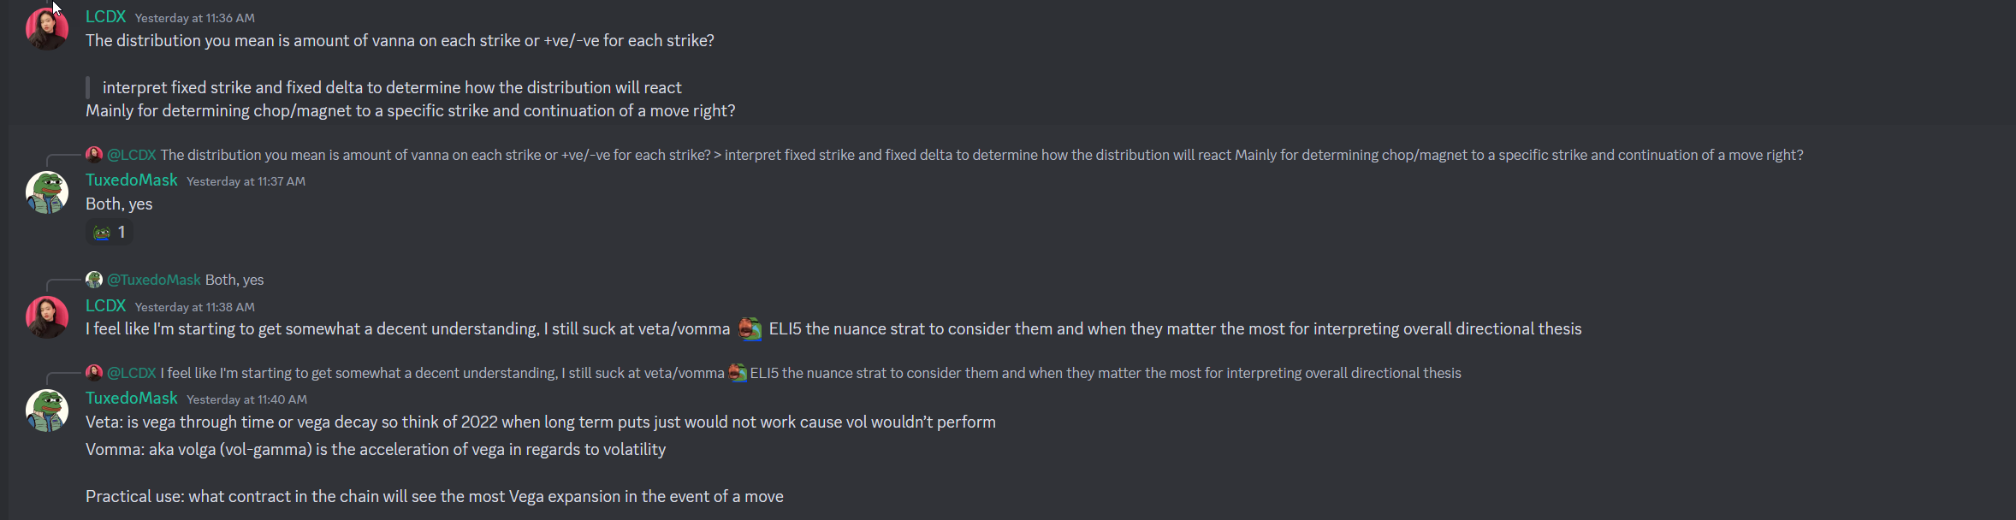
https://thetanerd.com/trading-options-with-vanna/

