JOHMARG
S T R I P S
PRODUCT CATALOGUE
Finishing Touches. Lasting Impression.
47 Products | 5 Ranges | Aluminium · Brass · Stainless Steel · PVC · Vinyl
trims@johmargstrips.co.za | +27 83 324 0532
Edition: July 2026

Contents
1. Metal Profiles — 22 products
2. Carpet, Wood & Laminate Profiles — 12 products
3. PVC Profiles — 4 products
4. Vinyl Profiles — 7 products
5. Tile Spacers — 2 products
This catalogue lists the complete Johmarg Strips product range across five families of tile trims, edge profiles, stair nosing, movement joints, and flooring transition strips. Materials, finishes and dimensions vary by product — contact our team for full specifications or a project-specific quotation.

1. Metal Profiles (22 products)
Our largest range — edge trims, stair nosing, corner protection, listellos and movement joints manufactured in Aluminium, Brass and Stainless Steel.
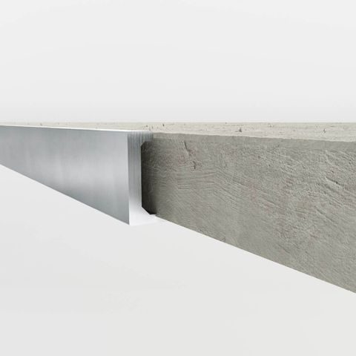  Straight Edge  A clean, straight finish and protective edge for all tiling applications.  MATERIALS: Aluminium, Brass, Stainless Steel | 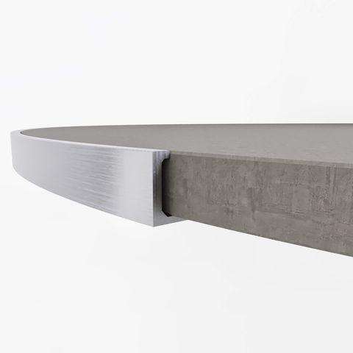  Formable Edge  Accommodates curved flooring areas with decorative, functional edge protection.  MATERIALS: Aluminium, Brass, Stainless Steel
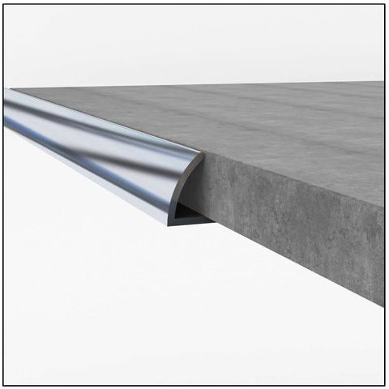  Round Edge  A semi-round face alternative to Straight Edge for efficient tile protection.  MATERIALS: Aluminium, Brass, Stainless Steel | 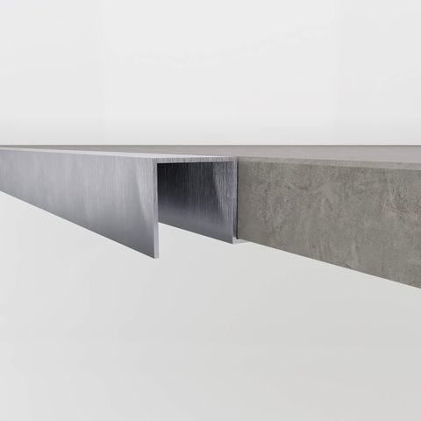  Square Edge  A versatile trim used vertically or horizontally as a feature strip on walls and floors.  MATERIALS: Aluminium, Brass, Stainless Steel
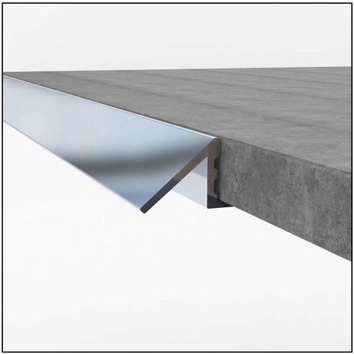  45° Ramp  Transitions between different floor covering heights while protecting exposed tile edges.  MATERIALS: Aluminium | 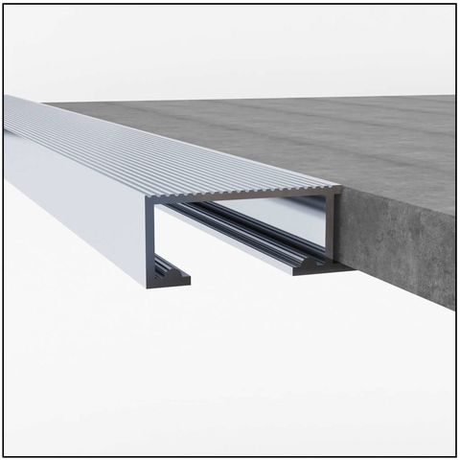  Tile In Step & Large Tile In Step  Installed during tiling to protect and finish ceramic stair edges, in two sizes.  MATERIALS: Aluminium
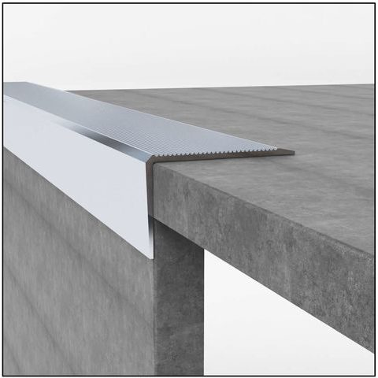  Retrofit Stair Nosing  Slip-resistant protection for existing tiled stairs, with optional PVC inserts.  MATERIALS: Aluminium, PVC Insert | 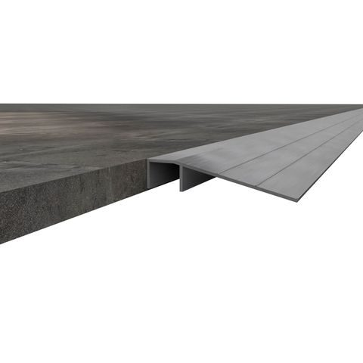  Retrofit Ramp  A post-installation transition profile between differing floor covering heights.  MATERIALS: Aluminium
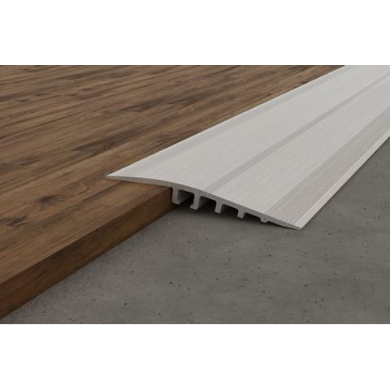  Large Transition Ramp  Transitions between floor covering heights across larger, wider areas.  MATERIALS: Aluminium | 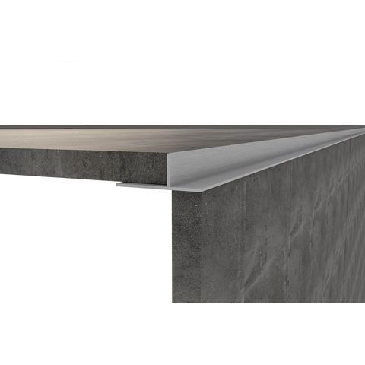  Tile In Internal Angle  Creates the opposite effect of a square edge, protecting internal corners.  MATERIALS: Aluminium
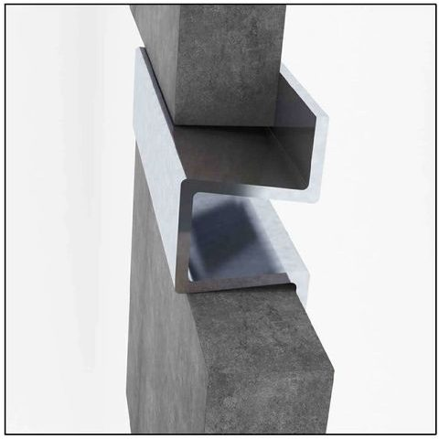  Listello  An elegant decorative feature strip for tiled wall coverings, multiple heights and finishes.  MATERIALS: Aluminium, Stainless Steel | 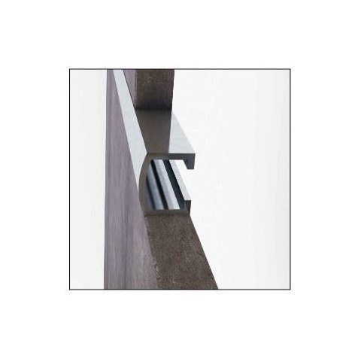  Retrofit / Pencil Listello  A slimline decorative alternative for elegant tiled wall coverings.  MATERIALS: Aluminium
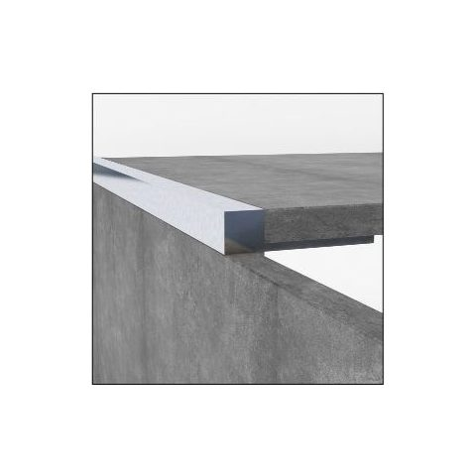  Mosaic Edge  Edge protection sized specifically for mosaic tiling applications, wall and floor.  MATERIALS: Polished Silver Aluminium | 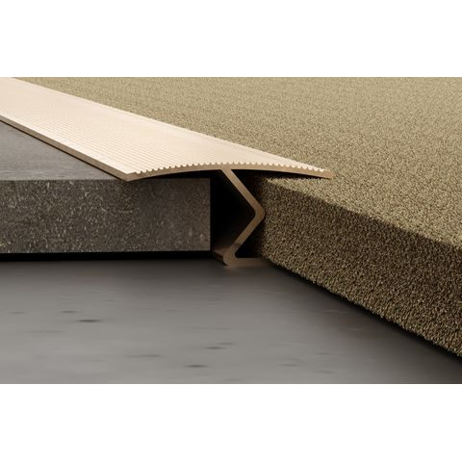  Vari Strip  A rounded, 28mm carpet-to-tile transition with gripper teeth to hold carpet in place.  MATERIALS: Aluminium
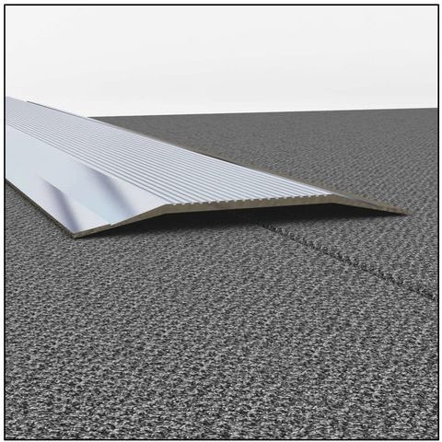  Cover Strip  A 40mm profile that covers gaps or edges between flooring installations.  MATERIALS: Aluminium | 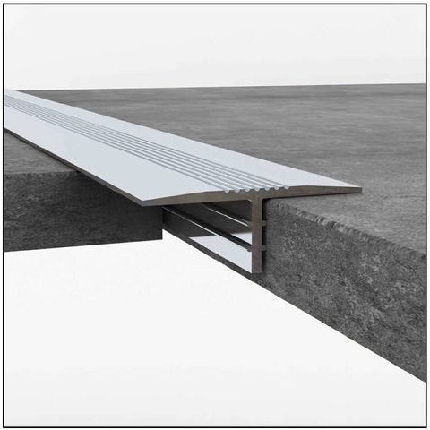  T-Piece  A 22mm dividing strip between different flooring surfaces, doubling as a protective solution.  MATERIALS: Aluminium
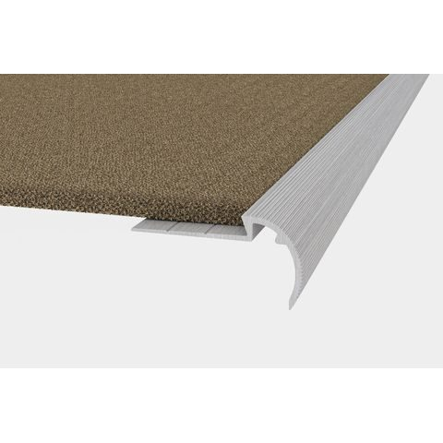  Carpet Tile Nosing  Joins carpet to other flooring types, particularly for staircase transitions.  MATERIALS: Aluminium | 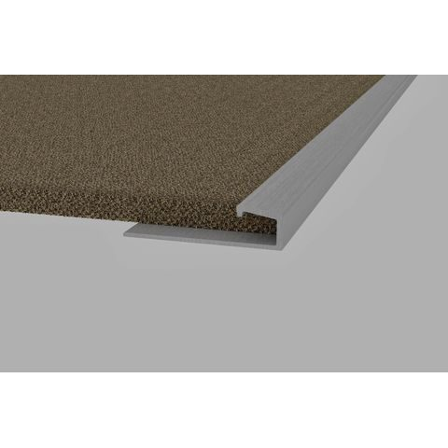  Carpet Square Edge (Fast Edge)  Protects the vulnerable edges typical of carpet installations.  MATERIALS: Aluminium
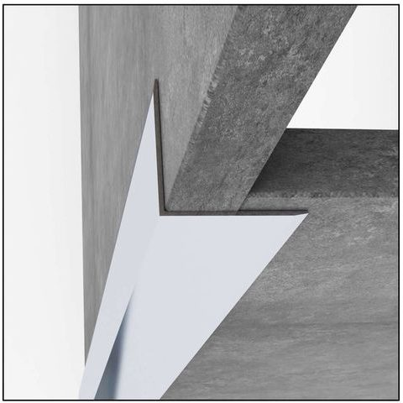  Retro Corner Protector  Prevents and cosmetically repairs damage on vulnerable external corners.  MATERIALS: Aluminium, Brass, Stainless Steel | 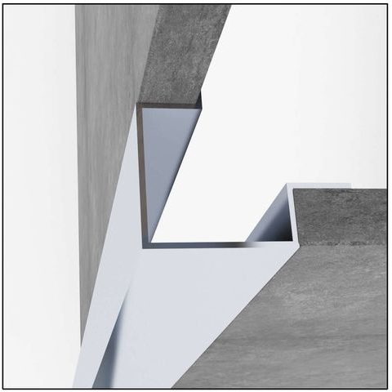  Tile In Corner Protector  Protects external corners of walls and columns as tiling is being installed.  MATERIALS: Aluminium, Brass, Stainless Steel
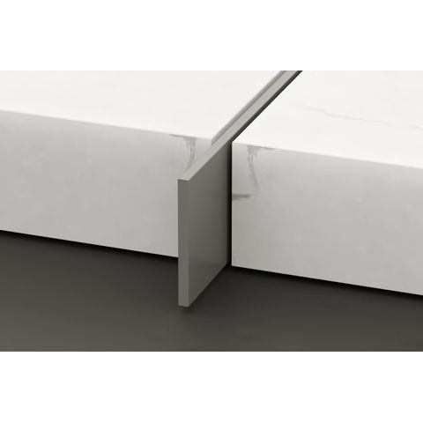  Dividing Strip / Flat Bar / Weather Bar / Skirting  A functional and decorative strip used to fill gaps and divide flooring.  MATERIALS: Aluminium, Brass, Stainless Steel | 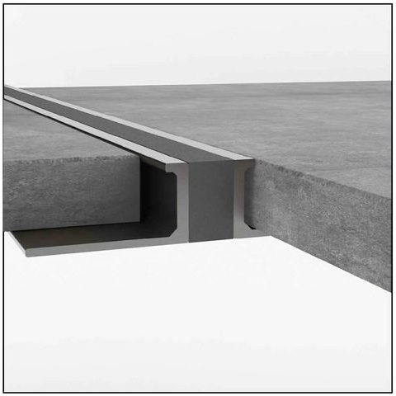  Heavy Duty Movement Joint  Allows tile panel movement to prevent cracking or lifting, medium to heavy duty.  MATERIALS: Aluminium, Brass, Stainless Steel

2. Carpet, Wood & Laminate Profiles (12 products)
Transition, edge and stair nosing profiles purpose-built for carpet, solid wood, laminate and LVT/SPC flooring installations.
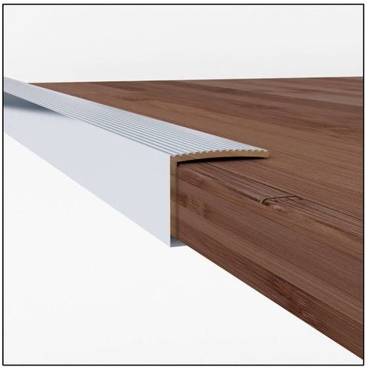  Wood Edge  Protects flooring outlines and edges while allowing for natural expansion and contraction.  MATERIALS: Aluminium | 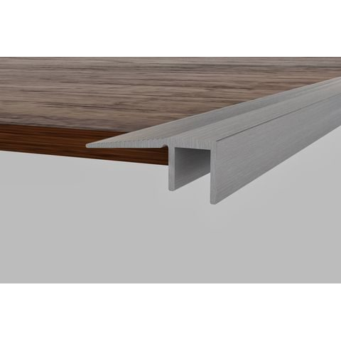  Wood End  Protects the vulnerable end edges of wooden flooring and covers small finishing gaps.  MATERIALS: Aluminium
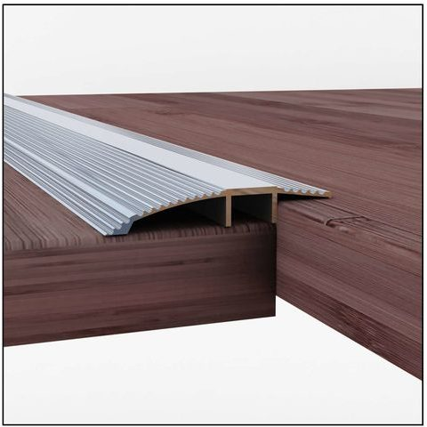  Wood Reducer / Transition  Transitions between different floor heights and coverings, such as tile to wood.  MATERIALS: Aluminium | 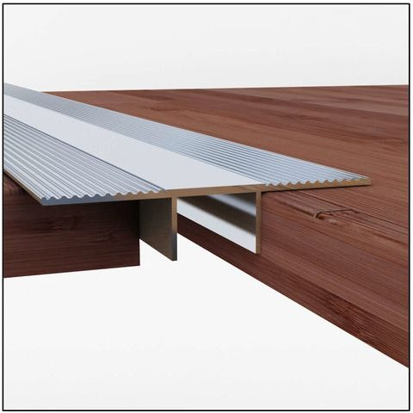  Wood Expansion Cover  Bridges gaps between hard, smooth finishes installed at the same height.  MATERIALS: Aluminium
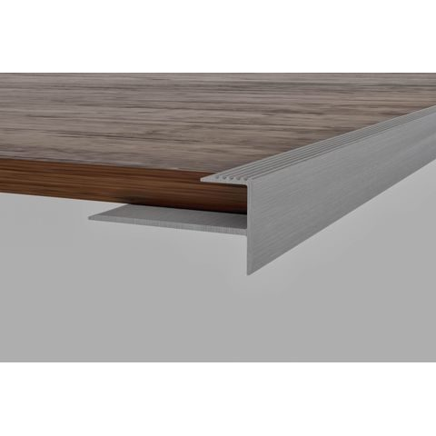  Wood Stair Nosing  Protects wooden stair edges with a clean, aesthetically pleasing finish.  MATERIALS: Aluminium | 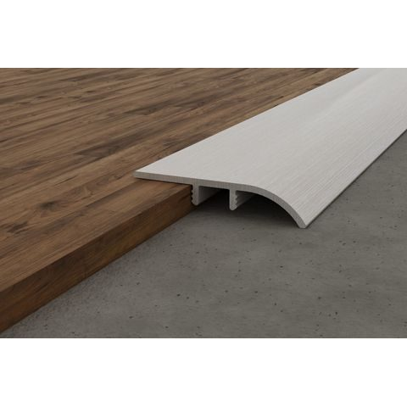  LVT / SPC Transition  Transitions between laminate/SPC flooring and other floor coverings.  MATERIALS: Aluminium
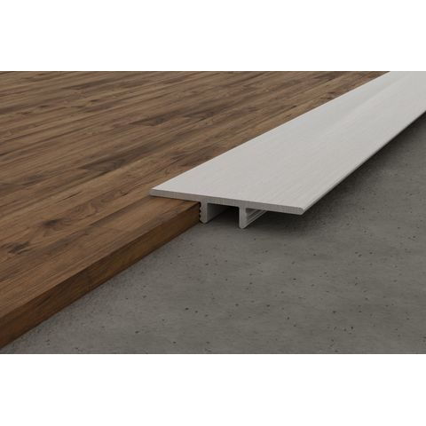  LVT / SPC Expansion  Allows for the expansion and contraction of laminate and SPC flooring.  MATERIALS: Aluminium | 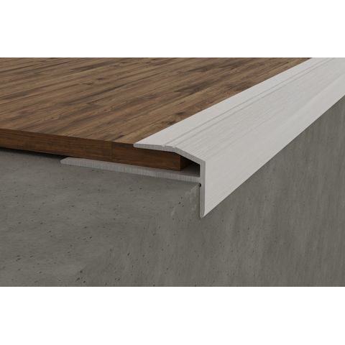  LVT / SPC Stair Nosing  Protects laminate and SPC stair edges with a clean, finished look.  MATERIALS: Aluminium
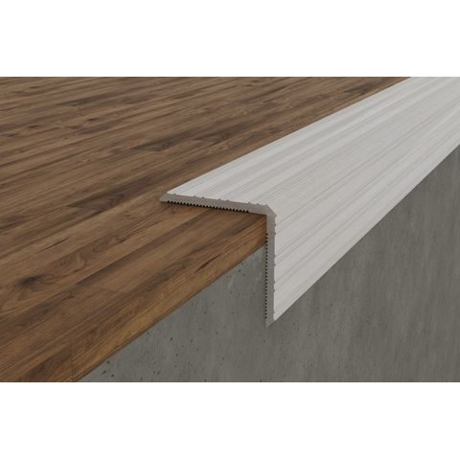  Retro 21 x 21 Stair Nosing  An alternative to standard Retrofit Stair Nosing with grooved corner adherence.  MATERIALS: Aluminium | 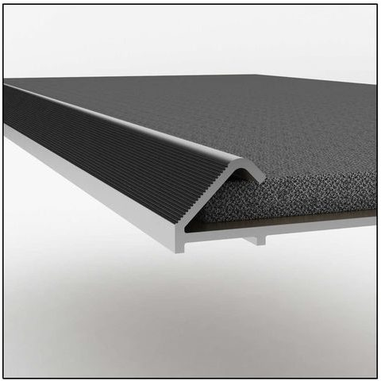  Naplock  Finishes and protects carpet installation edges, with gripper teeth to hold position.  MATERIALS: Aluminium
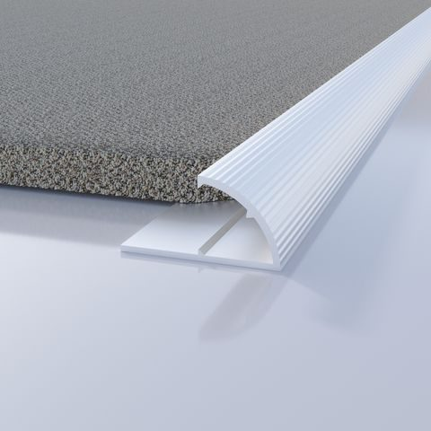  Thriftline  Similar to Naplock with a rounder face design and integrated gripper teeth.  MATERIALS: Aluminium | 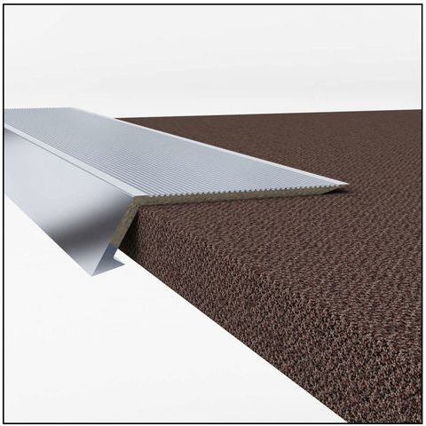  Tread Cover  A transition profile protecting the edges of vinyl, laminate or carpeted thresholds.  MATERIALS: Aluminium

3. PVC Profiles (4 products)
Lightweight, corrosion-resistant alternatives to metal trims — made from certified impact- and UV-resistant, non-toxic, lead-free virgin PVC.
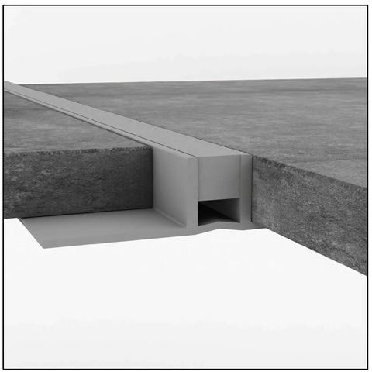  PVC Movement Joint  A lightweight alternative to metal movement joints, preventing tile cracking or lifting.  MATERIALS: Virgin PVC | 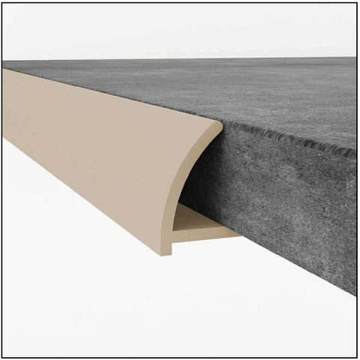  PVC Round Edge  A corner and wall-covering trim available in multiple heights, colours and marble finishes.  MATERIALS: Virgin PVC
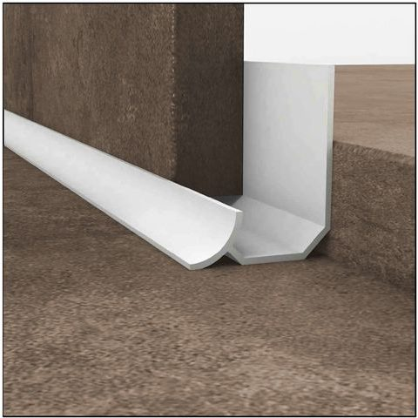  PVC Internal Seal Strip  A rigid, curved seal for horizontal and vertical surfaces installed during tiling.  MATERIALS: Virgin PVC | 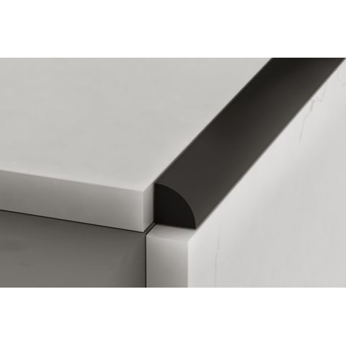  PVC Flexible Seal  A retrofit seal for horizontal and vertical surfaces, installed after tiling is complete.  MATERIALS: Virgin PVC

4. Vinyl Profiles (7 products)
Non-slip, hygienic and easy-to-clean vinyl profiles suited to healthcare, hospitality and other high-traffic environments.
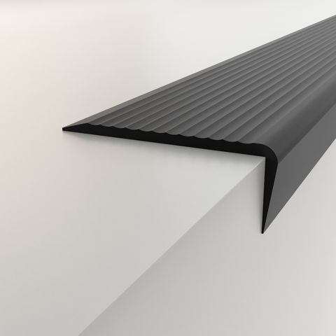  Vinyl Stair Nosing  Provides an effective non-slip surface and tread to the edge of steps.  MATERIALS: Vinyl | 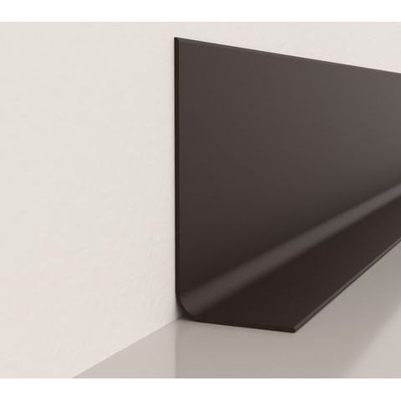  Vinyl Hospital Skirting  Installed in the angle between wall and floor for hygienic, hospital-grade finishes.  MATERIALS: Vinyl
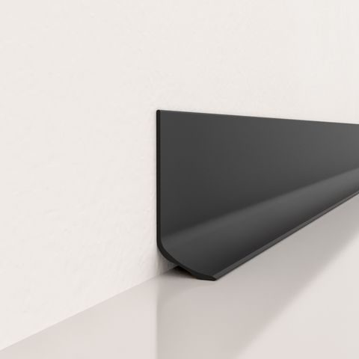  Vinyl Sit On Skirting  Installed over other profiles, such as the Cove Former, for a finished skirting look.  MATERIALS: Vinyl | 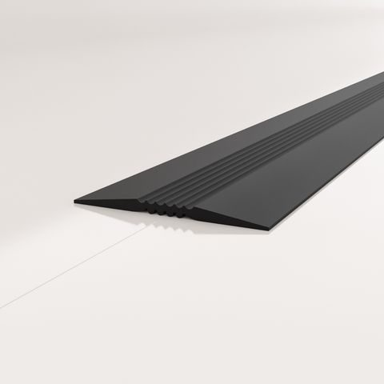  Vinyl Expansion Joint Cover  Installed over movement joints to absorb expansion and contraction.  MATERIALS: Vinyl
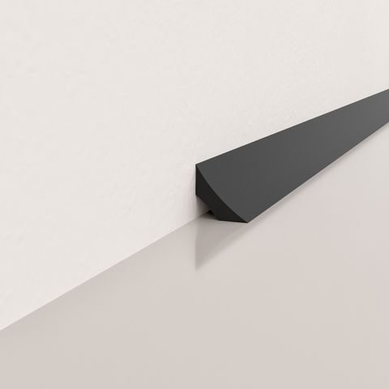  Vinyl Cove Former  A base installation profile for sheet flooring and wall applications.  MATERIALS: Vinyl | 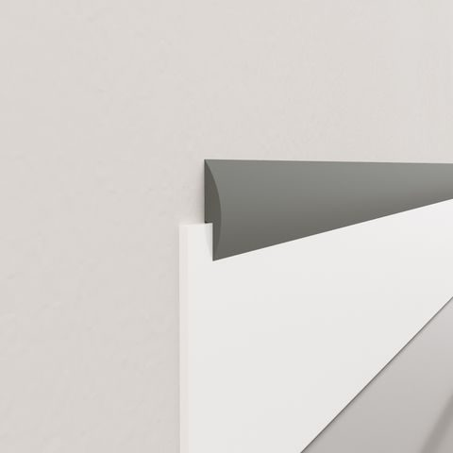  Vinyl Capping Strip 16mm  A sealed, finished edge for vinyl wall cladding and sheeting installations.  MATERIALS: Vinyl
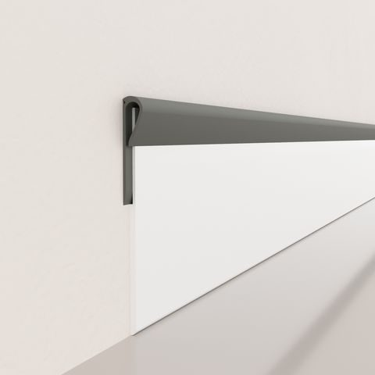
Vinyl Capping Strip 18mm
A wider sealed, finished edge for vinyl wall cladding and sheeting installations.
MATERIALS: Vinyl

5. Tile Spacers (2 products)
Essential installation accessories that keep tile spacing consistent and levels correct across every job.
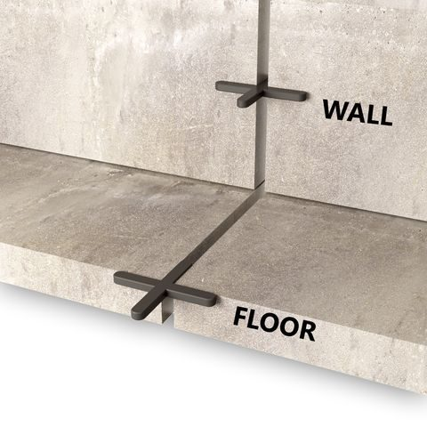  Tile Spacer  Maintains the desired space between tiles, used vertically or horizontally as required.  MATERIALS: Plastic | 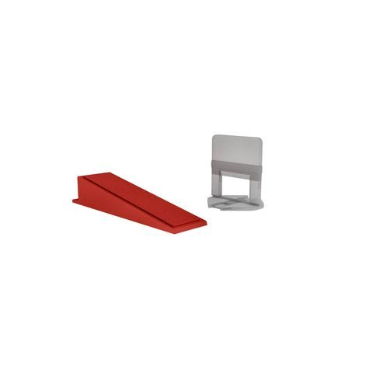  Self-Levelling Tile Spacers  Maintains correct spacing and levels during installation for a flawless finish.  MATERIALS: Plastic

JOHMARG STRIPS
trims@johmargstrips.co.za | +27 83 324 0532 | Currently operating online

