Sales Record

By

Meet Patel (17BCA061)

Akshay Ramnani (17BCA094)

Kartavya Vadera (17BCA114)

Under Guidance

of

Internal Guide

Dr. Dharmendra Patel

Submitted to



Smt. Chandaben Mohanbhai Patel Institute of Computer Applications

CHARUSAT

Changa

March/2020



[Accredited with Grade A by NAAC,  
 Accredited with Grade A by KCG](https://www.charusat.ac.in/)

CHAROTAR UNIVERISTY OF SCIENCE & TECHNOLOGY

Changa

**Acknowledgement**

Knowledge in itself is a continuous process. At this moment of our substantial enhancement, we rarely find words to express our gratitude towards those who were constantly involved with us.

The completion of any inter disciplinary project depends upon coordination, cooperation and combined efforts of several resources of knowledge, creativity, skill, energy and time. The work being accomplished now, we feel our sincerest urge to recall and knowledge through these lines, trying our best to give full credit wherever it deserves.

We would like to thank our project guide **Dr. Dharmendra Patel** and Dean & Principal **Dr. Atul Patel** who advised and gave us moral support through the duration of our project. Without their constant encouragement we could not have been able to achieve what we have.

It’s our good fortune that we had support and well wishes of many. We are thankful to all and those names which have been forgotten to acknowledge here but contributions have not gone unnoticed.

With Sincere Regards,

**17BCA061 (Meet Patel)**

**17BCA094 (Akshay Ramnani)**

**17BCA114(Kartavya Vadera)**

**Table of contents**

|  |  |  |  |
| --- | --- | --- | --- |
| **Sr. No** |  | **Subject** | **Page Number** |
| **1** |  | **Project Profile** | **5** |
| **2** |  | **Introduction to tools** | **7** |
| **3** |  | **System Study** | **11** |
|  | **1.** | Existing System | **12** |
|  | **2.** | Proposed System | **12** |
|  | **3.** | Scope of the Proposed System | **13** |
|  | 4. | Aim and Objective of the Proposed System | **13** |
|  | 5. | Feasibility Study | **14** |
|  |  | Operational Feasibility | **14** |
|  |  | Technical Feasibility | **14** |
|  |  | Economical Feasibility | **14** |
| **4** |  | **System Analysis** | **15** |
|  |  | Requirements Specification (along with System Modules) | **16** |
|  |  | Use Case Diagram | **18** |
|  |  | Activity Diagram | **19** |
|  |  | Class Diagram |  |
| **5** |  | **System Design** | **24** |
|  |  | Data Dictionary | **25** |
|  |  | Screen Layouts | **31** |
|  |  | Reports | **44** |
| **6** |  | **System Testing** | **45** |
|  |  | Testing Strategies | **46** |
|  |  | Test Cases | **47** |
| **7** |  | **Future Enhancement** | **49** |
| **8** |  | **Bibliography/References** | **51** |
| **9** |  | **Reporting Report (to be collected from respective internal guide)** |  |

Project Profile

* **Project Profile**

**Project Name:** **Sales Record**

**Type of Application:** **Mobile Application**

**Project Description: This application is a generalized system designed for any mobile phone company. It helps to track sales of the company in a particular zone and to maintain employee details of the company. By going through the flow, application helps to take attendance of employees, assign targets, salary summary, leave management, add shop details, daily work and track employee and also generate respective reports with security.**

**Team Size: 3**

**Front End: Android Studio**

**Back End: MySQL, XAMPP (Version 3.2.2)**

**Tools used: MS-Office (2019), Photoshop (CS6)**

Introduction to tools

* **Introduction to Tools**
* **Front End Tool:**

**Android Studio**



* Android Studio is the official integrated development environment (IDE) for Google's Android operating system, built on JetBrains' IntelliJ IDEA software and designed specifically for Android development. It is available for download on Windows, macOS and Linux based operating systems. It is a replacement for the Eclipse Android Development Tools (ADT) as the primary IDE for native Android application development.
* Android Studio was announced on May 16, 2013 at the Google I/O conference. It was in early access preview stage starting from version 0.1 in May 2013, then entered beta stage starting from version 0.8 which was released in June 2014. The first stable build was released in December 2014, starting from version 1.0.
* On May 7, 2019, Kotlin replaced Java as Google’s preferred language for Android app development. Java is still supported, as is C++.
* Android Studio supports all the same programming languages of IntelliJ (and CLion) e.g. Java, C++, and more with extensions, such as Go and Android Studio 3.0 or later supports Kotlin and "all Java 7 language features and a subset of Java 8 language features that vary by platform version." External projects backport some Java 9 features. While IntelliJ that Android Studio is built on supports all released Java versions, and Java 12, it's not clear to what level Android Studio supports Java versions up to Java 12 (the documentation mentions partial Java 8 support). At least some new language features up to Java 12 are usable in Android.

**About Kotlin**



* Kotlin is a cross-platform, statically typed, general-purpose programming language with type inference. Kotlin is designed to interoperate fully with Java, and the JVM version of its standard library depends on the Java Class Library, but type inference allows its syntax to be more concise. Kotlin mainly targets the JVM, but also compiles to JavaScript or native code (via LLVM). Language development costs are borne by JetBrains, while the Kotlin Foundation protects the Kotlin trademark.
* On 7 May 2019, Google announced that the Kotlin programming language is now its preferred language for Android app developers. Since the release of Android Studio 3.0 in October 2017, Kotlin has been included as an alternative to the standard Java compiler. The Android Kotlin compiler lets the user choose between targeting Java 6 or Java 8 compatible bytecode.
* Development lead Andrey Breslav has said that Kotlin is designed to be an industrial-strength object-oriented language, and a "better language" than Java, but still be fully interoperable with Java code, allowing companies to make a gradual migration from Java to Kotlin.
* **Back End Tool:**

**MySQL**



* MySQL is an open-source relational database management system (RDBMS). Its name is a combination of "My", the name of co-founder Michael Widenius's daughter, and "SQL", the abbreviation for Structured Query Language.
* MySQL is free and open-source software under the terms of the GNU General Public License, and is also available under a variety of proprietary licenses. MySQL was owned and sponsored by the Swedish company MySQL AB, which was bought by Sun Microsystems (now Oracle Corporation). In 2010, when Oracle acquired Sun, Widenius forked the open-source MySQL project to create MariaDB.
* MySQL is a component of the LAMP web application software stack (and others), which is an acronym for Linux, Apache, MySQL, Perl/PHP/Python. MySQL is used by many database-driven web applications, including Drupal, Joomla, phpBB, and WordPress. MySQL is also used by many popular websites, including Facebook, Flickr, MediaWiki, Twitter and YouTube.
* MySQL is written in C and C++. Its SQL parser is written in yacc, but it uses a home-brewed lexical analyzer. MySQL works on many system platforms, including AIX, BSDi, FreeBSD, HP-UX, eComStation, i5/OS, IRIX, Linux, macOS, Microsoft Windows, NetBSD, Novell NetWare, OpenBSD, OpenSolaris, OS/2 Warp, QNX, Oracle Solaris, Symbian, SunOS, SCO OpenServer, SCO UnixWare, Sanos and Tru64. A port of MySQL to OpenVMS also exists

**XAMPP server**



* XAMPP is a free and open-source cross-platform web server solution stack package developed by Apache Friends, consisting mainly of the Apache HTTP Server, MariaDB database, and interpreters for scripts written in the PHP and Perl programming languages. Since most actual web server deployments use the same components as XAMPP, it makes transitioning from a local test server to a live server possible.
* XAMPP's ease of deployment means a WAMP or LAMP stack can be installed quickly and simply on an operating system by a developer, with the advantage that common add-in applications such as WordPress and Joomla! can also be installed with similar ease using Bitnami.
* MySQL was replaced with MariaDB on 2015-10-19 and beginning with XAMPP versions 5.5.30 and 5.6.14, effectively altering the meaning of the acronym.
* Once XAMPP is installed, it is possible to treat a localhost like a remote host by connecting using an FTP client. Using a program like FileZilla has many advantages when installing a content management system (CMS) like Joomla or WordPress. It is also possible to connect to localhost via FTP with an HTML editor.

System Study

**Existing System:**

* Ding Talk: Team Collaboration & Communication
  + Source: Google play store
  + Publisher: Taobao
  + We have studied this application and communicate with the employee of a company who is currently using the application. This application includes features like Team collaboration, Task Management, Attendance, Unified Communication, Leave approvals.
  + Limitations of this application is:
    - Company unable to assign targets to their employee using this application.
    - Manual filling attendance is very tedious task for them. Employees have to take their photo at the time of punch and have to upload it into the application and then higher authority will check the photo and approved their attendance.
    - Employees unable to track their salary information using this application.
    - Company unable to add shop details using this application. It requires desktop.
    - There is no such option available which will help company to track their sales into particular area.
    - Employees unable to apply for resigning from company using application

**Proposed System:**

* The proposed system is mobile application that is design and developed by Sales Record
* The proposed system will include following features:
  + Insert, update and delete an employee.
  + Automatic filling attendance by verifying fingerprint and global positioning system.
  + Target management.
  + Sales tracking.
  + Salary summary.
  + Assign shop to employee.
  + Track routine task.
  + Generate different type of reports.

**Scope of the Proposed System**

* It is a mobile based application designed for any mobile phone company.
* This application includes following features:
* Insert, update and delete any employee of a company.
* Auto fill attendance, leave management, target status, salary summary, routine task, track employee
* Generate different types of reports.

**Aim and Objective of the Proposed System**

* This application is user friendly.
* Any mobile phone company can use it to maintain the information of employees and to track their sales.
* Existing application is having manual filling attendance and employee have to use other applications to use additional features.
* Proposed system will have the automatic attendance filling feature which will reduce the limitation of existing system and improve the efficiency of work
* Employee doesn’t require any other applications to use additional features

**Feasibility Study**

* + **Operational Feasibility**

|  |  |  |
| --- | --- | --- |
| **Super admin** | **Company** | **Employee** |
| Add company | Add employee | Edit details |
| Deactivate company | Deactivate employee | Punch attendance |
| Report | Edit details | Salary summary |
|  | Assign Target | Routine task |
|  | Leave approval | Leave application |
|  | Add shop | Reports |
|  | Reports |  |

* + **Technical Feasibility**
    - Front-End tools: Android Studio
    - Back-End tools: XAMPP (Version 3.2.2), MySQL
    - Others: MS-Office (2019), Photoshop (Version – PS6)
  + **Economical Feasibility**
    - As per budget

System Analysis

**Requirements Specification**

* **Actors:**
  + Super admin
  + Company
  + Employee
* **System Module**
  + Super Admin
    - Login
    - Deactivate company
    - Report
  + Company
    - Login
    - Add employee
    - Deactivate employee
    - Edit details
    - Assign Target
    - Add shop
    - Leave approval
    - Reports
  + Employee
    - Login
    - Edit details
    - Punch
    - Salary summary
    - Routine task
    - Pending target
    - Leave application
    - Reports
* Login: In this module, super admin, company and employee entered their id and password. System verifies their credentials. If credentials are verified then it will redirect to correct dashboard and if the credentials are invalid then proper error message displayed.
* Deactivate company (Super Admin): Super admin can disable any company’s credentials if its agreement is over.
* Report: In this module, super admin, company and employee can generate various kind of reports according to rights given to them.
* Add employee (Company): Company can add employee by filling their form.
* Deactivate employee (company): Company can deactivate employee if employee resigns form the company. Credentials are deactivated of that particular employee. Employee cannot be able to login by their credentials after that. Although company can get the details of that employee anytime.
* Edit details: In this module, company and employee can update their profile details.
* Assign target (Company): Company can assign monthly target to their employees.
* Add shop (Company): Company can add shop details and assign employee to particular shop.
* Leave approval (Company): Company can approve or decline any employee’s leave application.
* Punch (Employee): Employee can punch his/her attendance regularly.
* Salary summary (Employee): Employee can check his/her salary summary of current month.
* Routine task (Employee): Employee upload’s his/her routine sales.
* Leave application (Employee): Employee can apply for a leave.

**Use Case Diagram:**

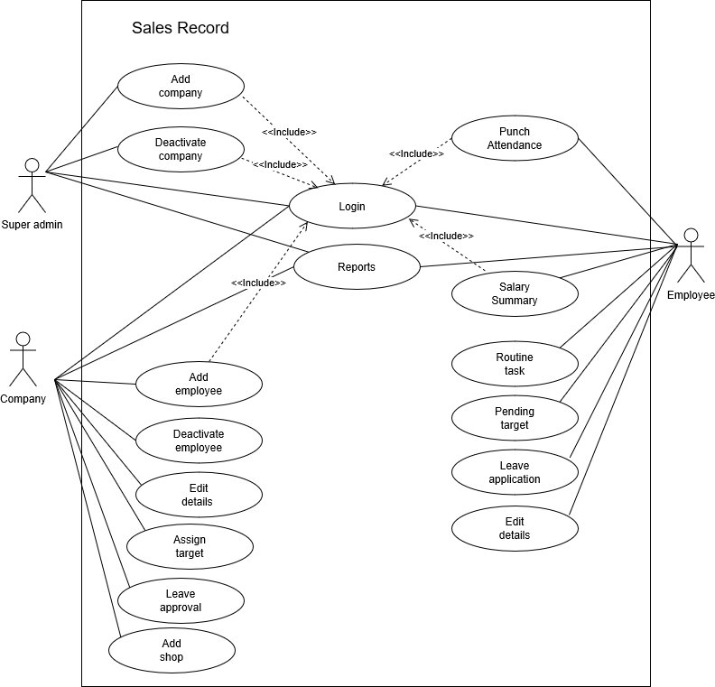

**Activity Diagram:**

* Actor – Super admin

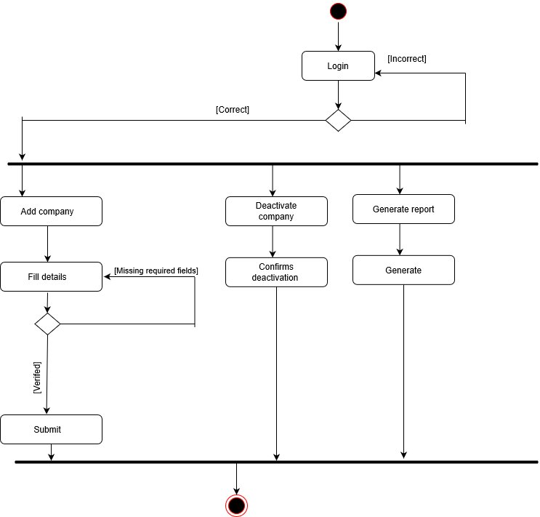

* Actor- Company

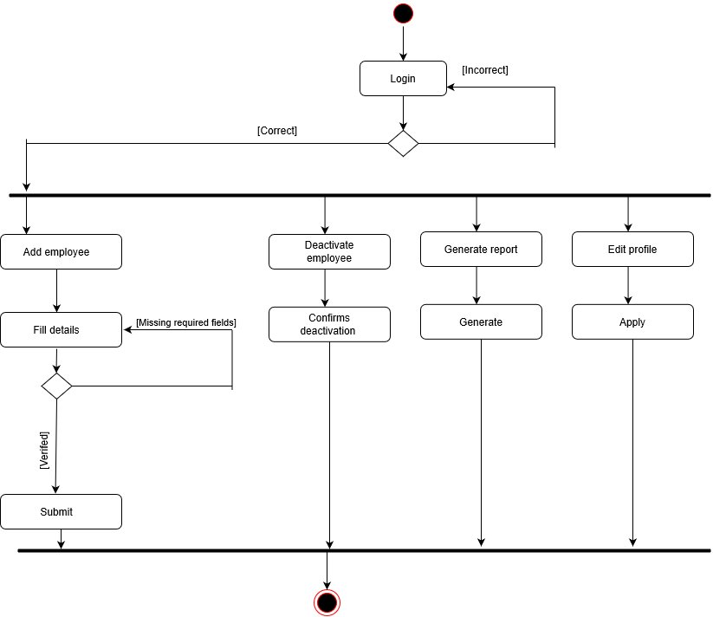

* Actor – company

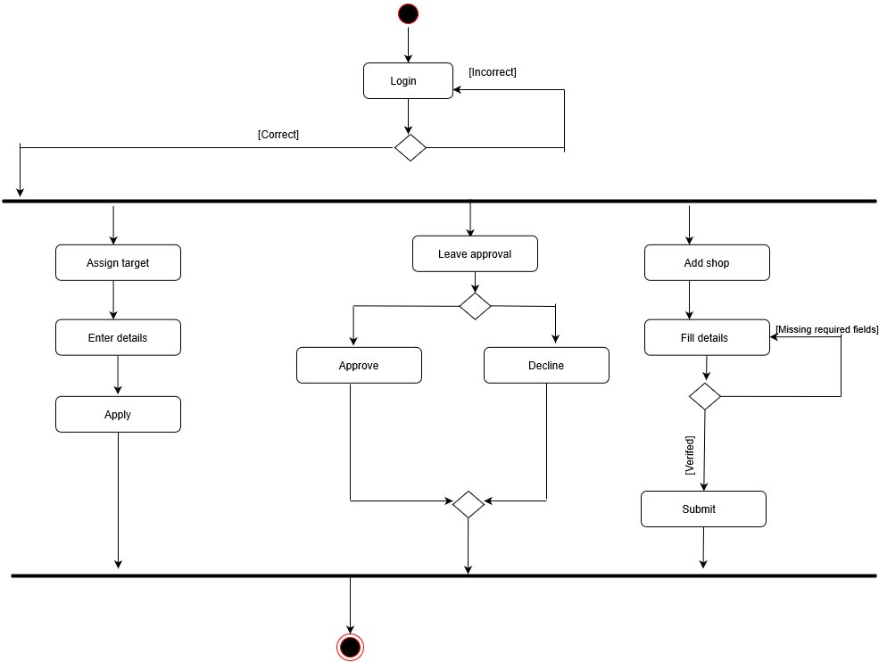

* Actor – Employee

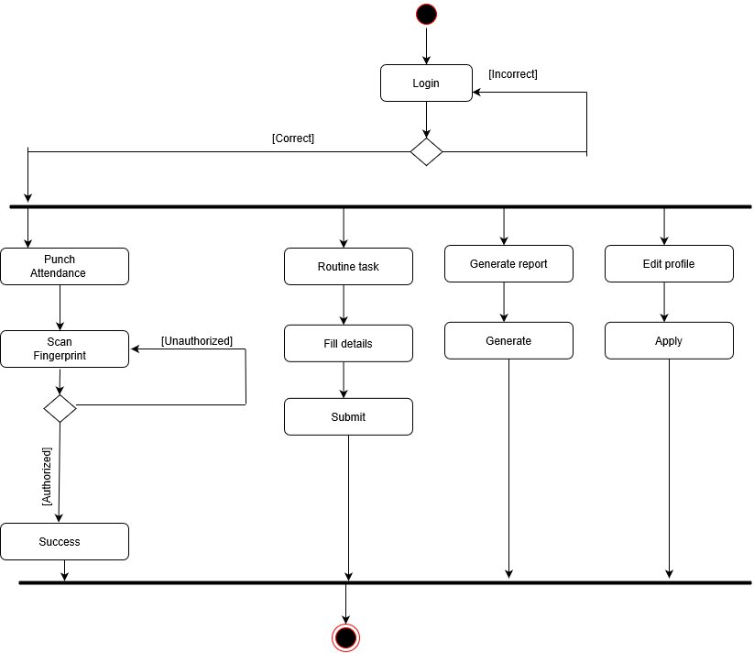

* Actor – Employee

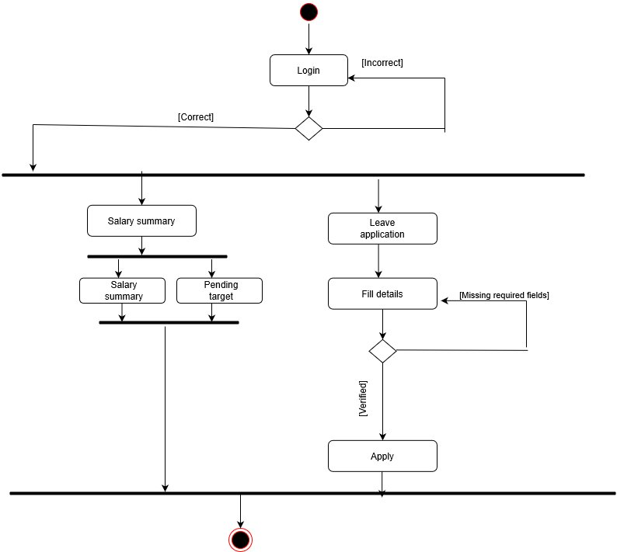

System Design

* **Data Dictionary:**
  + Table Name: super_admin

Table Description: This table stores the credentials of super admin

|  |  |  |  |  |
| --- | --- | --- | --- | --- |
| Field name | Data Type | Size | Constraint | Description |
| Username | Varchar | 5 | Primary key | Stores username of  super admin |
| Password | Varchar | 15 | Not null | Stores password of super admin |

* + Table Name: employee_master

Table Description: This table stores the employee details

|  |  |  |  |  |
| --- | --- | --- | --- | --- |
| Field name | Data Type | Size | Constraint | Description |
| Emp_id | Int | 6 | Primary key | Stores employee id |
| Comp_id | Int | 6 | Foreign key | Reference of company id from company_master |
| Emp_password | Varchar | 15 | Not null | Stores employee’s password |
| Emp_name | Varchar | 30 | Not null | Stores employee name |
| Emp_gender | Char | 1 | Not null | Stores gender details |
| Emp_dob | Date |  | Not null | Stores date of birth of an employee |
| Emp_aadharno | Varchar | 12 | Not null | Stores aadhar card number |
| Emp_mobileno1 | Varchar | 11 | Not null | Stores the mobile number of an employee |
| Emp_mobileno2 | Varchar | 11 | - | Stores the alternative mobile number of an employee |
| Emp_email | Varchar | 50 | Not null | Stores the employee’s email address |
| Emp_address | Varchar | 70 | Not null | Stores address of an employee |
| Emp_pincode | Int | 6 | Not null | Stores pincode of an employee |
| Emp_city | Varchar | 30 | Not null | Stores city of an employee |
| Emp_state | Varchar | 20 | Not null | Stores state detail of an employee |
| Emp_status | Varchar | 2 | Not null | Stores employee status |
| Emp_deg | Varchar | 15 | Not null | Stores employee’s designation |
| Emp_zone | Varchar | 30 | Not null | Stores employee’s zone detail |

* + Table Name: company_master

Table Description: This table stores the details of company

|  |  |  |  |  |
| --- | --- | --- | --- | --- |
| Field name | Data Type | Size | Constraint | Description |
| Company_id | Int | 6 | Primary key | Company’s unique id which is generated automatically |
| Company_password | Varchar | 15 | Not null | Password which is created by user |
| Company_name | Varchar | 15 | Not null | Stores the company’s name |
| Company_email | Varchar | 50 | Not null | Stores email of a company |
| Company_city | Varchar | 30 | Not null | Stores city of a company |
| Company_pincode | Int | 6 | Not null | Stores pincode of a company |
| Company_mobile1 | Varchar | 11 | Not null | Stores company’s mobile no |
| Company_mobile2 | Varchar | 11 | - | Stores company’s alternative mobile no |
| Contact_person | Varchar | 25 | Not null | Stores the name of company’s owner or CEO or employee |
| Company_licenseno | Varchar | 21 | Not null | Stores company’s license no |
| Company_gstno | Varchar | 15 | - | Stores company’s gst number |
| Company_website | Varchar | 15 | - | Stores company’s website |
| Company_status | Varchar | 12 | Not null | Stores company status |

* + Table Name: attendance

Table Description: This table stores the attendance details of employees

|  |  |  |  |  |
| --- | --- | --- | --- | --- |
| Field name | Data Type | Size | Constraint | Description |
| Attid | Varchar | 6 | Primary key | Stores the attendance id |
| Emp_id | Int | 6 | Foreign key | Reference of employee id from employee_master table |
| Pi_date | Varchar | 10 | Not null | Stores the punch in date of an employee |
| Pi_time | Varchar | 5 | Not null | Stores the in time of an employee |
| Pi_loc | Varchar | 25 | Not null | Stores punch in location |
| Po_time | Varchar | 5 | Not null | Stores the out time of an employee |
| Po_loc | Varchar | 25 | Not null | Stores punch out location |

* + Table Name: shop_master

Table Description: This table stores the location of shop

|  |  |  |  |  |
| --- | --- | --- | --- | --- |
| Field name | Data Type | Size | Constraint | Description |
| Shop_id | Int | 6 | Primary key | Stores shop id |
| Comp_id | Int | 6 | Foreign key | Reference of company id from company_master table |
| Shop_name | Varchar | 35 | Not null | Stores the name of the shop |
| Shop_locLat | Varchar | 40 | Not null | Stores shop’s latitude |
| Shop_locLong | Varchar | 40 | Not null | Stores shop’s longitude |

* + Table Name: emp_routinetask

Table Description: This table stores routine work of employees

|  |  |  |  |  |
| --- | --- | --- | --- | --- |
| Field name | Data Type | Size | Constraint | Description |
| rt_id | Int | 6 | Primary key | Stores routine task id |
| emp_id | Int | 6 | Foreign key | Reference of employee id from employee_master table |
| rt_date | Varchar | 11 | Not null | Stores date of submitted work |
| rt_unit | Varchar | 40 | Not null | Stores shop’s latitude |

* + Table Name: emp_sal

Table Description: This table stores the salary information of employees

|  |  |  |  |  |
| --- | --- | --- | --- | --- |
| Field name | Data Type | Size | Constraint | Description |
| es_id | Int | 6 | Primary key | Stores routine employee salary id |
| emp_id | Int | 6 | Foreign key | Reference of employee id from employee_master table |
| emp_bsal | Int | 5 | Not null | Stores basic salary of an employee |
| emp_inc | Int | 5 | Not null | Stores incentive of an employee |
| emp_totsal | Varchar | 7 | Not null | Stores total salary of an employee |
| emp_month | Varchar | 8 | Not null | Stores employee salary’s month |

* + Table Name: emp_ptarget

Table Description: This table stores employee’s pending target month wise

|  |  |  |  |  |
| --- | --- | --- | --- | --- |
| Field name | Data Type | Size | Constraint | Description |
| ep_id | Int | 6 | Primary key | Stores employee’s pending target id |
| emp_id | Int | 6 | Foreign key | Reference of employee id from employee_master table |
| p_target | Int | 6 |  | Stores pending target of an employee |
| p_month | Varchar | 8 |  | Stores pending target’s month |
| comp_id | Int | 6 | Foreign key | Reference of company id from employee_master table |

* + Table Name: emp_target

Table Description: This table stores company’s monthly target which is assigned to employees.

|  |  |  |  |  |
| --- | --- | --- | --- | --- |
| Field name | Data Type | Size | Constraint | Description |
| et_id | Int | 6 | Primary key | Stores assigned target’s id |
| comp_id | Int | 6 | Foreign key | Reference of company id from employee_master table |
| atargetmonth | Varchar | 8 |  | Stores assigned target’s month |
| atarget | Int | 5 |  | Stores assigned target value |
| p_target | Int | 6 | Not null | Stores assigned target value employee wise |

* + Table Name: leave_management

Table Description: This table stores leave details

|  |  |  |  |  |
| --- | --- | --- | --- | --- |
| Field name | Data Type | Size | Constraint | Description |
| Leave_id | Int | 5 | Primary key | Stores leave id |
| Emp_id | Int | 6 | Foreign key | Reference of employee id from employee_master table |
| fromDate | Varchar | 10 | Not null | Stores leave’s starting date |
| toDate | varchar | 10 | Not null | Stores leave’s ending date |
| type1 | varchar | 10 | Not null | Stores the details of half day or full day of from date |
| type2 | Varchar | 10 | Not null | Stores the details of half day or full day of to date |
| reason | varchar | 50 | Not null | Stores the reason of leave |
| status | varchar | 12 | Not null | Stores the request’s status |

* **Screen Layouts:**
  + Splash Screen

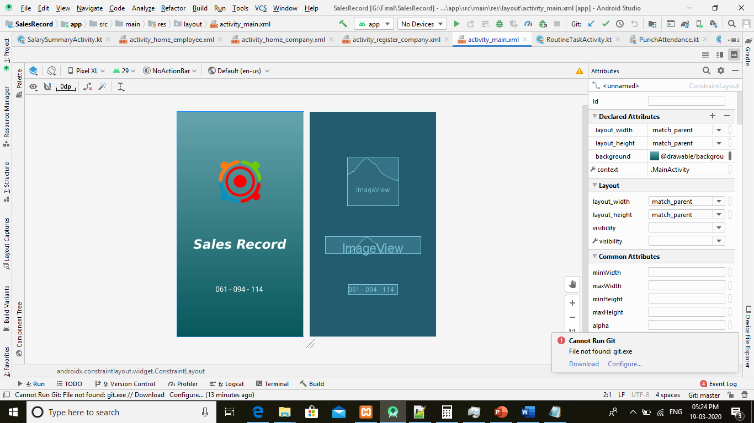

* + Login

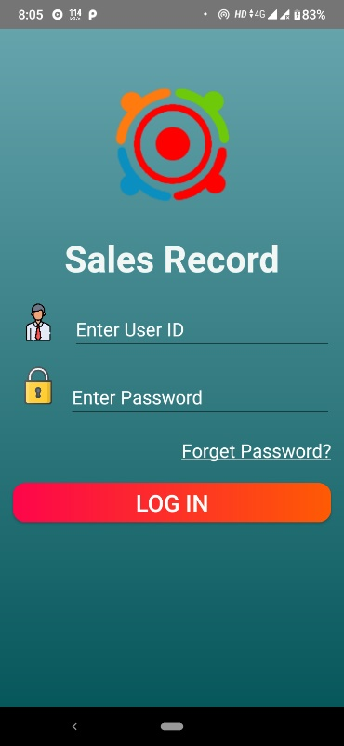

* + Super admin dashboard:

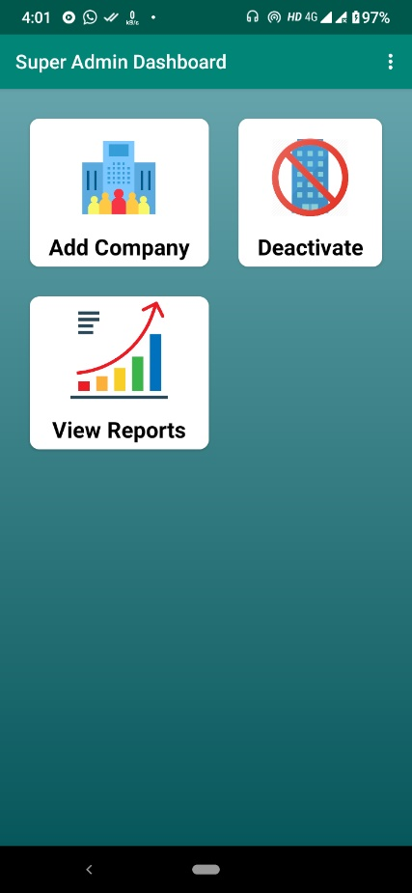

* + Add company (Super admin):

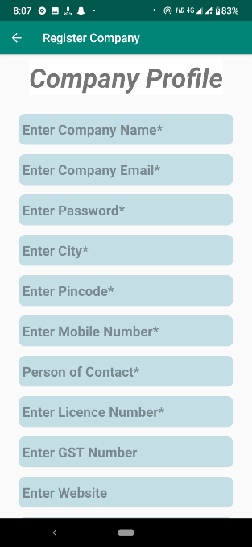 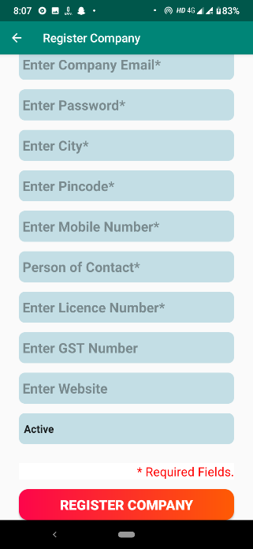

* + Deactivate company (Super admin):

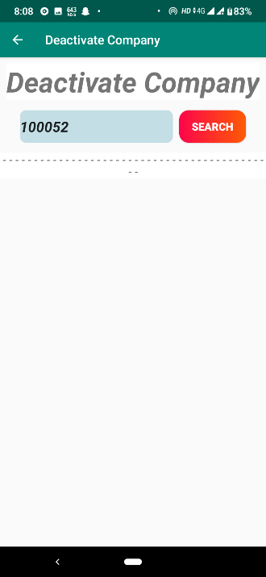 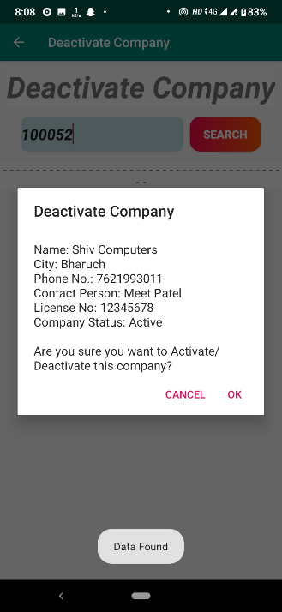

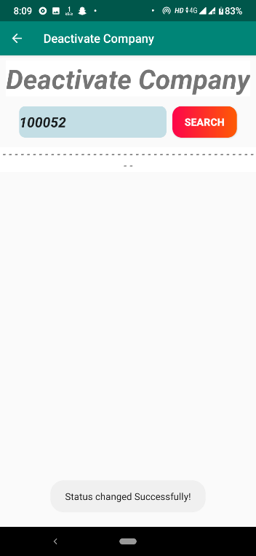

* + Logout (Super admin):

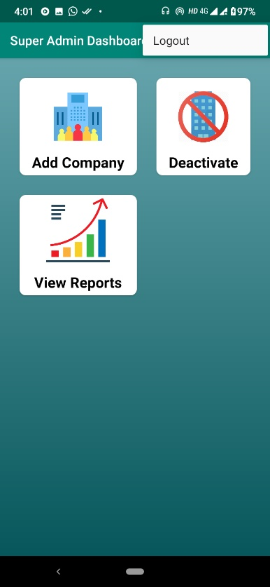 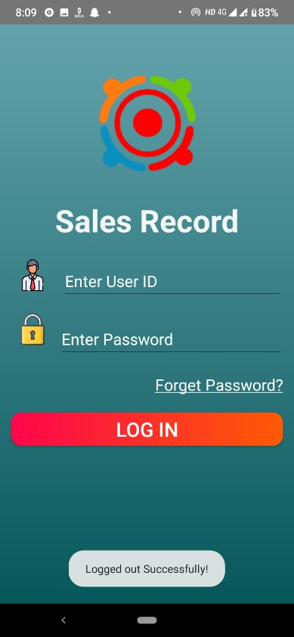

* + Company Dashboard:

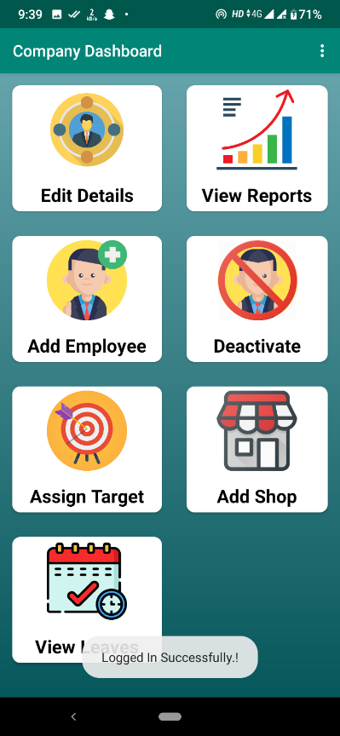

* + Edit details (company):

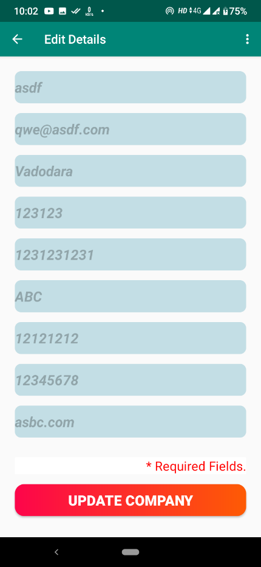 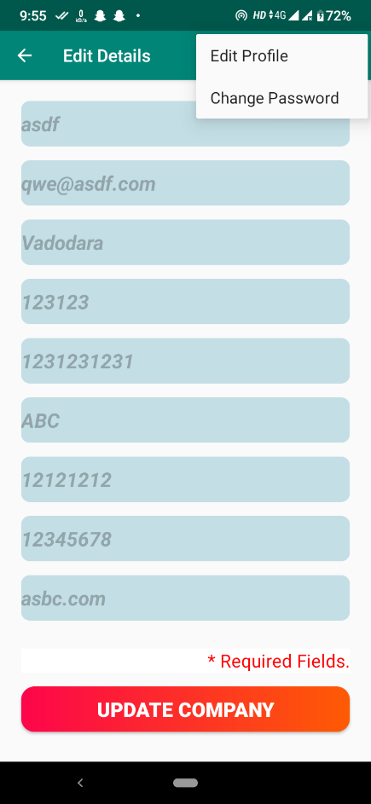

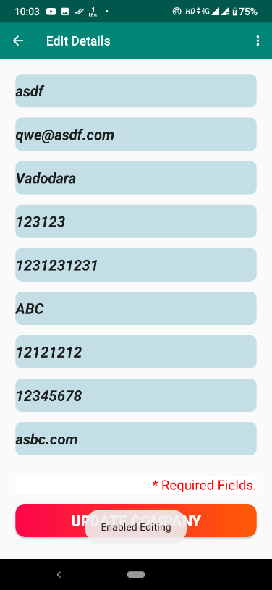 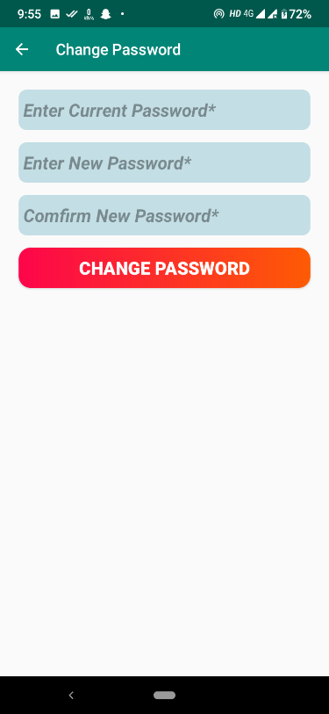

* + Add employee (Company):

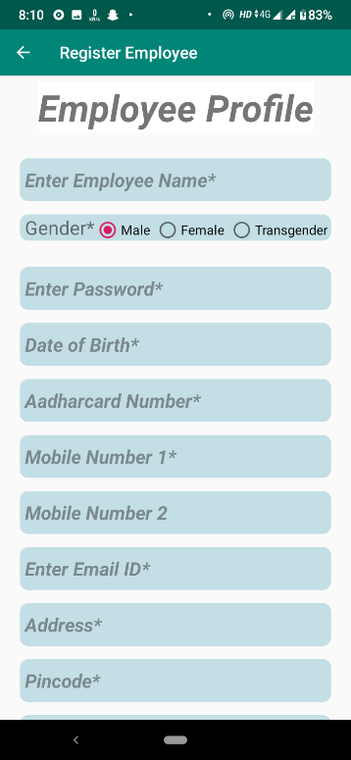 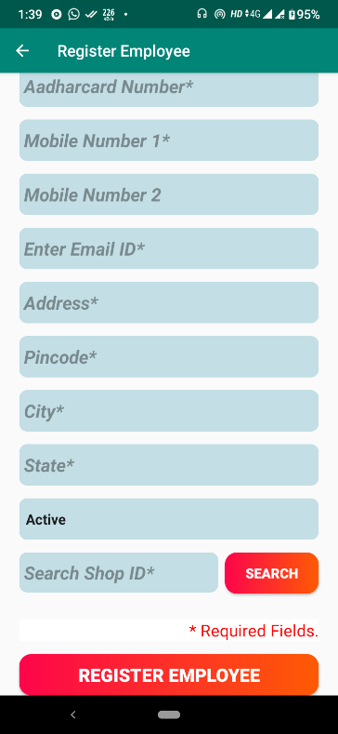

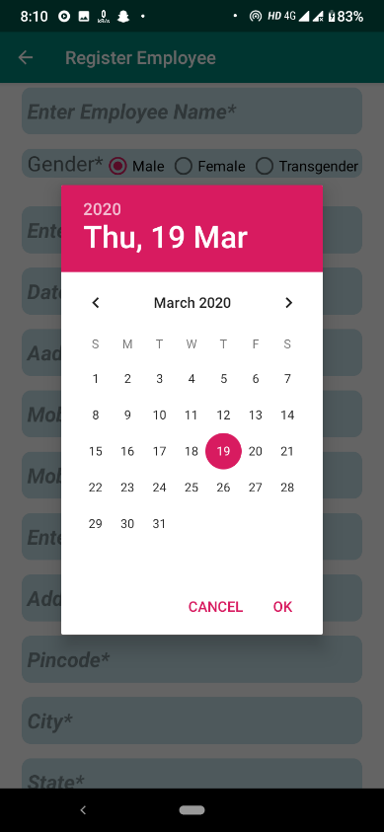 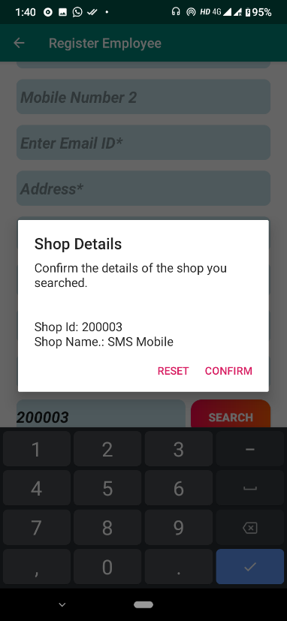

* + Deactivate employee (Company):

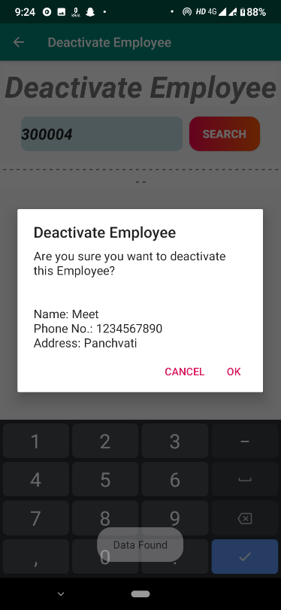 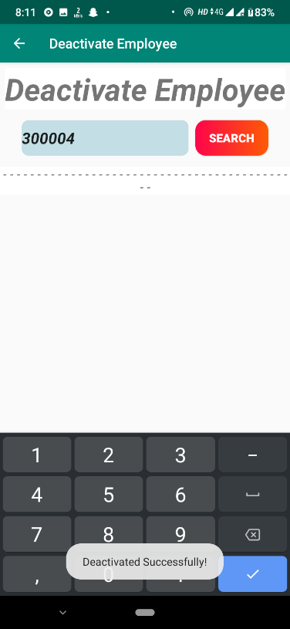

* + Assign Target (Company):

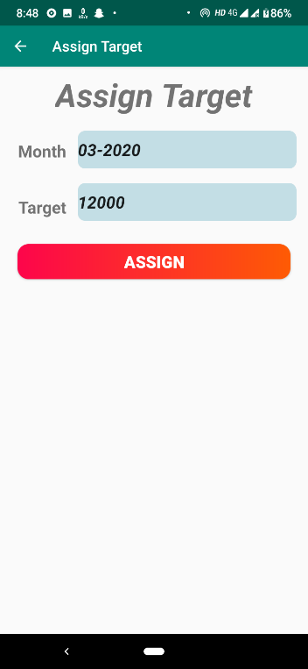 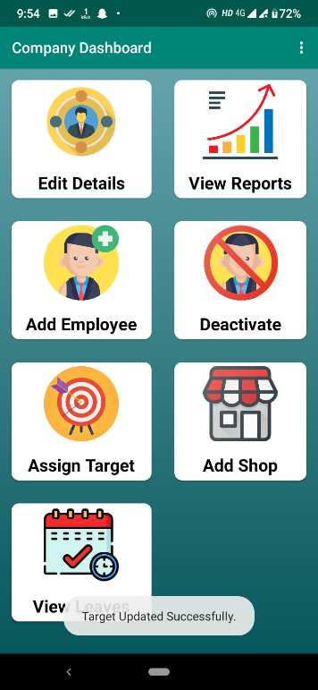

* + Register shop (Company):

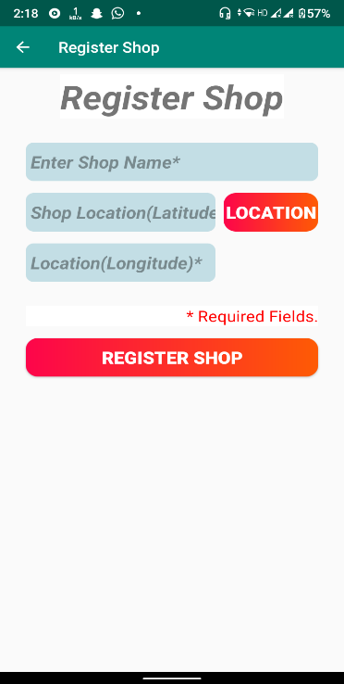

* + Leave management (Company):

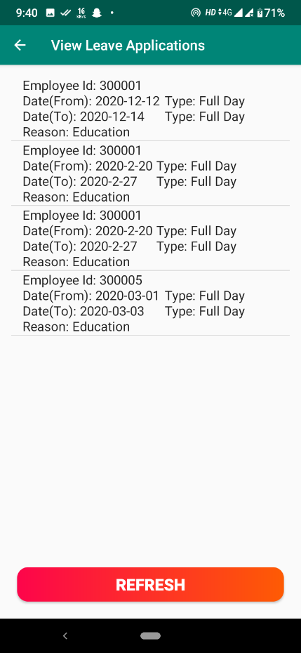 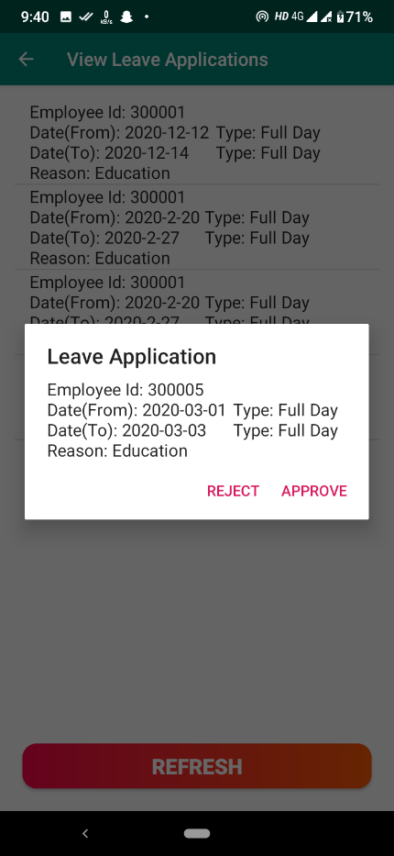

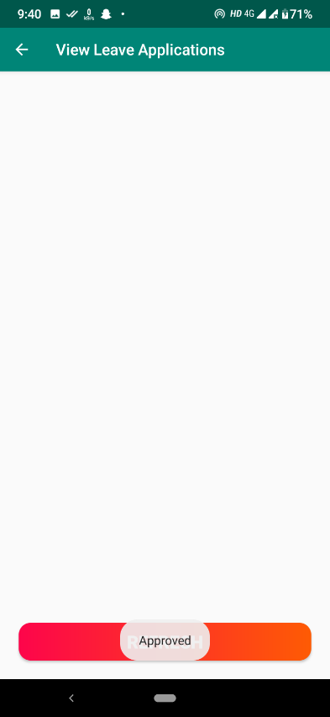

* + Employee dashboard:

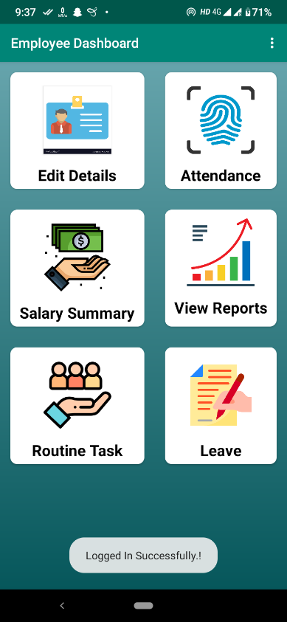 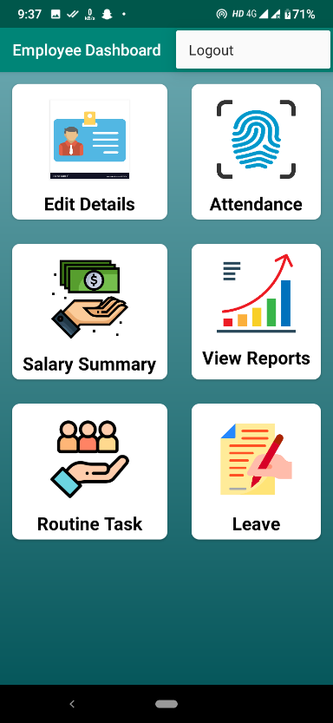

* + Edit details (Employee):

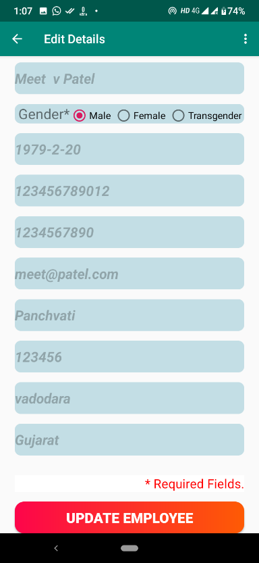 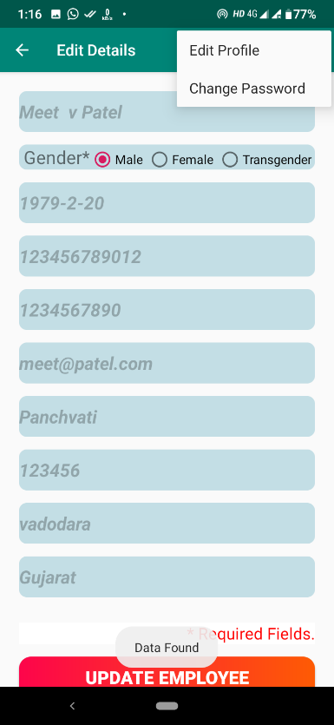

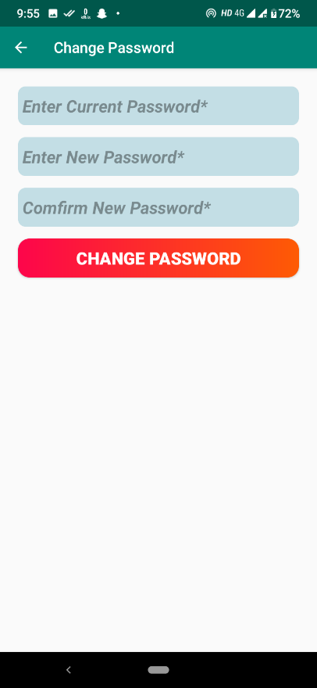 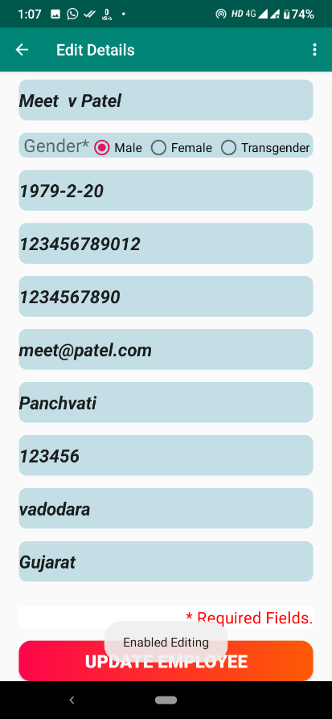

* + Punch attendance (Employee):

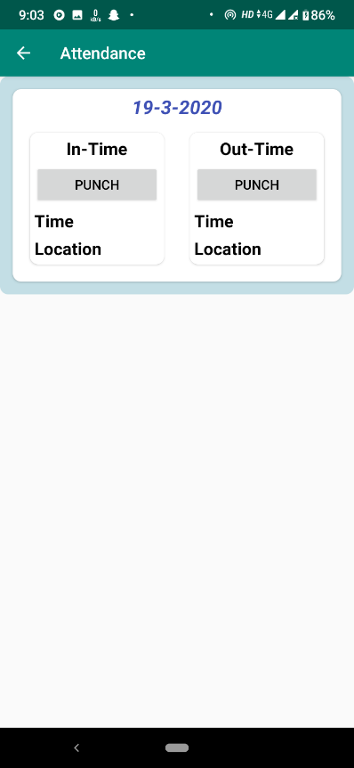 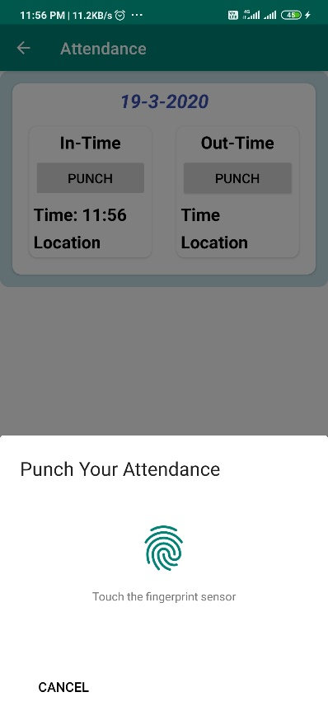

* + Salary Summary & Pending target (Employee):

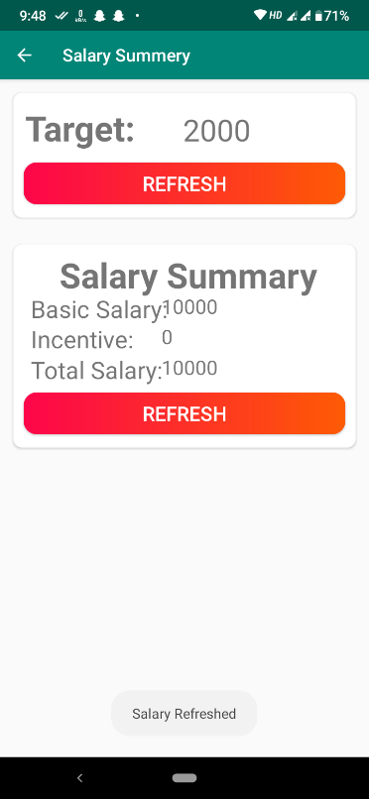 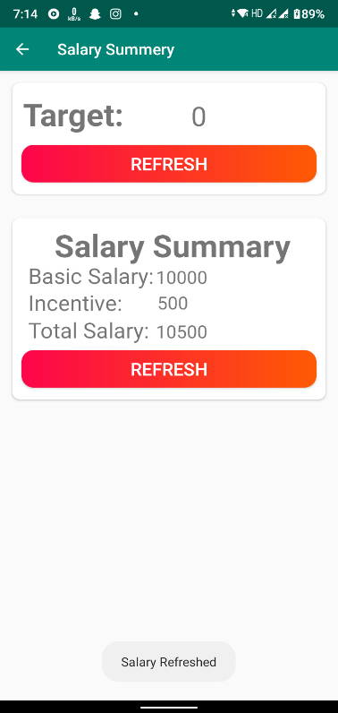

* + Routine task (Employee):

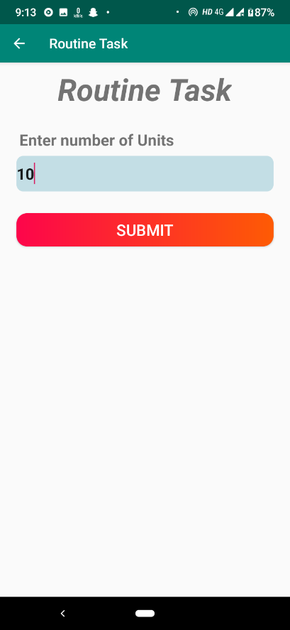

* + Leave apply (Employee):

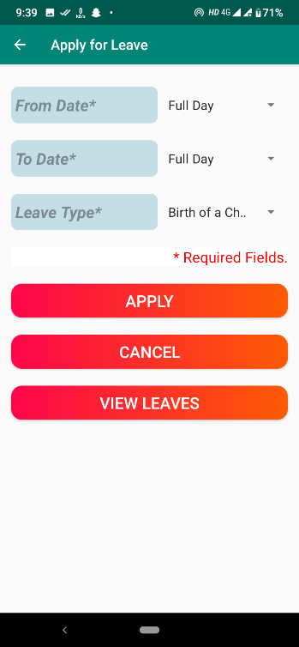 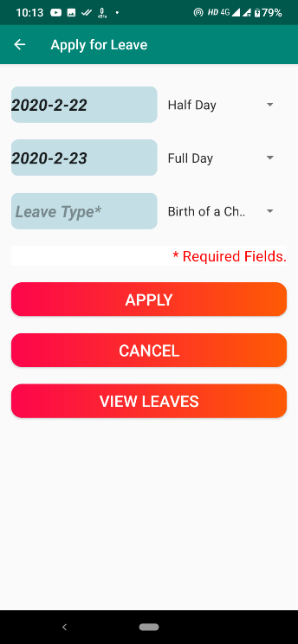

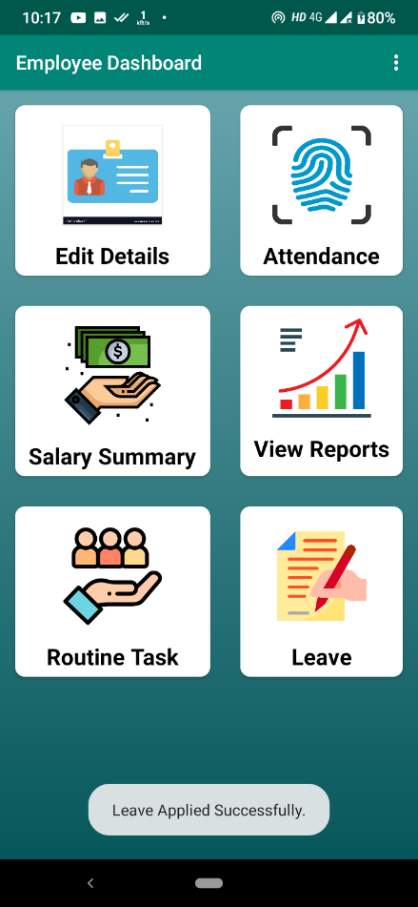

* + Pending Leave status (Employee):

 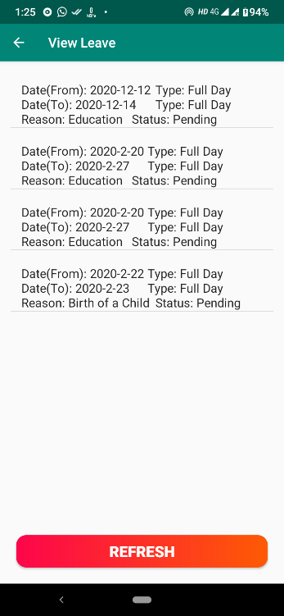

* **Reports**
  + Company report (Super admin): Super admin can check number of companies and status of particular company.
  + Target report (Company): Company can generate monthly employee wise target report.
  + Sales report (Company): Company can generate employee wise sales report which describes the sales of particular employee in a month.
  + Salary report (Company, employee): Company can generate employee wise salary report and employee can generate their own salary report month wise.
  + Leave report (Company, employee): Company can generate monthly leave report which describes leaves details employee wise and employee can generate leave report to get summary of leaves in particular month.
  + Attendance (Company, employee): Company can generate daily and monthly attendance report to check the attendance of employees and employee can generate monthly attendance report.

System Testing

* **Testing Strategies**
  + Unit testing:
    - Unit testing carried out in this application to check that each unit of the application works without error, which was successful.
  + System testing:
    - The entire application is tested to check that the application meets the requirements which is mentioned in this document, which was successful.
  + Integrating testing:
    - This testing check that each program module is connected with the respective actor, which was successful
* **Test cases:**

|  |  |  |  |  |  |
| --- | --- | --- | --- | --- | --- |
| Test case no | Field | Actual value | Expected outcome | Actual outcome | Remarks |
| 1 | Company_id |  | It should generate error message | It has been generated an error | Successful |
| 2 | Company_password | 1234 | It should generate error message | It has been generated an error | Successful |
| 3 | Company_password | 123456 | Checks the credentials and logged in successfully | Checks the credentials  and allow to logged in | Successful |
| 4 | Company_name | A&M Records | Valid name, allows to registration | Allowed to registration | Successful |
| 5 | Company_email | abc@gmail | It should generate error message | It has been generated an error | Successful |
| 6 | Company_email | [abc@gmail.com](mailto:abc@gmail.com) | Valid email, allows to registration | Allowed to enter data | Successful |
| 7 | Company_mobile1 | 1231b1@ | It should generate error message | It has been generated an error | Successful |
| 8 | Company_mobile1 | 9976325678 | Valid data,  allows to enter data | Allowed to enter data | Successful |
| 9 | Emp_name | abc@1 | It should generate error message | It has been generated an error | Successful |
| 10 | Emp_name | Kartavya | Valid data,  allows to enter data | Allowed to enter data | Successful |
| 11 | Emp_dob | 15/02/2022 | It should generate error message | It has been generated an error | Successful |
| 12 | Emp_dob | 11/07/1999 | Valid data,  allows to enter data | Allowed to enter data | Successful |

Future enhancement

* **Future Enhancement:**
  + Multiple employees’ registration at a time
  + Inter – employee communication
  + Employee’s load adjustment
  + Request to resign from company

bibliography/

references

* Web references:
  + Google play store [For existing system]
  + https://www.123formbuilder.com/free-form-templates/New-Employee-Registration-Form-2375089/

[For employee registration form]

* + https://www.123formbuilder.com/free-form-templates/Company-Registration-Form-2861029/

[For company registration form]

* + <https://stackoverflow.com/> [For solution of quires]
  + <https://app.diagrams.net/> [For drawing UML diagrams]
  + <https://www.flaticon.com/> [For icons]