Where did your dataset come from?
Semantic Features (Primary Decision Features)
“These tell us how well the candidate answered.”
Answer:
"We did not generate random values. Instead, we designed the dataset using a literature-driven methodology. We first studied adaptive interviewing systems, adaptive assessment, intelligent tutoring systems, Bloom's Taxonomy, scaffolding theory, and mastery learning. Based on these established educational and interview principles, we defined logical interview policies. Then we converted those principles into decision rules, which were used to generate the dataset."
Explain the process step by step
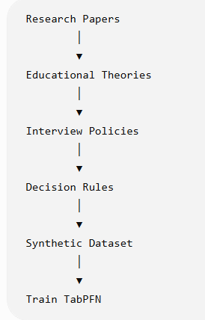

Step 1 – Literature Review
"We first reviewed research papers on adaptive interview systems, educational assessment, and intelligent tutoring systems."
The goal was to understand
How does a human interviewer decide the next question?
Step 2 – Extract Educational Principles
From the literature we identified several well-established principles.
Adaptive Testing
Meaning
If a candidate performs well
↓
Ask harder questions.
If a candidate struggles
↓
Ask easier questions.
This becomes
Increase Difficulty
Reduce Difficulty
Scaffolding
Meaning
If the candidate misses an important concept,
don't immediately increase difficulty.
Instead, ask about the missing concept.
This becomes
Probe Missing Concept

Bloom's Taxonomy
Meaning
Once the candidate understands the theory,
check whether they can apply it.
This becomes
Ask Application Question

Guided Tutoring
Meaning
If the answer is partially correct,
ask another question on the same topic.
This becomes
Ask Follow-up Question

Mastery Learning
Meaning
If the candidate consistently performs well,
move to another topic.
This becomes
Switch Topic
"These are not our own ideas. These interview strategies are supported by educational and adaptive assessment research."

Step 3 – Convert Principles into Rules
"Research papers explain the interview strategy, but they do not provide numerical thresholds. Therefore, we translated these educational principles into quantitative decision rules."
Example
Research says
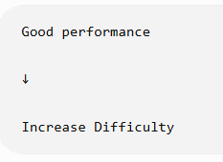
We define
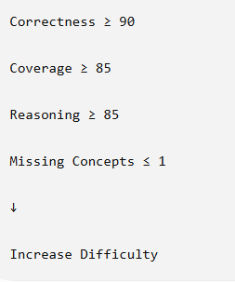
Similarly,
Research says
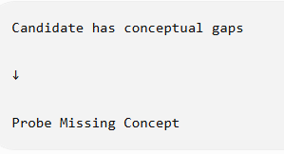
We define
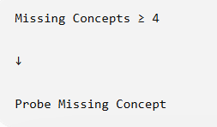
So
The educational theory comes from literature,
while
the numerical thresholds are our designed implementation.
Step 4 – Generate Dataset
For every interview state,
we create,
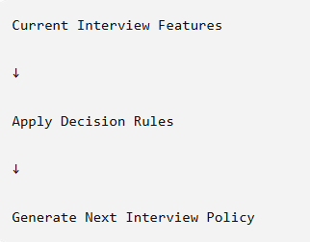

Example
Correctness | Coverage | Reasoning | Missing | Policy
94 | 91 | 90 | 0 | Increase Difficulty
Another
Correctness | Coverage | Reasoning | Missing | Policy
71 | 68 | 74 | 5 | Probe Missing Concept

Where did your dataset come from?
Behavioral Features (Supporting Decision Features)
“These tell us how the candidate behaves during the interview, providing additional context to the semantic evaluation.”
Answer:
" We did not generate these behavioral features randomly. Instead, we designed them using findings from research on AI-based interview systems, multimodal interview assessment, affective computing, non-verbal communication, and human-computer interaction. These studies show that interviewers naturally consider behavioral cues such as engagement, confidence, hesitation, and eye contact while interacting with candidates. Therefore, we incorporated these cues as supporting features to simulate realistic interview behavior. However, these features do not measure knowledge or intelligence; they only provide additional context for the interview decision."
Explain the process step by step
Step 1 – Literature Review
" We first reviewed research papers on AI interview systems, multimodal interview assessment, affective computing, behavioral computing, and non-verbal communication."
The goal was to understand
How do experienced interviewers use a candidate's behavior during an interview to decide the next question?
Step 2 – Extract Educational Principles
From the literature, we identified several well-established behavioral principles.
Engagement
Meaning
If a candidate is actively participating,
maintains attention,
and shows interest throughout the interview,
↓
the interviewer perceives the candidate as engaged.
This becomes
High Engagement
On the other hand,
if the candidate appears distracted,
inactive,
or loses attention,
↓
the interviewer perceives lower engagement.
This becomes
Low Engagement

Confidence
Meaning
If a candidate answers calmly,
maintains stable facial expressions,
and responds without visible anxiety,
↓
the interviewer perceives higher confidence.
This becomes
High Confidence
If the candidate frequently appears uncertain,
↓
confidence decreases.
This becomes
Low Confidence

Hesitation
Meaning
If a candidate frequently pauses,
takes excessive time before answering,
or repeatedly hesitates,
↓
the interviewer recognizes uncertainty.
This becomes
High Hesitation
If the candidate responds naturally with minimal pauses,
↓
hesitation remains low.
This becomes
Low Hesitation

Eye Contact
Meaning
Maintaining appropriate eye contact generally indicates that the candidate is attentive and actively interacting with the interviewer.
This becomes
High Eye Contact
Frequent loss of attention or looking away may indicate reduced interaction.
This becomes
Low Eye Contact

" These behavioral indicators are not intended to evaluate intelligence or technical ability. Instead, they provide additional contextual information that may help explain the candidate's interaction during the interview."

Step 3 – Convert Behavioral Principles into Rules
" Research papers explain the importance of behavioral cues but do not define numerical values for them. Therefore, we converted these qualitative behavioral observations into quantitative decision rules for synthetic dataset generation."
Example
Research says
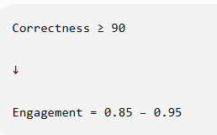
We define
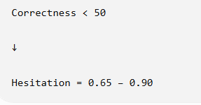
Similarly,
Research says
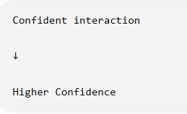
We define
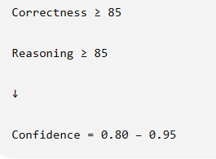
Research says
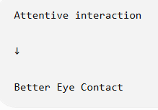
We define
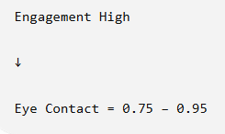
So
The behavioral principles originate from published literature,
while
the numerical ranges are our research-designed implementation for synthetic dataset generation.

Step 4 – Generate Dataset
For every interview state,
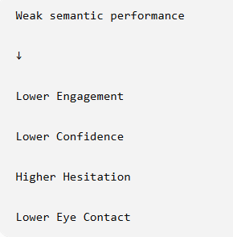
we create,
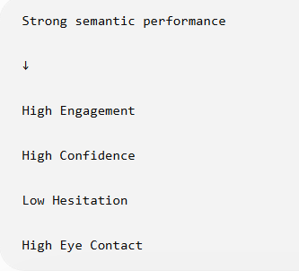

Example
Correctness | Coverage | Reasoning | Engagement | Confidence | Hesitation | Eye Contact
94 | 91 | 90 | 0.91 | 0.89 | 0.08 | 0.92

Another
Correctness | Coverage | Reasoning | Engagement | Confidence | Hesitation | Eye Contact
46 | 42 | 39 | 0.42 | 0.35 | 0.76 | 0.41

Where did your dataset come from?
Interview Context Features (Sequential Decision Features)
“These capture the current state and history of the interview, helping the system decide the most appropriate next interview action.”
Answer:
" We did not generate these interview context features randomly. Instead, we designed them using findings from research on adaptive testing, computer adaptive testing (CAT), intelligent tutoring systems, mastery learning, and sequential decision-making. These studies show that experienced interviewers do not evaluate a candidate based only on the current answer; they also consider the interview history, such as the current question difficulty and consecutive correct or incorrect responses. Therefore, we incorporated interview context features to simulate realistic interviewer decision-making during an adaptive interview."
Explain the process step by step
Step 1 – Literature Review
" We first reviewed research papers on adaptive interviewing, computer adaptive testing, mastery learning, intelligent tutoring systems, and educational data mining."
The goal was to understand
How does a human interviewer use previous interview history to decide the next question?
Step 2 – Extract Educational Principles
From the literature we identified several well-established contextual principles.
Current Question Difficulty
Meaning
Human interviewers always consider the difficulty of the current question before deciding the next one.
If a candidate correctly answers an Easy question,
↓
the interviewer usually increases the challenge.
If the candidate correctly answers a Hard question,
↓
instead of making it harder, the interviewer may switch to another topic or maintain the current level.
This becomes
Current Question Difficulty

Correct Streak
Meaning
A human interviewer rarely makes decisions based on only one answer.
Instead, they observe whether the candidate consistently performs well.

If the candidate answers several consecutive questions correctly,
↓
the interviewer assumes the candidate has mastered the current topic.
This becomes
Correct Streak

Wrong Streak
Similarly,
if the candidate repeatedly answers questions incorrectly,
↓
the interviewer recognizes that the current difficulty may be too high or that the candidate has conceptual gaps.
Instead of continuing with harder questions,
the interviewer reduces difficulty or revisits the fundamentals.
This becomes
Wrong Streak

" These interview context features do not measure knowledge directly. Instead, they represent the progression of the interview, allowing our system to mimic how experienced interviewers naturally adapt questioning based on previous responses rather than considering only the current answer."

Step 3 – Convert Interview Context Principles into Rules
" Research papers explain the adaptive interview strategy, but they do not define numerical thresholds. Therefore, we converted these qualitative interview principles into quantitative decision rules for synthetic dataset generation."
Example
Research says
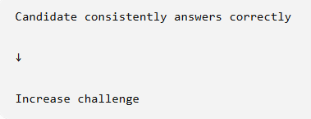
We define
Similarly,
Research says
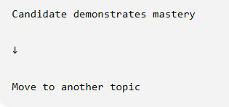
We define
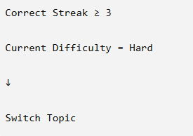
Research says
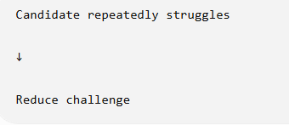
We define
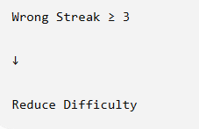
Research says
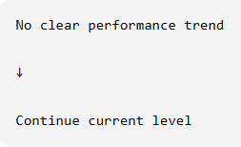
We define
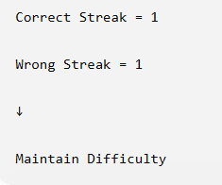
So
The interview context principles originate from established educational and adaptive testing research,
while
the numerical thresholds are our research-designed implementation for synthetic dataset generation..
Step 4 – Generate Dataset
For every interview state,
we create,

Example
Difficulty | Correct Streak | Wrong Streak | Next Policy
Easy | 2 | 0 | Increase Difficulty

Another
Difficulty | Correct Streak | Wrong Streak | Next Policy
Hard | 3 | 0 | Switch Topic
Another
Difficulty | Correct Streak | Wrong Streak | Next Policy
Medium | 0 | 3 | Reduce Difficulty

FINAL DATASET SCHEMA
Feature Category | Feature | Type | Example
Semantic | Correctness Score | Float (0-100) | 91
 | Concept Coverage | Float (0-100) | 88
 | Reasoning Score | Float (0-100) | 86
 | Missing Concepts | Integer | 1
Behavioral | Engagement Score | Float (0-1) | 0.89
 | Confidence Score | Float (0-1) | 0.84
 | Hesitation Score | Float (0-1) | 0.18
 | Eye Contact Score | Float (0-1) | 0.91
Interview Context | Current Difficulty | Easy / Medium / Hard | Medium
 | Correct Streak | Integer | 2
 | Wrong Streak | Integer | 0
Label | Next Interview Policy | 7 Classes | Ask Application Question

Label Classes
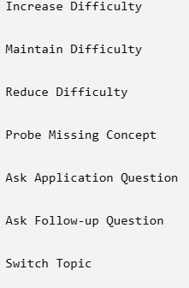
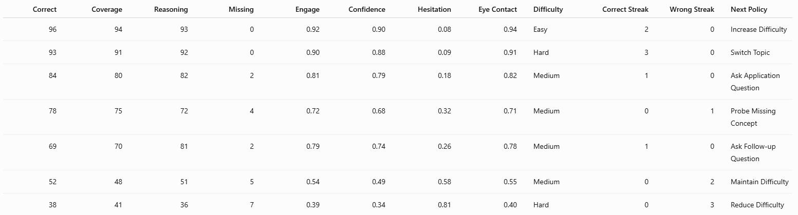
SAMPLE DATASET

"A rule-based probabilistic synthetic data generator was developed to produce 100,000 logically consistent interview states. Each sample was generated from one of 25 literature-derived interview decision rules. Rather than using fixed feature values, continuous features were sampled from constrained probability distributions to simulate realistic variations in candidate performance, behavior, and interview progression. A validation stage then removed inconsistent samples before constructing the final Adaptive Interview Policy Dataset (AIPD-100K)."

