TITLE: A Multimodal Adaptive AI Interview System Using Tabular Foundation Models for Intelligent Interview Policy Prediction
What we are going to predict?
Instead of
Hard
our model predicts
A4
Probe Missing Concept
or
A5
Ask Application Question
Then the LLM receives
Policy : Ask Application Question
Topic : Java Polymorphism
instead of
Generate Hard Question

What about dataset?
Input Features
From LLM
Feature
Correctness Score
Concept Coverage
Reasoning Score
Missing Concepts

From Vision
Feature
Engagement Score
Confidence Score
Hesitation Score
Eye Contact Score
Notice I removed "Emotion."
Instead we use measurable behavioral features.

Interview Context
Feature
Current Topic
Question Difficulty
Question Type
Questions Asked So Far
Consecutive Wrong Answers
Consecutive Correct Answers

Output Label
Interview Policy
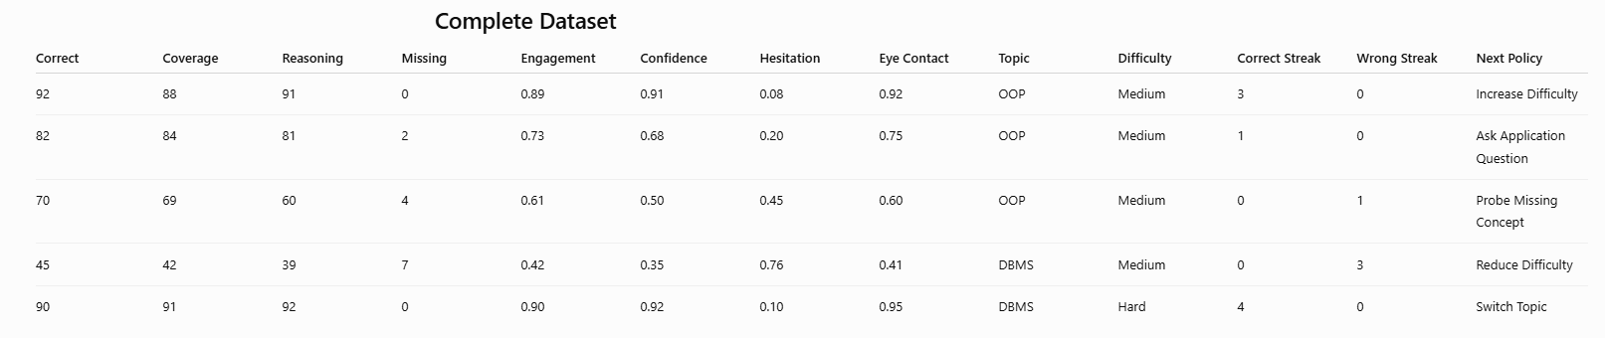

Why is this better?
Because our ML model is NOT replacing the LLM.
It is acting like the brain of the interviewer.

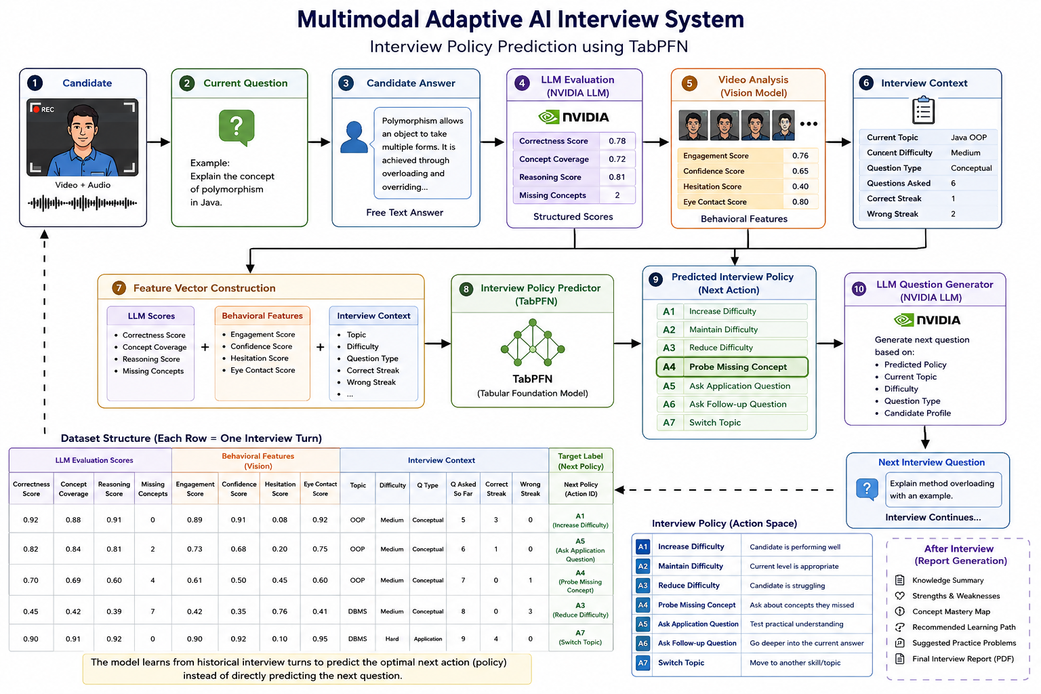
What about flow diagram? And What about after interview?

Where does TabPFN fit?
TabPFN is not predicting the next question.
It predicts the interview policy.

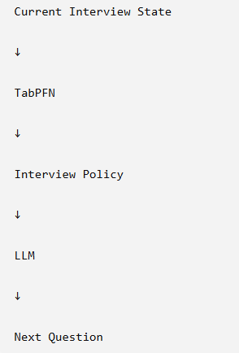

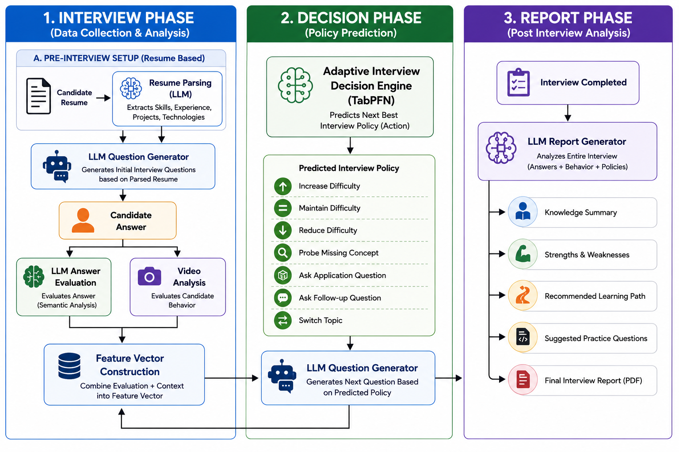
Flow diagram for ppt

