MLM web & App development

(Proposal)

For

Medi Science Pharmacy

* **INTRODUCTION**

**Kalari Infotech Pvt. Ltd.** is pleased to submit a proposal to create a Responsive Website for Your Company. This proposal describes the Technologies, Features details, Server configuration, commercials, terms, and schedule for the Responsive Website Design.

For over a decade we have built a large and loyal client base by delivering timeless and smart solutions. Advancement of technology is a reality of this ultra-modern world and thus its outcome does not seem an unreal too.   
  
We deliver smart and enduring solutions. In return we get client loyalty and the privilege to do it again.

* **ABOUT US**

Kalari Infotech Pvt. Ltd. is one of the pioneers in Website Design, App designing & Digital Marketing in INDIA. We have over **10 years of experience** in the Website Designing field with a long list of satisfied customers. We will be happy to provide additional references upon request.

**Other Services**

Kalari Infotech Pvt. Ltd. specializes in a number of Digital Marketing services, including:

* Web Design and Development
* Web Application Development
* E-Commerce Portal Development
* Mobile Application (Android/iOS)
* Hosting Solutions
* Search Engine Optimisation (SEO)
* Social Media Optimisation (SMO)
* Online Reputation Management (ORM)
* **OUR WORKING PROCESS**How we process step-by-step

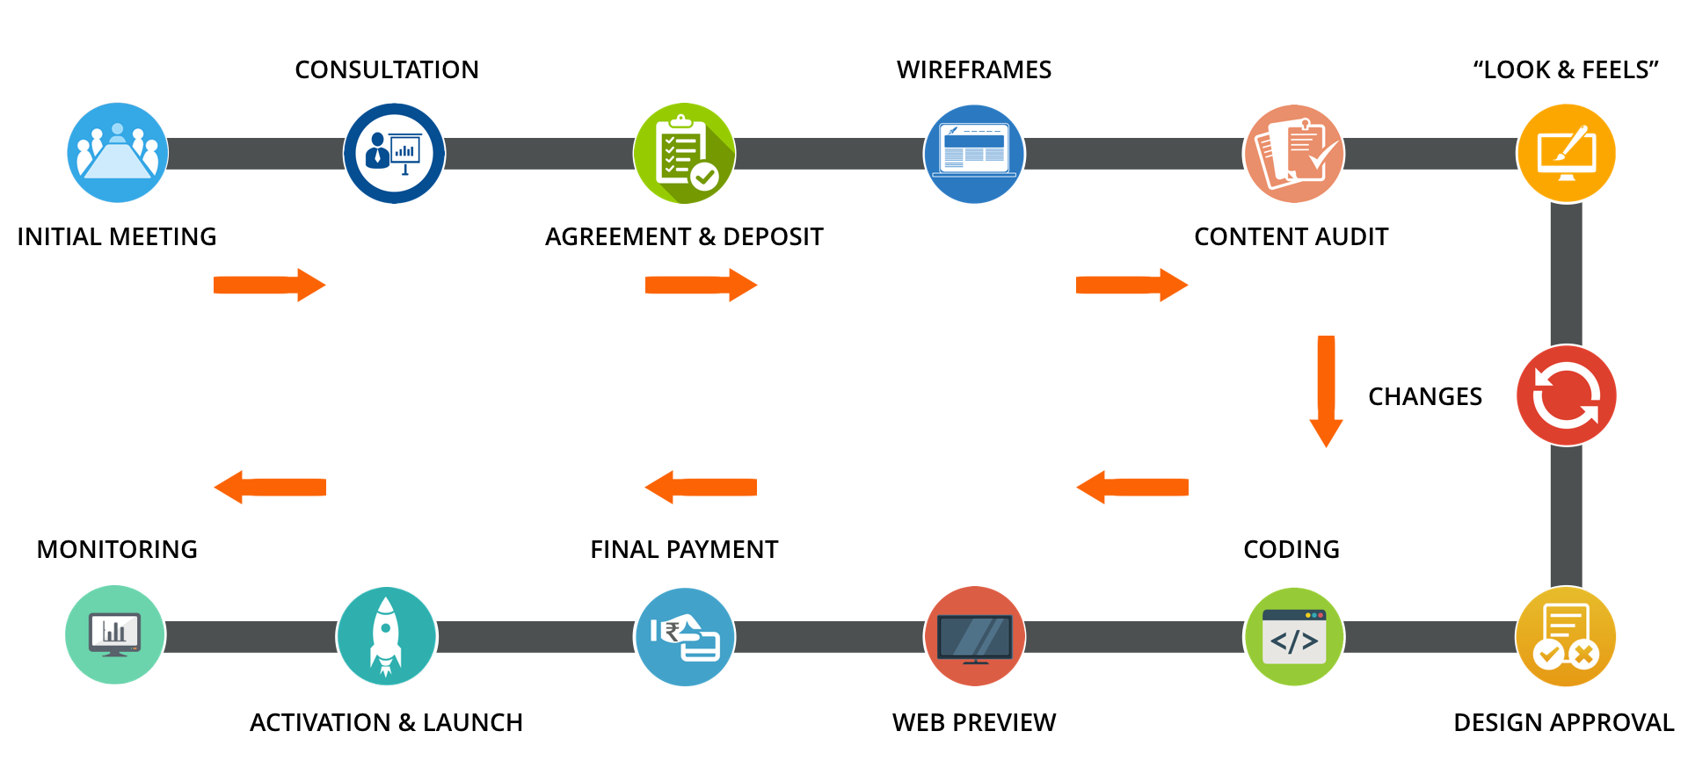

|  |
| --- |
|  |

* **Features details**
  + Custom Unique Layout With World-Class Design
  + 100% Responsive (Mobile Compatible) Website And Admin Panel
  + Enquiry/Feedback Form
  + Animated Banner
  + Fast Loading Pages
  + Unlimited Text/Tab/Pagination
  + Free Website Maintenance For 30 Days
  + Free Basic Search Engine Optimization
* Cross Browser Checking (Chrome/Firefox/)
* 5 Screen Resolution Check (320px, 480px, 768px, 1024px, 1024+ Px)
* Search Engine Friendly Design
* Standard Coding With Latest Platform
* HTML/HTML5 And Bootstrap Will Be Used For Responsive Design
* Smart Navigation For Your Customers, Who Will Be Happy To Navigate The Website With Ease
* CSS (Cascading Style Sheets) Will Be Used For Clean Coding And Faster Loading Of Pages
* Java Script/J Query Will Be Used For Latest Function/Validation/Navigation
* PHP Will Be Used For Mailing Function
* ADMINS & DASHBORD FEATURES
* **Super Admin Panel**
* Login
* Dashboard
* Create Sub admin: Admin can create/edit/delete multiple sub admins
* Super admin can define the role of sub admin
* Products Category/sub category/products: Admin can add/edit/delete
* Category name
* Sub category name
* Product name, description, short description, product images, price, discounted price, margin in % code, COD availability option by pin code
* List of registered users: there will be the list of all registered users along with their all the details like order details, status etc.
* Order History: Admin can check the status of current & previous order history
* Return & Refund history: Admin will get all the return and refund history. Admin & sub admin can set the time of return OR refund of any particular products. Return/refund will be managed by super admin only. Like whome to return/refund
* Member details: There will be an option from where admin can check the registered & unregistered members details
* Notifications
* Admin will get the notifications while any user register with the app OR website
* Admin will get the notifications when sub admin add the new product, after super admin will approve then only the new product will be added
* Notifications about every updations in product listing like price, images, description etc.
* A history will be created of every updations and admin can check it anytime
* Return/Refund notification
* Change password
* Tree view in web and app dashboard,
* User can view the wallet balance and statement
* **Sub Admin Panel**
* Login
* Dashboard
* Products Category/sub category/products: Sub Admin can add/edit/delete
* Category name
* Sub category name
* Product name, description, short description, product images, price, discounted price, margin in % code, COD availability option by pin code
* List of registered users: there will be the list of all registered users along with their all the details like order details, status etc.
* Order History: Admin can check the status of current & previous order history
* Member details: There will be an option from where admin can check the registered & unregistered members details
* Change password
* **Inventory Management**
* Total product list
* Stock
* Out of stock products
* **User Registration/Login || Become a member || Dashboard**
* New User can register with the website
* Registered user can login in next visit of the website
* There will be an option to enter the referral code like Do you have Referral Code, once the user will enter the code of anybody, user will add the referral code providers list
* User will be activate when he/she purchased the products minimum of INR 1000, when the user purchase the products new user will be the member of the MLM app/website
* Forgot password : When an user clicks on it, user will get a link on his/her registered email to reset his/her password
* Order History: User can check his/her order history
* User Management: User can check the status of the users associated by him/her also user can check the status of his/her chain. Once the tree will be completed the user will be retired after 10 steps the user has completed but user will get 2% of the income till life time.
* Tree view in web and app dashboard,
* User can view the wallet balance and statement
* Search option
* There will be a search option by which user can search everything within the website
* Payment gateway integration
* Cart
* One Payment gateway integration
* Check in & Check out: There will be two check in & Check out options one will be for registered user and 2nd one is for non registered user.
* Return/Refund: There will be an option of return/refund any product before the user is trying to place the order. A popup will show during the payment procedure messaged you have to pay shipping charges in case you cancel/return/refund the order
* Courier: When any return/refund will be initiated the courier company will get the notification of the return/refund product to pickup the order
* Specialized Credentials
* Books & Slandered
* FRONT END OF WEBSITE & APPLICATION
* **Registration & Membership**
* An user can register with the web & app to be a part of MLM
* There will be two registration one is for a prime member and 2nd one is for normal member
* User can purchase the products from the app from front end
* Prime User has to purchase the products of minimum INR 1000 then only user will be prime member of the MLM
* Search: User can search anything from the front end of the app/web like any product he/she want to purchase
* Shopping cart
* Sign in
* Sign up
* Order History
* Return Refund Cancellation
* Payment Gateway Integration
* TECHNOLOGY USING
  + **Programming Language**
  + **Front End :**  HTML/HTML5/CSS/ JavaScript / jQuery /Bootstrap
  + **Backend :** PHP 7 +
  + **Framework** : Laravel,
  + **Database** : MySql
  + **Mobile App (Android & IOS)** : Flutter and Dart
* PROJECT TIME FRAME
  + Once Order Is Confirmed, we will start the work
  + After Layout Approval Website/app Will Be Go Live Within 190-200 business Days.
* COMMERCIAL TERMS

**Note :** *GST (18%) Extra.  
*All right reserved @ **Kalari Infotech Pvt Ltd.**  
*Our terms and conditions, validity & pricing are subject to change according requirement increase or decrease. *All write up & APIs will be provided by you *Payment terms will be 50% advance before start the work and 50% after designing but before launching *Payment gateway details will be provided by you, we will integrate it on the website *If there will be any delay in the approval of any part of the website from your end, Kalari Infotech Pvt Ltd. will not be responsible for any financial losses & delay in project delivery. *After approval of any page/module of the website you want to redesign/recreation of that page/module it will cost you additional. *Once the Project is started revised meeting will not be scheduled for any changes/modifications at client place, Client can visit at Company's location for the same. *During project development conversation will be by mail only, no Video calls, calls, PPT and other conversation will be acceptable. *Products uploading will be done by clients only in dynamic website; we will upload only 10 products as demo. *Image Editing will not be done from Company's end in the project cost , if required then charges applicable

**Thank You!**