Code Generation tool using T4 template for (Db objects, Persist layer, WebApi COntroller and UI using Angular with Typescript and also nodejs.

Objective
- It is an initiation to learn the latest tools and approaches which are available in the industries using Microsoft platform.
- Initial stage, Microsoft was not focused much into the mobility platform along with them we (dotnet development team) also could not get that much exposure to move forward.
- Nowadays, everybody is talking about the mobility and new UI framework (lot of framework came in within short period) . As we are back end developer not showing interest on UI framework since all are javascript based. Our development scope is getting reduced to provide end to end solutions.

In order to make involved ourself into the full life development like db objects, Data access, busiess logic and Web api and building UI using Angular and Nodejs

There is another project which uses Mysql, Nodejs (data access layer and Restful service) and UI using nodejs, It includes open source CMS tool like PencilBlue.org and etc) would be released soon.

Project setup.

Below is the solution explorer in which it is organized into many projects to separate the layers which would help developer to follow the design pattern. Mostly, It does n’t require development effort since it has code generation tool.
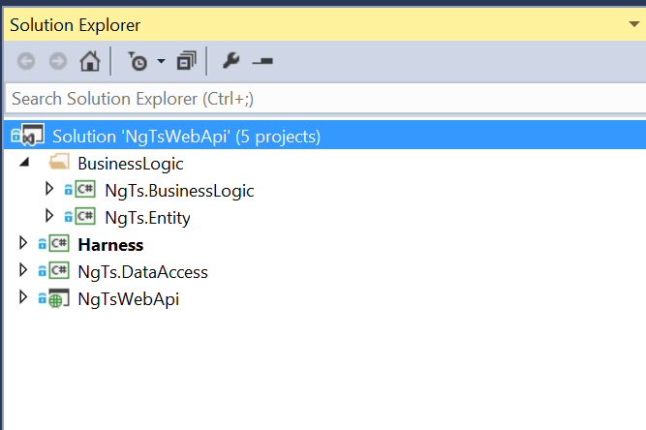

Data access Layer

Below is the data access project items. Now is the time to understand the T4 templates. To understand better follow the msdn link http://msdn.microsoft.com/en-us/library/bb126445.aspx, one of the component is dotnet dynamic framework. Please go through the Elastic object which is used in our project https://github.com/amazedsaint/ElasticObject . Which would helps to create dynamic objects from model xml. Models.xml is available under Model folder. Here is the place where you need to provide the model definition info which is the source to generate all the corresponding objects mainly db objects script, data access factory objects, Entity object to hold the data both UI and data access layers, Business manager class to add business logic here, Web api controller objects and Angularjs templates which need to be presented in the UI using typescripts.

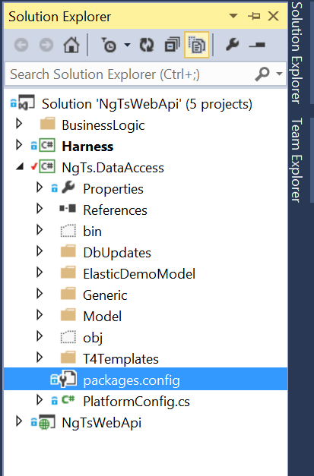

Data access layer follows the repository pattern along with microsoft enterprise lib 6.
To understand better about repository pattern http://msdn.microsoft.com/en-us/library/ff649690.aspx code project ref http://www.codeproject.com/Articles/526874/Repositorypluspattern-cplusdoneplusright

Please go through the EntLib6 features http://blogs.msdn.com/b/agile/archive/2013/04/25/just-released-microsoft-enterprise-library-6.aspx

Nuget package that needs to be installed for data access layers as given below

<packages>
<package id="AmazedSaint.ElasticObject" version="1.2.0" targetFramework="net45" />
<package id="EntLib" version="3.1.0.0" targetFramework="net45" />
<package id="T4" version="2.0.1" targetFramework="net45" />
<package id="T4.TemplateFileManager" version="2.1.2" targetFramework="net45" />
</packages>

By default above mentioned packages are installed while compile if not please install manually if you not familiar how use nuget Manager Please follow the link
http://docs.nuget.org/docs/start-here/installing-nuget

Microsoft does n’t support T4 code editor but there are many free code editor addins available, Tangible T4 code editor is free with basic features which is more than sufficient for our development. It is also available with commercial version.

https://visualstudiogallery.msdn.microsoft.com/6d1223ca-5e52-49d0-a489-910f9b76396e

Now you can define the entity that needs to be used in your app. It is available under Model folder as given below.

<?xml version="1.0" ?>
<schema>
<table name="NgTsUser">
<field name="UserId" type="int" primary_key="yes" />
<field name="UserName" type="varchar(50)" />
<field name="UserCode" type="varchar(50)" />
<field name="FirstName" type="varchar(50)" />
<field name="LastName" type="varchar(50)" />
<field name="Password" type="varchar(50)" />
</table>
<table name="Product">
<field name="ProductId" type="int" primary_key="yes" />
<field name="ProductName" type="varchar(50)" />
<field name="ProductDesc" type="varchar(50)" />
<field name="Price" type="decimal (12,2)" />
</table>

</schema>

After complete model definition you can run the t4 template to generate code as given below.

How to run the db updates from command prompt

From solution explorer goto data access project
Navigate to the dbUpdate folder
Right click on the dbupdate folder and click open folder option copy the path.

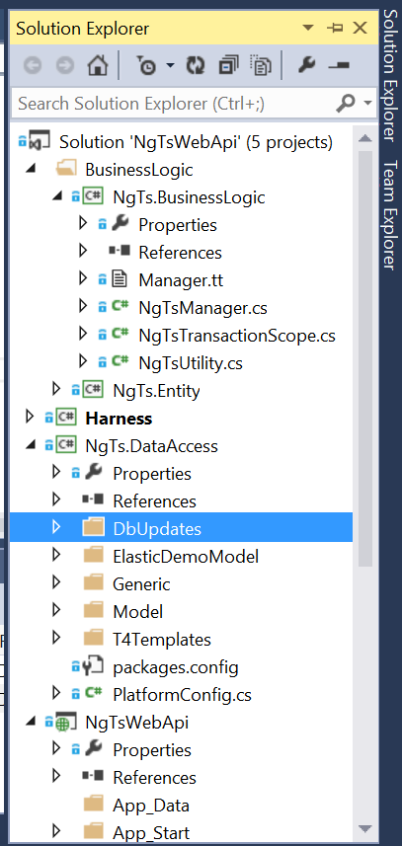

Go to command prompt change directory to by as given below
>cd D:\Ras\Projects\NgTsWebApi\NgTs.DataAccess\DbUpdates [press enter key]
D:\Ras\Projects\NgTsWebApi\NgTs.DataAccess\DbUpdates> DbUpdate.bat [press enter key] it will prompt you to enter db name and its credential as given below.

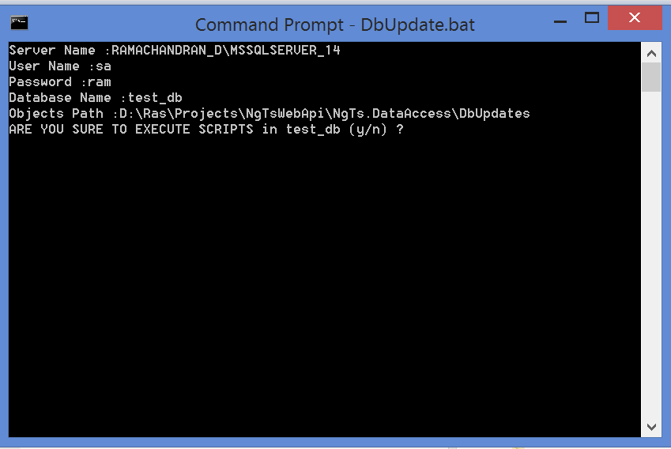

If yo press y letter all scripts would be executed in the db.
Now you you are ready to go and run the application and see the response.

