Homework 3
CSCIE 81 Machine Learning
Lu Wang, Ram Ochoa

For this assignment, we had to find the best classifier for a multi-class dataset. The supplied trainingData had roughly 17K rows, and it was to be used to create predictions on a blind dataset of 20050 rows.

Steps:

1. Loading and preprocessing data

The data provided had missing terms. Since all features had missing entries, and the most sparse only had a modest number of NAs (the average was 23, or less than 0.1% of the column), we decided not to delete any features. Furthermore, NAs were spread out evenly across the rows, so we did not drop any observations.

Therefore, we picked two ways to handle NA terms: by replacing them with zero, or by replacing them with the feature mean. In the future, I would like to experiment with methods of predicting NA values.

Histogram of NA count per column Histogram of NA counts per row
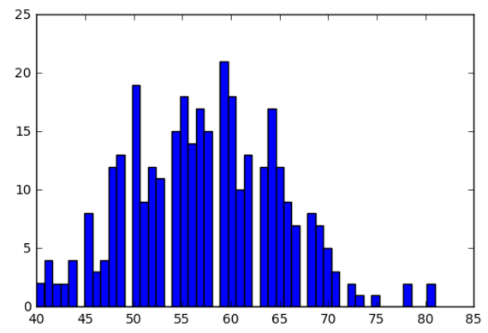
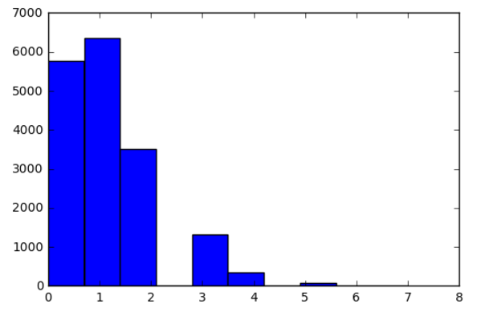

2. Initial assessment = high bias, high variance across 8 different models

We ran a panel of classifiers on the NA=0 and NA=mean datasets, and found that replacing with the feature mean yielded low lifts across nearly the entire list of classifiers. However, overall variance and bias were still quite high for most classifiers.
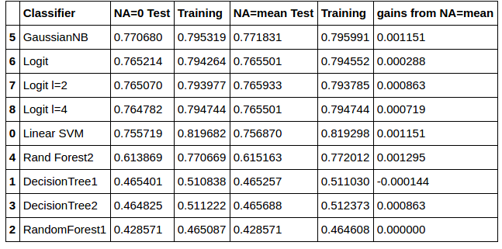

Under these high bias high variance circumstances, I decided to address the bias first. Perhaps the model is learning the wrong thing. I checked if the dataset was balanced. It was not. The most populous class 1 had 5666 predictions, and the smallest class 4 had only 2601.

Since 17K doesn’t feel like a dataset that is too big or small to be an obvious candidate for under or oversampling, respectively, I decided to try both. While oversampling did better than undersampling, it made my models all slightly worse than ones ran on unbalanced data.

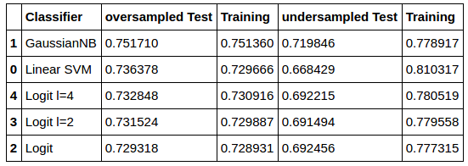

Now that I am writing this summary after my modeling is done, I realized that I should go back and apply balanced classes to the final best model and see if there is lift. I think I abandoned balancing classes too early.

3. Increasing model complexity (for bias) and reducing feature space (for variance)

I had read that random forests often do a good job picking out important features. I was skeptical since their performance was so poor. However, I used this opportunity to see if adding complexity to models would help, and trees are easily understood when adjusting complexity.

I experimented with trees of varying depth. Deeper trees were slightly more accurate, and may improve the bias problem, but none were close to Logit’s accuracy. With Logit, I also decreased lambda to increase model complexity, which lead to small lifts.

We used a decision tree and random forest to pick out important features, and ran models using only these inputs. The features picked by random forest yielded much better models, but it could have that random forests considered ~200 significant inputs. Decision tree only found 23 important inputs. Still, our best performing classifiers had the entire unbalanced dataset with means for NA. It was time to try revisit the features.

4. Feature transformations

I had read that PCA is an excellent way to reduce 100s of features into their most important components, so I was excited to give it a try when we received an extension! When reading about PCA, I also had someone suggest LDA. PCA was focused on finding the biggest variance within inputs, while LDA was focused on finding vectors that created the greatest linear separation between the classes. Both sounded different enough and worth a try.

I believe that LDA and PCA were my most important discoveries. For all models other than nonlinear SVM, PCA and LDA created significant improvement on all classifiers that originally had less than 70% accuracy.
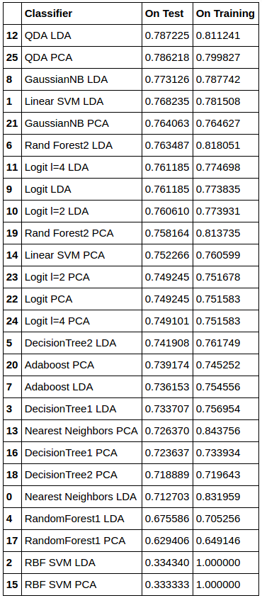
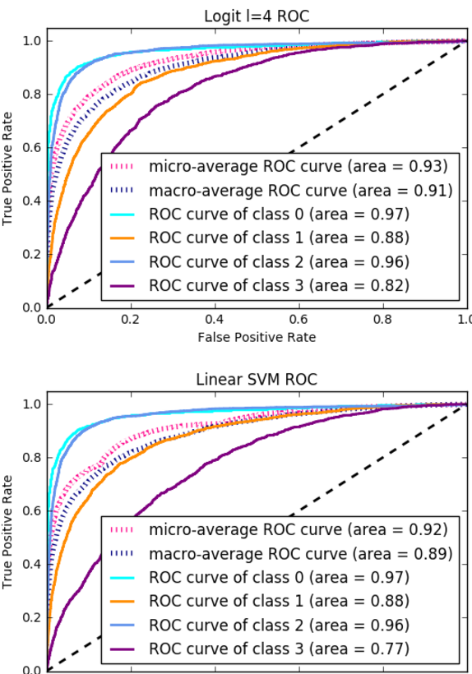
The ROC curves for the top three models show that the leader, Quadratic Discriminant Analysis, is not only good at overall accuracy, but it does a decent job predicting all four classes.
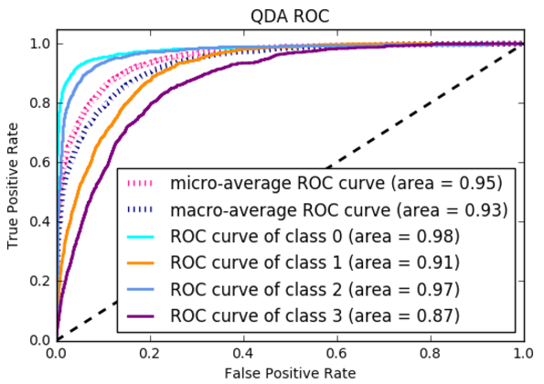

I was very surprised that this model jumped from the bottom rank to the top after feature transformation, but also relieved that I did not abandon it too early. Next steps would be to iterate back to earlier strategies and reapply them to the QDA model as it exists.

In conclusion, this was my favorite assignment to date, quite possibly because of how much time I put into it after struggling through the first two assignments. I enjoyed the opportunity to PRACTICE, and eventually to try and apply concepts that we learned in lecture. I fully appreciate the work that data scientists have to do and how much their experience matters.

