Configuration File Parameters for GUIDANCE v0.1.1
Last update: 9 August 2019

- wfDeep: Name that defines the number of stages to be executed. These stages are defined in Figures 1 and 2.
- init_chromosome: First chromosome to analyse.
- end_chromosome: Last chromosome to analyse.
- maf_threshold: Minor allele frequency cut-off used to filter final results.
- impute_threshold: IMPUTE2 info score cut-off used to filter final results.
- minimac_threshold: MINIMAC Estimated imputation accuracy (R²) cut-off used to filter final results.
- hwe_cohort_threshold: Hardy-Weinberg equilibrium p.value threshold for cohort.
- hwe_cases_threshold: Hardy-Weinberg equilibrium p.value threshold for cases.
- hwe_controls_threshold: Hardy-Weinberg equilibrium p.value threshold for controls.
- exclude_cgat_snps: Logical. Whether or not G>C or A>T SNPs should be excluded. We strongly recommend activating this flag as to avoid strand orientation issues. Most of the genotyping arrays have a very small number of such SNPs, and their exclusion should not result in any noticeable loss of imputation performance.
- imputation_tool: The name of the imputation tool to impute genotypes. To date, only “impute” to select IMPUTE2 and “minimac” to select MINIMAC4 are accepted.
- test_types: Names for the different analysis to be carried out by GUIDANCE, separated by commas. The association results for each “test_type” will be created in a directory with the same name inside the “associations” directory. Below this flag, different “test_types” have to be listed with the phenotype name and the covariates names to take into account in the association analysis (for instance, to analyse “test_types = DIA2,CARD” users should add: “DIA2 = DIA2:sex,BMI” and “CARD = CARD:sex,BMI” below, where sex and BMI are covariates).
- chunk_size_analysis: Size of the chunks considered to partition the data.
- file_name_for_list_of_stages: File into which all the commands launched in the workflow are stored.
- input_format: (I think that now we only support BED input since we have not tried with the other formats since I am working in the project…).
- mixed_cohort: Name of the cohort.
- mixed_bed_file_dir: The path to the directory with genotype files.
- mixed_bed/bim/fam/_file: Name of the file containing genotypes.
- mixed_sample_file_dir: Path to the directory where the sample file is located.
- mixed_sample_file:. Name of the sample file.
- genmap_file_dir: Path where genetic map files are located.
- genmap_file_chr_n: Name of the genetic map file for each chromosome in every new line.
- refpanel_number: Number of reference panels.
- refpanel_combine: 'NO' if there is only one panel or imputed results from different reference panels should not be integrated; 'YES' when different reference panels are expected to be used in the analysis and also the integration of all the results is required.
- refpanel_type: Name of the reference panel.
- refpanel_memory: Required amount of memory demanded by each particular panel. Currently, “HIGH”, “MEDIUM” and “LOW” are supported.
- refpanel_file_dir: Path where the reference panel for each chromosome is located.
- refpanel_hap_file_chr_n: Haplotypes files per chromosome of the reference panel provided in case IMPUTE2 is chosen as imputation tool and for the chrX in case Minimac4 is used.
- refpanel_leg_file_chr_n: Legend files per chromosome of the reference panel provided in case IMPUTE2 is chosen as imputation tool and for the chrX in case Minimac4 is used.
- refpanel_vcf_file_chr_n: VCF files per chromosome of the reference panel provided in case Minimac4 is used.
- outputdir: The path of the directory where the results will be written.

For a complete example of a configuration file, see Figures 3 and 4.

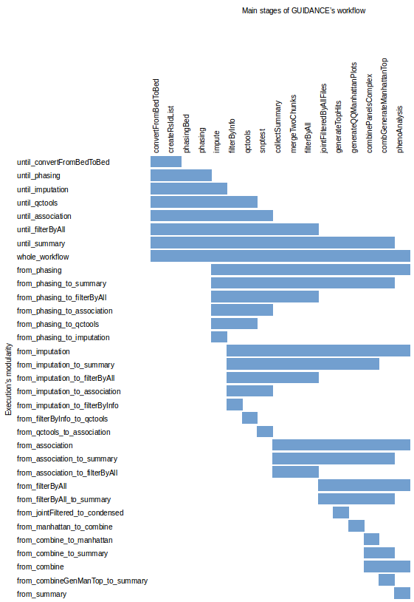
Figure 1. Modularity of the GUIDANCE workflow with IMPUTE2 as imputation tool. The user can choose between using running the whole workflow, or just a subset of stages. The bar represents the number of stages that will be run by each category of modularity.

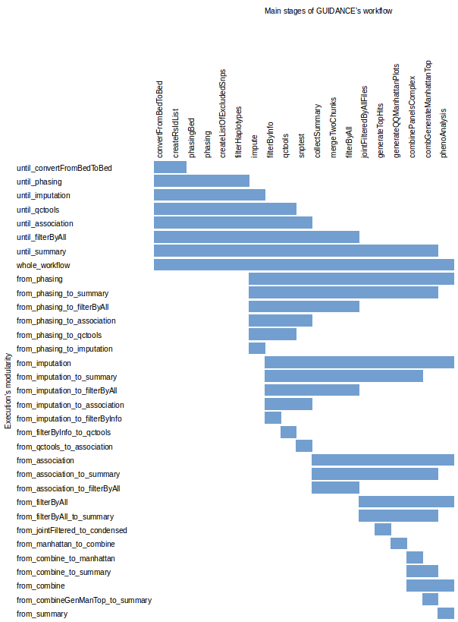
Figure 2. Modularity of the GUIDANCE workflow with Minimac4 as imputation tool. The user can choose between using running the whole workflow, or just a subset of stages. The bar represents the number of stages that will be run by each category of modularity.

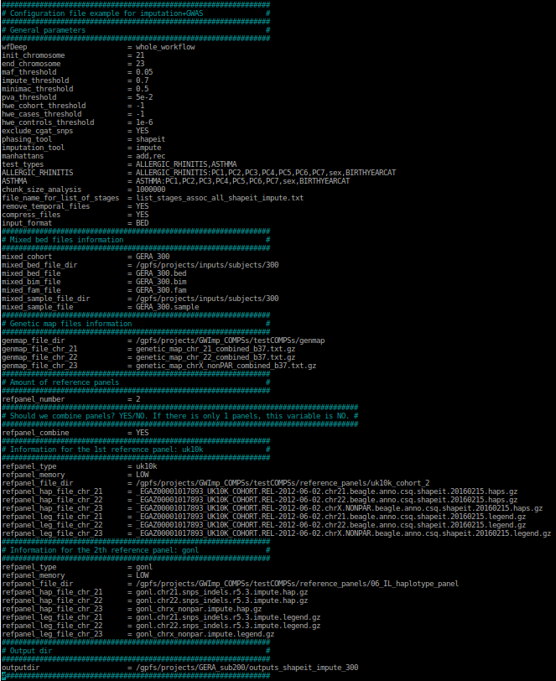
Figure 3. Configuration file example for a GUIDANCE execution with IMPUTE2 as imputation tool.

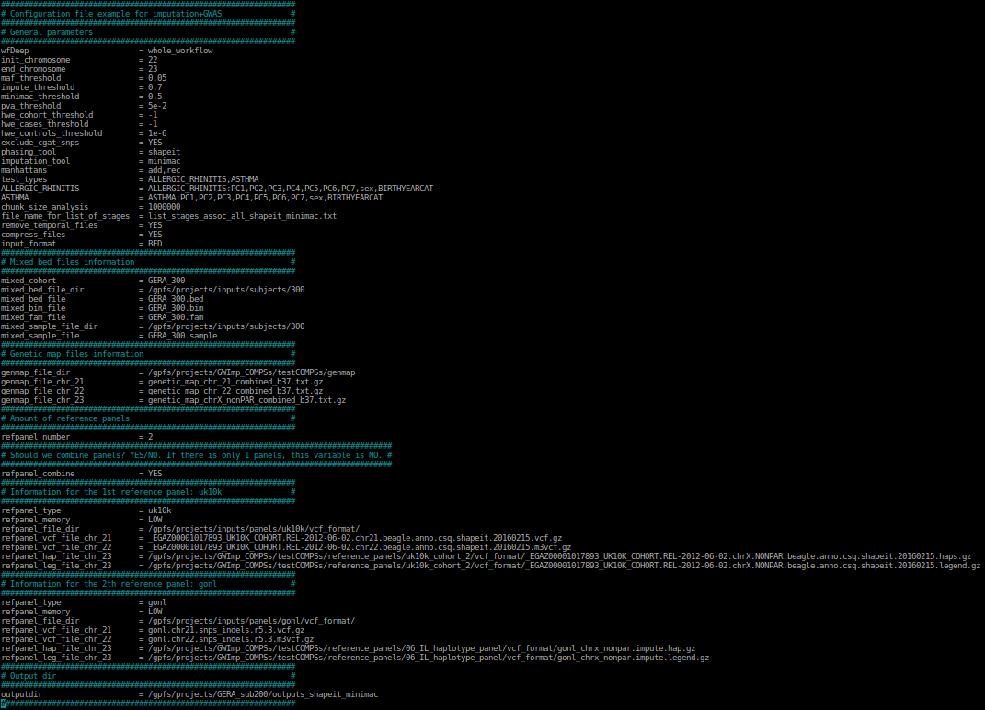
Figure 4. Configuration file example for a GUIDANCE execution with Minimac4 as imputation tool.

