数据统计与分析第4章作业
学号： 姓名： 班级： 总分：
第1题
#引入dstatR
source("dstatR2func.R")
data <- read.csv("ch2-3.csv", encoding = "UTF-8")
print(data)
#(1)
t1 = table(data$性别)
t1
png(file = "gender-ratio.png")
barplot(t1, col = c("#FF0000", "#00FF00"), names.arg = c("女", "男"))

#(2)
print("对于性别的频数表")
a <- Ftab(data$性别)
png(file = "gender-ratio2.png")
barplot(a)

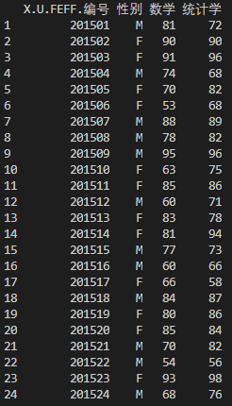
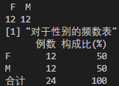
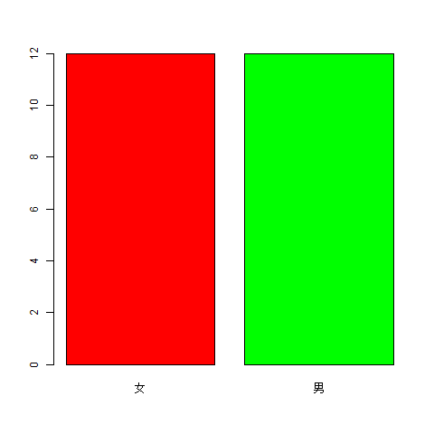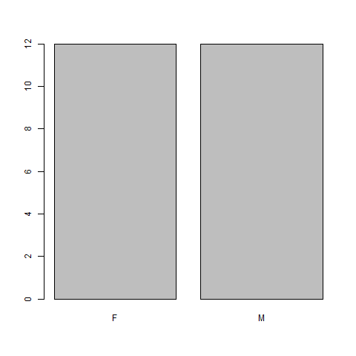
第2题
source("dstatR2func.R")
#(1)
info = c(3,4,1,1,3,4,3,3,1,3,2,1,2,1,3,4,1,1,3,4,3,3,1,3,2,1,2,1,2,3,2,3,1,1,1,1,4,3,1,2,3,2,3,1,1,1,1,4,3,1)
tsr=table(info)
tsr
print("饮酒人数")
sum(tsr)
names = c("红酒", "白酒", "黄酒", "啤酒")
cols = c("#FF0000", "#00FF00", "#0000FF", "#FFFF00")
png(file='wine-pie.png')
pie(tsr, labels=names, col=cols)
#(2)
print("频数表")
table(info)
#(3)
print("频数表")
Ftab(info)
print("频数图")
png(file='wine-freq.png')
Freq(info)

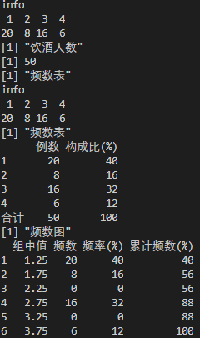
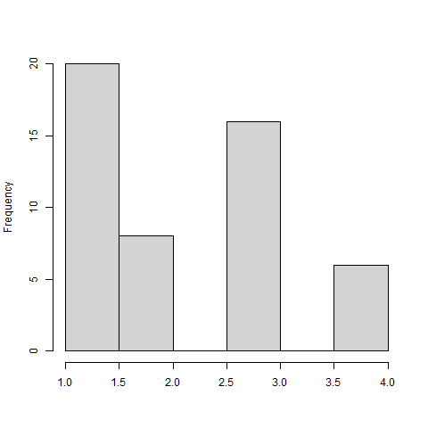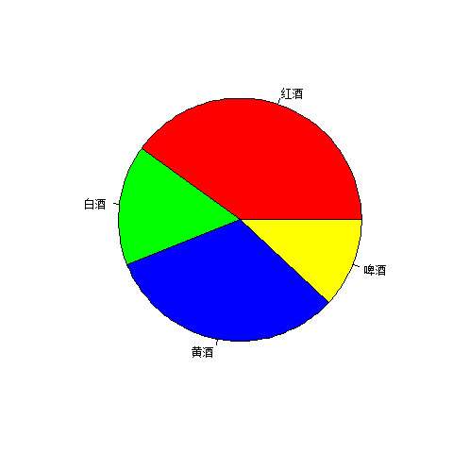
第3题
source("dstatR2func.R")
data <- c(2050,2100,2200,2300,2350,2450,2500,2700,2900,2850,3500,3800,2600,3000,3300,3200,4000,3100,4200,3500)
#(1)
print("均值")
mean(data)
print("中位数")
median(data)
print("方差")
var(data)
print("标准差")
sd(data)

#(2)
print("散点图")
x <- (1:20)
png(file = "plot4-3.png")
plot(x, data, "p")
print("直方图")
png(file = "hist4-3.png")
hist(data)

#(3)
print("频数表")
png(file = "freq4-3.png")
Freq(data)

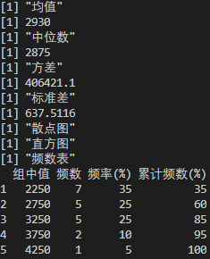
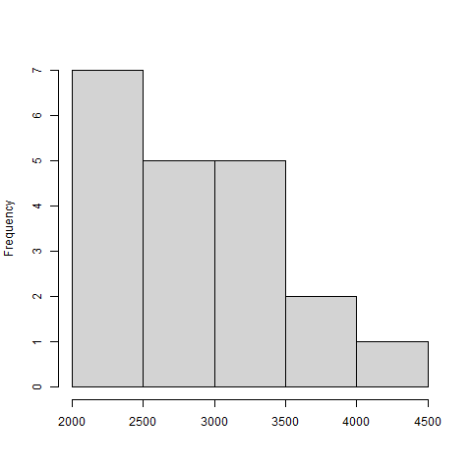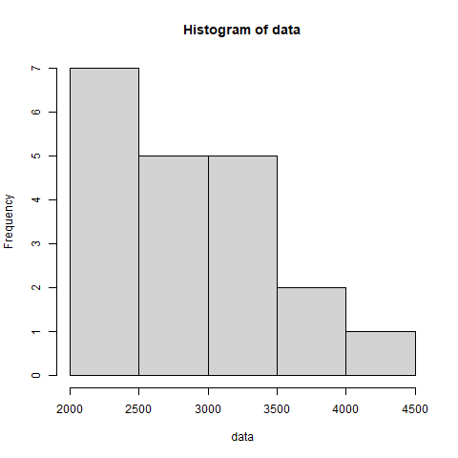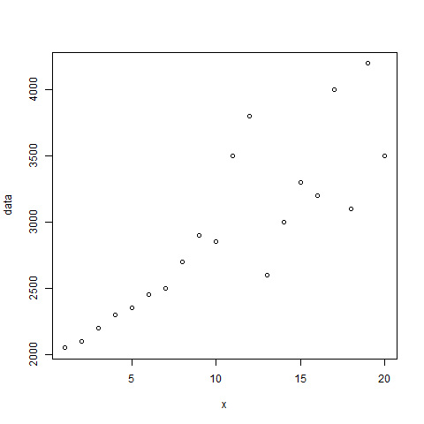
第4题
source("dstatR2func.R")
data <- c(11,19,14,22,14,28,13,81,12,43,11,16,31,16,23,42,22,26,17,22,13,27,108,16,43,82,14,11,51,76,28,66,29,14,14,65,37,16,37,35,39,27,14,17,13,38,28,40,85,32,25,26,16,120,54,50,18,27,16,14,33,29,77,50,19,34)

print("(1) 绘图分析")

print("(2) 分析数据的集中趋势和离散程度")
print("均值")
mean(data)
print("中位数")
median(data)
print("方差")
var(data)
print("标准差")
sd(data)

print("(3) 均值和中位数相差大说明财富分配不均，方差和标准差是看数据稳定程度的")

print("(4) 绘制散点图和直方图")
print("散点图")
png(file = "plot4-4.png")
plot(data)
print("直方图")
png(file = "hist4-4.png")
hist(data)

print("(5) 频数表和频数图")
png(file = "freq4-4.png")
Freq(data)
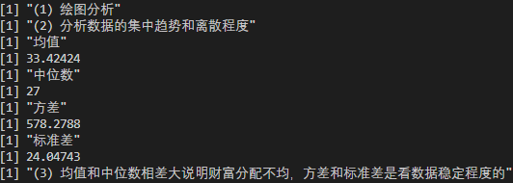
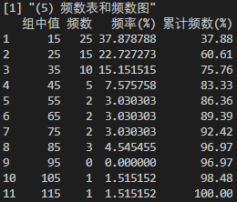
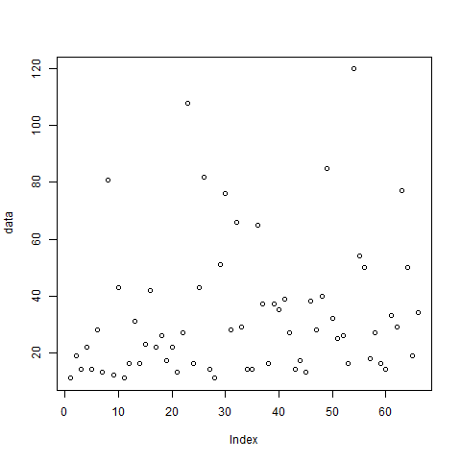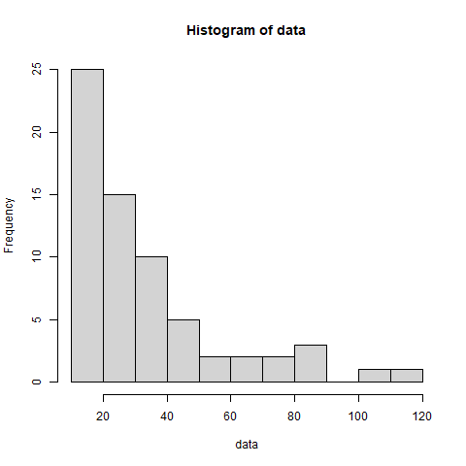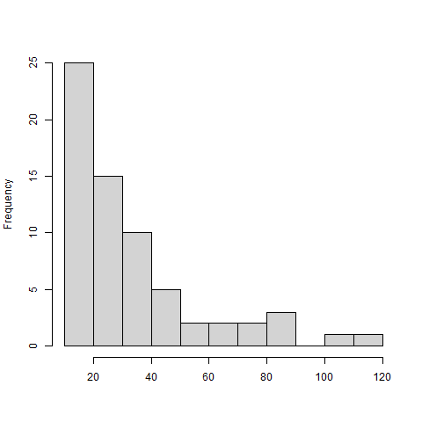
第5题
source("dstatR2func.R")
data <- read.csv("ch3-3.csv", encoding = "UTF-8")
head(data)

print("(1) 生成地区、性别、受教育程度、观点的频数表和图")

location <- Ftab(data$地区)
png(file = "freq-loc-4-5.png")
barplot(location)

gender <- Ftab(data$性别)
png(file = "freq-gen-4-5.png")
barplot(gender)

edu <- Ftab(data$受教育程度)
png(file = "freq-edu-4-5.png")
barplot(edu)

viewpoint <- Ftab(data$观点)
png(file = "freq-view-4-5.png")
barplot(viewpoint)

print("(2) 计算年龄、月收入、月支出基本统计量")
Stats(data$年龄)
Stats(data$月收入)
Stats(data$月支出)

print("(3) 计算年龄、月收入、月支出的探索性统计图")
png(file = "exp-age-4-5.png")
EDA(data$年龄)
png(file = "exp-income-4-5.png")
EDA(data$月收入)
png(file = "exp-outcome-4-5.png")
EDA(data$月支出)

print("(4) 计算年龄、月收入、月支出的频数表和频数图")
png(file = "freq-age-4-5.png")
Freq(data$年龄)
png(file = "freq-income-4-5.png")
Freq(data$月收入)
png(file = "freq-outcome-4-5.png")
Freq(data$月支出)

print("(5) 多变量联合分析")
tsr = table(data$性别, data$地区)
tsr
