**ISM3232**

**Assignment 2**

**Due Wednesday, 9/10/14, 11:59 p.m.**

Create a Windows Forms Application using Visual Basic Express 2010 and save it as ISM3232Assign2LastNameFirstName. It should have a form that looks something like this:

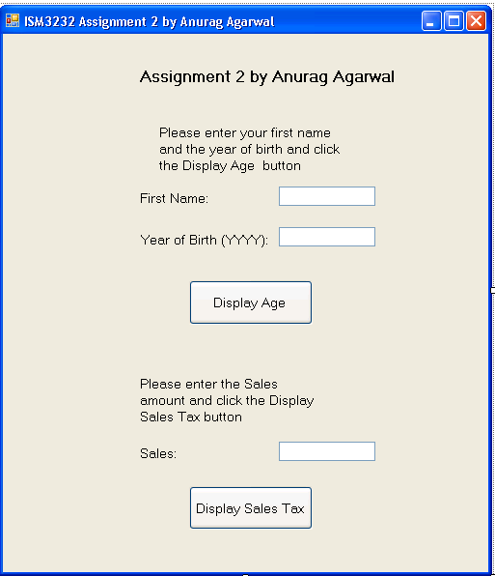

You will of course put your name instead of mine on the form title and on the form.

When the “Display Age” button is clicked, it should display a message that looks like this:

Dear <First Name>, you are approximately <age> years old.

The First Name should be picked up from the first name text box.

The age should be calculated as simply the difference between 2014 and the year of birth. Don’t worry about the month of birth. That is why the display says “approximately”.

Please declare a constant whose value is 2014 and use this symbolic constant in your calculations.

Please declare a variable to store the calculated age and use that variable in your statement that displays the message.

When the Display Sales Tax button is clicked, a message should appear that says:

“Your sales tax amount is: ” <the sales tax>

Where the sales tax is calculated as 7% of the sales amount that the user entered.

Please enter the sales tax rate in your code as a symbolic constant of type single with a value of 0.07

Please calculate and store the value of the sales tax amount in a variable declared as type single.

You may run ISM3232Assign2AgarwalAnurag.exe to see how the program should behave.

Submission Guidelines: The application should be named ISM3232Assign2LastNameFirstName, where LastName and FirstName are your last and first names. Please zip up the entire folder of your application and submit your zip file through blackboard.

Grading: I will look for whether you have named all the controls meaningfully. Please don’t leave the default names of the controls. I will look for whether you declared the relevant constants and variables using meaningful names.