**ISM3232, Fall 2014**

**Assignment 3**

**Due Monday, 9/17/14, 11:59 p.m.**

Create a Windows Forms Application using Visual Basic Express 2010 and save it as ISM3232Assign3LastNameFirstName. It should have a form that looks something like this:

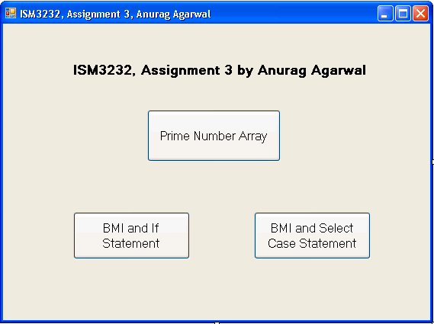

You will of course put your name instead of mine on the form title and on the form.

The event procedure for the “Prime Number Array” should do the following:

Declare an array for storing the first four prime numbers.

Assign the first four prime numbers (1,2,3,5) to the array using index value of 1 through 4.

Then using a loop of your choice (While or Do While or Do Until or For Next), display all these four values.

Then increase the size of the array to 8, such that the first four values are not lost.

Then assign the next four prime numbers (7,11,13 and 17) to index values 5 through 8.

Then using a different type of loop than the one used above, display all eight prime numbers.

When the “BMI and If Statement” button is clicked, it should ask the user for their weight (in lbs) and height (in inches) using Inputboxes. It should then calculate your BMI and then display the BMI. Then using If-Then-Else statements, it should determine and display whether the user is underweight, normal, overweight or obese.

BMI is weight (in lbs) * 703/ (height in inches)2

Assume that a BMI of below 18.5 implies you are “Underweight”, 18.5 to below 25 is considered “Normal Weight”; 25 to below 30 is considered “Overweight” and 30 or above is considered “Obese”

The “BMI and Select Case Statement” button should do exactly what the above button does, except it should use the Select Case statement instead of the If Statement.

Please run ISM3232Assign3AgarwalAnurag.exe file to see how the application behaves.

Submission Guidelines: The application should be named ISM3232Assign3LastNameFirstName, where LastName and FirstName are your last and first names. Please zip up the entire folder of your application and submit your zip file through Canvas.

Grading: I will look for whether you have named all the controls meaningfully and whether you have named variables meaningfully and used the appropriate data types.