**ISM3232**

**Assignment 5**

**Due Wednesday, 9/24/14, 11:59 p.m.**

Create a Windows Forms Application using Visual Basic Express 2010 and save it as ISM3232Assign4LastNameFirstName. After you name it, when you see the blank form (Form1), please do a “Save All”. It will save your application in a new folder. When you are done with the assignment, you will zip that entire folder and submit. Please do not save a form individually. Always do a “Save All”.

Your Assignment should have a form that looks something like this:

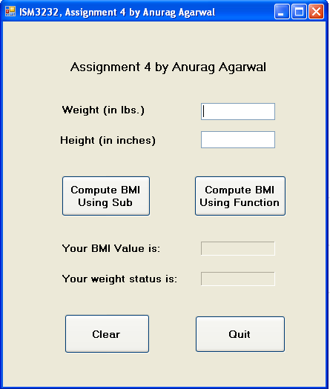

You will of course put your name instead of mine on the form title and on the form.

There are two text boxes, four buttons and seven labels. The Quit Button should quit the program. The event procedure for the quit button will have just one line of code - End.

The two text boxes are designed to accept the weight and the height of the user. The two empty labels above the Quit button are designed to display the BMI value and the weight status (Underweight, Normal, Overweight or Obese).

The Clear button should clear the two text boxes and the two labels for BMI and weight status above the quit button.

All labels, textboxes and buttons should be renamed appropriately using appropriate three letter prefixes. The form should also be renamed using the appropriate three letter prefix.

Write a Sub called ComputeBMI or CalculateBMI or FindTheBMI or ComputeTheBMI or something to that effect. Don’t call it BMI. This sub should have three parameters, two input parameters, weight and height and one output parameter, bmi. Choose appropriate data types for these parameters. The sub itself should have just one line of code that calculates the bmi using the weight and the height.

Write a function called BMI or TheBMI. It should have two input parameters – weight and height. Use appropriate data types for the input parameters and for the function itself.

Write a Sub called ComputeWeightStatus or DetermineYourWeightStatus or something to that effect. This Sub should have two parameters – one input and one output. The input parameter is BMI and the output parameter is WeightStatus of type String. The WeightStatus parameter can have one of the four possible values (Underweight, Normal Weight, Overweight or Obese). The cutoffs are as follows: BMI is < 18.5: Underweight. BMI of 18.5 or above and below 25: Normal. BMI of 25 or above and below 30: Overweight. BMI of 30 or above: Obese. You will write an IF statement in this Sub.

Write a function called WeightStatus of type String. It should have one input parameter – BMI of appropriate data type. It should return the WeightStatus (Underweight, Normal Weight, Overweight or Obese). Use the same cutoffs as above. But in this function you will not use IF statements. You will use SELECT CASE statements.

The Event Procedure for the first button will make use the two subs, i.e., it will call the two subs and display the weight and the weight status in the labels above the quit button. When naming variables in this event procedure, please make sure you use different variable names for Weight, Height, BMI and WeightStatus than the names used in the parameter lists of the subs. Also, if the user clicks on the button without entering a value for height and weight in the textboxes, the user should get a message about it. After displaying the message, the event procedure should end.

The Event Procedure for the second button will not use the subs but will use the two functions you wrote above, to display the weight and the weight status in the labels above the quit button. When naming variables in this event procedure, please make sure you use different variable names for Weight, Height and BMI than the names used in the parameter lists of the functions. Also, if the user clicks on the button without entering a value for height and weight in the textboxes, the user should get a message about it. After displaying the message, the event procedure should end.

Please make sure that the labels above the quit button are populated with values only by the event procedures and never by the subs and functions your wrote for BMI and WeightStatus.

Please run ISM3232Assign4AgarwalAnurag.exe file to see how the application behaves.

Submission Guidelines: The application should be named ISM3232Assign4LastNameFirstName, where LastName and FirstName are your last and first names. Please zip up the entire folder of your application and submit your zip file through Canvas.