**ISM-3232**

**Assignment 5**

**Due Wednesday, 10/1/14, 11:59 p.m.**

Create a Windows Forms Application using Visual Basic Express 2010 and save it as ISM3232Assign5LastNameFirstName.

It should have a form that looks something like this:

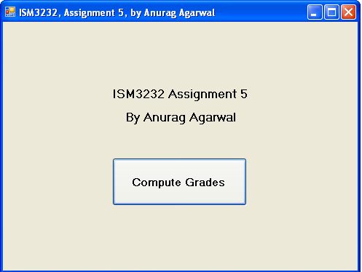

You will of course put your name instead of mine on the form and on the form title. Please rename the form and all the controls appropriately.

When the “Compute Grades” button is clicked, the following should happen:

It should read data from a data file called StudentScores.txt (provided along with the zip file of this assignment). Please copy this data file in the Debug folder of your project.

A sample record from the data file looks like this: William,Cox,14.0,13.5,15.0,12.5,13.5,27.5,25.0

Each record has the first and last name of the student, followed by five quiz scores (out of 15) and two exam scores (out of 30)

For each student, your code should (i) read the data from the data file in appropriately named variables, (ii) calculate the total score, (iii) figure out the percent score and (iv) based on the percent score, it should calculate the grade (90 or above A, 80-90 B, 70-80 C, 60-70, D, <60 F), (v) display a message box that looks something like : “Grade for William Cox is B” and (vi) write a record in an output file with the name, the total score, the percent score and the grade. For this student, for example, the output record should look like this: William,Cox,121,89.62963,B

Where 121 is the total score in the course, 89.62963 is the percent score and B is the grade.

To compute the grade in requirement (iii) above, you should either write a Sub or a Function. If you are writing a Sub, the sub should take an input parameter (the percent score) and return one output parameter (the grade). If you writing a function, it should just have one input parameter (the percent score).

In addition, your code should keep track of the (i) highest total score and the name of the student with the highest total score and (ii) lowest total score and the name of the student with the lowest score.

It should display the above two things through two message boxes and also print them in the output file.

You may run ISM3232Assign5AgarwalAnurag.exe (also provided in the zip file for this assignment) to see how the program should behave. Just make sure that the StudentScores.txt file is in the same folder as the exe file. Also check how the output file created by the program look like.

Zip up your application folder called ISM3232Assign5LastNameFirstName and submit through Canvas.