|  |  |  |  |  |  |  |  |
| --- | --- | --- | --- | --- | --- | --- | --- |
|  | | | rosa%20transpUNIVERSIDADE LUTERANA DO BRASIL ULBRA–Torres CURSOS DE SI E STADS | |  | | |
| Disciplina...............: | Estrutura de dados I | | Código.................: | |  |
| Professor...............: | Ramon dos Santos Lummertz | | Semestre letivo...: | | 2016/1 |
| Curso.....................: | Sistemas de Informação Stads | | Data | |  |
| Aluno.....................: |  | | Nota ....................: | |  |

|  |
| --- |
| INSTRUÇÕES DA ATIVIDADE  Prova individual sem consulta  Peso da prova 6 |

1. Considerando a implementação da estrutura abaixo como exemplo, implemente os métodos push(int a) e pop() para estrutura pilha. A implementação deve considerar que a pilha foi inicializada, que não se remova caso a pilha esteja vazia e que não se adicione caso a pilha esteja cheia. **(1)**

|  |
| --- |
|  |
|  |

1. Considerando a implementação da estrutura abaixo como exemplo, implemente os métodos add(int a) e remover() para estrutura fila. A implementação deve considerar que a fila foi inicializada, que não se remova caso a fila esteja vazia e que não se adicione caso a fila esteja cheia.**(1)**

|  |
| --- |
|  |
|  |

3 – Dado o seguinte trecho de código **(1)**

1. Mostre o que será exibido na tela.
2. Implemente um método que receba o vetor “DNA”, linha 4, e que inverta a sequencia;

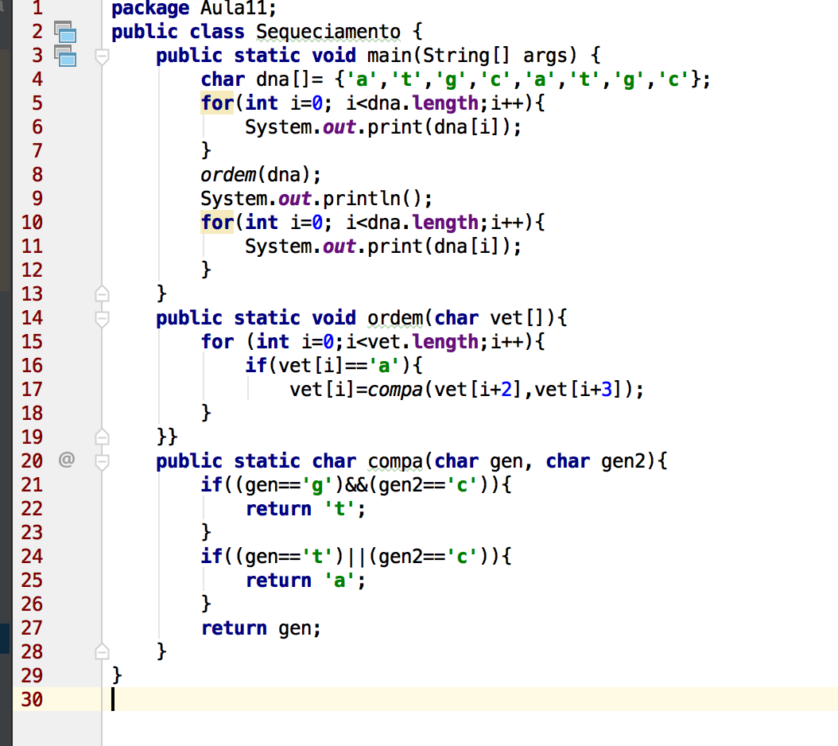

1. -Conceitue e exemplifique o conceito FIFO **(1)**

____________________________________________________________________________________________________________________________________________________________________________________________________________________________________________________________________________________________________________________________________________________________________________________________________________________________________________________________________________________________________________________________________________________________________________________________________________________________________________________________________________________________________________________________________________________________________________________________________________________________________________________________________________________________________________________________________________________________________________________________________________________________________________________________________________________________________

1. Conceitue e exemplifique o conceito LIFO; **(1)**

____________________________________________________________________________________________________________________________________________________________________________________________________________________________________________________________________________________________________________________________________________________________________________________________________________________________________________________________________________________________________________________________________________________________________________________________________________________________________________________________________________________________________________________________________________________________________________________________________________________________________________________________________________________________________________________________________________________________________________________________________________________________________________________________________________________________________

**1-** Questão retirada da prova do ENADE 2014.(1)

