# SQL Database Artifacts

## OXXO Promotion Mock Database

### Table Schemas

#### POS_PRM_HEAD

#### FEM_POS_MODS_PRM_STG

#### FEM_POS_PROM_DETAIL_STG

#### XXFC_MAESTRO_DE_CRS_V

### Sample Data

## SQL Promotion Database

### Table Schemas

#### PRM_PROMOTION_HEADER

#### PRM_PROMOTION_DATA

#### PRM_PROMOTION_DATA_DETAILS

#### PRM_XXFC_MAESTRO_DE_CRS_V

#### PRM_DOC_STATUS

#### PRM_POS_RULES_DOC_CFG

#### PRM_RUNNING_PROMOTIONS

### Stored Procedures

##### SQL Script

# Azure Data Factory Artifacts

## Linked Services

## Datasets

## Pipelines

### CopyPromotionDataToAzureSQLPipeline

#### ForEach loop processing

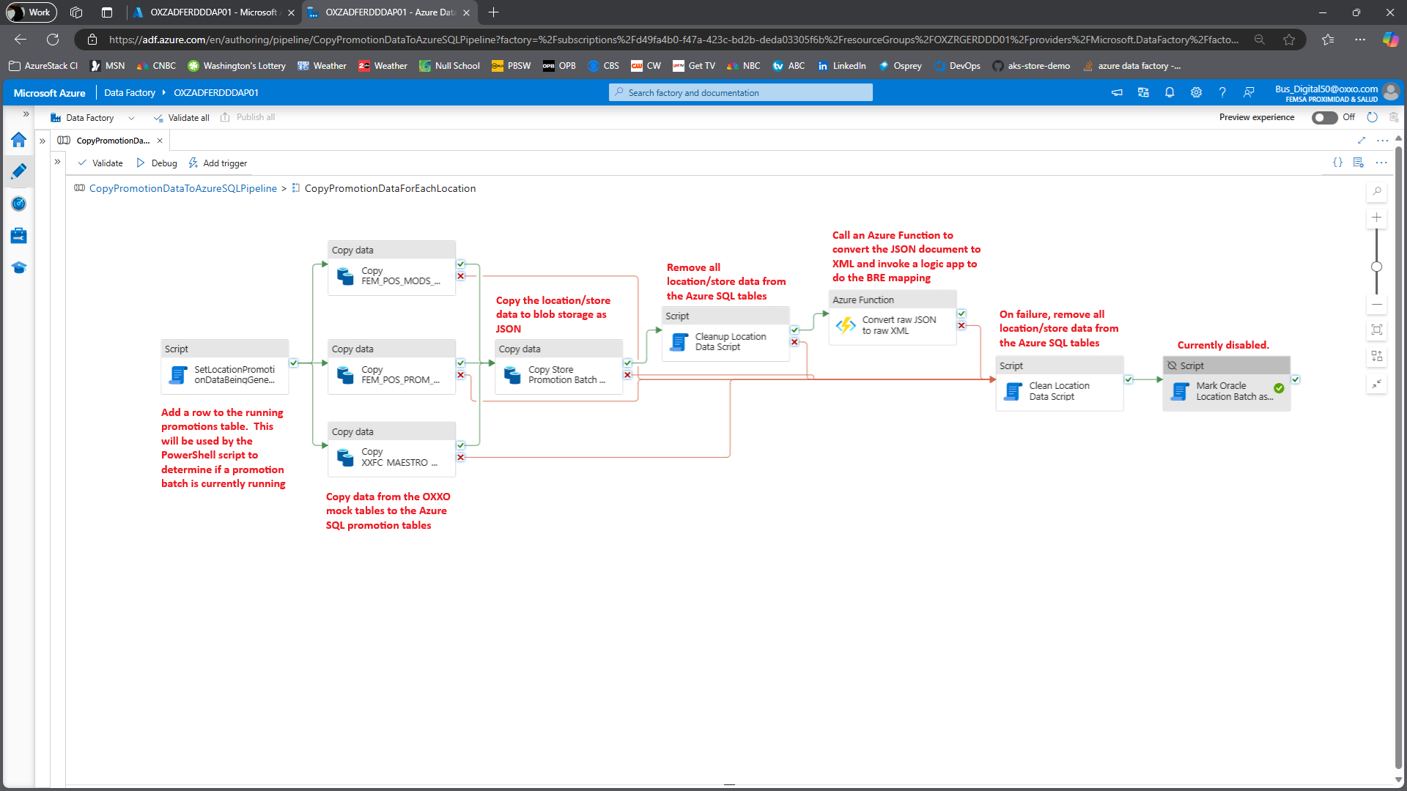

### CopyPromotionsFromOracleDbToSqlDb_DevTesting

# Successful debug run

# Azure Function App Functions

## Convert JSON to XML

